**SUDOKU GAME - USER INSTRUCTIONS AND ERROR HANDLING**

* **Valid Input Cases:**

1. When a user enters '0' in a cell, all other cells in the grid become locked (non-editable). The game remains in this state until the user enters a valid number (1-9) in the cell containing '0'. Once corrected, all cells return to their normal editable state.

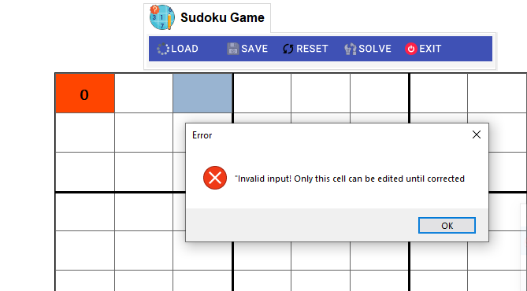

1. When a user enters a two-digit number starting with '0' (such as '01', '02', etc.), the system detects this as an invalid input. The entire grid becomes locked, and the user must correct this cell by entering a single valid digit (1-9) before being able to continue playing.

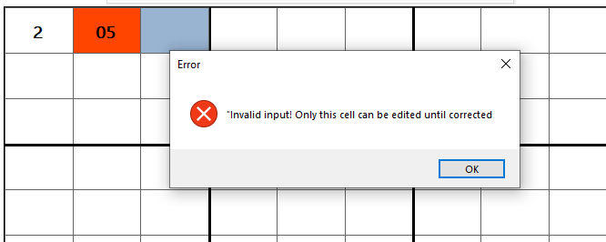

1. When a user enters any non-numeric character (letters, symbols, or special characters), the entire grid becomes locked. The game remains locked until the user replaces the invalid character with a valid single digit (1-9).

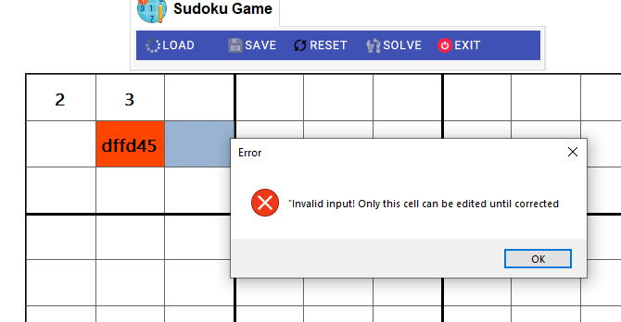

1. When a user enters a number that already exists in the same row, same column, or same 3x3 box, the entire grid becomes locked. The game remains in locked state until the user either

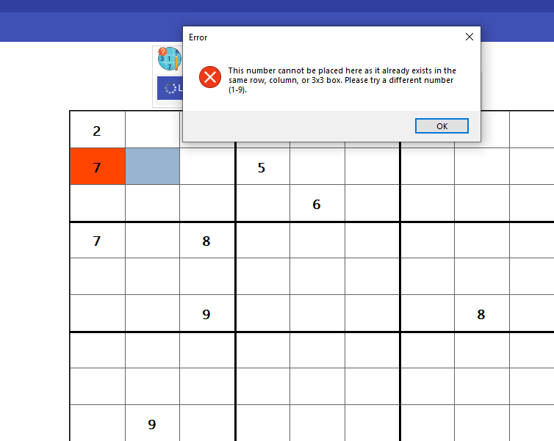

* **Click 'Solve' to:**

1. The Solve button activates after your first correction, but will still require ALL cells to be valid before solving the puzzle.

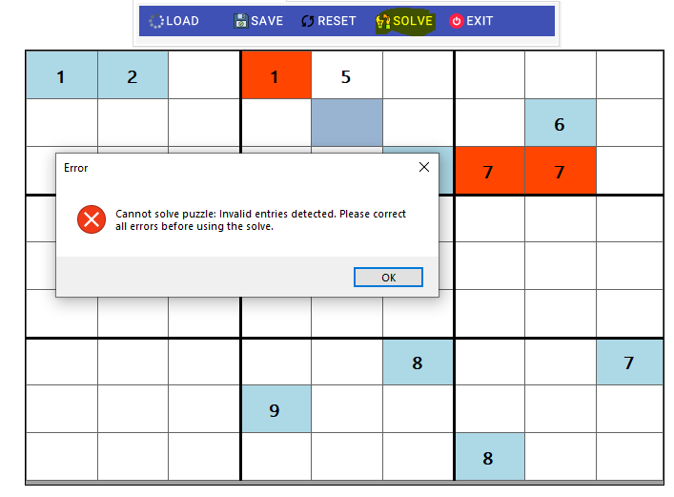

1. the current arrangement of numbers makes it mathematically impossible to complete the puzzle. In this case, the user must revise and modify their entries to allow for a valid solution.

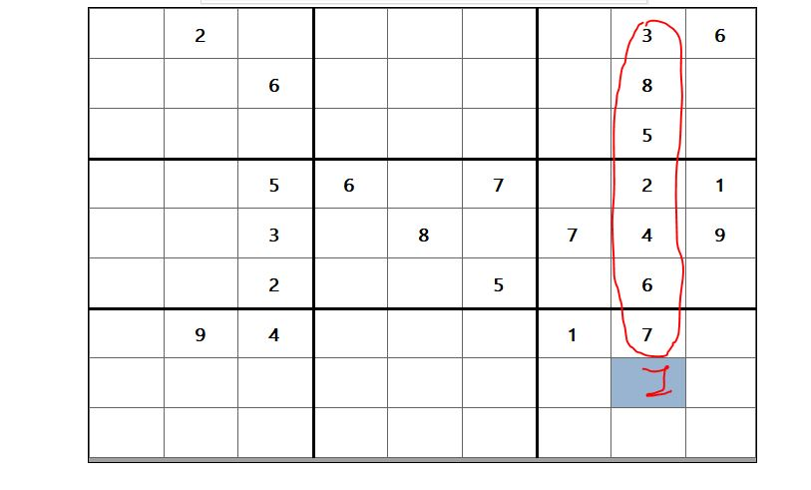

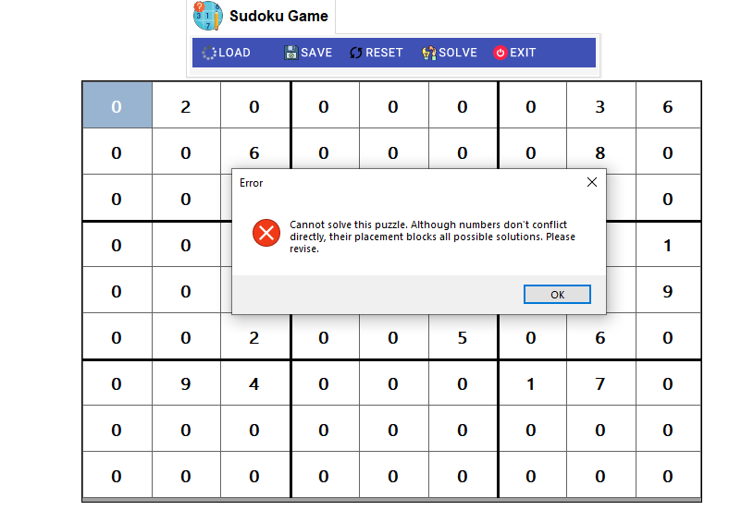

* **Click Load File:**

1. When attempting to load a file with an extension other than .json, the system displays an error message

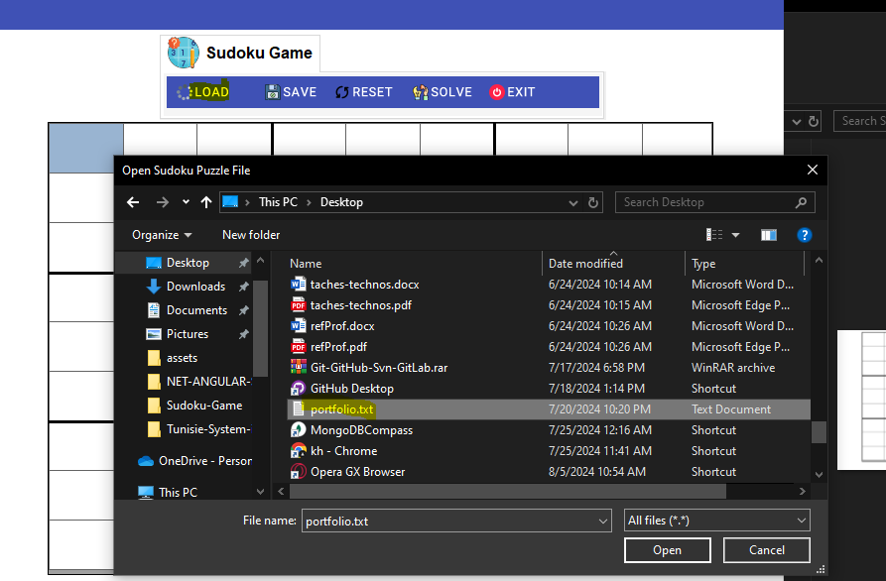

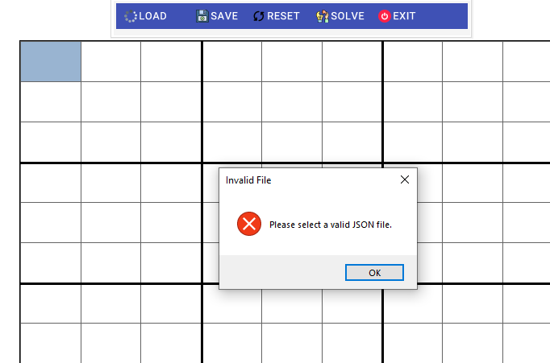

1. When attempting to load a file with a Sudoku puzzle not sized 9x9, the system displays an error message and blocks all operations.

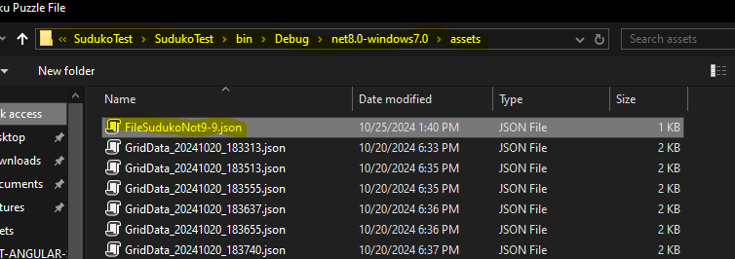

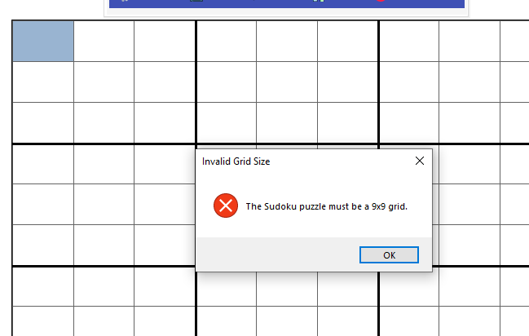

1. When attempting to load a file with a Sudoku puzzle containing values outside the range of 1 to 9, the system displays an error message and blocks all operations

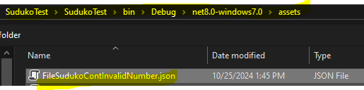

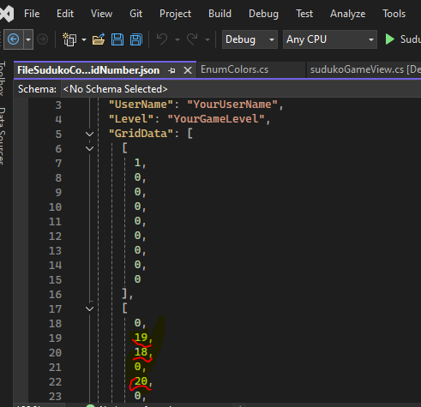

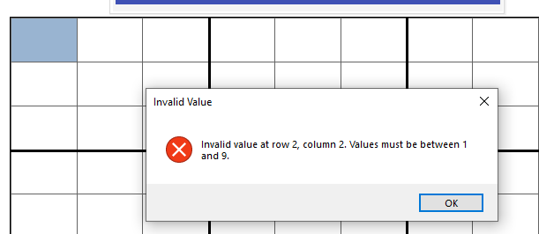

1. When a user loads a file with valid format but contains numbers that conflict in the same row, column, or 3x3 subgrid, the data is loaded with conflicting cells highlighted in red and remaining cells displayed in a different color:

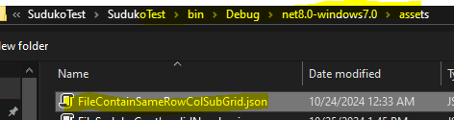

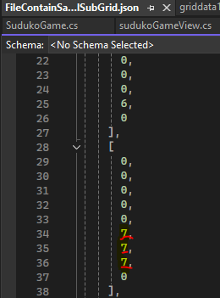

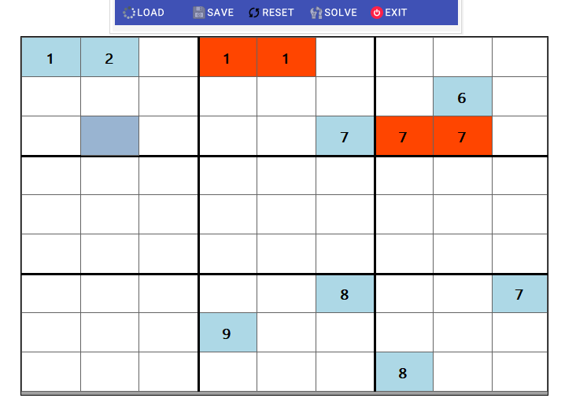

* **Click Save File:**

1. When clicking the save button, it creates an 'assets' folder in the current directory as the base directory

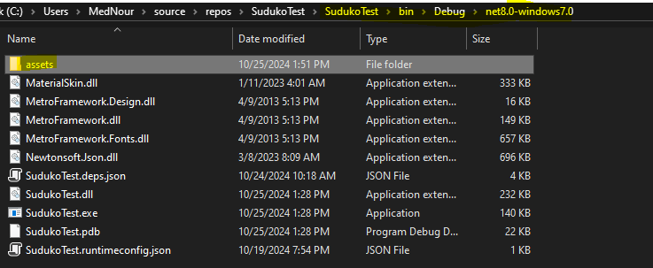

1. The system checks when saving and displays a message if the grid is empty

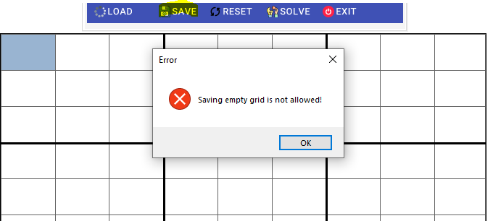

1. The system checks when saving and displays an error message if the grid contains invalid cells

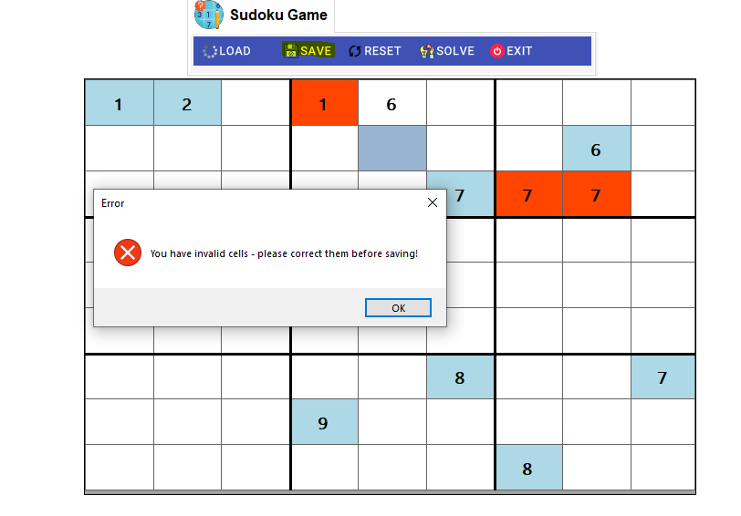

* **Click Exit Game:**

1. When clicking exit, the system verifies if the user wants to save the level file before closing

