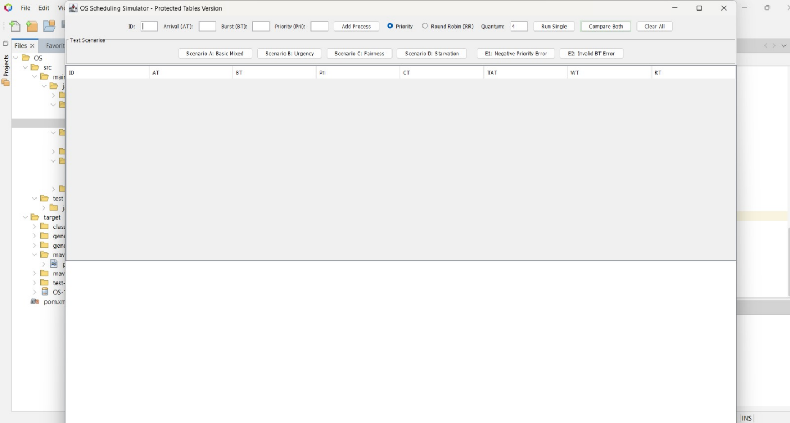

This photo before added any process
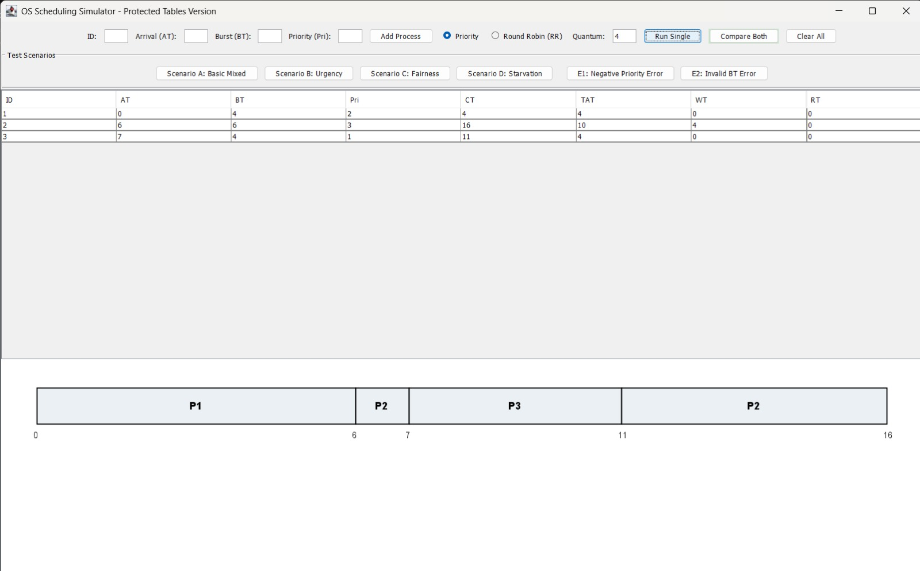

This photo after added process and apply priority
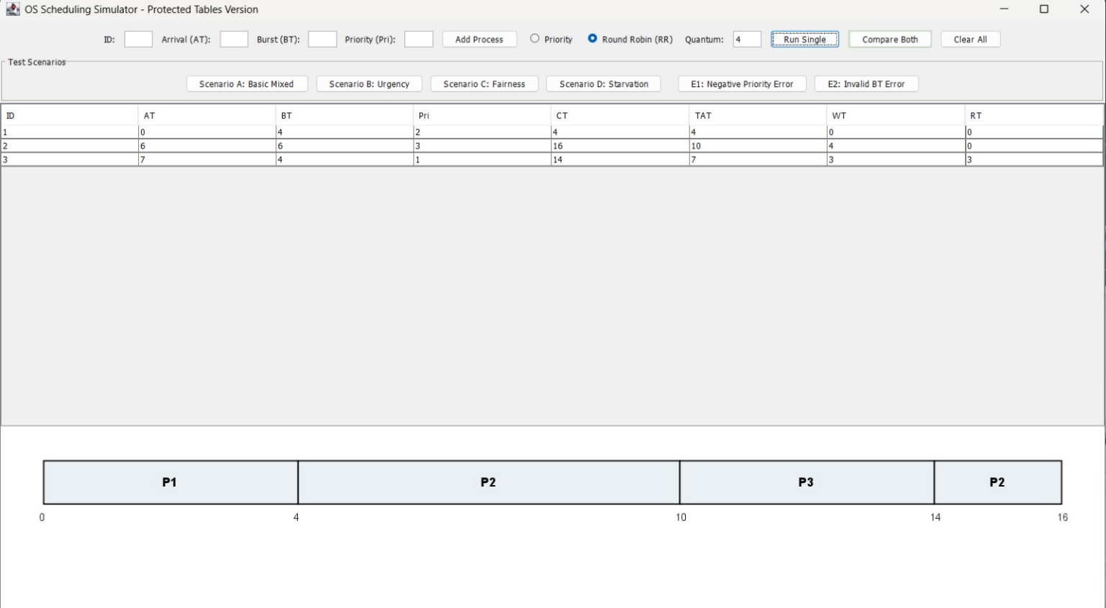

This photo after added process and apply Round Robin(RR)
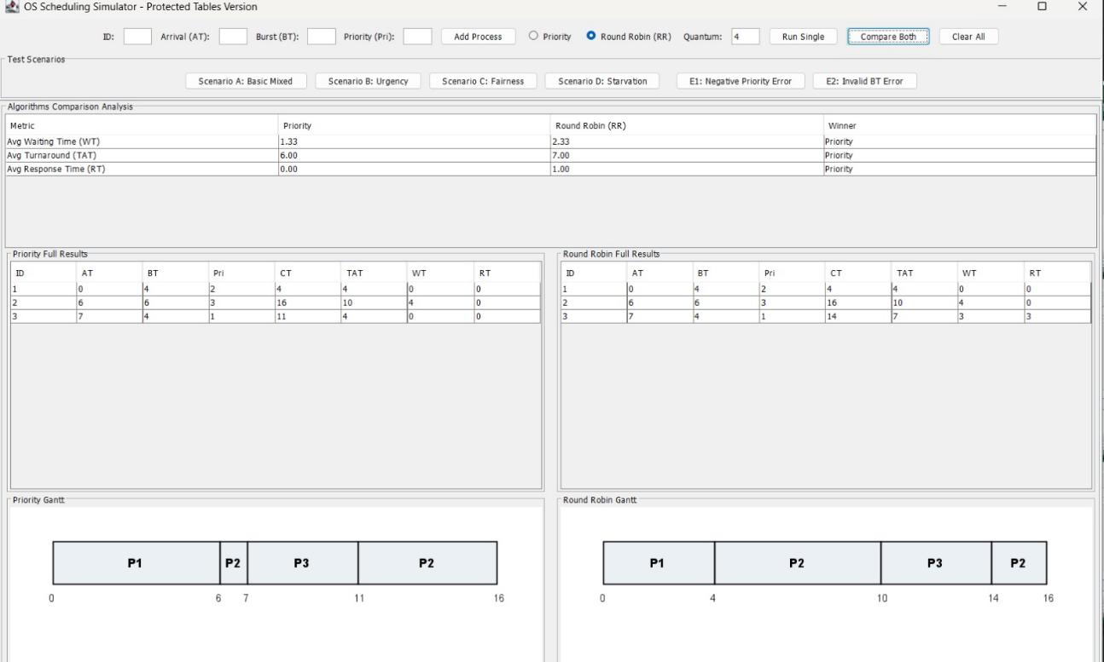
This photo after added process and apply priority and Round Robin(RR) and compare Both

