Introduction
When going to the gym, it is important to be able to track our performance during training. There are many solutions for this, for example, some people keep track of their training plan and details in a notebook, some in their notes. However, in today's world, applications designed for this purpose provide a great advantage.

Why did we choose this?
While researching these, we realized that the free apps didn't provide the full experience. That's why we created our own workout tracking app.

What is our goal with this?
Creating personalized training plans.
It allows users to track and analyze workout performance (e.g. weights lifted, reps, duration).
Motivating users through gamification (e.g. training sequences, best practices).

Developer documentation

Architecture overview
The backend is a Node.js-based API that handles logic, data processing, and database operations. Data is stored in an SQLite database.
The system communicates with three different clients:
- with a website (React + Vite),
- with a mobile app (React Native + Expo),
- and an admin interface (C# Windows Forms).
Each client accesses the data through the backend API, making the system centralized and easy to maintain. This architecture enables scalability and uniform data management across all platforms.
The technology stack are:
- Backend: Node.js, Express, SQLite3
- Mobile: React Native , Expo
- Web: React, Vite
- Admin: .NET Windows Forms
- Database: SQLite

Installation and setup

Local setting
Each component of the system can be configured and run separately. The steps below show the process of installing and starting each part.

Backend API
To set up the backend, you must first navigate to the api directory and then install the required dependencies using the npm install command.
Next, you need to create an .env file containing the environment variables by copying .env.example . The file should contain the necessary configurations, such as the email service details ( EMAIL_USER , EMAIL_PASS ) and the API port ( API_PORT ).
Initialize the database with npm run dev command, which runs the migration script ( db/migration.js ) and creates maxxedout.db SQLite database.
Finally, the API server is npm run It can be started with the dev command.

Mobile application (React Native )
To set up the mobile app, you need to navigate to the app directory and then install the dependencies.
Next, you need to create the .env file and set the path to the backend API and website ( API_URL , WEB_URL ).
The development server is npm run It can be started with the dev command, which starts the Expo environment.
You can try it out and test it on the web interface or with the Expo Go mobile application using the QR code issued on the console.

Website (React/Vite)
In the case of the website, the process also begins with installing the dependencies after navigating to the web directory.
VITE_API_URL ) must be specified in the .env file so that the application can communicate with the server properly.
The development environment can be started with the npm start command.

Admin interface (C# Windows Forms)
To set up the admin panel, you need to go to the admin directory, then dotnet Use the restore command to install the necessary packages.
The configuration also requires a .env file, which contains the API path ( API_URL ) and the key required for admin privileges ( API_KEY ).
Building and running the application using dotnet It is done with the run command.

Configuration

Environment variables
For the system to function properly, various environment variables need to be set. These vary by component and ensure configuration flexibility and secure handling of sensitive data.

Backend API
The environment variables required for the backend to function determine the email service configuration, admin access, and server operation.
- EMAIL_USER : Email address used to send notifications
- EMAIL_PASS : The password for the email service (e.g. Google app password)
- ADMIN_API_KEY : Secret key for administrator access
- API_PORT : API server port (default: 6600)

Mobile application
The variables required for the mobile application provide access to the backend and web interface.
- API_URL : Path to the backend API
- WEB_URL : The path to the website

Website
Website configuration is limited to backend API availability.
- VITE_API_URL : Path to the backend API

Admin interface
The admin panel uses a separate authentication mechanism, so it has its own API key configuration.
- API_URL : Path to the backend API
- API_KEY : Administrator API key for authentication

Database description

DBMS ( Database Management System)
The database manager of choice in the system is SQLite .

Advantages
No need for a separate server
Easy to integrate into backend application
Rapid development
File-based operation

Disadvantages
Limited scalability
Weaker parallel write handling

Boards

users​
This table stores basic user information, including email address, nickname, and password.
CREATE TABLE users (
id INTEGER PRIMARY KEY NOT NULL,
email TEXT NOT NULL,
nickname TEXT,
password TEXT NOT NULL
);

workouts​
It stores workout metadata, such as the user, workout start and end times, and name.
CREATE TABLE workouts (
id INTEGER PRIMARY KEY NOT NULL,
user_id INTEGER NOT NULL,
started_at DATETIME,
ended_at DATETIME,
name TEXT,
FOREIGN KEY ( user_id ) REFERENCES users ( id ) ON DELETE CASCADE
);

exercises​
The table includes the name and type of exercises (compound or isolation).
CREATE TABLE exercises (
id INTEGER PRIMARY KEY NOT NULL,
name TEXT NOT NULL,
type TEXT NOT NULL CHECK ( type IN (' Compound ', ' Isolation '))
);

sets​
sets , reps, and weights for exercises , as well as references to the workout and exercise.
CREATE TABLE sets (
id INTEGER PRIMARY KEY NOT NULL,
workout_id INTEGER NOT NULL,
exercise_id INTEGER,
exercise_name TEXT,
rep INTEGER,
weight INTEGER,
FOREIGN KEY ( workout_id ) REFERENCES workouts ( id ) ON DELETE CASCADE,
FOREIGN KEY ( exercise_id ) REFERENCES exercises ( id ) ON DELETE CASCADE,
CHECK (
( exercise_id IS NOT NULL AND exercise_name IS NULL) OR
( exercise_id IS NULL AND exercise_name IS NOT NULL)
)
);

muscle_groups (muscle groups)
Stores the names of all muscle groups.
CREATE TABLE muscle_groups (
id INTEGER PRIMARY KEY NOT NULL,
name TEXT NOT NULL
);

muscle_groups_exercises (muscle group–exercise relationship)
It establishes a connection between muscle groups and exercises and indicates the role of the muscle (primary or secondary).
CREATE TABLE muscle_groups_exercises (
muscle_group_id INTEGER NOT NULL,
exercise_id INTEGER NOT NULL,
role TEXT NOT NULL CHECK ( role IN (' Primary ', ' Secondary ')),
FOREIGN KEY ( muscle_group_id ) REFERENCES muscle_groups ( id ) ON DELETE CASCADE,
FOREIGN KEY ( exercise_id ) REFERENCES exercises ( id ) ON DELETE CASCADE
);

plans (training plans)
Contains users' training plans.
CREATE TABLE plans (
id INTEGER PRIMARY KEY NOT NULL,
user_id INTEGER NOT NULL,
name TEXT NOT NULL,
FOREIGN KEY ( user_id ) REFERENCES users ( id ) ON DELETE CASCADE
);

plans_exercises (plan–exercise relationship)
Stores exercises and sets assigned to a training plan.
CREATE TABLE plans_exercises (
plan_id INTEGER NOT NULL,
exercise_id INTEGER,
exercise_name TEXT,
sets INTEGER,
FOREIGN KEY ( plan_id ) REFERENCES plans ( id ) ON DELETE CASCADE,
FOREIGN KEY ( exercise_id ) REFERENCES exercises ( id ) ON DELETE CASCADE ,
CHECK (
( exercise_id IS NOT NULL AND exercise_name IS NULL) OR
( exercise_id IS NULL AND exercise_name IS NOT NULL)
)
);

codes (confirmation codes)
Code to be sent to email when data is changed.

CREATE TABLE IF NOT EXISTS codes (
code TEXT PRIMARY KEY NOT NULL,
user_id INTEGER NOT NULL,
expiry DATETIME DEFAULT ( DATETIME( ' now ', '+10 minutes ')),
FOREIGN KEY ( user_id ) REFERENCES users ( id )
ON DELETE CASCADE
);

tokens​​​
code received upon login that can be used to validate API requests.

CREATE TABLE IF NOT EXISTS tokens (
token TEXT PRIMARY KEY NOT NULL,
user_id INTEGER NOT NULL,
expiry DATETIME DEFAULT ( DATETIME( ' now ', '+7 days ')),
FOREIGN KEY ( user_id ) REFERENCES users ( id )
ON DELETE CASCADE
);

Normal forms

1st Normal Form (1NF)
All fields contain atomic values (no arrays or repeating groups).
Each record is uniquely identified by a primary key ( id or composite key).
The data is of a uniform type per column.

2nd Normal Form (2NF)
All non-key attributes are fully dependent on the primary key.
For tables that could be composite keys (e.g., pivot tables), there are no partial dependencies.
Relationships were moved to separate tables (e.g. muscle_groups_exercises , plans_exercises ), thus eliminating partial dependencies.

3rd Normal Form (3NF)
There are no transitive dependencies, i.e. a non-key field does not depend on another non-key field.
For example, user data is in a separate table ( users ), and other tables just reference it with a foreign key.
Repetitive data (e.g. exercises, muscle groups) has been organized into separate entities.

ER diagram
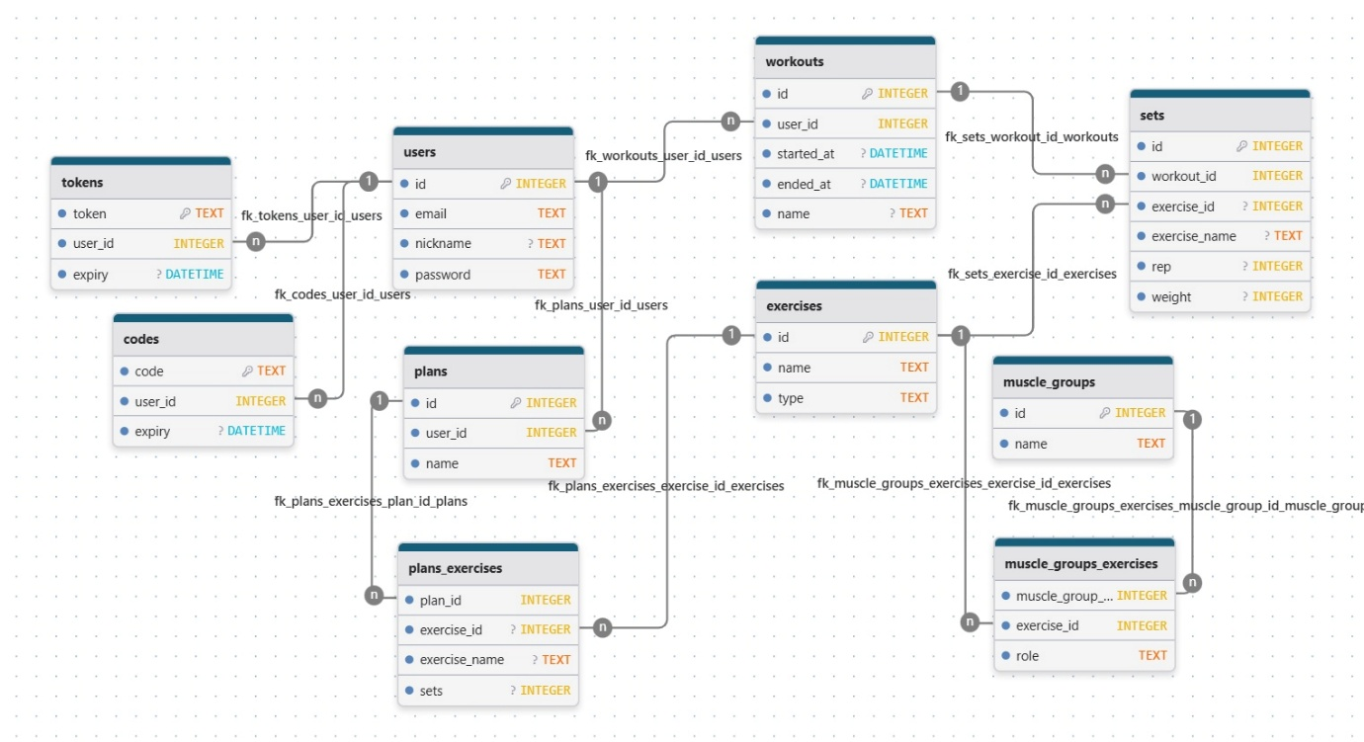

API documentation

Base URL
http://localhost:6600

Authentication
- API endpoints use token -based authentication.
- Users must send their token in the Authorization header for protected routes.

Endpoints

Users​​
Endpoint | Method | Description | Authentication
/ register | POST | Register a new user | Not
/login | POST | User login | Not
/ forgot-password | POST | Request password reset | Not
/ reset-password | POST | Reset password with code | Not
/ verify-code | POST | Check password reset code | Not
/ user | PATCH | Update user data | Yes ( User )
/ user | DELETE | Delete user account | Yes ( User )
/ user /admin | GET | Query all users | Yes (Admin)
/ user /admin | POST | Add a new user | Yes (Admin)
/ user /admin | PUT | User update | Yes (Admin)
/ user /admin/: id | DELETE | Delete user | Yes (Admin)

Workouts​​
Endpoint | Method | Description | Authentication
/ workouts | GET | Query workouts | Yes ( User )
/ workouts /: time | GET | Query a specific workout | Yes ( User )
/ workouts | PUT | Add a new workout | Yes ( User )
/ workouts /: time | DELETE | Deleting a workout | Yes ( User )

Training plans ( Plans )
Endpoint | Method | Description | Authentication
/ plans | GET | Retrieve user training plans | Yes ( User )
/ plans / info /: id | GET | Get training plan details | Yes ( User )
/ plans /: id | GET | Request a specific training plan | Yes ( User )
/ plans | POST | Add a new workout plan | Yes ( User )
/ plans /: id | PATCH | Update training plan | Yes ( User )
/ plans /: id | DELETE | Delete a training plan | Yes ( User )

Statistics​​
Endpoint | Method | Description | Authentication
/ statistics | GET | Retrieve user statistics | Yes ( User )

Exercises​​
Endpoint | Method | Description | Authentication
/ exercises | GET | Query all exercises | Not
/ exercises /: id | GET | Query a specific exercise | Not
/ exercises /admin | GET | Query all exercises | Yes (Admin)
/ exercises /admin | POST | Add a new exercise | Yes (Admin)
/ exercises /admin | PUT | Practice update | Yes (Admin)
/ exercises /admin/: id | DELETE | Delete exercise | Yes (Admin)

Muscle groups ( Muscle Groups​
Endpoint | Method | Description | Authentication
/ muscle_groups | GET | Query all muscle groups | Not
/ muscle_groups /admin | POST | Add a new muscle group | Yes (Admin)
/ muscle_groups /admin | PUT | Muscle group update | Yes (Admin)
/ muscle_groups /admin/: id | DELETE | Delete muscle group | Yes (Admin)

Test documentation

Test user details
Email address : johndoe@yahoo.com
Password : 1234

Functional tests

User authentication
Description | Prerequisite | Steps | Expected result
Successful login | User exists in the database. | Valid email/password → "Login" | Redirect to dashboard , token saved
Login failed (wrong password) | User exists | Incorrect password → "Login" | "Invalid credentials" error
Forgotten password process | User exists | "Forgot password" → email → code → new password | Email sent, password updated
Incorrect email format | - | Incorrect email (e.g. “body”) → “Login” | "Invalid email" error

Manage training plans
Description | Prerequisite | Steps | Expected result
Create a new training plan | User is logged in | Select exercises → “ Save ” | Training plan saved, appears in the list
Edit workout | Training exists | “Edit plan ” → Edit → “ Save ” | Changes saved in DB and UI
Delete workout | Training exists | Open → “Delete” | Training removed

Workout tracking
Description | Prerequisite | Steps | Expected result
Create a new workout | User is logged in | Enter workout elements → save | Workout saved, appears in the list
Delete workout | Training exists | Open → “Delete” | Training removed
Filter by date | There are multiple workouts | Select "Last month" | Workouts for a specific period only

Exercises and muscle group treatment
Description | Prerequisite | Steps | Expected result
Add new practice (Admin) | Admin logged in | "Add" → form → save | Practice is added to the database
Muscle group assignment | Practice exists | Edit → muscle groups → save | Contact saved in DB
Find an internship | There are several exercises | Enter " Bench " | Filtered list
Delete muscle group | Muscle group exists | Select → delete | Deleted from DB

Statistics
Description | Prerequisite | Steps | Expected result
View all training times | There is training. | “Statistics” → “All time” | Correct amount
Best performances | There is training. | Checking “Best lifts ” | Max values are correct
Monthly streak | Continuous training | “ Strake ” | Correct number

Admin panel
Description | Prerequisite | Steps | Expected result
Add a new user | Admin logged in | “Add User ” → save | User is created
Change username | User exists | Edit → save | Updated

Planned developments

Release 0.2

Offline mode
- Training plans, storage of previous workouts
- Save workout to device

Estimated workout completion time
- The user can get an estimated time when they will finish their workout

Release 1.0

User interface (UI) development
- Complete UI revamp with a more modern design
- swipe -based navigation for faster handling
- Use animated loading elements to enhance the visual experience

User account management enhancements
- Possibility to change email address

Functional simplification
- Remove quotes feature

Introducing a ranking and XP system
A combined ranking and experience point system will be developed to motivate users and track their progress.
- XP calculation:
  - Total weight moved
  - Regularity of training
- Progressively difficult leveling system
- Determining ranks based on levels achieved
- Visual display in statistical view

Statistics module expansion
- Display personal records (PR) per exercise

User documentation
MaxxedOut is a fitness app that helps users track and analyze their workouts. The app provides a seamless experience, allowing users to easily manage their workouts with personalized plans.

Basic user functions

Training plans
- Create and follow personalized training plans.

Practice database
- Browse exercises by muscle group and type (compound/isolation).
- Adding custom exercises.

Training Logging
- Record workouts with exercises, sets, reps, and weights.
- Track your workout duration and rest periods.

Statistics and analytics
- View training history and personal records.
- Track metrics such as total weight lifted, average workout time, and streaks .

Notifications and reminders
- Push notifications when rest time is up.
- Send email for confirmation codes.

User profiles
- Create and manage user profiles with nicknames.
- Update personal information (e.g. nickname, email, password).

Target users

Fitness enthusiasts
- Goal: Track progress and improve performance
- Demographics: Over 16, active gym goers
- Needs: Training logging, statistics, personalized training plans

Main use cases

Create a training plan
- The user opens the training plans section
- I press the plus button.
- Add exercises, sets
- The system saves the plan and allows you to load it
- The user can modify the plan as needed

Recording a workout
- Selects a pre-written workout plan
- Provides workout data (exercises, sets, reps, weights)
- The system saves the data to the database.

View previous workouts
- User opens the log section
- Select a previous workout from your past workouts or a specific date from the calendar

Bibliography
Installing a React Native environment
https://reactnative.dev/docs/environment-setup
React Native push notification https://wix.github.io/react-native-notifications/docs/getting-started/
Implementing Async Storage
https://github.com/react-native-async-storage/async-storage
Javascript array mutation
https://developer.mozilla.org/en-US/docs/Web/JavaScript/Reference/Global_Objects/Array/from

