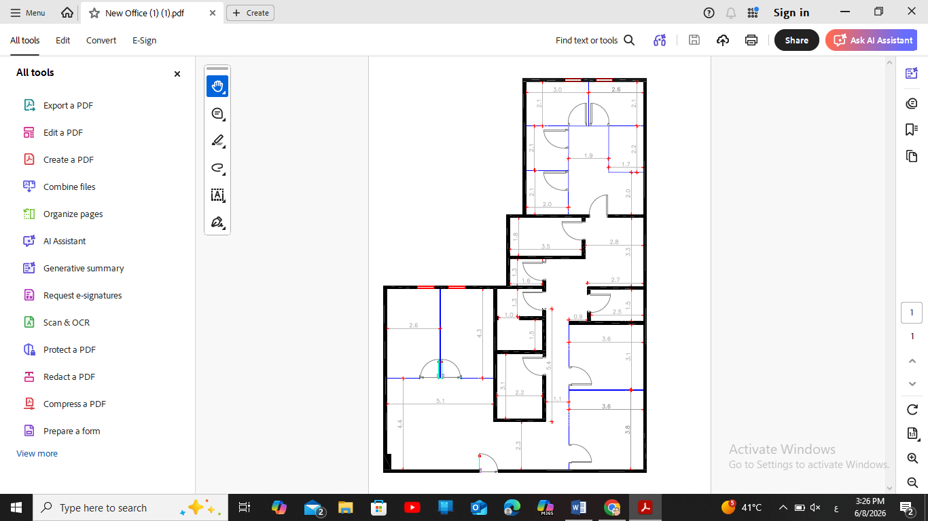
Riyada Center for Speech, Language, and Skills Development

Logo

Who We Are
Riyada Center for Speech, Language, and Skills Development is a specialized center dedicated to providing comprehensive rehabilitation and therapy services for children through integrated programs based on evidence-based practices and the highest professional standards.
Our mission is to support and empower children in developing their communication, behavioral, and functional skills through a qualified multidisciplinary team specializing in Applied Behavior Analysis (ABA), Speech and Language Therapy, and Occupational Therapy.
At Riyada Center, we believe that every child possesses unique strengths and potential that deserve nurturing and development. Therefore, we work closely with families to design individualized intervention plans tailored to each child's needs, promoting independence, social participation, and an improved quality of life.
We serve children aged 3 to 12 years in a safe, supportive, and stimulating environment that encourages learning, growth, and the achievement of their fullest potential.

Vision
To be the leading destination for pediatric rehabilitation and therapy services, empowering children to achieve their full potential and independence.

Mission
To provide specialized rehabilitation and therapeutic services according to the highest professional standards in partnership with families.

Core Values
- Quality
- Professionalism
- Transparency
- Teamwork
- Continuous Improvement

Our Services

1. Assessments & Consultations
Riyada Center provides comprehensive and specialized assessments for children aged 3 to 12 years to identify their strengths, needs, and developmental goals. Based on these assessments, individualized intervention plans are developed to support each child’s progress. We also offer professional consultations and family guidance services to empower parents and maximize therapeutic outcomes.

2. Applied Behavior Analysis (ABA)
Riyada Center offers Applied Behavior Analysis (ABA) services through individualized, evidence-based programs tailored to each child’s unique needs. Our ABA services focus on enhancing communication, learning, independence, and social skills while reducing challenging behaviors using scientifically validated intervention strategies.

3. Speech & Language Therapy
We provide assessment and treatment services for speech, language, communication, and feeding/swallowing disorders. Our services address language delays, speech sound disorders, social communication challenges, and swallowing difficulties through individualized therapy plans designed to meet each child’s specific needs.

4. Occupational Therapy
Our Occupational Therapy services aim to enhance fine and gross motor skills, sensory processing abilities, self-care skills, and overall independence. Through targeted interventions, we help children develop the skills and confidence needed to successfully participate in daily activities and reach their full potential.

Target Population
- Autism Spectrum Disorder (ASD)
- ADHD
- Speech & Language Delays
- Developmental Delays
- Learning Difficulties
- Sensory Processing Disorders

Operating Hours
- Sunday to Thursday
- Center operating hours: 8:00 AM – 5:00 PM
- Therapy sessions commence at 9:00 AM, with the final session concluding at 5:00 PM.

Available Packages

Package | Hours per Week | Discount | Monthly Fee (SAR)
Individual Sessions | As Needed | - | 350 SAR/Hour
Package A | 5 Hours/Week | 5% | 6,650
Package B | 10 Hours/Week | 10% | 12,600
Package C | 15 Hours/Week | 15% | 17,850
Intensive Package | 30 Hours/Week | 30% | 29,400
- Note: All prices are subject to VAT as per applicable regulations.

Why Riyada Center?
- Qualified Team
- Individualized Programs
- Safe Environment
- Progress Reports
- Family Partnership
- Modern Digital Systems

Founders
- Mohammed Al Harthi
- Bader Al Harthi

Chief Executive Officer
- Dua Atieh

Our Team
- Behavior Specialists
- Speech & Language Therapists
- Occupational Therapists

Center Facilities
- Behavior Therapy Rooms
- Speech & Language Rooms
- Occupational Therapy Rooms
- Waiting Area
- Reception Area

Contact Information
- Address:
Makkah Al Mukarramah Road, Al Sulaymaniyah District, Riyadh, Saudi Arabia
- Phone Number:
+966 55 501 9224
- Email:
- Website:
- Social Media:

