**Artist-Level Music Recommender**

**Pipeline:**

1. Acquire data via webscraping
2. Store in MongoDB (cloud)
3. Preprocess data
4. Build app with Streamlit

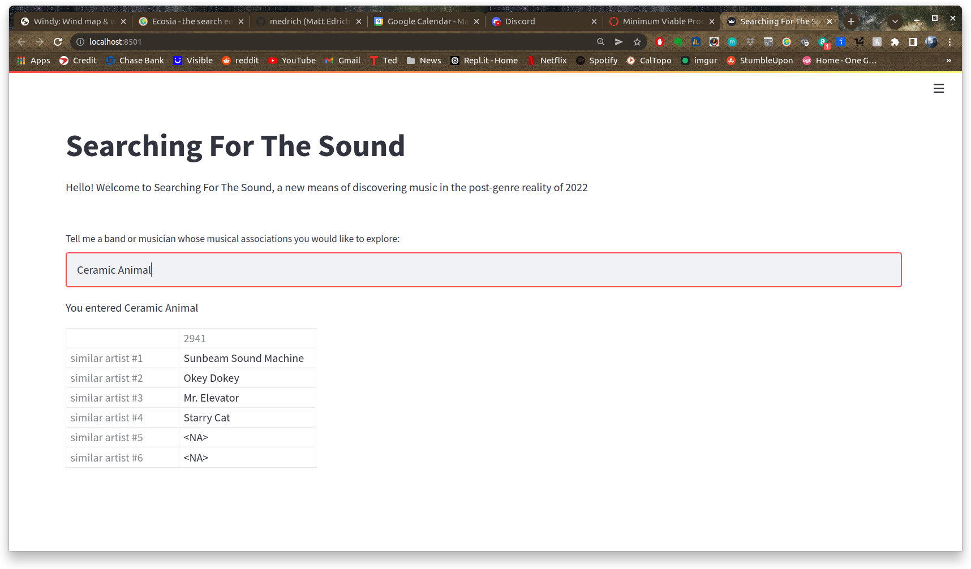

This version of the app is running with data based on 20,000 artists out of nearly 400,000, or roughly 5% of my data. It is not nearly as visually pleasing as I want it to be and it doesn’t have nearly the depth that I was hoping for. I am struggling to figure out how to connect more data to the app, which is my primary concern at the moment.

If I can manage to bring in more data (at least 5x more, if not all of it), I will then focus on cleaning up the presentation of the app through embedding spotify links in the artist recommendations, perhaps with a random song from the recommended artist that can be played right there in the app.

This app will be deployed with either AWS or Heroku, depending on how the data processing works out.