**Relational RDBMS :**

* **MySQL**
* **PostgreSQL**
* **SQL SERVER**

***Definition and comparaison***

***Made by: Med Salah Belkhiria***



* MySQL is an Oracle-backed open-source relational database Management systems RDBMS.
* Based on Strutered Query Language

It runs on virtually all platforms including Linux, UNIX and

Windows.

* It’s often associated with web applications and online

Publishing.



* PostgreSQL is an open-source relational database management systems RDBMS
* Supports SQL and JSON.
* Works with many operating system including Linux and

Windows.

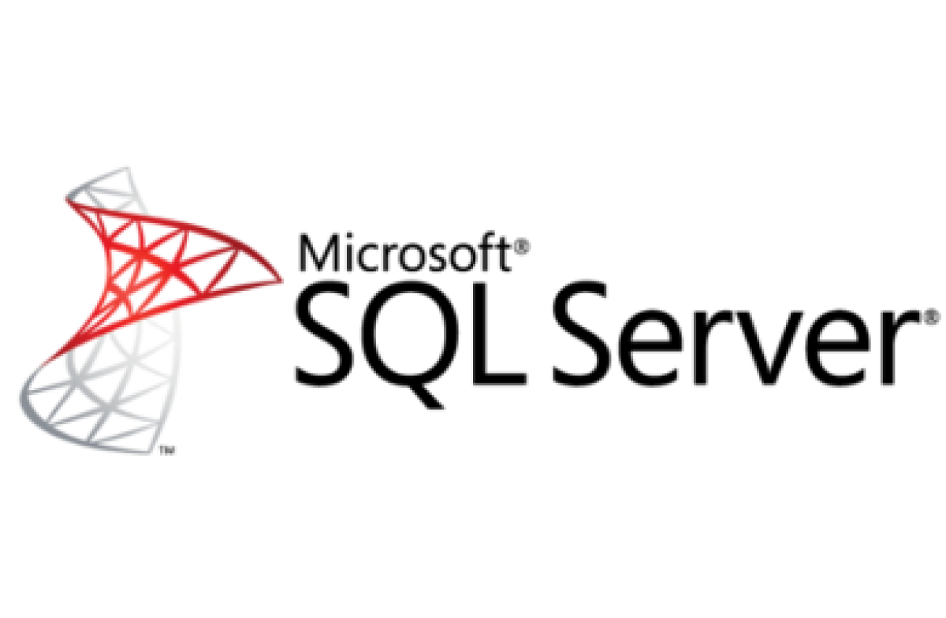

* SQL Server is an open-source relational database management systems RDBMS.
* Supports SQL.
* Work with many operating system including Linux and

Windows.

Comparison between the three RDBMS

|  |  |  |  |  |  |  |  |  |  |  |  |  |  |  |  |  |  |  |  |  |  |  |  |  |  |  |  |  |  |  |  |  |  |  |  |  |  |  |  |  |  |  |  |  |  |  |  |  |  |  |  |  |  |  |  |  |  |  |  |  |  |
| --- | --- | --- | --- | --- | --- | --- | --- | --- | --- | --- | --- | --- | --- | --- | --- | --- | --- | --- | --- | --- | --- | --- | --- | --- | --- | --- | --- | --- | --- | --- | --- | --- | --- | --- | --- | --- | --- | --- | --- | --- | --- | --- | --- | --- | --- | --- | --- | --- | --- | --- | --- | --- | --- | --- | --- | --- | --- | --- | --- | --- | --- |
| **Editorial information provided by DB-Engines** | | | | | | | | | | | | | | | | | | | | | | | | | | | | | | | | | | | | | | | | | | | | | | | | | | | | | | | | | | | | | |
| Name | **Microsoft SQL Server**[**X**](https://db-engines.com/en/system/MySQL%3BPostgreSQL) | **MySQL**[**X**](https://db-engines.com/en/system/Microsoft+SQL+Server%3BPostgreSQL) | **PostgreSQL**[**X**](https://db-engines.com/en/system/Microsoft+SQL+Server%3BMySQL) |  |  |  |  |  |  |  |  |  |  |  |  |  |  |  |  |  |  |  |  |  |  |  |  |  |  |  |  |  |  |  |  |  |  |  |  |  |  |  |  |  |  |  |  |  |  |  |  |  |  |  |  |  |  |  |  |  |  |
| Description | Microsofts relational DBMS | Widely used open source [RDBMS](https://db-engines.com/en/article/RDBMS) | Widely used open source [RDBMS](https://db-engines.com/en/article/RDBMS) info |  |  |  |  |  |  |  |  |  |  |  |  |  |  |  |  |  |  |  |  |  |  |  |  |  |  |  |  |  |  |  |  |  |  |  |  |  |  |  |  |  |  |  |  |  |  |  |  |  |  |  |  |  |  |  |  |  |  |
| Primary database model | [Relational DBMS](https://db-engines.com/en/article/RDBMS) | [Relational DBMS](https://db-engines.com/en/article/RDBMS) info | [Relational DBMS](https://db-engines.com/en/article/RDBMS) info |  |  |  |  |  |  |  |  |  |  |  |  |  |  |  |  |  |  |  |  |  |  |  |  |  |  |  |  |  |  |  |  |  |  |  |  |  |  |  |  |  |  |  |  |  |  |  |  |  |  |  |  |  |  |  |  |  |  |
| Secondary database models | [Document store](https://db-engines.com/en/article/Document+Stores) [Graph DBMS](https://db-engines.com/en/article/Graph+DBMS) | [Document store](https://db-engines.com/en/article/Document+Stores) | [Document store](https://db-engines.com/en/article/Document+Stores) |  |  |  |  |  |  |  |  |  |  |  |  |  |  |  |  |  |  |  |  |  |  |  |  |  |  |  |  |  |  |  |  |  |  |  |  |  |  |  |  |  |  |  |  |  |  |  |  |  |  |  |  |  |  |  |  |  |  |
| |  |  | | --- | --- | | [DB-Engines Ranking](https://db-engines.com/en/ranking) info | [ranking trend](https://db-engines.com/en/ranking_trend/system/Microsoft+SQL+Server%3BMySQL%3BPostgreSQL) | | [Trend Chart](https://db-engines.com/en/ranking_trend/system/Microsoft+SQL+Server%3BMySQL%3BPostgreSQL) | | |  |  |  | | --- | --- | --- | | Score | 1037.64 | | | Rank | #3 | [Overall](https://db-engines.com/en/ranking) | |  | #3 | [Relational DBMS](https://db-engines.com/en/ranking/relational+dbms) | | |  |  |  | | --- | --- | --- | | Score | 1241.64 | | | Rank | #2 | [Overall](https://db-engines.com/en/ranking) | |  | #2 | [Relational DBMS](https://db-engines.com/en/ranking/relational+dbms) | | |  |  |  | | --- | --- | --- | | Score | 555.06 | | | Rank | #4 | [Overall](https://db-engines.com/en/ranking) | |  | #4 | [Relational DBMS](https://db-engines.com/en/ranking/relational+dbms) | |  |  |  |  |  |  |  |  |  |  |  |  |  |  |  |  |  |  |  |  |  |  |  |  |  |  |  |  |  |  |  |  |  |  |  |  |  |  |  |  |  |  |  |  |  |  |  |  |  |  |  |  |  |  |  |  |  |  |
| Website | [www.microsoft.com/­en-us/­sql-server](https://www.microsoft.com/en-us/sql-server/) | [www.mysql.com](https://www.mysql.com/) | [www.postgresql.org](https://www.postgresql.org/) |  |  |  |  |  |  |  |  |  |  |  |  |  |  |  |  |  |  |  |  |  |  |  |  |  |  |  |  |  |  |  |  |  |  |  |  |  |  |  |  |  |  |  |  |  |  |  |  |  |  |  |  |  |  |  |  |  |  |
| Technical documentation | [docs.microsoft.com/­en-US/­sql/­sql-server](https://docs.microsoft.com/en-US/sql/sql-server/) | [dev.mysql.com/­doc](https://dev.mysql.com/doc/) | [www.postgresql.org/­docs](https://www.postgresql.org/docs/) |  |  |  |  |  |  |  |  |  |  |  |  |  |  |  |  |  |  |  |  |  |  |  |  |  |  |  |  |  |  |  |  |  |  |  |  |  |  |  |  |  |  |  |  |  |  |  |  |  |  |  |  |  |  |  |  |  |  |
| Developer | Microsoft | Oracle info | PostgreSQL Global Development Group info |  |  |  |  |  |  |  |  |  |  |  |  |  |  |  |  |  |  |  |  |  |  |  |  |  |  |  |  |  |  |  |  |  |  |  |  |  |  |  |  |  |  |  |  |  |  |  |  |  |  |  |  |  |  |  |  |  |  |
| Initial release | 1989 | 1995 | 1989 info |  |  |  |  |  |  |  |  |  |  |  |  |  |  |  |  |  |  |  |  |  |  |  |  |  |  |  |  |  |  |  |  |  |  |  |  |  |  |  |  |  |  |  |  |  |  |  |  |  |  |  |  |  |  |  |  |  |  |
| Current release | SQL Server 2019, November 2019 | 8.0.22, 2020 | 13.1, November 2020 |  |  |  |  |  |  |  |  |  |  |  |  |  |  |  |  |  |  |  |  |  |  |  |  |  |  |  |  |  |  |  |  |  |  |  |  |  |  |  |  |  |  |  |  |  |  |  |  |  |  |  |  |  |  |  |  |  |  |
| License info | commercial info | Open Source info | Open Source info |  |  |  |  |  |  |  |  |  |  |  |  |  |  |  |  |  |  |  |  |  |  |  |  |  |  |  |  |  |  |  |  |  |  |  |  |  |  |  |  |  |  |  |  |  |  |  |  |  |  |  |  |  |  |  |  |  |  |
| Cloud-based only info | no | no | no |  |  |  |  |  |  |  |  |  |  |  |  |  |  |  |  |  |  |  |  |  |  |  |  |  |  |  |  |  |  |  |  |  |  |  |  |  |  |  |  |  |  |  |  |  |  |  |  |  |  |  |  |  |  |  |  |  |  |
| DBaaS offerings (sponsored links) info |  | [ScaleGrid for MySQL](https://t.sidekickopen79.com/s1t/c/5/f18dQhb0SdYj8bGch0W2n0x6l2B9nMJW7t69v68pTbB4W63Bc1d16gGCMf3DJp1901?te=W3R5hFj4cm2zwW4cHbrv3K4dNZW3GGZrk1LBf35F47PNcYS6TW1&si=370885007&pi=a68632e2-e84c-4cff-8541-4a0fd2702aba): Fully managed MySQL hosting on AWS, Azure and DigitalOcean with high availability and SSH access on the #1 multi-cloud DBaaS. | [ScaleGrid for PostgreSQL](https://t.sidekickopen79.com/s1t/c/5/f18dQhb0SdYj8bGch0W2n0x6l2B9nMJW7t69v68pTbB4W63Bc1d16gGCMf3DJp1901?te=W3R5hFj4cm2zwW4cHbrv3K4dNZW3GGZrk1LCtCBW4fHrkG4cP21jf3R5h1204&si=370885007&pi=a68632e2-e84c-4cff-8541-4a0fd2702aba): Fully managed PostgreSQL hosting on AWS, Azure and DigitalOcean with high availability and SSH access on the #1 multi-cloud DBaaS. |  |  |  |  |  |  |  |  |  |  |  |  |  |  |  |  |  |  |  |  |  |  |  |  |  |  |  |  |  |  |  |  |  |  |  |  |  |  |  |  |  |  |  |  |  |  |  |  |  |  |  |  |  |  |  |  |  |  |
| Implementation language | C++ | C and C++ | C |  |  |  |  |  |  |  |  |  |  |  |  |  |  |  |  |  |  |  |  |  |  |  |  |  |  |  |  |  |  |  |  |  |  |  |  |  |  |  |  |  |  |  |  |  |  |  |  |  |  |  |  |  |  |  |  |  |  |
| Server operating systems | Linux Windows | FreeBSD Linux OS X Solaris Windows | FreeBSD HP-UX Linux NetBSD OpenBSD OS X Solaris Unix Windows |  |  |  |  |  |  |  |  |  |  |  |  |  |  |  |  |  |  |  |  |  |  |  |  |  |  |  |  |  |  |  |  |  |  |  |  |  |  |  |  |  |  |  |  |  |  |  |  |  |  |  |  |  |  |  |  |  |  |
| Data scheme | yes | yes | yes |  |  |  |  |  |  |  |  |  |  |  |  |  |  |  |  |  |  |  |  |  |  |  |  |  |  |  |  |  |  |  |  |  |  |  |  |  |  |  |  |  |  |  |  |  |  |  |  |  |  |  |  |  |  |  |  |  |  |
| Typing info | yes | yes | yes |  |  |  |  |  |  |  |  |  |  |  |  |  |  |  |  |  |  |  |  |  |  |  |  |  |  |  |  |  |  |  |  |  |  |  |  |  |  |  |  |  |  |  |  |  |  |  |  |  |  |  |  |  |  |  |  |  |  |
| XML support info | yes | yes | yes info |  |  |  |  |  |  |  |  |  |  |  |  |  |  |  |  |  |  |  |  |  |  |  |  |  |  |  |  |  |  |  |  |  |  |  |  |  |  |  |  |  |  |  |  |  |  |  |  |  |  |  |  |  |  |  |  |  |  |
| Secondary indexes | yes | yes | yes |  |  |  |  |  |  |  |  |  |  |  |  |  |  |  |  |  |  |  |  |  |  |  |  |  |  |  |  |  |  |  |  |  |  |  |  |  |  |  |  |  |  |  |  |  |  |  |  |  |  |  |  |  |  |  |  |  |  |
| SQL info | yes | yes info | yes info |  |  |  |  |  |  |  |  |  |  |  |  |  |  |  |  |  |  |  |  |  |  |  |  |  |  |  |  |  |  |  |  |  |  |  |  |  |  |  |  |  |  |  |  |  |  |  |  |  |  |  |  |  |  |  |  |  |  |
| APIs and other access methods | ADO.NET JDBC ODBC OLE DB Tabular Data Stream (TDS) | ADO.NET JDBC ODBC Proprietary native API | ADO.NET JDBC native C library ODBC streaming API for large objects |  |  |  |  |  |  |  |  |  |  |  |  |  |  |  |  |  |  |  |  |  |  |  |  |  |  |  |  |  |  |  |  |  |  |  |  |  |  |  |  |  |  |  |  |  |  |  |  |  |  |  |  |  |  |  |  |  |  |
| Supported programming languages | C# C++ Delphi Go Java JavaScript (Node.js) PHP Python R Ruby Visual Basic | Ada C C# C++ D Delphi Eiffel Erlang Haskell Java JavaScript (Node.js) Objective-C OCaml Perl PHP Python Ruby Scheme Tcl | .Net C C++ Delphi Java info JavaScript (Node.js) Perl PHP Python Tcl |  |  |  |  |  |  |  |  |  |  |  |  |  |  |  |  |  |  |  |  |  |  |  |  |  |  |  |  |  |  |  |  |  |  |  |  |  |  |  |  |  |  |  |  |  |  |  |  |  |  |  |  |  |  |  |  |  |  |
| Server-side scripts info | Transact SQL, .NET languages, R, Python and (with SQL Server 2019) Java | yes info | user defined functions info |  |  |  |  |  |  |  |  |  |  |  |  |  |  |  |  |  |  |  |  |  |  |  |  |  |  |  |  |  |  |  |  |  |  |  |  |  |  |  |  |  |  |  |  |  |  |  |  |  |  |  |  |  |  |  |  |  |  |
| Triggers | yes | yes | yes |  |  |  |  |  |  |  |  |  |  |  |  |  |  |  |  |  |  |  |  |  |  |  |  |  |  |  |  |  |  |  |  |  |  |  |  |  |  |  |  |  |  |  |  |  |  |  |  |  |  |  |  |  |  |  |  |  |  |
| Partitioning methods info | tables can be distributed across several files (horizontal partitioning); sharding through federation | horizontal partitioning, sharding with MySQL Cluster or MySQL Fabric | partitioning by range, list and (since PostgreSQL 11) by hash |  |  |  |  |  |  |  |  |  |  |  |  |  |  |  |  |  |  |  |  |  |  |  |  |  |  |  |  |  |  |  |  |  |  |  |  |  |  |  |  |  |  |  |  |  |  |  |  |  |  |  |  |  |  |  |  |  |  |
| Replication methods info | yes, but depending on the SQL-Server Edition | Multi-source replication Source-replica replication | Source-replica replication info |  |  |  |  |  |  |  |  |  |  |  |  |  |  |  |  |  |  |  |  |  |  |  |  |  |  |  |  |  |  |  |  |  |  |  |  |  |  |  |  |  |  |  |  |  |  |  |  |  |  |  |  |  |  |  |  |  |  |
| MapReduce info | no | no | no |  |  |  |  |  |  |  |  |  |  |  |  |  |  |  |  |  |  |  |  |  |  |  |  |  |  |  |  |  |  |  |  |  |  |  |  |  |  |  |  |  |  |  |  |  |  |  |  |  |  |  |  |  |  |  |  |  |  |
| Consistency concepts info | Immediate Consistency | Immediate Consistency | Immediate Consistency |  |  |  |  |  |  |  |  |  |  |  |  |  |  |  |  |  |  |  |  |  |  |  |  |  |  |  |  |  |  |  |  |  |  |  |  |  |  |  |  |  |  |  |  |  |  |  |  |  |  |  |  |  |  |  |  |  |  |
| Foreign keys info | yes | yes info | yes |  |  |  |  |  |  |  |  |  |  |  |  |  |  |  |  |  |  |  |  |  |  |  |  |  |  |  |  |  |  |  |  |  |  |  |  |  |  |  |  |  |  |  |  |  |  |  |  |  |  |  |  |  |  |  |  |  |  |
| Transaction concepts info | ACID | ACID info | ACID |  |  |  |  |  |  |  |  |  |  |  |  |  |  |  |  |  |  |  |  |  |  |  |  |  |  |  |  |  |  |  |  |  |  |  |  |  |  |  |  |  |  |  |  |  |  |  |  |  |  |  |  |  |  |  |  |  |  |
| Concurrency info | yes | yes info | yes |  |  |  |  |  |  |  |  |  |  |  |  |  |  |  |  |  |  |  |  |  |  |  |  |  |  |  |  |  |  |  |  |  |  |  |  |  |  |  |  |  |  |  |  |  |  |  |  |  |  |  |  |  |  |  |  |  |  |
| Durability info | yes | yes | yes |  |  |  |  |  |  |  |  |  |  |  |  |  |  |  |  |  |  |  |  |  |  |  |  |  |  |  |  |  |  |  |  |  |  |  |  |  |  |  |  |  |  |  |  |  |  |  |  |  |  |  |  |  |  |  |  |  |  |
| In-memory capabilities info | yes | yes | no |  |  |  |  |  |  |  |  |  |  |  |  |  |  |  |  |  |  |  |  |  |  |  |  |  |  |  |  |  |  |  |  |  |  |  |  |  |  |  |  |  |  |  |  |  |  |  |  |  |  |  |  |  |  |  |  |  |  |
| User concepts info | fine grained access rights according to SQL-standard | Users with fine-grained authorization concept info | fine grained access rights according to SQL-standard |  |  |  |  |  |  |  |  |  |  |  |  |  |  |  |  |  |  |  |  |  |  |  |  |  |  |  |  |  |  |  |  |  |  |  |  |  |  |  |  |  |  |  |  |  |  |  |  |  |  |  |  |  |  |  |  |  |  |