**Brain Tumor Detection and Prediction using Deep Learning methods and understanding models using XAI**

**Introduction**

The project will design an automated brain tumor detection and classification system using CNN, which will boost up the accuracy rate in diagnosing the patient. It will detect and classify brain tumors in real-time from a series of MRI scans, with the determination of the type and malignancy. It utilizes advanced CNN models such as ResNet50 and VGG16, which go a great extent in elevating detection precision so that radiologists may minimize errors and enhance speed in the diagnostic process so that early and accurate interventions may be made.

**Literature Review**

|  |  |  |  |  |
| --- | --- | --- | --- | --- |
| **Paper** | **Models** | **Metrics** | **Accuracy** | **Research Gaps** |
| **Brain Tumor Detection and Classification Using Machine Learning: A Comprehensive Survey**[1] | Deep and quantum learning | Accuracy  Sensitivity  Specificity  F1 Score | 98.71% | Generalization across varied imaging conditions remains challenging. |
| **Brain Tumor Detection and Classification Using Transfer Learning Models** [2] | Hybrid VGG16-ResNet50 | Accuracy  Sensitivity  Specificity  F1 Score | AlexNet: 95.60%  VGG16: 97.66%  ResNet-50: 96.90%  Hybrid VGG16-ResNet50: 99.98% | Limited generalization and interpretability restrict real-world clinical use |
| **A Deep Analysis of Brain Tumor Detection from MR Images Using Deep Learning Networks** [3] | CNN | AUC: 98.43%  Recall: 91.19%  Loss: 0.25 | Accuracy: 93.3% | Limited exploration of transfer learning fine-tuning and lack of interpretability through tumor region visualization. |
| **Brain Tumor Classification Based on Attention Guided Deep Learning Model** [4] | CNN model | Accuracy  Sensitivity  Specificity  F1 Score | 98.61% | Addressing misclassification of meningioma samples and overfitting through data augmentation and further network structure improvements. |
| **Improved Fine-Tuned Model Based on CNN with ResNet50 and U-Net for Brain Tumor Detection and Segmentation** [5] | CNN model finetuned using ResNet50 and U-Net | IoU: 0.91  DSC: 0.95  SI: 0.95  Precision (Non-Tumor): 0.98  Recall (Non-Tumor): 0.95  Precision (Tumor): 0.87  Recall (Tumor): 0.92 | Non-Tumor: 94%  Tumor: 96% |  |
| **CNN-Based Brain Tumor Detection Model Using Local Binary Pattern and Multilayered SVM Classifier** | Cnn,Multi-SVM Classifier | Sensitivity:95.73%  Specificity:97.12%  Precission:97.34% | 99.23% | The research gap is the need for improved brain tumor detection methods that preserve small details during segmentation and explore additional deep networks for enhanced classification. |
| **Brain Tumor Detection and Classification Using Fine-Tuned CNN with ResNet50 and U-Net Model: A Study on TCGA-LGG and TCIA Dataset for MRI Applications** [6] | Fine tuned CNN model | Accuracy  Sensitivity  Specificity  F1 Score | Accuracy: 92% | The research gap lies in validating the model on larger, more diverse datasets to address potential biases and improve real-world clinical applicability. |
| **Classification of brain tumours in MR images using deep spatiospatial models** [7] | ResNet Mixed Convolution | Macro F1-score of 0.9345 | Accuracy: 6.98% | A potential research gap is exploring the impact of using diverse MRI contrasts and datasets on the performance of spatiospatial models for brain tumor classification. |
| **Brain Tumor Detection Based on Deep Learning Approaches and Magnetic Resonance Imaging** [8] | YOLOv7 model through transfer learning | Accuracy  Sensitivity  Specificity  F1 Score | Accuracy: 99.5% | The research gap lies in expanding the dataset to include diverse brain lesions for improved model generalization. |
| **DACBT: deep learning approach for classification of brain tumors using MRI data in IoT healthcare environment** [9] | ResNet | Accuracy  Sensitivity  Specificity  F1 Score | ResNet: 99.90%  VGG-16-CNN: 96.78%  Inception V3-CNN: 97.00%  DenseNet201-CNN: 97.00%  Xception-CNN: 98.20% | Exploring multimodal MRI data and advanced segmentation techniques could improve the ResNet-CNN model's performance in brain tumor classification.  4o mini |
| **Enhancing brain tumor classification in MRI scans with a multi-layer customized convolutional neural network approach** [10] | CNN model | Accuracy  Sensitivity  Specificity  F1 Score | 99% | The research gap lies in developing more robust models for brain tumor classification that can handle diverse MRI scan variations and provide better interpretability for clinical use. |
| **Brain tumor classification using fine-tuned transfer learning models on magnetic resonance imaging (MRI) images** [11] | VGG16, ResNet50, MobileNetV2, DenseNet201, EfficientNetB3, and InceptionV3 | Accuracy  Sensitivity  Specificity  F1 Score | 100%  After cross-validation 99.96% | Real-time clinical integration, bias mitigation, and model explainability in AI-driven brain tumor detection need further development. |
| **A robust MRI-based brain tumor classification via a hybrid deep learning technique** [12] | GoogleNet,  SVM, KNN | Accuracy Sensitivity  Specificity  F1 Score | GoogleNet: 92.3%  SVM: 97.8%  KNN: 98% | A research gap exists in enhancing the generalization and accuracy of hybrid brain tumor classification models by incorporating a more diverse range of tumor subtypes and larger patient datasets. |
| **Brain Tumor Detection and Brain Tumor Area Calculation with Matlab** [13] | • Fuzzy C-Means (FCM)  • Region Growing  • Self-Organizing Maps (SOM)  • K-means Clustering  • Watershed Segmentation  • Graph-Cut Segmentation | Jaccard similarity index:85%  F1-score:92% | Jaccard Similarity Index: K-means 0.8580, Very Grassy Threshold 0.8549, Fuzzy C-means: 0.79, Watershed segmentation: 0.8339, Graph-Cut segmentation: 0.7834 | Accurately differentiating brain tumor from surrounding fluid requires further improvement. |
| **An Effective Diagnosis System for Brain Tumor Detection and Classification** [14] | SVM  K Means Clustering | Precission:99.315  Recall:99.66 % | 99.19% | The research gap addressed in this paper is the need for a practical, reliable, and fast system to detect and classify brain tumors more accurately than the current state-of-the-art methods. |
| **Brain Tumor Detection and Classification Using a New Evolutionary Convolutional Neural Network** [15] | CNN  **(NLCMFO)** algorithm | Sensitivity:96%  Specificity:98.6,  Precision:98.4%  F1-Score:96.6% | 97.4% | The research gap is the need for more efficient optimization algorithms that effectively balance exploration and exploitation phases for large-scale problems, such as hyperparameter tuning in convolutional neural networks. |
| **Brain Tumor Detection and Classification based on Hybrid Ensemble Classifier** [16] | Hybrid Ensemble Classifier: KNN-RF-DT | Precission:97.73%  Sensitivity:97.04%  F1Score:97.41%  Specificity:97.6% | 97.305% | The research gap is the need for more effective tumor segmentation methods that combine deep learning and morphological techniques for improved classification accuracy across varied datasets. |
| **Vision Transformers, Ensemble Model, and Transfer Learning Leveraging Explainable AI for Brain Tumor Detection and Classification** [17] | VGG16,Inception V3, Xception, VGG19,ResNet50, InceptionResNetV2 | Precission Score  (ResNetV2):99.88% | Inception V3:95.72%,  VGG 16:95.11 %,  Xception:94.50%,  IVX16:96.94%,  ResNet50:93.88%  VGG19:94.19 %,  InceptionResNetV2:  93.58% | The research gap is the lack of robust ensemble models that effectively combine multiple TL algorithms to improve brain tumor classification and detection accuracy while addressing overfitting.  4o mini |
| **Meningioma brain tumor detection and classifcation using hybrid CNN method and RIDGELET transform** [18] | HCNN classifier |  | 99.8% | The research gap is the need for more efficient and robust tumor segmentation methods that improve classification accuracy across diverse brain image datasets. |
| **Brain tumor detection from images and comparison with transfer learning methods and 3-layer CNN** [19] | VGG16 | F-score: 97%  AUC: 99%,  Recall value: 98%, Precision value: 98%. | 98% | The study lacks data augmentation techniques like rotation and cropping, which could improve model generalization and performance. |

Summarization of previous Approaches

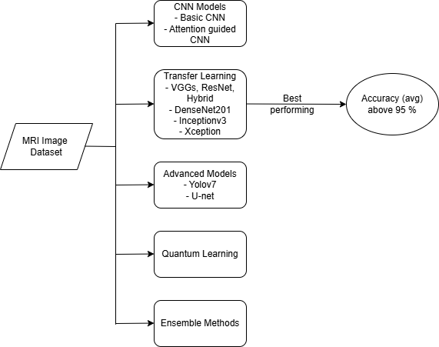

Figure Model summarisation in literature review

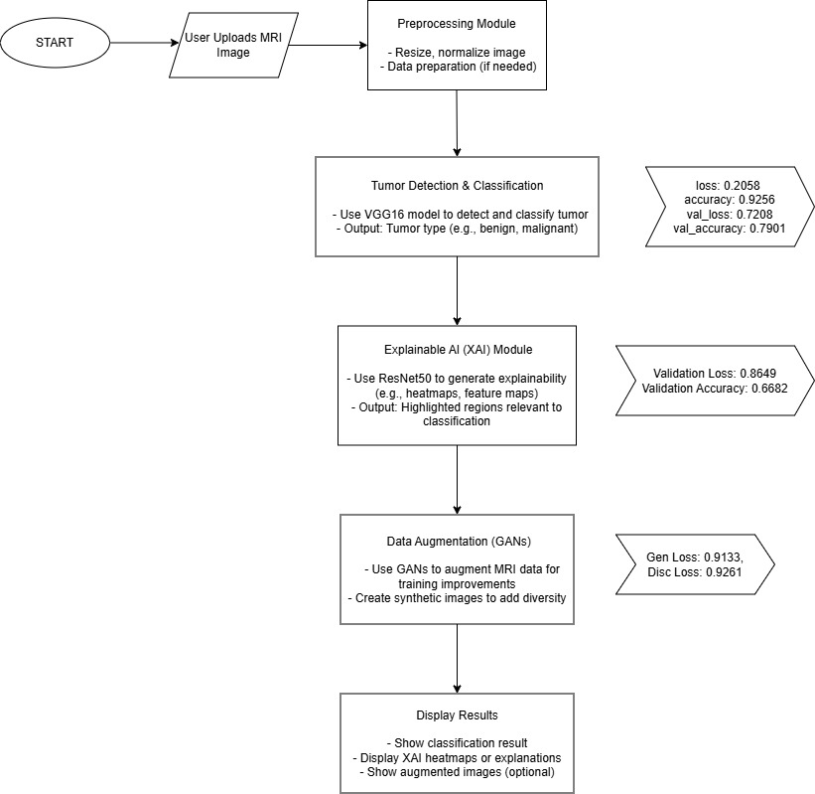

Figure : Approach used moving forward

**Work Done Till Now**

Detection & Classification : Developed ResNet50 and VGG16 for efficient detection and classification of the brain tumors.

Data Augmentation with GANs: The GANs were applied to the augmentation of the MRI datasets, which in turn improved the generalization of the model and even facilitated improvement.

Real-Time Feedback: A system was designed for obtaining instant results concerning the diagnosis; however, such a system also brings prompt insight for faster decision making.

This solution addresses the shortcomings of the traditional methods of diagnosis and supports the result of better patient outcomes since quicker, more accurate detection and characterization of tumors are possible. Future work includes refinement to achieve maximum performance for the model as well as developing more sophisticated techniques for increased accuracy.

**Novelty and Differentiation from Earlier Works**

Unlike previous studies, which have focused mainly on the classification and detection of tumors based on CNN-based structures such as ResNet and VGG16, the proposed project extends the scope by including capability in the prediction of the tumor growth through an explainable AI (XAI). Most of the current systems classify the existence of the tumor but fail to predict what it might grow into over time. On the other hand, our system gives the possibility of predicting tumor progression and will be supportive for assessing the response to the treatment. XAI further improves interpretability in that clinicians can also understand the model predictions. Thus, our system is more reliable and actionable in clinical settings.

# Works Cited

|  |  |
| --- | --- |
| [1] | M. S. A. H. M. Y. &. R. S. N. Javaria Amin, “Brain Tumor Detection and Classification Using Machine Learning: A Comprehensive Survey,” *Complex & Intelligent Systems,* p. 3161–3183, 2021. |
| [2] | V. Dhakshnamurthy, M. Govindan, K. Sreerangan, M. Nagarajan and Thomas, “ Brain Tumor Detection and Classification Using Transfer Learning Models,” 2024. |
| [3] | M. Mahmud, M. Mamun and Abdelgawad, “A Deep Analysis of Brain Tumor Detection from MR Images Using Deep Learning Networks,” *Algorithms,* 2023. |
| [4] | W. L. Z. Jun, “Brain Tumor Classification Based on Attention Guided Deep Learning Model,” *International Journal of Computational Intelligence Systems,* 2022. |
| [5] | S. A. A. T. A. M. I. M. A. S. M. K. H. H. A. A. A. A. A. S. Asiri AA, “Improved Fine-Tuned Model Based on CNN with ResNet50 and U-Net for Brain Tumor Detection and Segmentation,” 2023. |
| [6] | A. S. A. M. A. M. I. A. M. M. T. H. A. H. A. ,. A. F. A. A. a. S. M. A. Abdullah A. Asiri, “Brain Tumor Detection and Classification Using Fine-Tuned CNN with ResNet50 and U-Net Model: A Study on TCGA-LGG and TCIA Dataset for MRI Applications,” *Artificial Intelligence Applications in Medical Imaging,* 2023. |
| [7] | F. A. N. A. N. &. O. S. Soumick Chatterjee, “Classification of brain tumours in MR images using deep spatiospatial models,” 2022. |
| [8] | M. M. a. T. K. W. Akmalbek Bobomirzaevich Abdusalomov, “Brain Tumor Detection Based on Deep Learning Approaches and Magnetic Resonance Imaging,” *Brain Tumor: Recent Advances and Challenges,* 2023. |
| [9] | J. P. L. S. K. M. A. A. R. M. A. &. C. M. Amin ul Haq, “DACBT: deep learning approach for classification of brain tumors using MRI data in IoT healthcare environment,” 2022. |
| [10] | A. T. T. D. R. D. R. D. S. B. K. B. K. T. R. M. R. M. A. A. A. A. K. A. A. M. S. A. Eid Albalawi, “Enhancing brain tumor classification in MRI scans with a multi-layer customized convolutional neural network approach,” 2024. |
| [11] | M. M. I. M. A. T. M. A. U. M. K. M. K. a. M. Z. K. Sadia Maduri Rasa, “Brain tumor classification using fine-tuned transfer learning models on magnetic resonance imaging (MRI) images,” 2024. |
| [12] | I. Y. H. M. A. &. M. A. M. Shaimaa E. Nassar, “A robust MRI-based brain tumor classification via a hybrid deep learning technique,” *The Journal of Supercomputing,* pp. 2403-2427, 2023. |
| [13] | M. BN, “Brain Tumor Detection and Brain Tumor Area Calculation with Matlab”. |
| [14] | A. S. A. Ahmed A. Alsheikhy, “An Effective Diagnosis System for Brain Tumor Detection and Classification,” 2022. |
| [15] | M. H. M. N. S. M. A. S. S. Amin Abdollahi Dehkordi, “Brain Tumor Detection and Classification Using a New Evolutionary,” 2022. |
| [16] | R. G. Ginni Garg, “Brain Tumor Detection and Classification based on Hybrid Ensemble Classifier,” *Computer Vision and Pattern Recognition,* 2021. |
| [17] | S. Hossain, A. Chakrabarty, T. R. Gadekallu, M. Alazab and M. J. Piran, “Vision Transformers, Ensemble Model, and Transfer Learning Leveraging Explainable AI for Brain Tumor Detection and Classification,” *IEEE Journal of Biomedical and Health Informatics,* 2024. |
| [18] | A. R. K. N. S. S. K. D. S. S. R. J. J. H. K. M. M. P. &. H. D. B. V. Prakash, “Meningioma brain tumor detection and classification using hybrid CNN method and RIDGELET transform,” 2023. |
| [19] | M. B. M. Khaliki, “Brain tumor detection from images and comparison with transfer learning methods and 3-layer CNN,” 2024. |
| [20] | Y.-C. B. Amreen Batool, “Brain tumor detection with integrating traditional and computational intelligence approaches across diverse imaging modalities - Challenges and future directions,” *Computers in Biology and Medicine,* 2024. |
| [21] | M. G. O. K. S. D. N. A. T. Vinod Kumar Dhakshnamurthy 1ORCID, “Brain Tumor Detection and Classification Using Transfer Learning Models,” *The 2nd Computing Congress 2023,* 2024. |