EXPERIMENT 5
DATA VISUALIZATION USING MATPLOTLIB

AIM
To create and analyze various data visualizations such as Line Charts, Bar Charts, Pie Charts, Histograms, Scatter Plots, and Box Plots using Matplotlib for effective data interpretation on the FIFA World Cup 2026 Player Performance dataset.

PROGRAM / CODE
import pandas as pd
import matplotlib.pyplot as plt
# Load FIFA World Cup 2026 Player Performance dataset
df = pd.read_csv("fifa_world_cup_2026_player_performance.csv")
# 1. LINE CHART - Top 10 players by rating
top10 = df.nlargest(10, "player_rating")
plt.figure(figsize=(10,5))
plt.plot(top10["player_name"], top10["player_rating"], marker="o")
plt.title("Top 10 Players by Player Rating")
plt.xlabel("Player Name")
plt.ylabel("Player Rating")
plt.xticks(rotation=45, ha="right")
plt.tight_layout()
plt.show()
# 2. BAR CHART - Average rating by position
position_rating = df.groupby("position")["player_rating"].mean()
plt.figure(figsize=(8,5))
plt.bar(position_rating.index, position_rating.values)
plt.title("Average Player Rating by Position")
plt.xlabel("Position")
plt.ylabel("Average Player Rating")
plt.show()
# 3. PIE CHART - Player distribution by position
position_count = df["position"].value_counts()
plt.figure(figsize=(7,7))
plt.pie(
position_count.values,
labels=position_count.index,
autopct="%1.1f%%"
)
plt.title("Player Distribution by Position")
plt.show()
# 4. HISTOGRAM - Player rating distribution
plt.figure(figsize=(8,5))
plt.hist(df["player_rating"].dropna(), bins=10)
plt.title("Player Rating Distribution")
plt.xlabel("Player Rating")
plt.ylabel("Number of Players")
plt.show()
# 5. SCATTER PLOT - Minutes played vs rating
plt.figure(figsize=(8,5))
plt.scatter(
df["minutes_played"],
df["player_rating"],
alpha=0.5
)
plt.title("Minutes Played vs Player Rating")
plt.xlabel("Minutes Played")
plt.ylabel("Player Rating")
plt.show()
# 6. BOX PLOT - Market value
plt.figure(figsize=(7,5))
plt.boxplot(df["market_value_eur"].dropna())
plt.title("Market Value Distribution")
plt.ylabel("Market Value (EUR)")
plt.show()
# 7. MULTIPLE LINE CHART - Goals and assists
top_players = df.nlargest(10, "player_rating")
plt.figure(figsize=(10,5))
plt.plot(
top_players["player_name"],
top_players["goals"],
marker="o",
label="Goals"
)
plt.plot(
top_players["player_name"],
top_players["assists"],
marker="o",
label="Assists"
)
plt.title("Goals and Assists of Top 10 Rated Players")
plt.xlabel("Player Name")
plt.ylabel("Count")
plt.xticks(rotation=45, ha="right")
plt.legend()
plt.tight_layout()
plt.show()

OUTPUT / INTERPRETATION
Line Chart: The line chart displays the player ratings of the top 10 players and allows comparison of their ratings.
Bar Chart: The bar chart compares the average player rating across Goalkeeper, Defender, Midfielder, and Forward positions.
Pie Chart: The pie chart shows the percentage distribution of players across different positions.
Histogram: The histogram shows the frequency distribution of player ratings.
Scatter Plot: The scatter plot represents the relationship between minutes played and player rating.
Box Plot: The box plot shows the distribution of player market values and helps identify potential outliers.
Multiple Line Chart: The multiple line chart compares goals and assists among the top 10 rated players.

RESULT
Thus, various visualization techniques such as Line Charts, Bar Charts, Pie Charts, Histograms, Scatter Plots, and Box Plots were successfully created using Matplotlib for the FIFA World Cup 2026 Player Performance dataset. The graphical representations helped in understanding trends, distributions, comparisons, and relationships within the dataset.

OUTPUT
Dataset Shape
(54600, 75)
Output 1 – Top 10 Players by Rating
player_name player_rating
Mohamed Elneny 9.4
Vinicius Nunes 9.2
Anibal Sanchez 9.2
Mohammed Otoo 9.2
Memphis Zerrouki 9.2
Jackson Vukovic 9.1
Sam James 8.9
Sebastian Pellerano 8.9
Wilfred Iheanacho 8.9
Mathew Behich 8.9
Output 2 – Average Player Rating by Position
Forward 3.883770
Midfielder 3.860786
Defender 3.789778
Goalkeeper 2.068429
Output 3 – Player Distribution by Position
Defender 18900
Midfielder 16800
Forward 12600
Goalkeeper 6300
Output 4 – Player Rating Statistics
Minimum : 0.0
Maximum : 9.4
Mean : 3.634699633699633
Median : 5.5
Output 5 – Minutes Played vs Player Rating
Correlation : 0.8372259983553233
Output 6 – Market Value Statistics
Minimum : 528822
Q1 : 4444778.0
Median : 10271107.0
Q3 : 23420128.0
Maximum : 200000000
Output 7 – Goals and Assists of Top 10 Rated Players
player_name goals assists
Mohamed Elneny 0 0
Vinicius Nunes 1 0
Anibal Sanchez 1 0
Mohammed Otoo 1 1
Memphis Zerrouki 4 1
Jackson Vukovic 2 0
Sam James 0 0
Sebastian Pellerano 0 1
Wilfred Iheanacho 0 1
Mathew Behich 0 0

Exact Graphical Outputs
Figure 1 – Top 10 Players by Rating
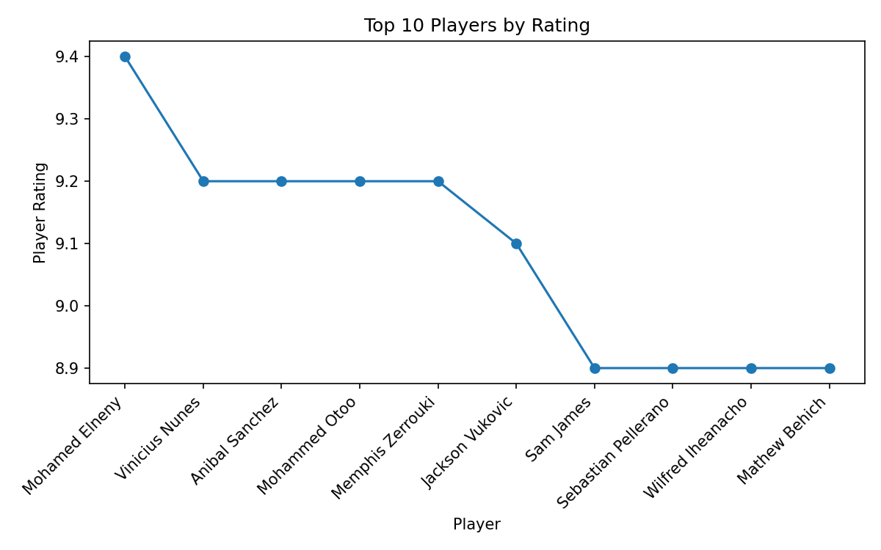
Figure 2 – Average Player Rating by Position
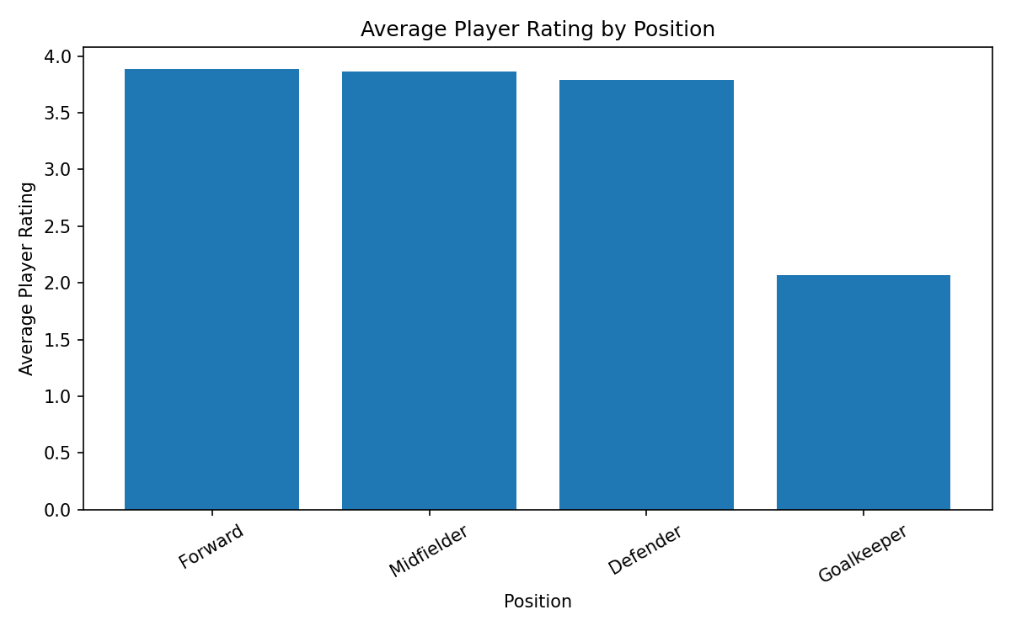
Figure 3 – Player Distribution by Position
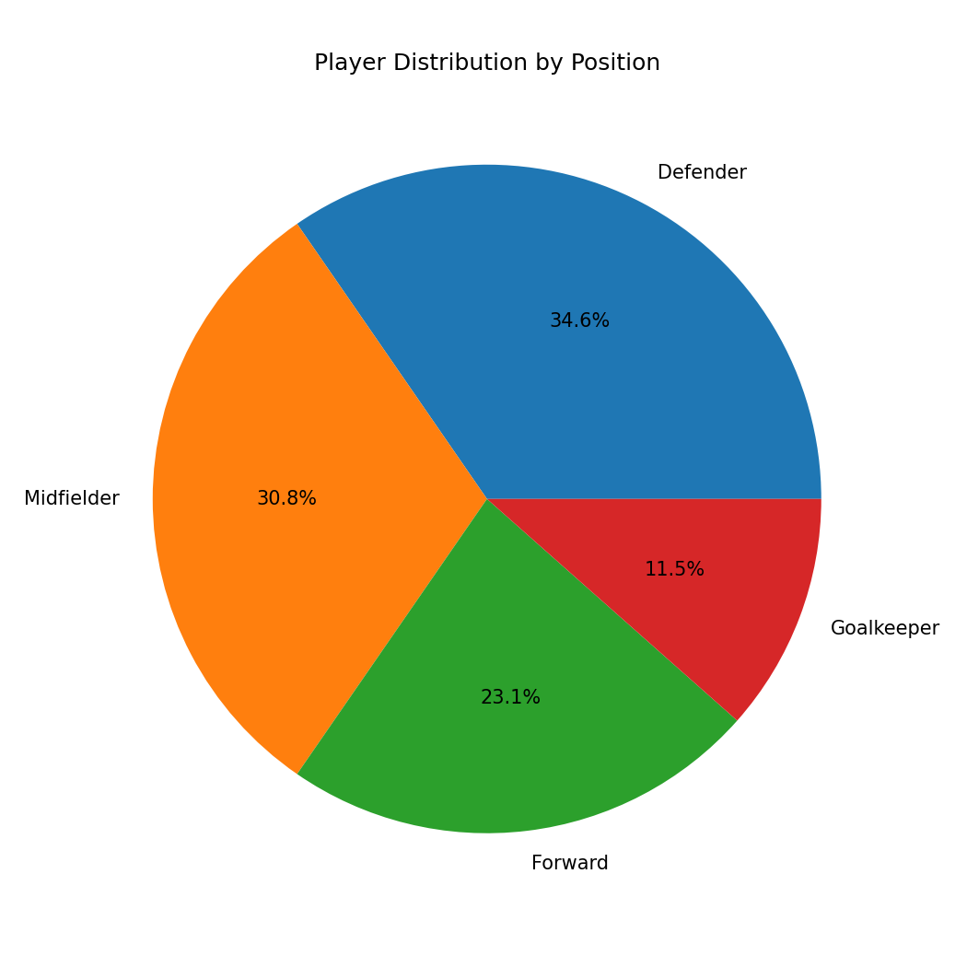
Figure 4 – Distribution of Player Ratings
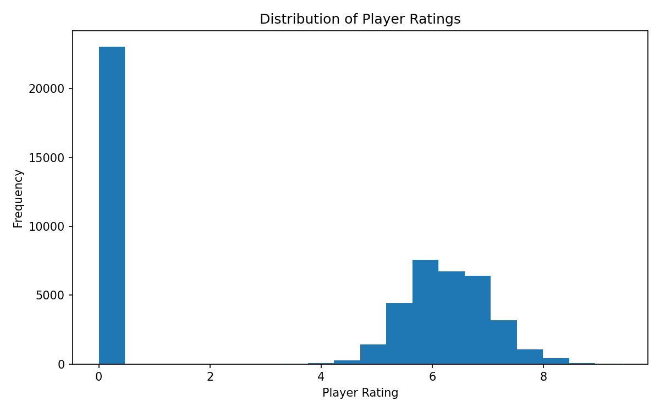
Figure 5 – Minutes Played vs Player Rating
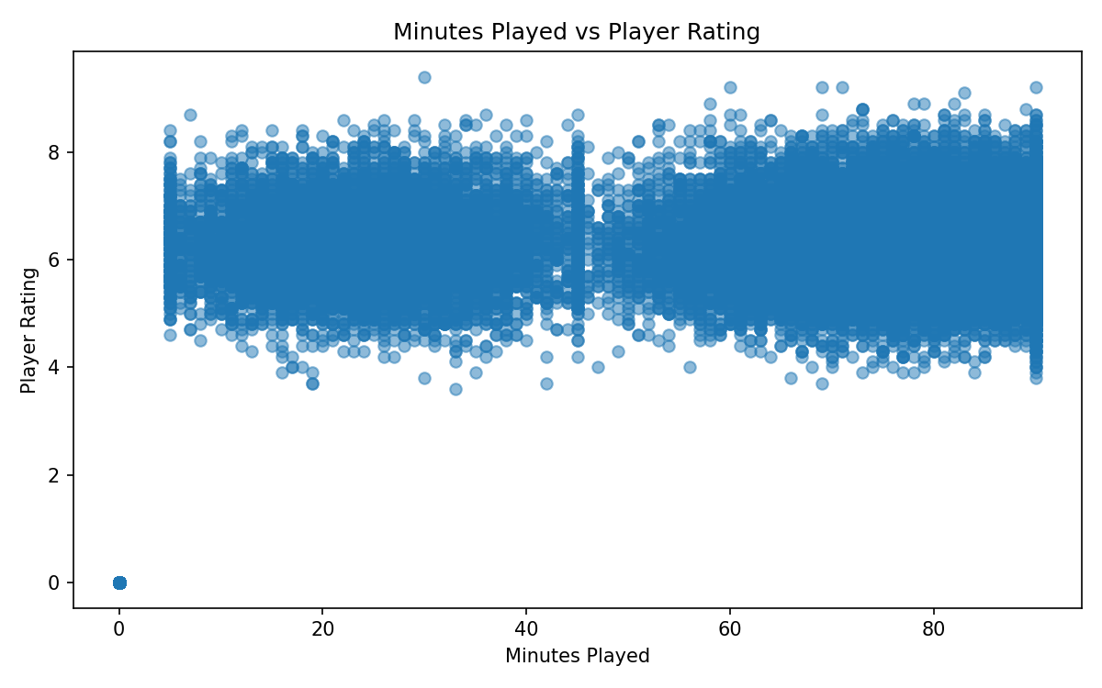
Figure 6 – Market Value Distribution
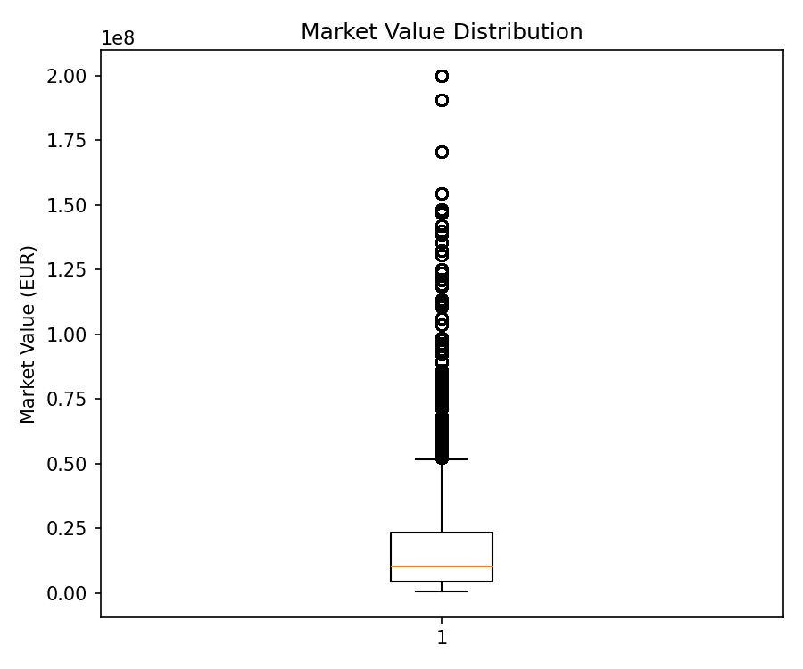
Figure 7 – Goals and Assists of Top 10 Rated Players
