EXPERIMENT 6
DATA VISUALIZATION USING POWER BI

Aim
To import, transform, analyze, and visualize the FIFA World Cup 2026 Player Performance dataset using Microsoft Power BI Desktop and create an interactive dashboard.

Software Requirements
• Microsoft Power BI Desktop
• Microsoft Excel
• CSV Dataset
• Windows Operating System

Procedure
1. Open Microsoft Power BI Desktop.
2. Select Home → Get Data → Text/CSV and import the FIFA Player Performance dataset.
3. Open Transform Data and verify the required columns.
4. Click Close & Apply.
5. Create the required visualizations from the FIFA player-performance fields.
6. Use preferred_foot as the category field for the grouped comparison chart.
7. Create pie and doughnut charts using the numerical performance fields.
8. Create a funnel/bar-style visual using tournament and performance measures.
9. Arrange the four visuals on one report page and add the title 'FIFA PLAYER PERFORMANCE STATISTICS'.

Visualizations Used
Power BI Visual | Fields Used
Pie Chart | Sum of clean_sheet, decelerations, age, accelerations and jersey_number.
Doughnut Chart | Sum of age, distance_covered_km, defensive_actions, accelerations, sprint_distance_km, successful_crosses, successful_passes, top_speed_kmh and total_passes.
Column Chart | Comparison by preferred_foot using successful_dribbles, aerial_duels_lost, assists, crosses, blocks, goals and key_passes.
Funnel/Bar Visual | Sum of recoveries, total_assists_tournament, yellow_cards, successful_dribbles and total_goals_tournament.

OUTPUT
FIFA PLAYER PERFORMANCE STATISTICS – POWER BI DASHBOARD
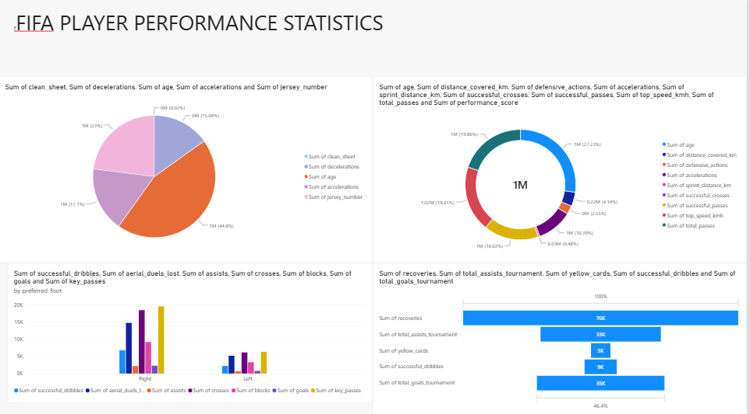
The above figure is the Power BI dashboard output using the FIFA Player Performance dataset. It contains four visualizations: a pie chart, doughnut chart, preferred-foot comparison chart, and a tournament/performance summary visual.

Result
The FIFA Player Performance dataset was successfully visualized in Microsoft Power BI. The dashboard displays multiple player-performance measures and comparisons in a single report page.

