RESULTS
ICVGIP 2026 — Submission 485
Glacial Lake Segmentation using YOLOv11m-seg and SAM2 with Uncertainty-Guided Refinement

Annexure: Revised Tables and Figures
Table 1: Dataset Distribution
Dataset | Source | Images | Ground Truth
Training | Roboflow glacial-lake datasets (training split) | 333 | 333
Validation | Roboflow glacial-lake datasets (validation split) | 464 | 464
Test | Kaggle Glacial Lake Dataset (Sentinel-2, 10 m, Himalaya) | 1640 | 1640
Total | All Dataset combined | 2437 | 2437
Table 2: Performance of YOLOv11 variants and component-wise ablation
S.No. | Model / Configuration | IoU | Dice/F1 | Prec. | Recall | Spec. | Pix. Acc. | Bal. Acc. | Params
1 | YOLOv11n-seg | 0.7511 | 0.8579 | 0.8950 | 0.8237 | 0.9877 | 0.9737 | 0.9067 | 2.9M
2 | YOLOv11s-seg | 0.7117 | 0.8315 | 0.8172 | 0.7605 | 0.8927 | 0.9703 | 0.8766 | 10.1M
3 | YOLOv11m-seg | 0.7021 | 0.8250 | 0.8368 | 0.7370 | 0.9947 | 0.9698 | 0.8659 | 22.4M
4 | YOLOv11l-seg | 0.7221 | 0.8386 | 0.8776 | 0.7794 | 0.9415 | 0.9711 | 0.8855 | 27.6M
5 | YOLOv11x-seg | 0.6978 | 0.8220 | 0.8627 | 0.7477 | 0.8424 | 0.9687 | 0.8700 | 62.1M
6 | YOLOv11m-seg + SAM2 | 0.7600 | 0.8150 | 0.7520 | 0.8154 | 0.9868 | 0.9804 | 0.8991 | 103.2M
7 | + Boundary-aware box | 0.6459 | 0.7849 | 0.7764 | 0.7936 | 0.9651 | 0.9423 | 0.8793 | 103.2M
8 | + Boundary-aware box and points | 0.6804 | 0.8098 | 0.8024 | 0.8174 | 0.9692 | 0.9491 | 0.8933 | 103.2M
9 | + Random clicks (same number) | 0.7092 | 0.8299 | 0.8499 | 0.8108 | 0.9781 | 0.9559 | 0.8944 | 103.2M
10 | + Distance-based clicks (same number) | 0.7049 | 0.8269 | 0.8436 | 0.8109 | 0.9770 | 0.9550 | 0.8940 | 103.2M
11 | + Uncertainty-guided correction (proposed) | 0.7876 | 0.8222 | 0.7636 | 0.8126 | 0.9867 | 0.9802 | 0.8997 | 103.2M
12 | Full framework (box, points and correction) | 0.7876 | 0.8222 | 0.7636 | 0.8126 | 0.9867 | 0.9802 | 0.8997 | 103.2M
Table 3: Comparison with other methods
Dataset | Method | IoU | Dice/F1 | Precision | Recall
(a) Trained on the same data and tested on the same test set
Kaggle test set (Sentinel-2) | U-Net | 0.5145 | 0.6795 | 0.6058 | 0.7735
Kaggle test set (Sentinel-2) | DeepLabV3+ | 0.6403 | 0.7807 | 0.8706 | 0.7077
Kaggle test set (Sentinel-2) | YOLOv11m-seg + SAM2 | 0.7600 | 0.8150 | 0.7520 | 0.8154
Kaggle test set (Sentinel-2) | Proposed framework | 0.7876 | 0.8222 | 0.7636 | 0.8126
(b) Reported in other papers on their own datasets (for reference only, not directly comparable)
Sentinel-1 & Sentinel-2 | U-ViT | 0.808 | 0.894 | 0.902 | 0.887
Sentinel-1 & Sentinel-2 | U-Net | 0.655 | 0.792 | 0.814 | 0.771
Sentinel-1 & Sentinel-2 | DeepLabV3+ | 0.662 | 0.797 | 0.820 | 0.775
Sentinel-2 | YOLOv5-seg | 0.7160 | 0.7900 | 0.8245 | 0.7600
Sentinel-2 | Adaptive SAM | 0.7600 | 0.8073 | 0.8200 | 0.8113

Table 4: Performance after each iteration
Iteration | IoU | Dice/F1 | Precision | Recall
Initial SAM2 | 0.7157 | 0.8343 | 0.8583 | 0.8116
1 | 0.7142 | 0.8333 | 0.8572 | 0.8107
2 | 0.7180 | 0.8359 | 0.8629 | 0.8104
3 | 0.7184 | 0.8361 | 0.8623 | 0.8115
4 | 0.7876 | 0.8222 | 0.7636 | 0.8126
5 | 0.7876 | 0.8222 | 0.7636 | 0.8126
Table 5: Validation of the uncertainty map against SAM2 error pixels
Uncertainty map | AUROC
Attention entropy (proposed) | 0.728
Distance to boundary | 0.693
Predictive entropy | 0.559

Table 6: IoU and Dice under challenging conditions
Condition | Images | IoU (YOLOv11m-seg + SAM2) | Dice (YOLOv11m-seg + SAM2) | IoU (Proposed Framework) | Dice (Proposed Framework)
Small lakes | 137 | 0.5774 | 0.7321 | 0.7024 | 0.8283
Medium lakes | 136 | 0.7263 | 0.8415 | 0.7618 | 0.8686
Large lakes | 137 | 0.7653 | 0.8670 | 0.8237 | 0.9062
Regular boundary | 137 | 0.8869 | 0.9401 | 0.9126 | 0.9580
Irregular boundary | 136 | 0.7396 | 0.8503 | 0.7864 | 0.8838
Highly irregular boundary | 137 | 0.4837 | 0.6520 | 0.6218 | 0.7696
Single lake | 60 | 0.9559 | 0.9775 | 0.9452 | 0.9753
Multiple lakes | 350 | 0.6794 | 0.8091 | 0.7425 | 0.8554
Snow, ice or cloud surroundings | 280 | 0.7674 | 0.8684 | 0.8014 | 0.8928
Low-contrast boundary | 137 | 0.6836 | 0.8121 | 0.6967 | 0.8251
Clear water | 78 | 0.5859 | 0.7389 | 0.8691 | 0.9334
Table 7: Computational cost on an NVIDIA T4 GPU
Component | Value
YOLOv11m-seg | 59.3 ms (123.3 GFLOPs)
SAM2 image encoder (once per image) | 309.6 ms (646.8 GFLOPs)
SAM2 mask decoder (per iteration) | 19.7 ms (3.66 GFLOPs)
Average corrective clicks per image | 0.91
YOLOv11m-seg + SAM2 (total) | 408.9 ms per image
Proposed framework (total) | 420.8 ms per image (2.38 images/s), 774.6 GFLOPs
Peak GPU memory | 1.37 GB
Parameters | 103.2M (no additional parameters)
Table 8: Comparison with related prompt-refinement approaches (Page No. 8, Section 4.5)
Approach | Needs training | Needs user clicks | Iterative correction | Uses model uncertainty
RITM, SimpleClick (interactive segmentation) | Yes | Yes | Yes | No
FocSAM | Yes | Yes | Yes | No
VRP-SAM | Yes | No | No | No
Adaptive SAM | Yes | No | No | No
RS-SAM (remote-sensing SAM adaptation) | Yes | No | No | No
Detector-to-SAM pipeline (YOLO + SAM2) | No | No | No | No
Proposed framework | No | No | Yes | Yes

Table 9: Results for each Roboflow hard-case image

Case | Split | YOLOv11m-seg + SAM2 IoU | YOLOv11m-seg + SAM2 Dice | Proposed IoU | Proposed Dice | Proposed Precision | Proposed Recall | Clicks
Terrain shadow (Fig. 10a) | training | 0.739 | 0.850 | 0.863 | 0.926 | 0.865 | 0.997 | 6
Terrain shadow (Fig. 10b) | test | 0.780 | 0.876 | 0.800 | 0.889 | 0.840 | 0.943 | 10
Terrain shadow (Fig. 10c) | training | 0.828 | 0.906 | 0.789 | 0.882 | 0.855 | 0.910 | 39
Snow and ice (Fig. 11a) | validation | 0.503 | 0.669 | 0.515 | 0.680 | 0.523 | 0.971 | 10
Snow and ice (Fig. 11b) | test | 0.936 | 0.967 | 0.926 | 0.962 | 0.978 | 0.946 | 0
Snow and ice (Fig. 11c) | test | 0.974 | 0.987 | 0.964 | 0.982 | 0.996 | 0.967 | 3
Debris (Fig. 12a) | validation | 0.716 | 0.835 | 0.718 | 0.836 | 0.895 | 0.784 | 14
Debris (Fig. 12b) | test | 0.915 | 0.956 | 0.873 | 0.932 | 0.945 | 0.919 | 6
Debris (Fig. 12c) | validation | 0.686 | 0.814 | 0.730 | 0.844 | 0.818 | 0.872 | 14
Mean (9 images) |  | 0.786 | 0.873 | 0.797 | 0.881 | 0.857 | 0.923 | 11.3

Table 10: Comparison of primary and alternative data-split strategies and segmentation performance
Data-Split Strategy | Training | Validation | Test | IoU | Dice/F1 | Precision | Recall
Primary split (used in study) | 333 (13.7%) | 464 (19.0%) | 1640 (67.3%) | 0.7876 | 0.8222 | 0.7636 | 0.8126
Alternative split (70:15:15) | 1706 (70.0%) | 366 (15.0%) | 365 (15.0%) | 0.7209 | 0.8378 | 0.8660 | 0.8114

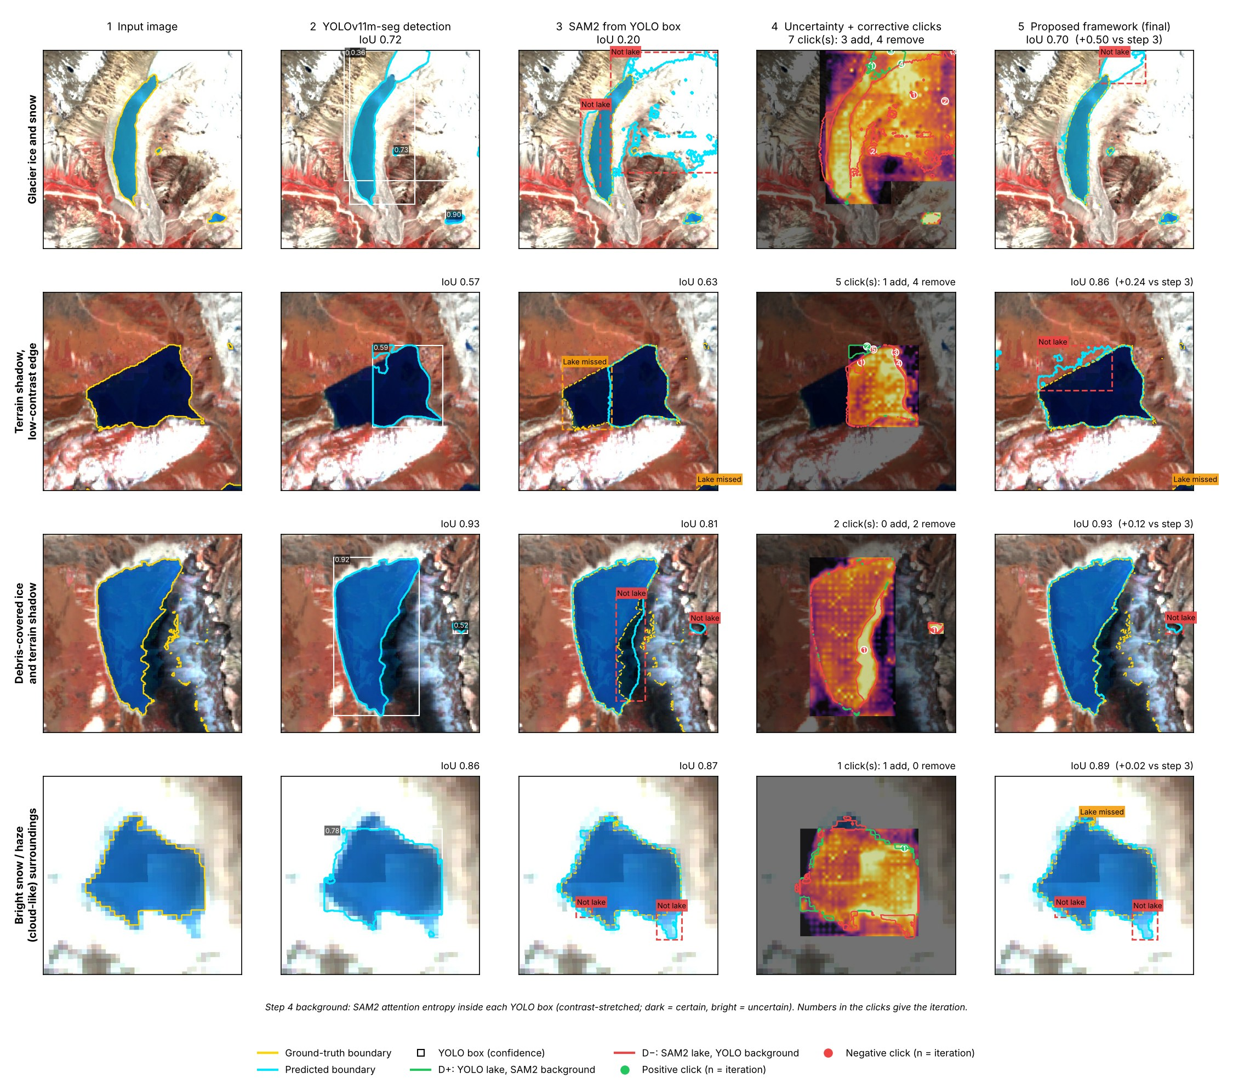
Fig. 1: Step-by-step correction under challenging conditions
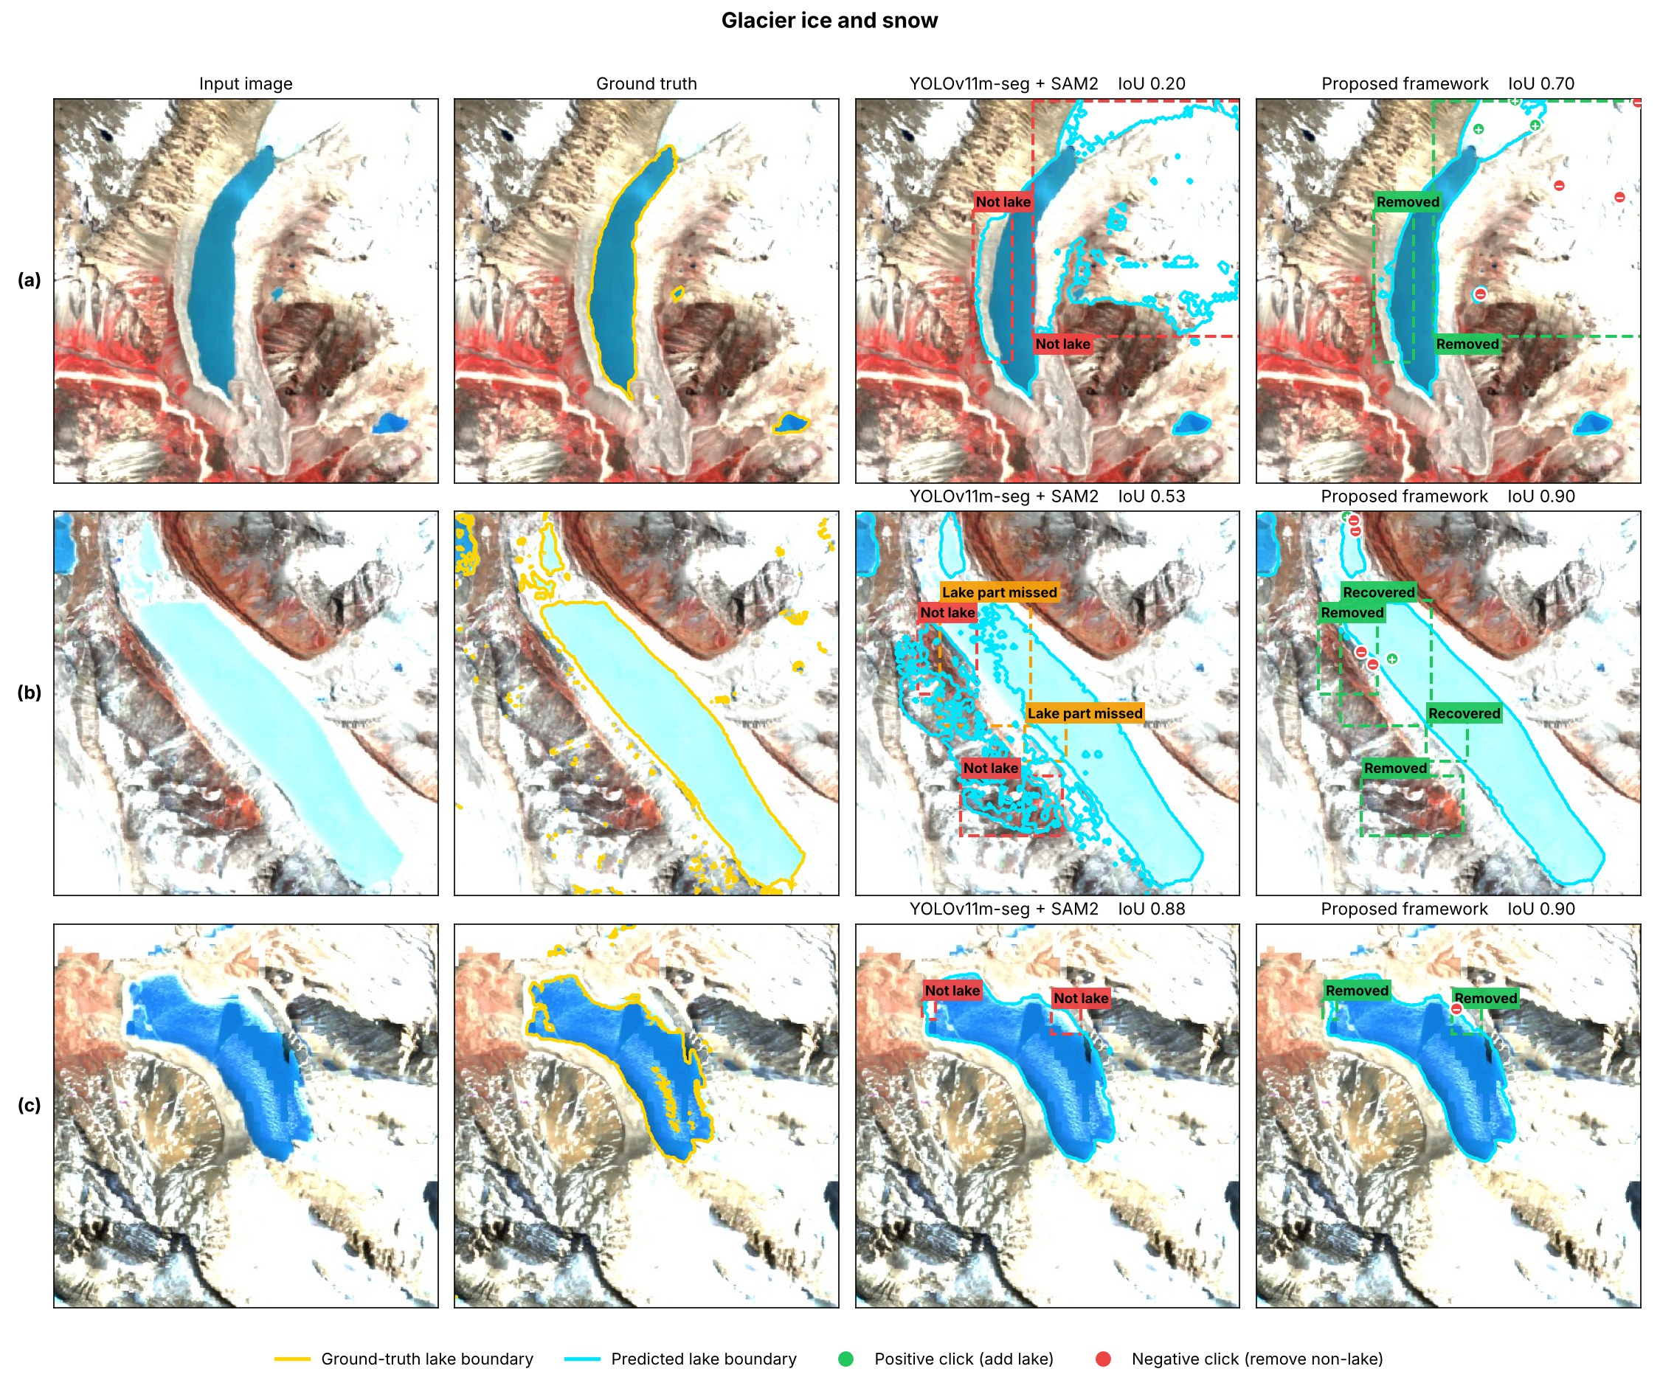
Fig. 2: Glacier ice and snow, Kaggle test images
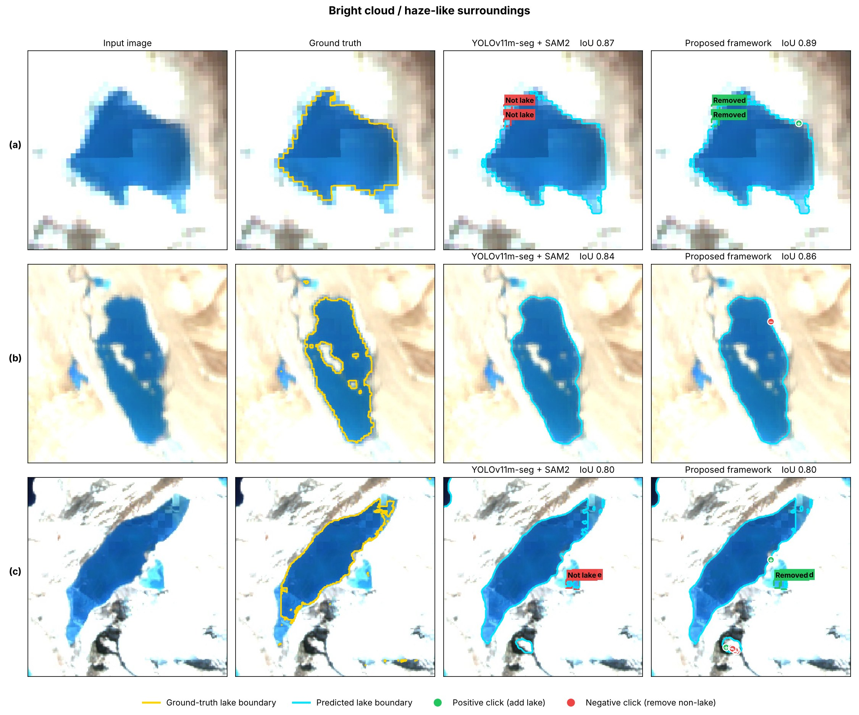
Fig. 3: Bright cloud- or haze-like surroundings, Kaggle test images
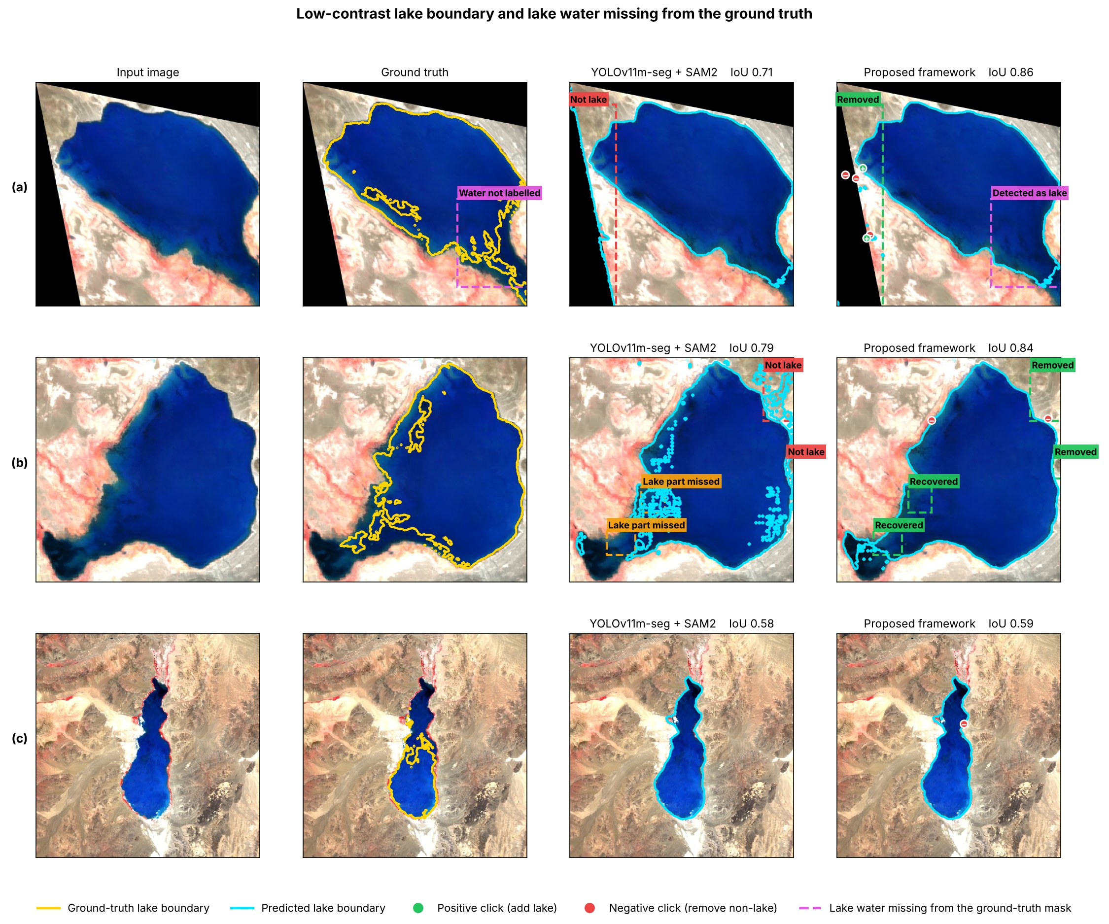
Fig. 4: Low-contrast lake edges and lake water missing from the ground truth, Kaggle test images
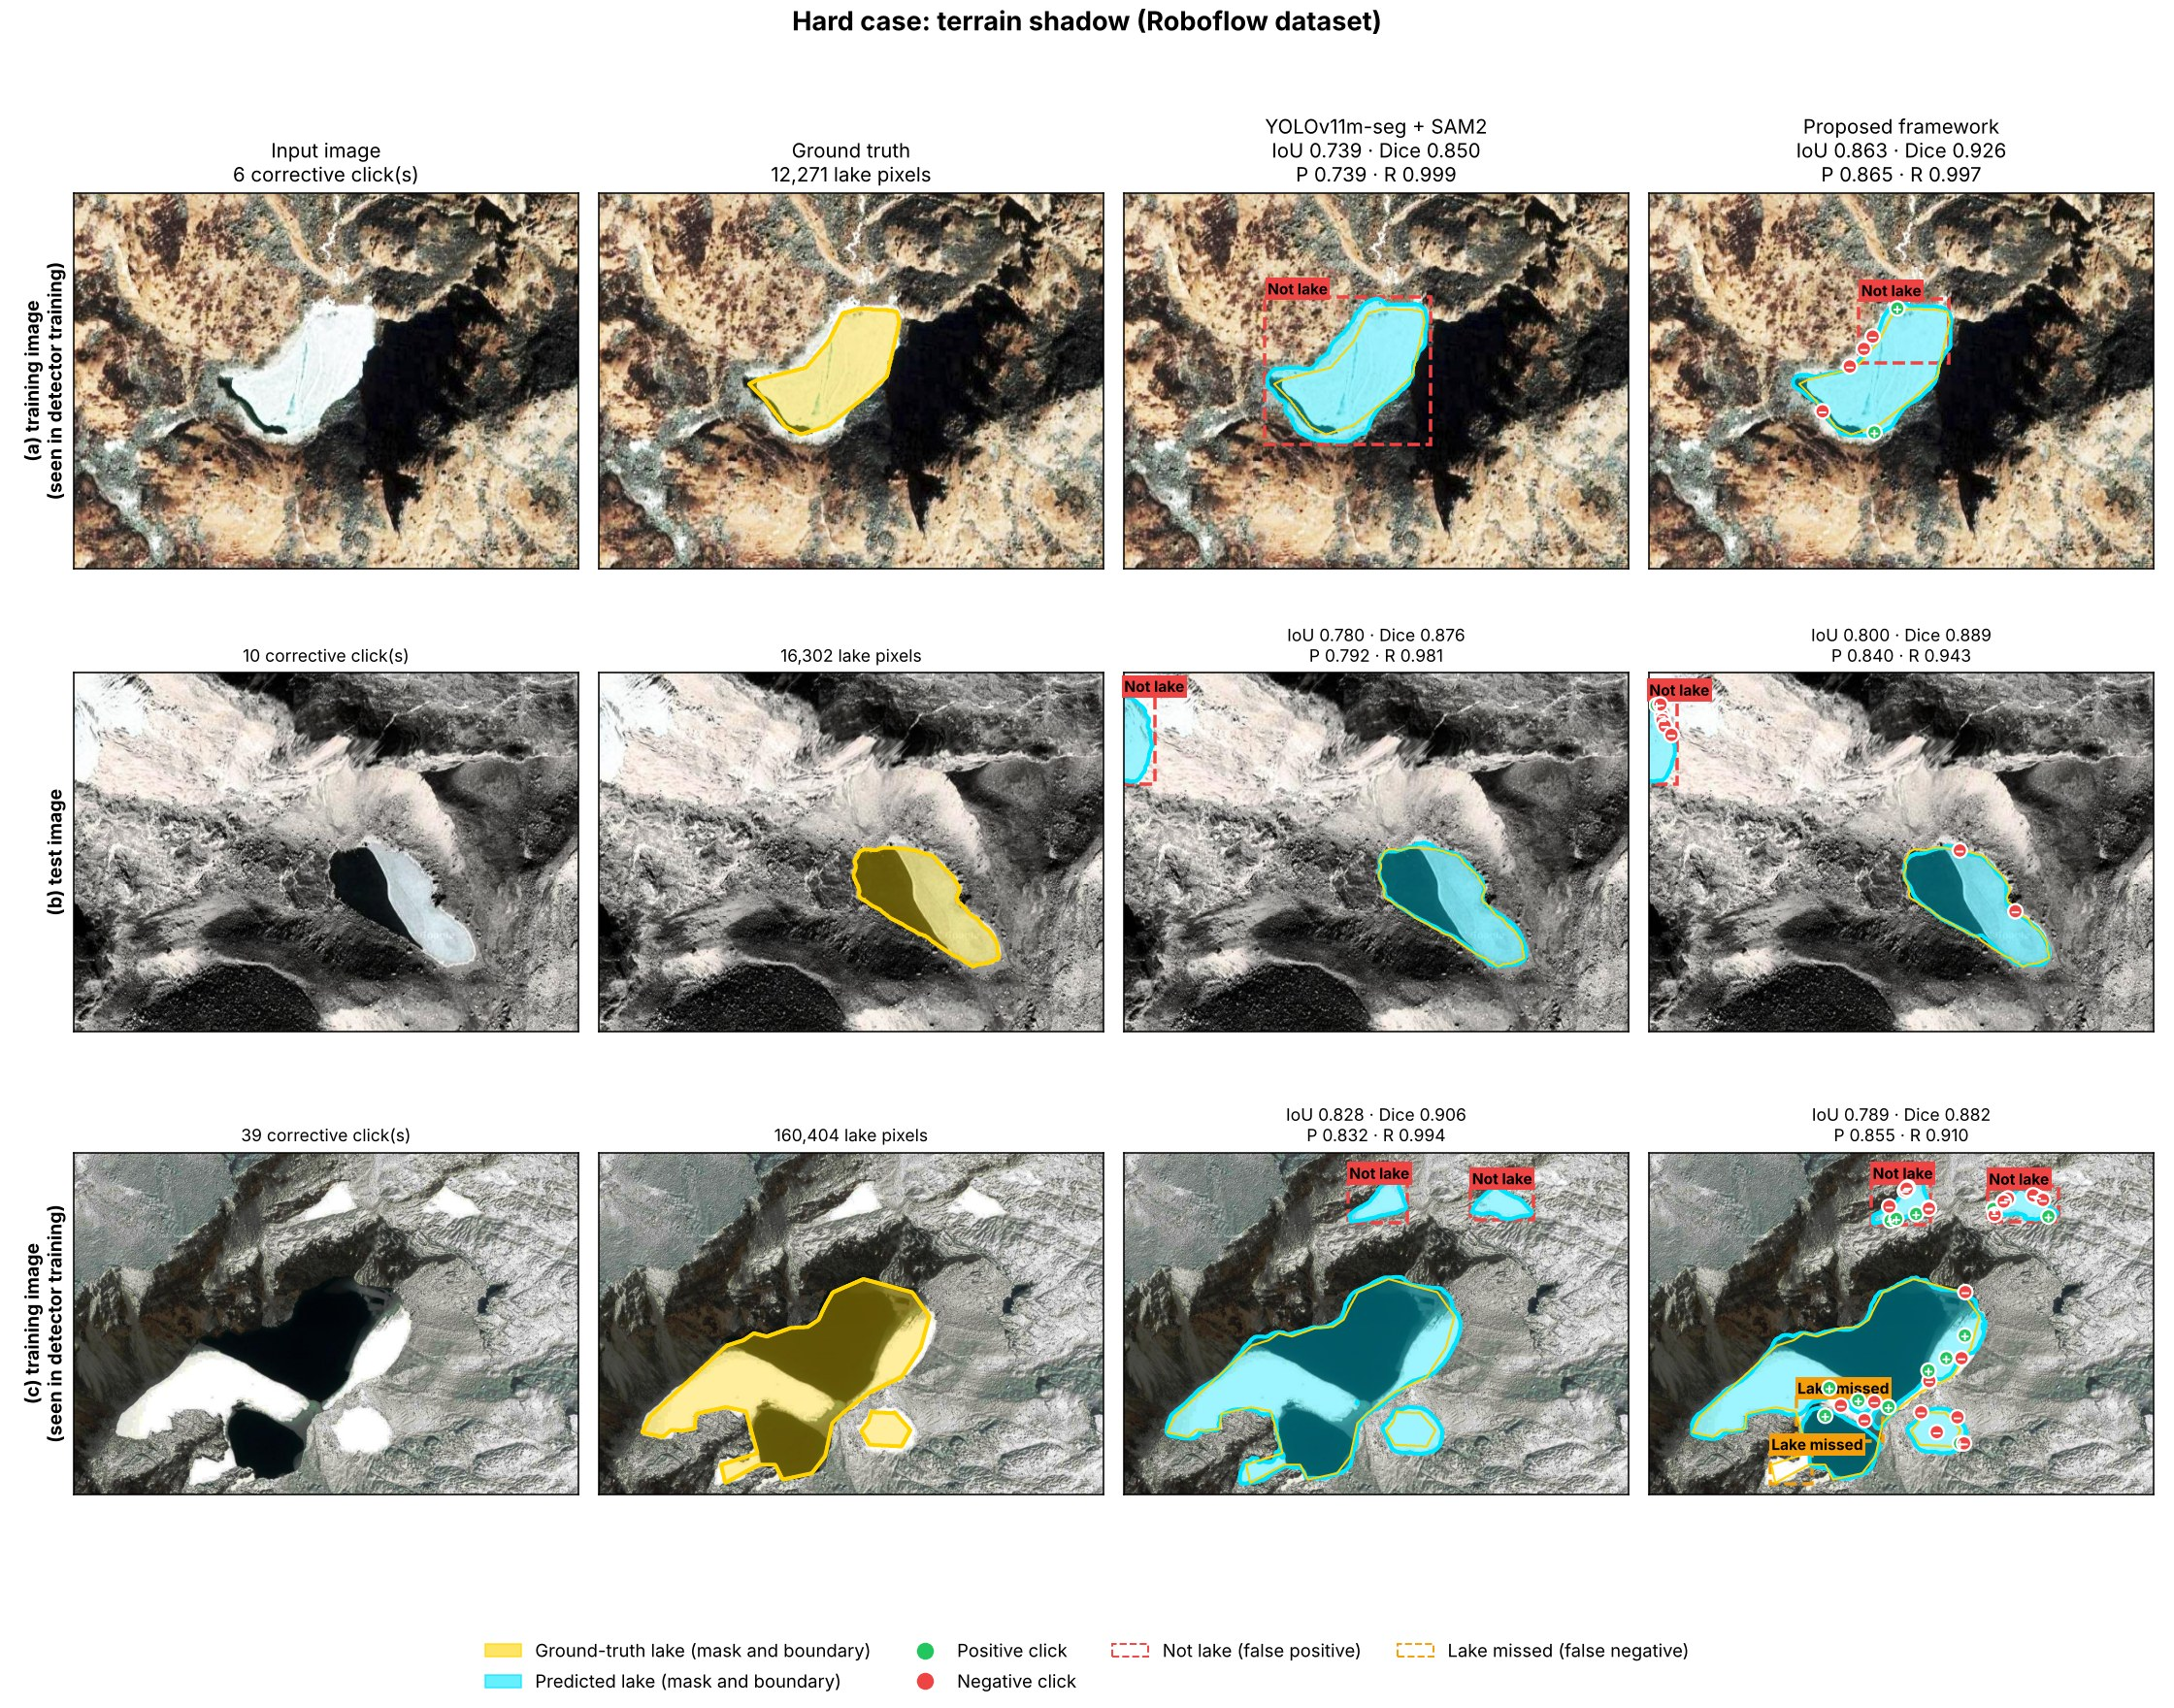
Fig. 5: Terrain shadow, Roboflow images
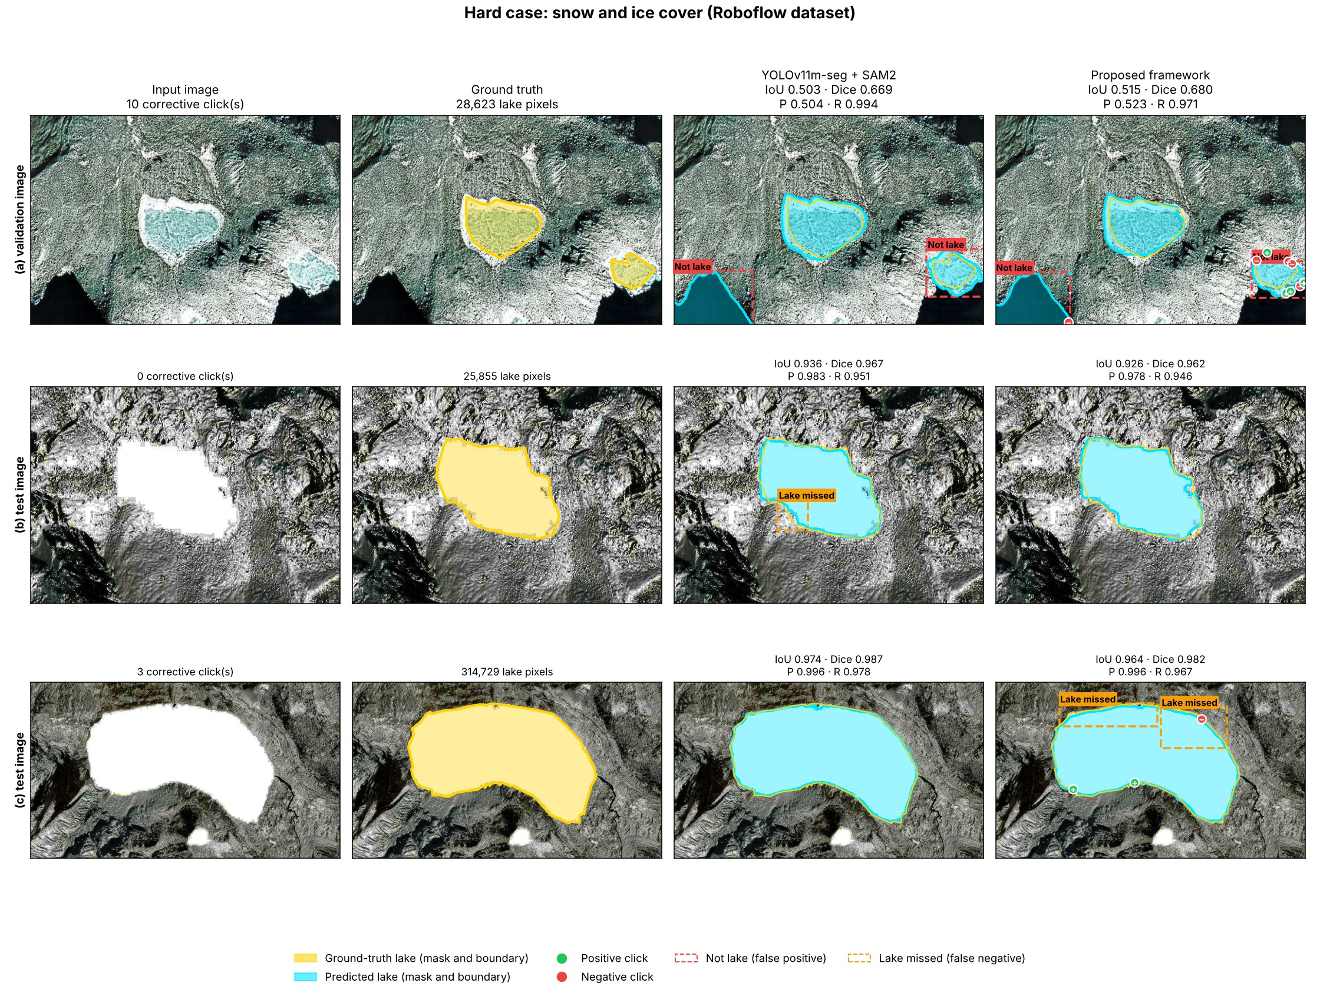
Fig. 6: Snow and ice cover, Roboflow images
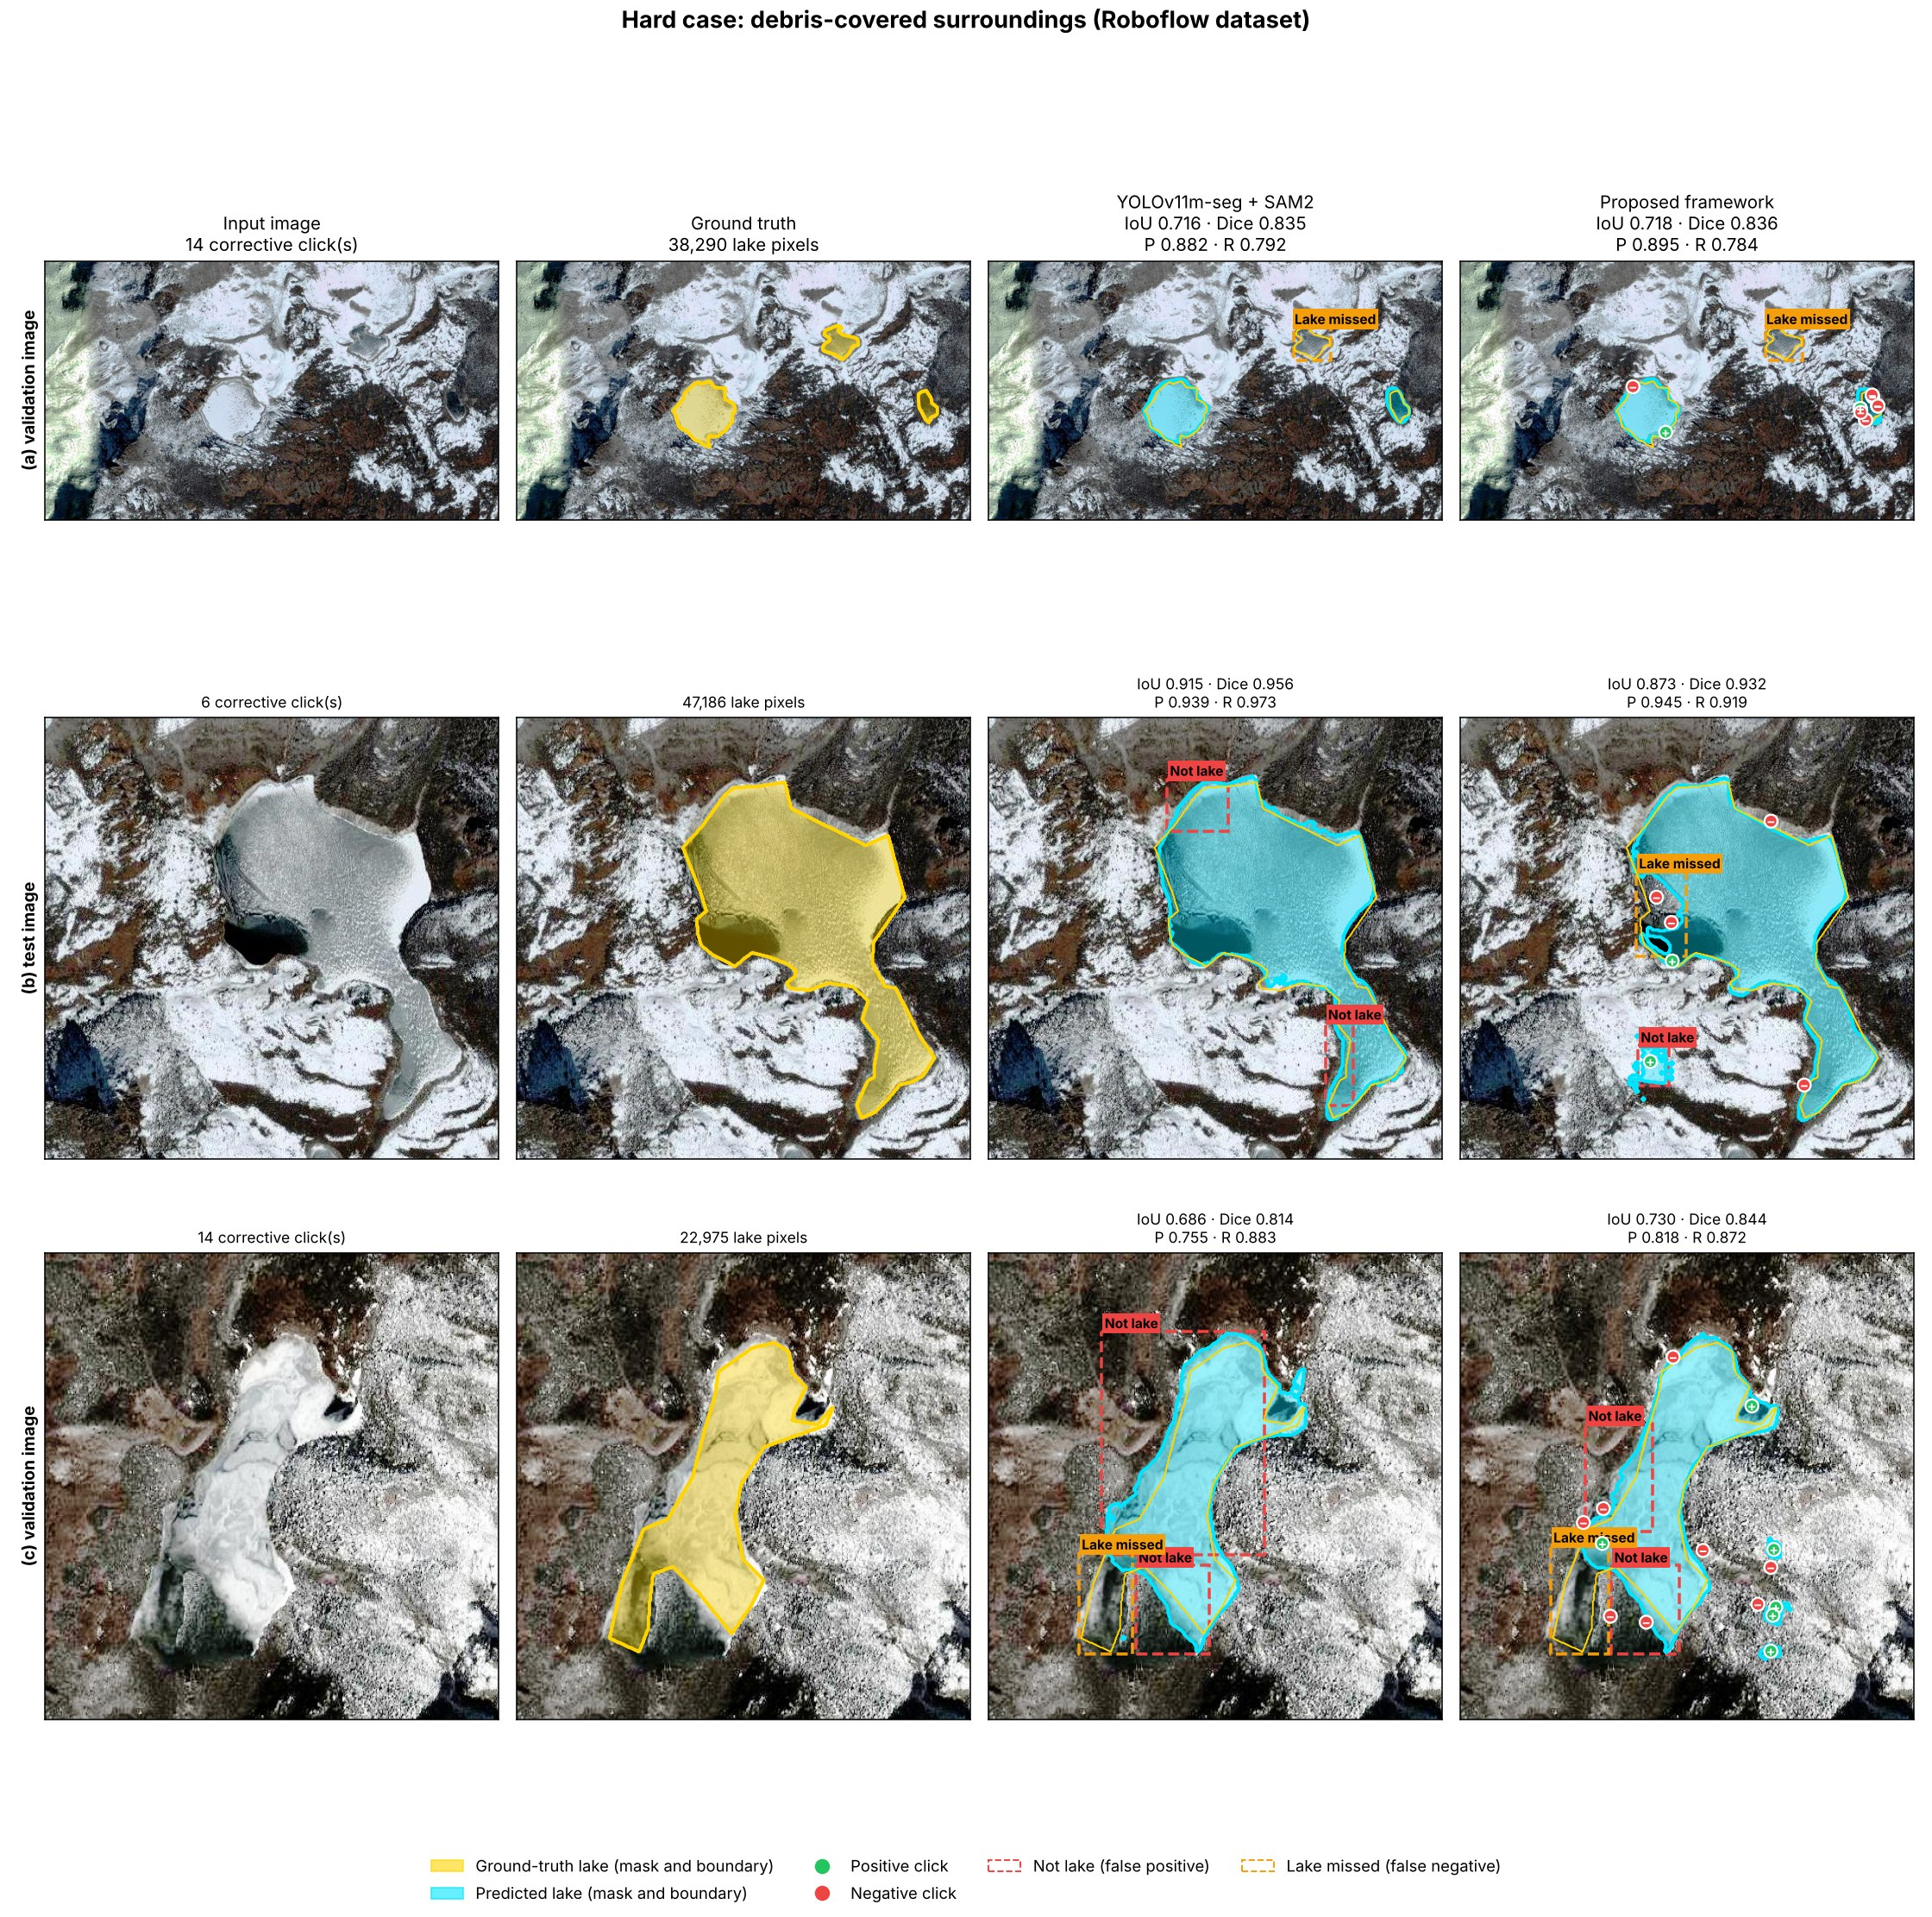
Fig. 7: Debris-covered surroundings, Roboflow images
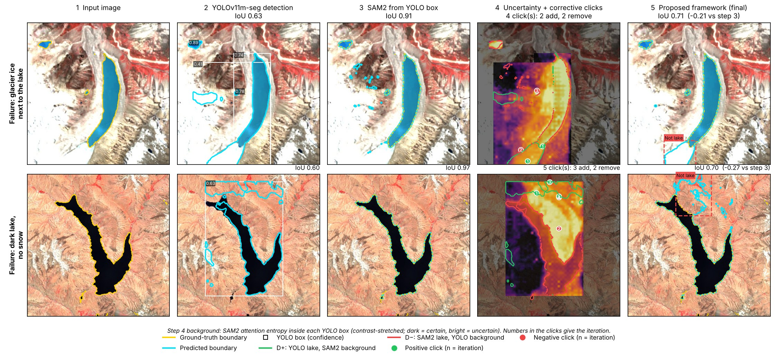
Fig. 8: Cases where the correction fails
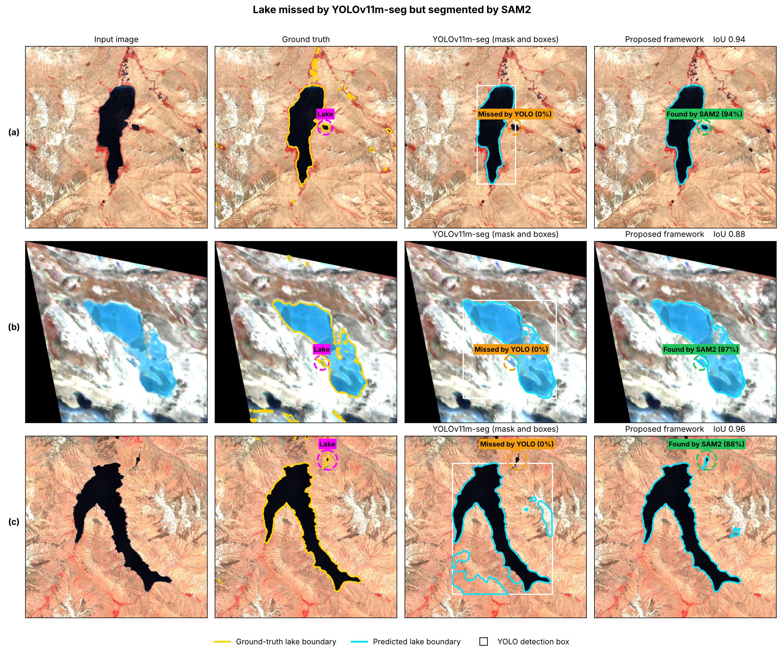
Fig. 9: Lakes missed by YOLOv11m-seg but found by SAM2

