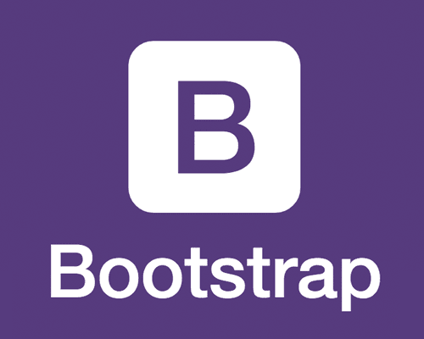

**Bootstrap**

* Who owns/manages the code?

Bootstrap was Created by [Mark Otto](https://twitter.com/mdo) and [Jacob Thornton](https://twitter.com/fat), and maintained by the [core team](https://github.com/orgs/twbs/people) with the massive support and involvement of the community and its licensed to [Bootstrap Authors](https://github.com/twbs/bootstrap/graphs/contributors) and Twitter, Inc.

* What does the code do? Why is it interesting or unusual?

Bootstrap is a powerful front-end framework for faster and easier web development. It has a lot of features that helps in building better responsive websites.

It include [CSS](http://getbootstrap.com/css/) and [JS](http://getbootstrap.com/javascript/) functions like : styling forms, buttons, tables, Dropdowns, modals, popover… .

* How recently was the code updated?

The code is begging updated frequently, and the latest version is V3.3.7 and was released in July 25 2016, but they are going to release the V4 soon.

* What dependencies does the code have? (e.g. does it require JQuery? Does it require an api key?)

Bootstrap requires JQuery, but no need for api keys, you can just download it or use a CDN link.

* Where is the public code location (e.g. on Github.com)?

The code exist in [Github](https://www.google.com/url?sa=t&rct=j&q=&esrc=s&source=web&cd=4&cad=rja&uact=8&ved=0ahUKEwiRquqwmdzSAhVK62MKHSv6AKUQFgg2MAM&url=https%3A%2F%2Fgithub.com%2Ftwbs%2Fbootstrap&usg=AFQjCNGlItNt3flFEfYVd1_2R1uZy6wTnA&sig2=AnVvKvsmtU5kgOfPKwOTZA&bvm=bv.149760088,d.cGw) and also in CDN’s.