Piguerra, Joshua

2ECE – E

**Programming Assignment 9**

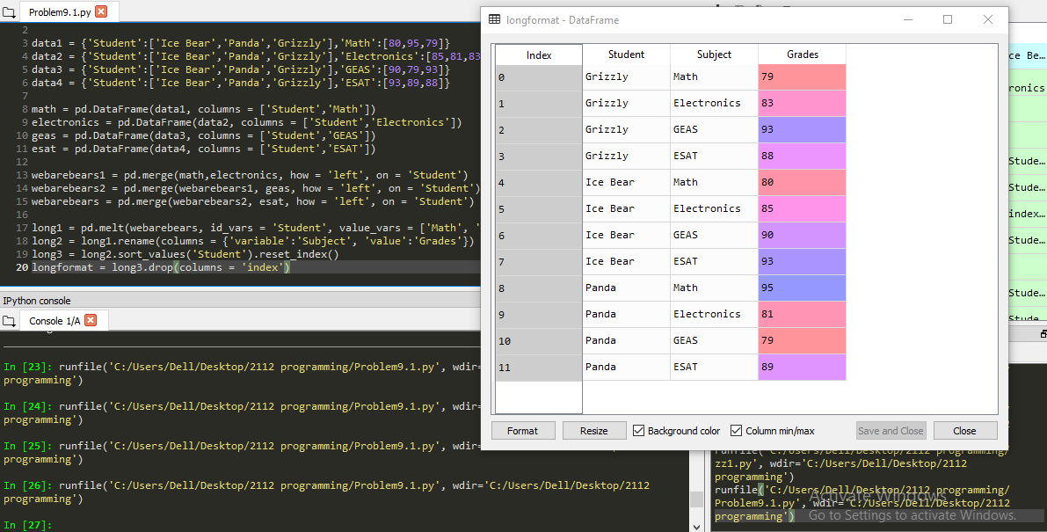**Problem 1**

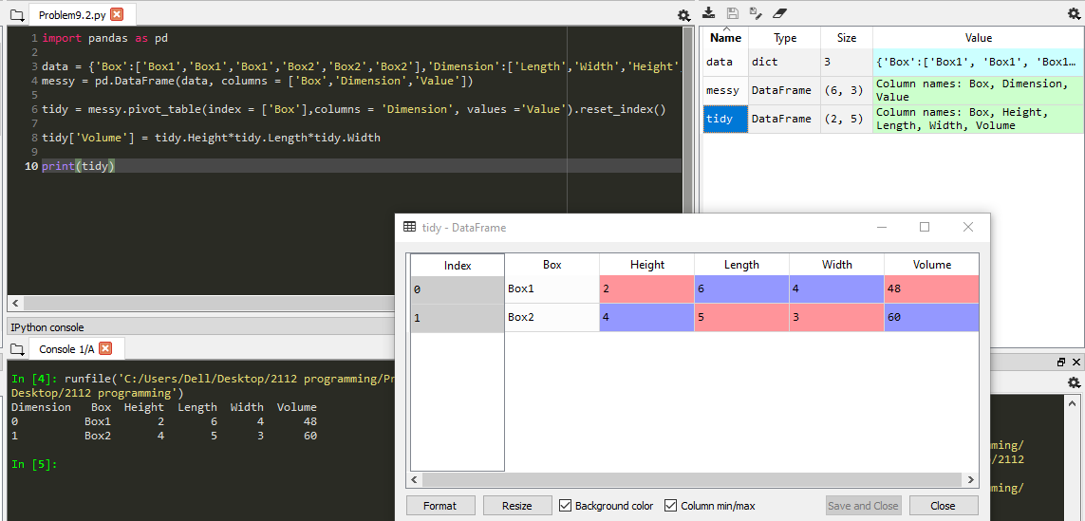**Problem 2**