Data lifecycle in a redux app

You call store.dispatch(action)

Understanding Children

children is a special prop that grabs any elements between the opening and closing tag of the component

example:

App.js
<Person name=”dave”>this is the child content</Person>

Person.js
<div>
{props.children}
</div>

What triggers React to re-render components?
… changes in props and state

Vocab:
<div></div> is called a Wrapping Element

JSX is a preprocessor step that adds XML syntax to Javascript. It is syntactic sugar for javascript
To use jsx syntax you need to import React.

functional stateless or presentational component
the opposite is class-based components - “containers”, “smart”, or “stateful” components... they are not presentational and are more concerned with how things work, rarely have HTML markup

props allow you to pass data from a parent(wrapping) component to a child (embedded) component

state is used to change the component state. It is a property of the component class.

State allows you to change your component at runtime
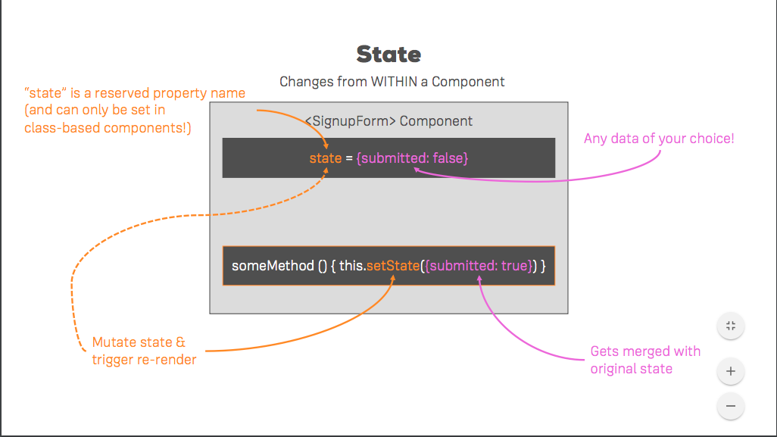

how to not mutate an array → array.slice() or spread operator [...array]

const personIndex = this.state.persons.findIndex(p => {return p.id === id})

str.search("W3Schools")

Understanding State:

store “stores the entire application state” instead of having state management spread out in many places across the app... it works like a global store

How does Redux work:

it's all about a central store

component ---> dispatch ----> action (reaches) ---> Reducer (updates)----> Central Store --->

---> triggers all subscriptions whenever the state changes.... → pass updated state as props to the component

store

Action (pre-defined information package)
reducer is a pure function that receives action and old action as input, spits out updated state
(reducer is synchronous code only... pure sync functions)

[process for updating the state]

component

Setting up store

const redux = require ('redux')
const createStore = redux.createStore

const initialState = {
counter: 0
}

//reducer
const rootReducer = (state = initialState, action) => {
return state;
}

//store
const store = createStore(rootReducer);

a store must be initialized with a reducer

Provider component allows you to inject your redux store into react

mapstatetoprops is essentially setting up a subscription

mapstatetoprops is the state we want to pass through the connect higher order component

State is not changed internally, props are changed internally

mapdispatchtoprops, holds reference to function that will dispatch an action

the prop holds a reference to the function

connect is a function that returns a higher order component

arrow function x = () => {}

