What is SSH Secure Shell ?

SSH Secure Shell is a program that helps you log into another computer over a network, to execute commands in a remote machine, or to move files from one computer to another. It replaces the old telnet tool, and the UMD server does not support telnet anymore. In this course, we will use SSH to log into the Engineering server and practice Unix commands there remotely from you desktop or laptop computers.

Where do I get the SSH Secure Shell ?

The software is free only to academic users. I posted the installation executable at Canvas in the folder of cis 200L. Please note that you are not allowed to sell or distribute this installation executable. It is limited only for your own use, and can not be used for commercial purpose.

Installation Procedures

Download SSH.exe to a directory on your PC. Note it works only on Window operating systems. Double click of SSH.exe will launch an automatic installation process. Just follow the instructions in the prompts until the installation process is finished.

How to use SSH Secure Shell ?

At your desktop screen, you will find an icon named as “SSH Secure Shell Client” (if you could not find the icon, then you need to invoke the “SSH Secure Shell Client” through Start->All Programs->SSH Secure Shell->Secure Shell Client at the lower left corner of the window screen. Double click of this icon will bring up a GUI window. In the window, click “Quick Connect” icon, then another small window is prompted with a title “Connect to Remote Host”. In the “Host Name” field, input “login.umd.umich.edu”, and in the “User Name” field, input your user name for UM-D computer system. Then, click the “Connect” button at the right upper corner. Next, another window is prompted up with a title “Enter Authentication Response”. You need to input your password into the password field. Finally, the SSH Secure Shell window will look like the following picture:

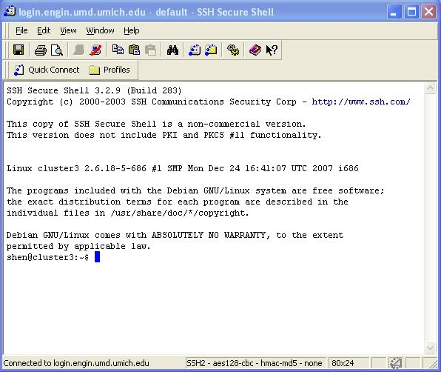

The above window indicates that you are already in a Unix environment with a prompt $. From this point, you may practice all the Unix commands listed in the Lecture Note for Week 1 at Canvas. Eventually, you type $logout and hit the “Enter” key to logout the remote connection.

Besides SSH Secure Shell Client, you may use putty as an alternative tool to achieve a similar goal.

SSH Secure File Transfer

Right now, the campus server supports SSH file transfer or WinSCP, which may be considered as a secured ftp. You can double-click the icon for SSH Secure File Transfer, if it exists on your desktop screen. Otherwise, you use need to invoke the “SSH Secure File Transfer” through Start->All Programs->SSH Secure Shell->Secure File Transfer Client at the lower left corner of the window screen. When its working window is prompted up, click the “Quick Connect” button. In the “Host Name” field, type in “login.umd.umich.edu”; in the “User Name” field, type in you unique user name for UMD domain. Next, click the “Connect” button at the right side of the Quick Connect window. A password window will be popped up, and type in your password. An “Enter Authentication Response” window will then be prompted up, and you just click the “OK” button. If your password is accepted, you will see your Unix account in the right sub-window, while your PC directory is in the left sub-window. You can do file transfer by dragging a file from one sub-window to the other, and vice versa. After finishing the file transfers, you may select “Disconnect” from the pull-down menu to end the session.

Note that one thing that may prevent you from logging into the Unix system is that you should not use SSH Secure Shell and SSH Secure File Transfer at the same time. Close the SSH Secure Shell first, and then use the SSH Secure File Transfer or WinSCP.

