**CIS-298 Intro to Python**

**With Professor Robert Mann**

**HW #4**

**Student: Demetrius Johnson**

**02 February 2023**

**Due: 07 February 2023 at 4pm**

#Author: Demetrius Johnson

#CIS-298 Intro to Python with Professor Robert Mann

#HW4 - FUNCTIONS

#Remember to copy/paste your code for each question separately. Then, follow it with a snippet showing the output.

# #1. Write a Python program to find all numbers which are divisible by 7 and multiple of 5, #between 1500 and 2700 (both included).

dividend_list = list(range(1500, 2701))

divisible_list = []

for dividend in dividend_list:

if (dividend % 35) == 0: #in order to be divisible by 7 and a multiple of 5 (same as divisble by both 7 and 5), must be a multiple of 7*5 = 35

divisible_list += [dividend]

print(divisible_list)

# #2. Write a Python program to convert temperatures to and from celsius, fahrenheit. Formulas : F = (9C / 5) + 32 or C = (f-32)* 5 / 9

#Expected Output :

#60°C is 140 in Fahrenheit

#45°F is 7 in Celsius

F = int(input("Enter a temperature in Farenheit (whole numbers only): "))

print("The temperature in Celcius is: ", int((F-32) * (5 / 9)))

C = int(input("Enter a temperature in Celcius (whole numbers only): "))

print("The temperature in Farenheit is: ", int(((9 * C) / 5) + 32))

# #3. Write a Python program to guess a number from 1 to 9

seed = 1/2 #make CPU do some work so buffers will change and generate new seed each time program runs

seed = id(seed) #update seed --> set = to seed object memory address

random_num_1_9 = seed % 10 #do mod 10 so that we always reduce seed number to a value between 0 and 9

if random_num_1_9 == 0: # we need values from 1 to 9 not 0 to 9, therefore if random num = 0, add 1 to it to reduce range to 1-9

random_num_1_9 += 1

print(random_num_1_9)

# #4. Write a Python program to construct the following pattern, using a nested for loop.

#*

#* *

#* * *

#* * * *

#* * * * *

#* * * *

#* * *

#* *

#*

#

#print(list(reversed(range(1, 5))))

#print(len(range(1,6)))

for count in range(1, 6): #run this loop starting at taking 1, ending at 6 (6 is not inclusive)

for count in range(count): #print * symbol count times (count takes values from 1 to 5 as outer loop iterates)

print('*', end=' ')

print() # print new line

for count in reversed(range(1, 5)): #same as above, but reverse iteration values --> go from count = 4 to 1

for count in range(count):

print('*', end=' ')

print()

# #5. Write a Python program to get the Fibonacci series from 0 to 50. Note : The Fibonacci Sequence is the series of numbers :

#0, 1, 1, 2, 3, 5, 8, 13, 21, ....

#Every next number is found by adding up the two numbers before it.

#Expected Output : 1 1 2 3 5 8 13 21 34 …

def Fibonacci(seq_range):

#initialize sequence:

Fib_sequence = [0,1]

previous2 = 0

previous1 = 1

#now loop, by adding the previous 2 elements in order to get the next element in the sequence (list):

while(Fib_sequence[previous1] <= seq_range):

Fib_sequence += [Fib_sequence[previous1] + Fib_sequence[previous2]]

previous1 += 1 #now increment the previous value variables so that they will be at the NEW indexes of the previous 2 elements

previous2 += 1

return Fib_sequence

print(Fibonacci(50))

# #6. Write a Python program that prints all the numbers from 0 to 6 except 3 and 6.

#Note : Use 'continue' statement.

list_0_6 = list(range(7))

print(list_0_6,"\n")

for i in (list_0_6):

if i == 3 or i == 6:

continue #continue will skip rest of this iteration of the for loop and start at next iteration

print(i)

# #7. Write a Python program to count the number of even and odd numbers from a series of numbers.

#Sample numbers : numbers = (1, 2, 3, 4, 5, 6, 7, 8, 9)

#Expected Output :

#Number of even numbers : 4

#Number of odd numbers : 5

num_list = [1, 2, 3, 4, 5, 6, 7, 8, 9]

num_even = 0

num_odd = 0

for i in num_list:

if i % 2 == 0:

num_even += 1

else:

num_odd += 1

print("Sample list of numbers is: ", num_list)

print("Number of even numbers in the list: ", num_even)

print("Number of odd numbers in the list: ", num_odd)

# #8. Write a Python program that prints each item and its corresponding type from the following list.

#Sample List: datalist = [1452, 11.23, 1+2j, True, 'w3resource', (0, -1), [5, 12], {"class":'V', "section":'A'}]

datalist = [1452, 11.23, 1+2j, True, 'w3resource', (0, -1), [5, 12], {"class":'V', "section":'A'}]

#Note to self: enumerator() function returns an iterable oject (which can be casted as a list since lists are iterable objects),

#which contains a list of (index, value) pair of all elements of an iterable passed to the function, starting at index 0,

#thus it returns [(0,value1,), (1, value2)...,(i, valuei)],

#and so you can do for a,b in list, since each element is a tuple of 2 values that can be taken by a and b:

print(list(enumerate(datalist)))

#index will take first value of the tuple in the tuple list returned by enumerator, element will take the second value...:

for index, element in enumerate(datalist):

print("Element", index, "-----Value:", element, "-----Type:", type(element))

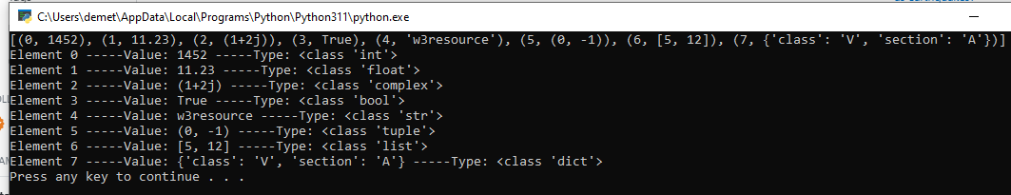

# #9. Write a Python program which iterates the integers from 1 to 50.

#For multiples of three print "Fizz" instead of the number

#and for the multiples of five print "Buzz".

#For numbers which are multiples of both three and five print "FizzBuzz".

#Sample Output:

#fizzbuzz

#1

#2

#fizz

#4

#buzz

for i in range(1,51): #iterate from 1 to 50 (51 is not included) -- [1,50)

if i % (3*5) == 0: #first check if it is a multuple of 3 and 5 --> 3*5 = 15;

print("FizzBuzz")

elif i % 3 == 0: #now check smaller number 3

print("Fizz")

elif i % 5 == 0: #now check larger number 5

print("Buzz")

else: #otherwise it is not divisible by 5 and it is not divisble by 3, so print index

print(i)

# #10. Write a Python program that accepts a string and calculate the number of digits and letters.

#Sample Data : Python 3.2

#Expected Output :

#Letters 6

#Digits 2

def calc_Dig_Alph(sample = "Python 3.2"):

Letters = 0

Digits = 0

for i in sample:

if i.isalpha():

Letters += 1

if i.isdigit():

Digits += 1

print("Test String:", sample)

print("Letters:",Letters)

print("Digits:", Digits)

calc_Dig_Alph()

sample = input("Enter any string/digits, and the number of digits and letters will be calculated:")

# #11. Write a Python program to check whether a letter is a vowel or consonant.

#Expected Output:

#Input a letter of the alphabet: k k is a consonant.

vowels = "aeiou"

while True:

print("Vowels:", vowels)

letter = input("Input a letter, and this program will tell you if it is a vowel or consonant: ")

if letter.isalpha(): #check if in put is a letter

for vowel in vowels: #compare letter to all vowels to see if it is a vowel

if letter == vowel:

print(letter, "is a vowel")

break #if we find a vowel match, no need to waste energy continuing to check

elif letter != vowel and vowel == 'u':

print(letter, "is a consonant")

# #12. Write a Python program to check a string represent an integer or not.

#Expected Output:

#Input a string: Python The string is not an integer.

value = input("enter some input, and this program will say if it is an integer or not: ")

if value.isdigit():

print(value, "is an integer")

else:

print(value, "is not an integer")

# #13. Re-Write problem 10 as a function that returns the count of letters, digits, and other.

def calc_Dig_Alph(sample = "Python 3.2"):

Letters = 0

Digits = 0

Others = 0

for i in sample:

if i.isalpha():

Letters += 1

elif i.isdigit():

Digits += 1

else:

Others += 1

print("Test String:", sample)

print("Letters:",Letters)

print("Digits:", Digits)

print("Others:", Others)

calc_Dig_Alph()

sample = input("Enter any string/digits, and the number of digits and letters will be calculated:")

calc_Dig_Alph(sample)

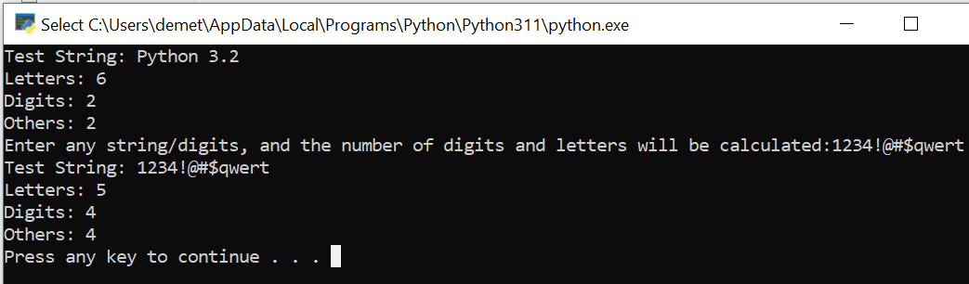

# #14. Write a function that returns two values: first is a Boolean of whether or not the passed-in string value is a float number.

#Second is the float value of the string or -1.0 if not a float.

def isFloatFunc(value = "defaultVal"):

value_no_decimal = value.replace('.', '', 1) #replace 1 (the first) occurence of '.' with '' (empty string char)

if value.isdigit(): #first, check if original value before removing decimal point (if any) has only digits

return [not value.isdigit(), -1.0]

elif value_no_decimal.isdigit(): #else check if only digits in the string after removing decimals

return [value_no_decimal.isdigit(), float(value)]

else: #there is more than one '.' or nondigits thus it is not a decimal or number at all

return [False, -1.0]

print("Default Test Value for function (defaultVal):")

print(isFloatFunc())

value = input("Enter some input, and this program will say if it is an float or not: ")

print(isFloatFunc(value)) #float number test

value = input("Enter some input, and this program will say if it is an float or not: ")

print(isFloatFunc(value)) #integer test

# #15.Write a function to calculate tips.

#It should have two parameters, one for total amount and one for tip percentage to use.

#Make the default percentage 15%, using default parameter value.

def CalcTips(total, tip_perc = 0.15):

return total * tip_perc

total = float(input("Enter Total bill amount:"))

tip = input("Enter a tip percentage (as a decimal, 15% = 0.15 is default if you do not specify tip amount):")

if (tip.replace('.', '', 1)).isdigit():

tip = float(tip)

print("Total tip amount is:",CalcTips(total, tip))

else:

print("Total tip amount is:",CalcTips(total)) #default, no tip amount specified tip = '', thus do not pass to function

