Test 1

CIS 306  
Dr. John P. Baugh – Winter 2021

**Total: ____________ / 150**

**Printed Name: ____Demetrius Johnson_______3-8-2020______**

**GRADER/TA: *[CO for Question 1, P v NP, please record statistics]***

I, _________________, have neither given nor received assistance on this examination except that which is provided by, or approved by, the instructor.

1. [15 pts] If an algorithm A is in the complexity class P, is it necessarily in the complexity class NP? Explain why or why not.
2. [15 pts] Given an alphabet Σ = {a, b, c}, list all strings from length 1 to 3 in the language   
   **L = a(a + b + c)\*** Assume the empty string λ is length 0.
3. [15 pts] Draw a state transition diagram for the FA of regular language L(r) where   
   **r = (a + b)*a**
4. [15 pts] Write a regular expression for the language L using alphabet {a, b} where all strings in the language start with a single b, followed by any number of a’s (including none), and end in a single a.
5. [20 pts] Draw the state transition diagram for the finite automaton that models the regular expression **b*ab(a + b)\***
6. 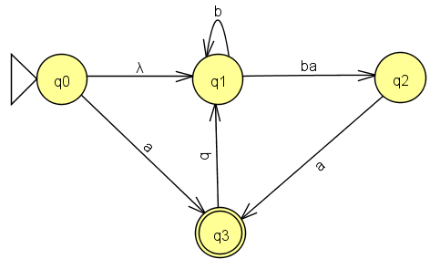[20 pts] Convert the following transition graph into a finite automaton by filling in the (final) table and **identifying** the start and accept states. You do not have to draw the state transition diagram for the FA, just fill in the table (note that this is NOT the intermediate table.

|  |  |  |
| --- | --- | --- |
| **FA State** | **a** | **b** |
|  |  |  |
|  |  |  |
|  |  |  |
|  |  |  |
|  |  |  |
|  |  |  |
|  |  |  |
|  |  |  |

1. [15 pts] Give the configuration after applying the appropriate transition function, using the symbols a, b, c. Only apply the transition function *once*.   
   Assume the **original configuration is: bbabbq2aaab**

**Available transition functions:**

* **δ(q1, a) = (q2, a, R)**
* **δ(q1, b) = (q3, c, L)**
* **δ(q2, a) = (q2, b, L)**
* **δ(q2, b) = (q3, c, R)**
* **δ(q3, a) = (q4, c, R)**
* **δ(q3, b) = (q2, a, L)**

1. [15 pts] Given sets A = {a, b, c, f, g} and B = {a, c, d, g}:
   1. Find A B

* 1. Find A B

* 1. Find A - B

1. [20 pts] Name the accept states (accept *group* states) in the machine L1’ L2

