Name: __**Demetrius Johnson**____________Date: 2-3-2021________________

*No calculators are allowed.* Show your work. The points for each problem are indicated. Problems with incomplete work may receive partial, or no credit.

***COs: [Question 2 fulfills Course Outcome 4 for CIS 306]***

**Points: ______________ / 25**

1. [10 pts] Write a regular expression for a language L, using the alphabet {a, b} where all strings in the language L start with any number of a’s and b’s, followed by aba, or start with any number of a’s, followed by bbb
2. [10 pts] Draw a finite automaton that models the regular expression **a*bb(ab)\***
3. [5 pts] Determine which of the following strings are accepted by the following Transition Graph (TG)
   1. 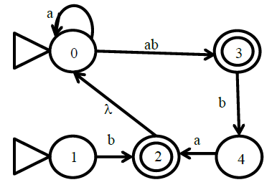ba
   2. baab
   3. abbaab
   4. baaabba
   5. ababaab