EXAM 1

CIS 310

summer, 2021

Your Name **___Demetrius Johnson__________**

***\*\*notice: I answered the questions on paper, scanned them, and took screenshots of them and pasted them into this document; my printer is out of ink at the moment, so I figured out a way to do this and make it still neat and easy to grade. Thank you(:***

Upload your answers on CANVAS by the midnight 6/6/21 (Sun). Write legibly.

1. Decode (or interpret) the following as indicated. Use the ASC II table at the end of the exam if necessary.

VAR_1 43495320333130

VAR_2 E9

VAR_3 42F70000

i.VAR_1 as ASCII characters ( 5 points)

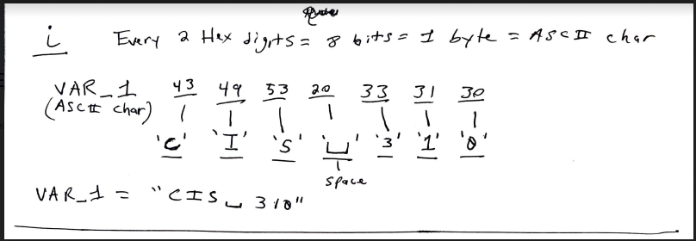

ii.VAR_2 as a signed integer in one byte (show all work) (10 points)

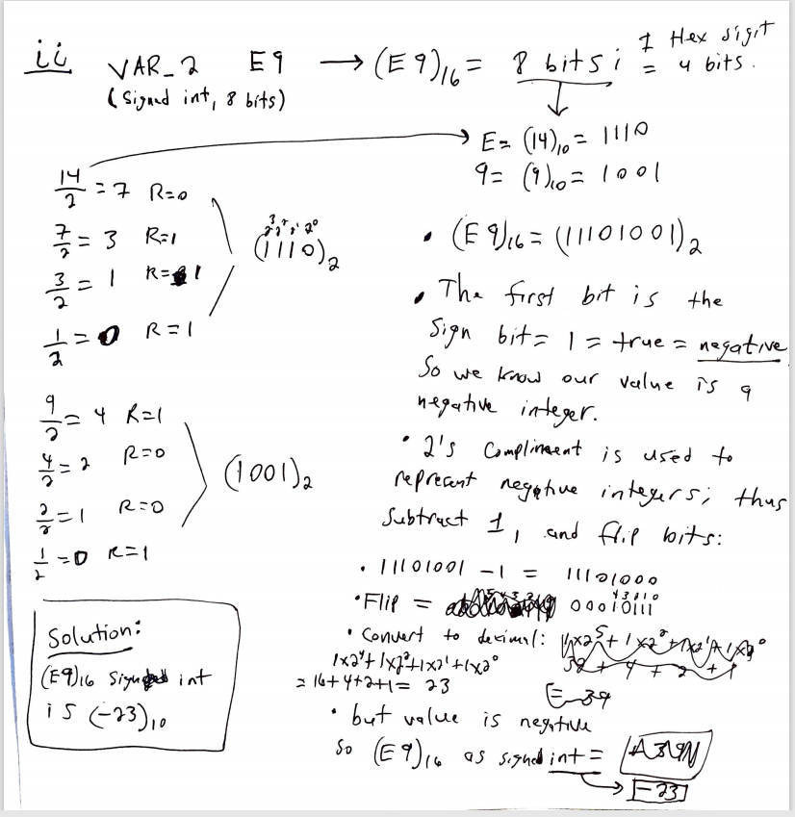

iii.VAR_3 as An IEEE Floating point number in 4 bytes (show all work) (20 points).

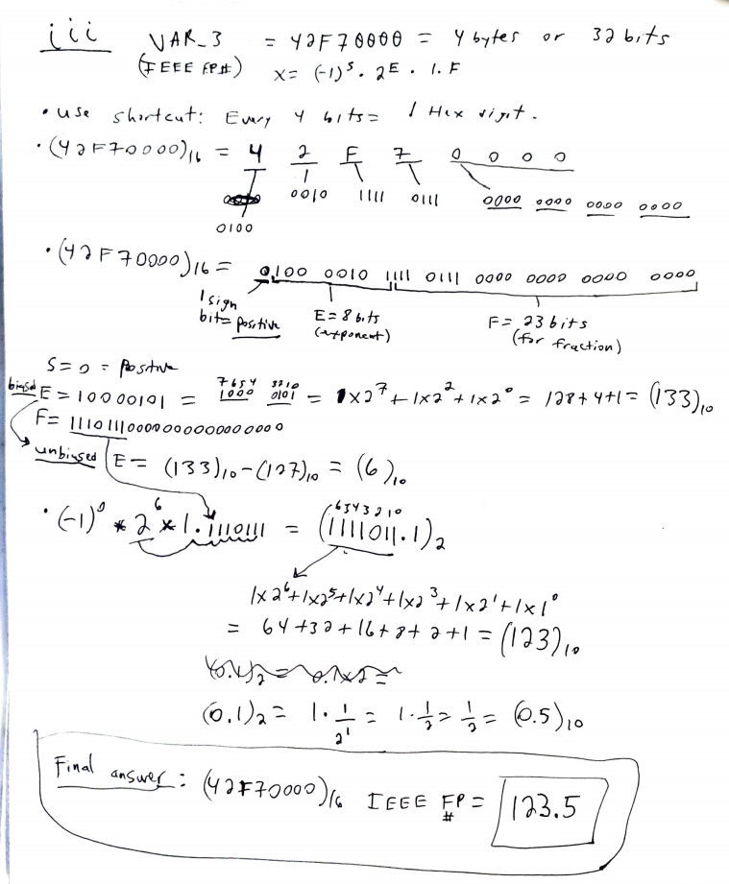

1. Figure out the following FLAGs after the execution of the following instruction:

Z,S,O,C.

Assume data registers AL has 00101011 and BL 00011010.

ADD AL. BL (10 points)

Show the contents of AL after the execution of the instruction and figure out Z, S, O and C.

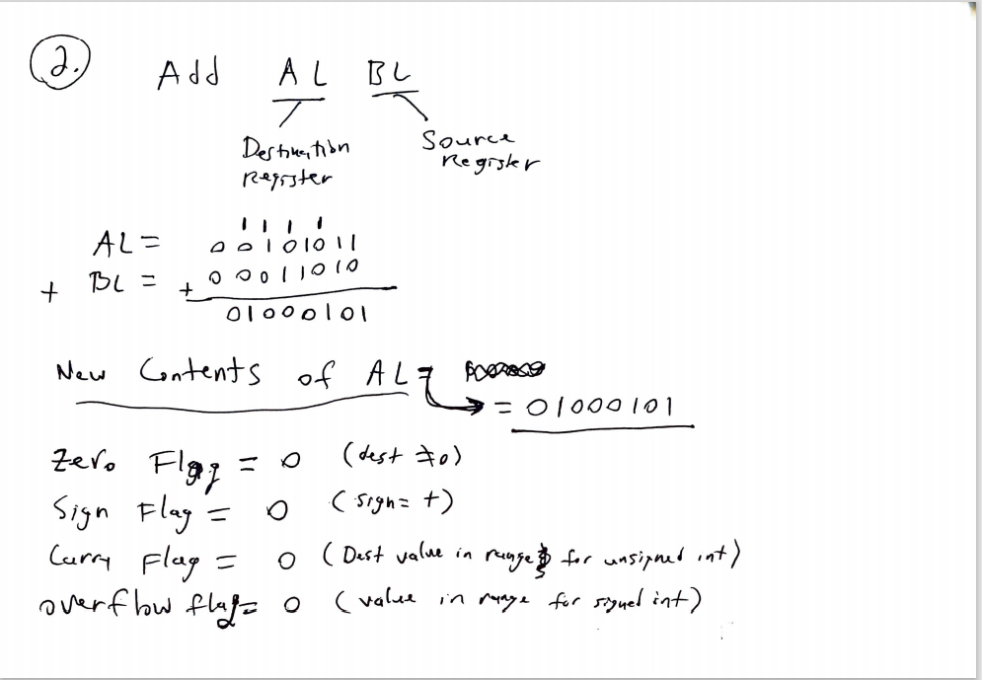

1. Draw the memory map of the following data: (put one byte in each cell) (25 points).

***\*note that the _ character in my map refers to the space ‘ ’ character.***

.DATA

First BYTE 12, 48

Name BYTE ‘My name is Danny’

Num1 REAL4 123.5

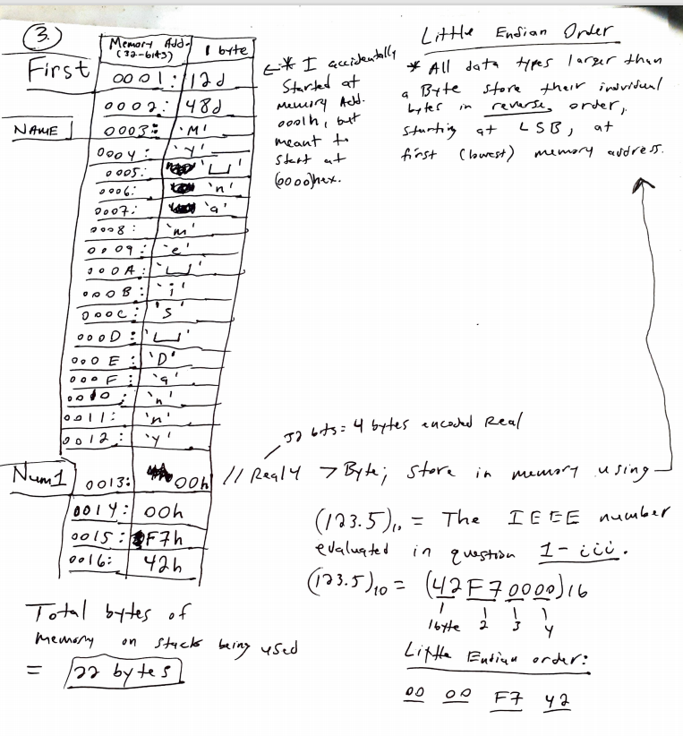

4. Write program segment in X86 assembly language to compute 5 x 4

( 10 points).

* **I wrote my program in visual studio and ran it to make sure it worked and it did!(:**

;CIS-350 SUMMER 2021 WITH PROFESSOR DAVID YOON

;Name: Demetrius Johnson

;Date: 6-06-21

;Program Description: EXAM I Question 4: write a program that computes 5x4

.386

.model flat,stdcall

.stack 4096

ExitProcess proto,dwExitCode:dword

.DATA

.CODE

main proc

mov al, 5d ;move 5 into al 8-bit register 05h = 5d

mov bl, 4d ;move 4 into bl 8-bit register 04h = 4d

mul bl ;multiply al * bl --> it will be stored in the 16-bit AX register 0014h =20d

invoke ExitProcess,0

main endp

end main

