**CIS 350/3501 Summer 2020**

**Data Structures and Algorithm Analysis**

**Homework # 1**

**Student Name: Demetrius Johnson**

**Due: 6/3/2021**

**Total points: 90**

**Problem 1** (10 points)

Order the following functions by growth rate: √*N*, *N*, 2*/N*, 2*N* , *N*3, *N* log*N*, *N* log2 *N*, 37, *N*2 log *N*, *N*1.5, *N* loglog *N*, *N*2, 2*N/*2, *N* log*(N*2*)*. Also, indicate which functions asymptotically grow at the same rate.

Growth Rate (smallest to largest):

|  |
| --- |
| 1. 37 //constant time |
| 1. 2*/N //**Grows (decays) asymptotically towards x-axis as N🡪 Infinity* |
| 1. √*N* |
| 1. *N* |
| 1. *N* log(log *N)* |
| 1. *N* log *N* |
| 1. *N* log*(N*2*)* |
| 1. *N* log2 *N* |
| 1. *N*1.5 |
| 1. *N*2 |
| 1. *N*2 log *N* |
| 1. *N*3 |
| 1. 2*N/*2 |
| 1. 2*N* |

**Problem 2** (16 points)

For each of the following six program fragment, give an analysis of the running time in Big-Oh (worst case) notation.

(1) sum = 0;

for(i = 0; i < n; i++)

sum++;

* **Worst Case: O(N)**
  + There is a loop that will execute a single instruction that will take constant time (sum++;), N times.

(2) sum = 0;

for(i = 0; i < n; i++)

for(j = 0; j < n; j++)

sum++;

* **Worst Case: O(N2)**
  + There are two loops, with one of the loops nested inside of the other loop. Both loops are controlled by and will execute N times, however, the inner loop executes N times for every time the outer loop executes. Thus, Nouter*Ninner = N2 🡪 inner loop executes N times every iteration of the outer loop, which will execute N times.

(3) sum = 0;

for(i = 0; i < n; i++)

for(j = 0; j < n * n; j++)

sum++;

* **Worst Case: O(N3)**
  + There are two loops, an i-loop and a j-loop. The j-loop is nested inside of the i-loop. The i-loop executes N times, and for every iteration of the i-loop, the j-loop executes N*N times. Thus, the total number of executions will be N*(N*N) times == N3times.

(4) sum = 0;

for(i = 0; i < n; i++)

for(j = 0; j < i; j++)

sum++;

* **Worst Case: O(N2)**
  + There are two loops, an i-loop and a j-loop. The j-loop is nested inside of the i-loop. The i-loop executes N times, and for every iteration of the i-loop, the j-loop executes up to one less than the current iteration of the i-loop; for example, if n = 4, the i-loop executes 4 times, and the j-loop executes 0+1+2+3 = 6 times.
  + Thus, the total number of executions will be:
    - n-1 + n-2 + n-3 +...+ n-n times.
  + More formally, total executions will be:
    - The Σ[i=1, i=n]{(n-i)}
    - Or similarly, Σ[i=n-1, i=0]{i}
  + Now, after doing some simplification, the sum of total executions in the inner loop for a given n reduces to n((n-1)*0.5) = n((n-1)/2) = (n2-n)/2 🡪 which ultimately grows as N2 as n approaches infinity. I discovered this simplification by noticing how each subsequent sum for a given n will produce a sum that is an additional 0.5 times bigger than the n value.

(5) sum = 0; //multiply the highest orders of each tree together

for(i = 0; i < n; i++) //n

for(j = 0; j < i * i; j++) //n2

for(k = 0; k < j; k++) //n2

sum++;

* **Worst Case: O(N5)**
  + Here we have 3 loops, with each subsequent loop nested inside of the other (i🡪j🡪k). The i-loop will iterate N times, the j loop will iterate the square of one less than the current iteration of the i-loop. The k-loop will iterate j times for every iteration of the j-loop.
  + For example, for n = 4, the i-loop will iterate N times, the j loop will iterate 02 + 12 + 22 + 32 times, and the k-loop will iterate 0 + (0+…+12) + (0+…+22) + (0+…+32).
  + Formally, the summation for the j-loop will simplify to:
    - The Σ[i=1, i=n]{(n-i)2}
    - or similarly, The Σ[i=n-1, i=0]{i2}
  + Using summation properties, we can simplify:
    - Σ[i=n-1, i=0]{i2} =
    - n(n-1)(2n-1)/6
    - which simplifies to: (2n3-3n2+n)/6
  + Now, for every element in the above j-sum, you need to account for the k-loop which will provide a number of executions for every j-loop element of the above sum, namely:
    - The Σ[i=1, i=n]{(n-i)}, for each j-sum element.
    - Which we know from the previous problem, simplifies to: (n2-n)/2
  + Since each element evaluated in the j-sum must be summed up using (n2-n)/2 in order to determine the total number of k-loop executions, we can use our j-sum and plug it into this equation:
    - The Σ[i=1, i=n]{[((n-i)2)2 – (n-i)2]/2}
    - Which simplifies to:
    - Σ[i=1, i=n]{[(n-i)4 – (n-i)2]/2}
  + Now, as I was doing this I realized that I can also rewrite the above sum in another way:
    - Σ[i=n-1, i=0]{i} = (n2-n)/2 is what needs to be resolved for every j element in the sum Σ[i=n-1, i=0]{i2}
    - Thus, Σ[i=n-1, i=0]{[(i2)2-(i2)]/2}
    - Which simplifies to Σ[i=n-1, i=0]{[(i4-i2]/2}
    - (½)[Σ[i=n-1, i=0]{i4} - Σ[i=n-1, i=0]{i2}
  + This ultimately simplifies to:
    - [(2n3-3n2+n)/6] * [(n2-n)/2] =
    - **(2n5-5n4+4n3-n2)/12** 🡪 total executions of the k-loop == total executions of the function.
  + Thus, (2n5-5n4+4n3-n2)/12 has the highest power of n5, so big O complexity of the function is **O(N5)**.

(6) sum = 0;

for(i = 1; i < n; i++) // n

for(j = 1; j < i * i; j++) // n2

if (j % i == 0 )

for(k = 0; k < j; k++) // n

sum++;

* **Worst Case: O(N4)**
  + The i-loop will execute n times.
  + The j-loop will execute up to i*i times, which at its largest degree, means that the j-loop execute n2 times.
  + The k-loop will execute depending on the if-statement, which is determined by j%i == 0 ; when j is at its largest (i*i = n2), then you have i2%i = 0, so the k-loop will execute up to a max when j = i2, thus k-loop executes at a largest degree of n2 : n + 2n + 3n + .. n2. Instead of k executing n2 times however, because of the % operator n loops are skipped, thus we can reduce n2 to n.
  + So, worst case becomes: n * n2 * n = n4

(7)

**int sum (int n) {**

**if n == 1 {**

**return 1;**

**}**

**return n + sum(n-1);**

**}**

* **Worst Case: O(N)**
  + There will be a recursive call of the sum function:
  + n will be reduced by 1 every recursive call; thus there will be approximately n recursive calls for this function.

(8)

**int sum (int n)**

**{**

**if (n <= 1 )**

**return 1;**

**else**

**return n + sum((3*n)/5);**

**}**

* **Worst Case: O(N)**
  + this function will execute recursive iterations, with each iteration reducing n by 3/5ths, until n is <= 1. With that being considered, as n approaches infinity, the 3/5 factor become irrelevant, and so we see that the growth of the function is n.

**Problem 3** (9 points)

An algorithm takes 0.5 ms for input size 100. How long will it take for input size 500 if the running time is the following (assuming low-order terms are negligible)?

*Since run time is 100/0.5 = 200 executions in 1 millisecond.

1. *Linear*

* *x, x = 500; thus, 500 executions will occur; it will take 500/200 =* ***2.5ms***

1. *O(NlogN)*

* *xlog(x), x =500; thus, 500*log(500) = 1350 executions will occur; it will take 1350/200 =* ***6.75ms***

1. *Quadratic*

* *x2, x = 500; thus, 5002 = 250,000 executions will occur; it will take 250,000/200 =* ***1,250ms***

1. *Cubic*

* *x2, x = 500; thus, 5003 = 125,000,000 executions will occur; it will take 125,000,/200 =* ***625,000ms***

**Problem 4** (10 points)

Show that the maximum number of nodes in a binary tree of height h is 2h+1-1.

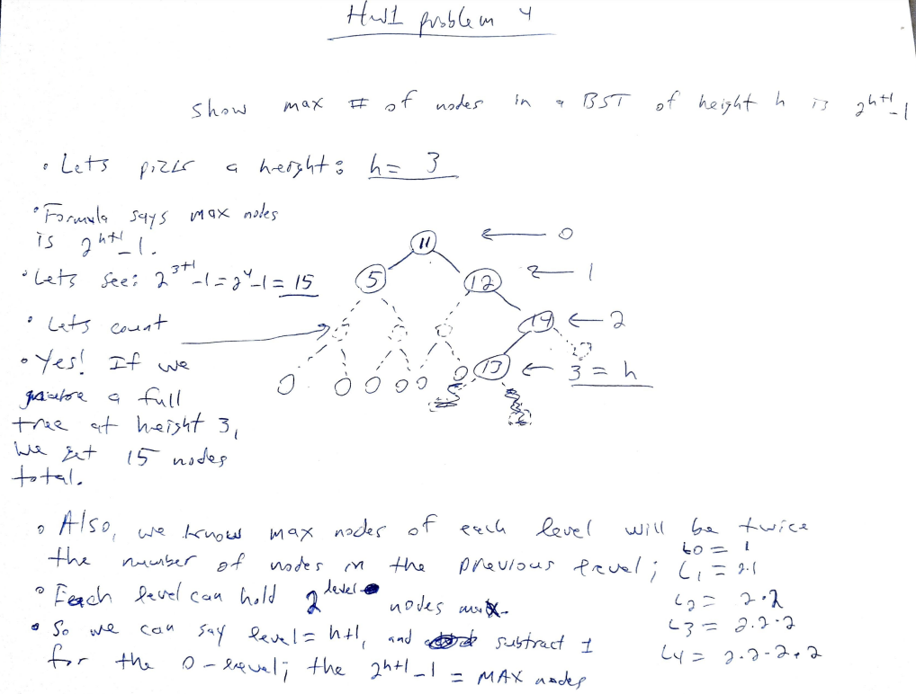

**Problem 5** (10 points)

Give the prefix (based on the preorder traversal), infix (based on the inorder traversal), and postfix (based on the postorder traversal) expressions corresponding to the following tree:

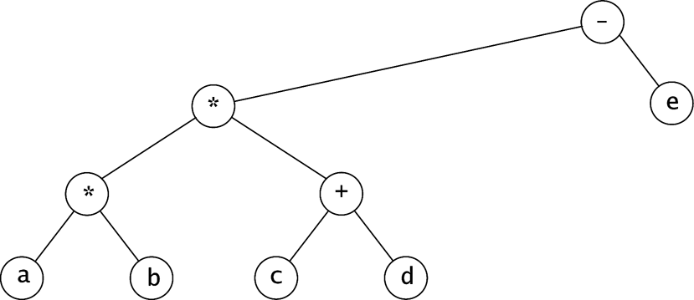

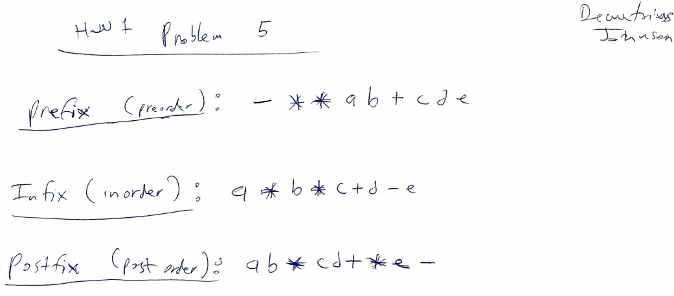

**Problem 6** (10 points)

1. Show the result of inserting 3, 1, 4, 6, 9, 2, 5, 7 into an initially empty binary search tree.
2. Show the result of deleting the root.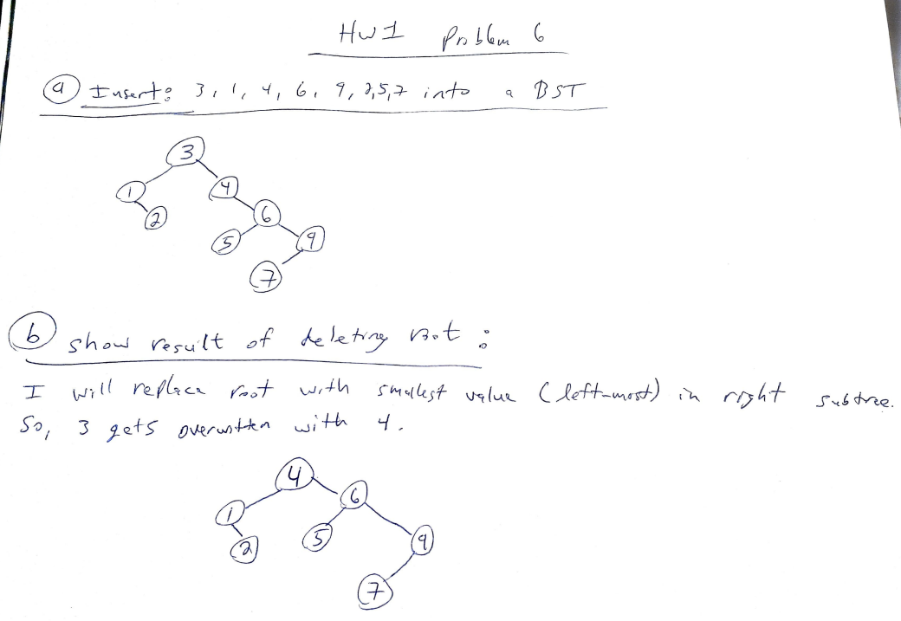

**Problem 7** (15 points)

Write efficient functions that take only a pointer to the root of a binary tree, T, and compute:

1. The number of nodes in T.

Int numNodes(BinaryNode* t){

If(t == NULL)

Return 0;

If(t🡪left!= NULL || t🡪right != NULL)

Return 1+ (numNodes(t🡪left) + numNodes(t🡪right));

}

1. The number of leaves in T.

Int numLeaves(BinaryNode* t){

If(t == NULL)

Return 0;

If(t🡪left!= NULL && t🡪right != NULL)

Return 1;

Return countLeaves(t🡪left) + countLeaves(t🡪right);

}

1. The number of full nodes in T.

Int numFullNodes(BinaryNode* t){

If(t == NULL)

Return 0;

If(t🡪left!= NULL && t🡪right != NULL)

Return 1 + numFullNodes(t🡪left) + numFullNodes(t🡪right);

Return 0;

}

What is the running time of your functions.

**O(logN) since they are all binary-search based**

**Problem 8** (10 points)

Show how the tree in the figure below is represented using a firstChild/nextSibling link implementation (as described in the PPT lecture 4, slide 17).

