**CIS 350/3501 Summer 2020**

**Data Structures and Algorithm Analysis**

**Homework # 2**

**Student Name: Demetrius Johnson**

**Due: 6/15/2021**

**Total points: 30**

*Note, this is an individual homework assignment.*

**Problem 1** (20 points): **Hash Table**

Draw the result of hashing 431, 123, 673, 399, 344, 679, and 389 into a table if the *h*(*x*) = *x* mod 10. The initial hash table size is 10. If you cannot fit everything into the table, then you have to rehash (reset the table size to 21), but show both tables. For collisions use: a) separate chaining; b) linear probing; c) quadratic probing; and d) double hashing *h*2(*x*)= 7 – (*x* mod 7).

**\*\*SEE EXCEL SPREAD SHEET I UPLOADED AND LOOK AT MY TABLES/FORMULAS**

**Problem 2** (10 points): **AVL Tree**

Show the result of inserting 2, 1, 4, 5, 9, 3, 6, 7 into an initially empty AVL tree.

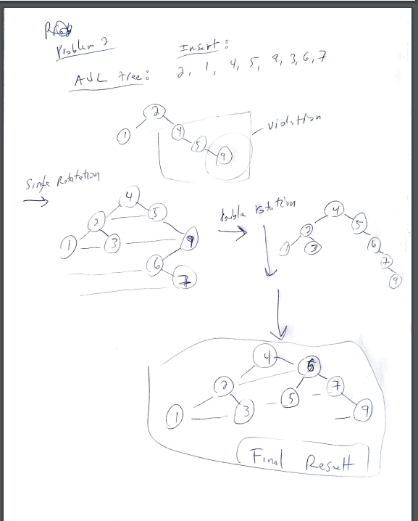

**Problem 3** (20 points): **Max Priority Queue**

1. Show the result of inserting 10, 12, 1, 14, 6, 5, 8, 15, 3, 9, 7, 4, 11, 13, and 2, one at a time, into an initially empty binary heap

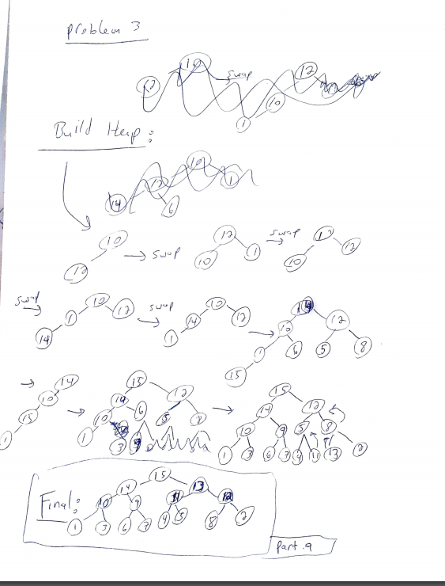

**Problem 4** (10 points): **Splay Tree**

Show the tree after the search for key 10 in the following splay tree:



