CIS 350/3501 Summer 2020 Data Structures and Algorithm Analysis

Homework # 1

Due: 6/1/2021
Total points: 90

Note, this is an individual homework assignment.

Submission instruction:
Upload your homework as a single WORD or PDF file to Canvas under the Assignment “HW1” folder.

Problem 1 (10 points)
Order the following functions by growth rate: √N, N, 2/N, 2^{N} , N³, N logN, N log² N, 37, N² log N, N^{1.5}, N loglog N, N², 2^{N/2}, N log(N²). Also, indicate which functions asymptotically grow at the same rate.

Problem 2 (16 points)
For each of the following six program fragment, give an analysis of the running time in Big-Oh notation.

(1) sum = 0;
for(i = 0; i < n; i++)
sum++;

(2) sum = 0;
for(i = 0; i < n; i++)
for(j = 0; j < n; j++)
sum++;

(3) sum = 0;
for(i = 0; i < n; i++)
for(j = 0; j < n * n; j++)
sum++;

(4) sum = 0;
for(i = 0; i < n; i++)
for(j = 0; j < i; j++)
sum++;

(5) sum = 0;
for(i = 0; i < n; i++)
for(j = 0; j < i * i; j++)
for(k = 0; k < j; k++)
sum++;

(6) sum = 0;
for(i = 1; i < n; i++)
for(j = 1; j < i * i; j++)
if (j % i == 0 )
for(k = 0; k < j; k++)
sum++;

(7)

int sum (int n) {
if n == 1 {
return 1;
}
return n + sum(n-1);
}

(8)
int sum (int n)
{
if (n <= 1 )
return 1;
else
return n + sum((3*n)/5);
}

Problem 3 (9 points)
An algorithm takes 0.5 ms for input size 100. How long will it take for input size 500 if the running time is the following (assuming low-order terms are negligible)?
- Linear
- O(NlogN)
- Quadratic
- Cubic

Problem 4 (10 points)
Show that the maximum number of nodes in a binary tree of height h is 2^{h+1}-1.

Problem 5 (10 points)
Give the prefix (based on the preorder traversal), infix (based on the inorder traversal), and postfix (based on the postorder traversal) expressions corresponding to the following tree:
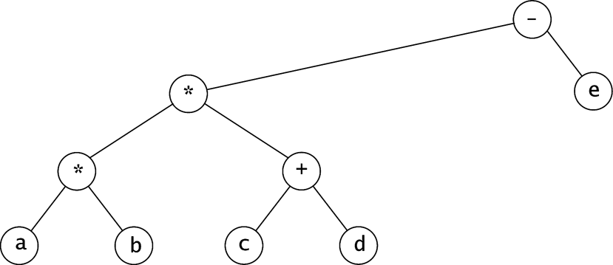

Problem 6 (10 points)
- Show the result of inserting 3, 1, 4, 6, 9, 2, 5, 7 into an initially empty binary search tree.
- Show the result of deleting the root.

Problem 7 (15 points)
Write efficient functions that take only a pointer to the root of a binary tree, T, and compute:
- The number of nodes in T.
- The number of leaves in T.
- The number of full nodes in T.
What is the running time of your functions.

Problem 8 (10 points)
Show how the tree in the figure below is represented using a firstChild/nextSibling link implementation (as described in the PPT lecture 4, slide 17).
