|  |  |  |  |
| --- | --- | --- | --- |
|  | Interlock (for PLC – work cell controller) | Type | Condition |
| 1 | Microswitch (proximity sensor🡪PLC) | **Input** | Tells PLC if a part is in the machine; depends on sensor read |
| 2 | Signal: Acquire and load part into machine (PLC🡪Robot controller) | **Output** | No part in machine; depends on proximity sensor microswitch feedback |
| 3 | signal: start machine cycle (PLC 🡪 machine) | **Output** | Part is in machine |
| 4 | Machine cycle Timer limit switch (machine timer 🡪 PLC) | **Input** | Timer reaches 0 |
| 5 | Signal: unload finished part and place on output conveyor (PLC 🡪Robot controller) | **Output** | Machine cycle timer = 0; |

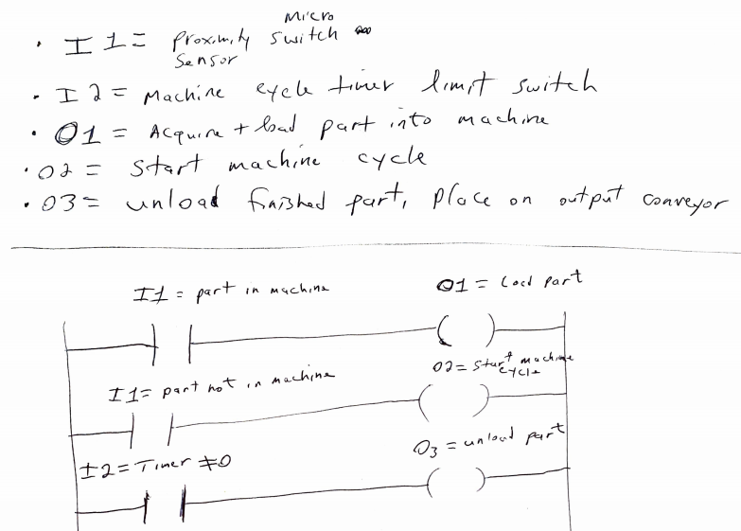**DEMETRIUS JOHNS**  **ON, QUESTION 27 CIS-381 FINAL EXAM 4-20-21**