5. Consider the following transformation of a coordinate frame (CF):

“Translate 3 along X, then Rotate 45o about Z,”

1. **Find the transformation matrix for the above transformation.**

* Translation: (x,y,z) = (3, 0, 0)
* Rotation[about Z-axis] = 45deg.

1. First, we are translating along X.
2. Second, we are rotating about Z 45 deg.

* Note: Every transformation is a transformation of the ORIGIN of the frame with respect to the current position and orientation of the frame after each subsequent transformation.

1. Use: 
   * This is from the slides.
2. For the Trans(x,y,z), use:
   * 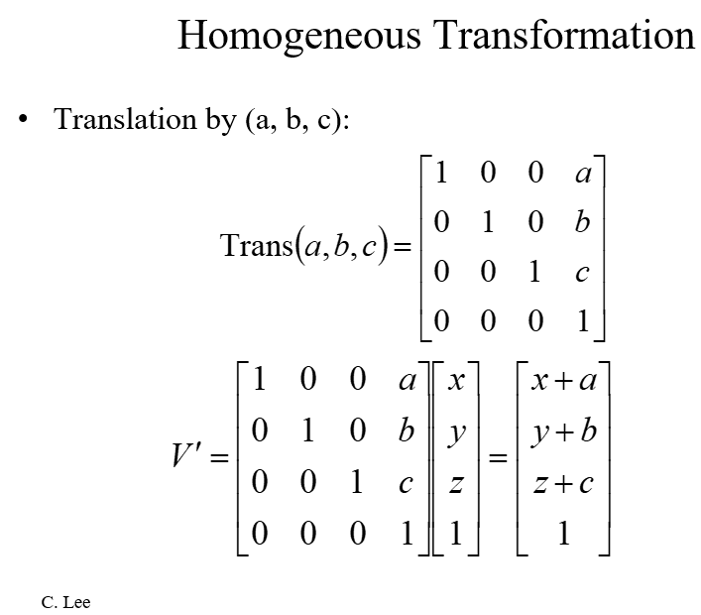
   * Trans(3, 0, 0) =

|  |  |  |  |  |  |
| --- | --- | --- | --- | --- | --- |
|  | 1 | 0 | 0 | 3 |  |
|  | 0 | 1 | 0 | 0 |  |
|  | 0 | 0 | 1 | 0 |  |
|  | 0 | 0 | 0 | 1 (w = dummy coord.) |  |

1. For rotation, use:
   * 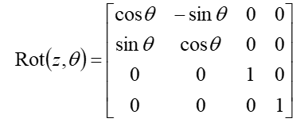
   * Rot(z, 45deg.)=

|  |  |  |  |  |  |
| --- | --- | --- | --- | --- | --- |
|  | cos(45) | -sin(45) | 0 | 0 |  |
|  | sin(45) | cos(45) | 0 | 0 |  |
|  | 0 | 0 | 1 | 0 |  |
|  | 0 | 0 | 0 | 1(w = dummy coord.) |  |

1. Now, for executing a series of homogenous transformations of a Coordinate Frame (CF), we use this formula in order to find the total Transformation:
   * T = Trans. * Rot., which is:

TRANS. ROT.

|  |  |  |  |  |  |
| --- | --- | --- | --- | --- | --- |
|  | 1 | 0 | 0 | 3 |  |
|  | 0 | 1 | 0 | 0 |  |
|  | 0 | 0 | 1 | 0 |  |
|  | 0 | 0 | 0 | 1 |  |

|  |  |  |  |  |  |
| --- | --- | --- | --- | --- | --- |
|  | cos(45) | -sin(45) | 0 | 0 |  |
|  | sin(45) | cos(45) | 0 | 0 |  |
|  | 0 | 0 | 1 | 0 |  |
|  | 0 | 0 | 0 | 1 |  |

X

T =

|  |  |  |  |  |  |
| --- | --- | --- | --- | --- | --- |
|  | cos(45) | -sin(45) | 0 | 3 |  |
|  | sin(45) | cos(45) | 0 | 0 |  |
|  | 0 | 0 | 1 | 0 |  |
|  | 0 | 0 | 0 | 1 |  |

7.

(b) Identify the position of the origin of the new frame after the transformation with respect to the original coordinate frame:

* Last column of T represents the origin of the new frame with respect to the old frame:
* Thus solution is: Pnew = (3, 0, 0).

(c) Find the old frame coordinate of (1,1,1) in the new frame:

* USE: [coordinates of a fixed point wrt old CF] = **T** ⋅ [coord. of the same point wrt new CF].
* Coord. wrt Old Frame = (1,1,1)
* Coord. wrt New Frame = (?,?,?)

1. (1,1,1) = **T** ⋅ [coord. of the same point wrt new CF]
2. [coord. of the same point wrt new CF] = (1,1,1,w) / T
3. [coord. of the same point wrt new CF] = T-1 * (1,1,1,w)
4. Use:

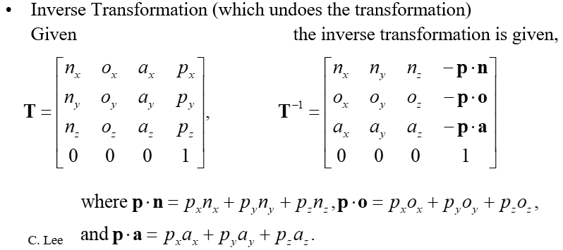

In order to solve for T-1.

* 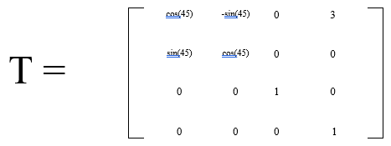

|  |  |  |  |  |  |
| --- | --- | --- | --- | --- | --- |
|  | cos(45) | sin(45) | 0 | -2.12 |  |
|  | -sin(45) | cos(45) | 0 | 2.12 |  |
|  | 0 | 0 | 1 | 0 |  |
|  | 0 | 0 | 0 | 1 |  |

T-1 =

*note for Inverse Transformation, the last column represents the coordinates of the Old Frame WRT the New Frame.

*for the non-inverse (T), then the last column represents the coordinates of the New Frame WRT the Old Frame.

1. Now we can do T-1 * (1,1,1,w):

|  |  |  |
| --- | --- | --- |
|  | 1 |  |
|  | 1 |  |
|  | 1 |  |
|  | 0 |  |

|  |  |  |
| --- | --- | --- |
|  | 1.41 |  |
|  | 0 |  |
|  | 1 |  |
|  | 0 |  |

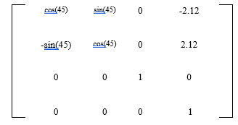

=

x

**Solution: (1,1,1) in old frame = (1.41, 0, 1) in new frame.**

(d) Find the inverse matrix for the transformation:

We already calculated this in the previous step:

