The University of Michigan - Dearborn

CECS

Industrial and Manufacturing Systems Engineering Department

IMSE/CIS 381: Industrial Robots

Sample Time allowed 2.00 Hours

Name: ___________________________________________________
Last First Initials

Honor Code:

I HAVE NEITHER GIVEN NOR RECEIVED AID IN THIS EXAMINATION.

SIGNATURE ____________________________________

Instructions:

This examination consists of two parts. The first part is multiple choice and essay questions while the second part is a problem solving questions. The students will start with the first part. Students are allowed during solving the first part to have pens, pencils and erasers only. After finishing the first part, the students must hand it on before taking the second part. The students are allowed to have formula sheet(s) and calculators during solving the second part.

Answer the following questions.

Question # 1 Multiple choice (10 points)

- The arm-and-body of a robot manipulator generally performs which of the following functions in an application?
( ) Orientation, or
( ) Positioning

- A SCARA robot is normally associated with which of the following applications (one answer)
( ) Assembly
( ) Arc welding
( ) Inspection
( ) Machine loading and unloading
( ) Resistance welding

- In robotics, spray painting applications are which of the following?
( ) Continuous path, or
( ) Point-to- point

- Programmable automation is used when the volume of production is relatively low and there are varieties of products to be made.
( ) True
( ) False

- There are three types of rotational joints (R: Rotational, T: Twisting, and V: Revolving) used in the design of robots' joints. Which type of the rotational joints has the axis of rotation perpendicular to the axes of the connecting links?
( ) Rotational
( ) Twisting
( ) Revolving

- The accuracy of a robot varies within its work volume, tending to worse when the arm is closer to the robot's base and improves as the arm moves to the outer range of the work volume
( ) True
( ) False

- A cylindrical configuration robot consists of the following:
( ) A rotating base, a column, and a horizontal arm
( ) A rotating base, a telescopic arm, and a column
( ) Three links pivoted with each other.

- The purpose of forward transformation in robot kinematics is to determine:
( ) the coordinates of the end point in the world coordinate system
( ) the coordinates of the end point in joint coordinate system
( ) the coordinates of the end point in the cylindrical coordinate system.

- Vacuum cups are used as the primary grippers in robotics when the object has any of the following configurations?
( ) Flat perforated surface
( ) Sheet metals or flat glass plates
( ) Complex shapes such as curved and spherical surfaces

- Who is the inventor of robots in USA?
( ) George Dovel
( ) Joseph Engelberger
( ) Isaac Asimov

Question # 2 (10 points)

Define the following terms in relation to robotics applications
- Robot work volume

- Load Carrying capacity

- Spatial resolution

- Repeatability

Question # 3 (20 points)

- What is meant by reverse transformation in robotics kinematics?

2. What is the difference between an open-loop positioning control system and a closed-loop positioning system? Under what circumstances is the closed-loop positioning system preferable to an open-loop system.

3. What are the advantages and disadvantages of using suction-cup grippers in robotics applications?

- What are the three basic types of drives used in robotics? State the advantages and disadvantages of one (ONLY) of the three types.

Question # 4 (10 points)

- What are the basic robot configurations?

- Which configuration fits the best for each of the following characteritics?
- Reach

- Left capacity

- Machine loading

- Assembly

- What are the basic categories of tactile sensors? What are the uses of each category?

Question # 5 (15 points)

A TLR robot has a rotational joint (R) whose output link is connected to the wrist assembly. Considering the design of this joint only, the output link is 30.00 inches long, and the total rang of rotation of the joint is 60 degrees. The spatial resolution of this joint is expressed as a linear measure at the wrist and is specified to be 0.04 inches. It is known that the mechanical inaccuracies in the joint has a normal distribution with a standard deviation of 0.006 degrees of rotation. It is assumed that the output link is perfectly rigid so as to cause no additional errors due to deflection.
- Determine the minimum number of bits required in the robot's control memory in order to obtain the spatial resolution specified.

- Determine the linear repeatability of this axis.

Question # 6 (10 points)

A part weighing 25 lb is to be held by a gripper using friction against four opposing fingers. The coefficient of friction between the fingers and the part surfaces is estimated to be 0.25. The orientation of the gripper will be such that the weight of the part will be applied in direction parallel to the contacting finger surfaces. A fast work cycle is anticipated so that the g factor to be used in force calculations should be 3.0. The factor of safety is 1.5. Compute the required gripping force for the specification given.

Question # 7 (15 points)

Consider a TRL:R robot (shown in the figure below) with the following setting :

Length of base link L₁ = 20.00 in.
Length of extension link L = 30.0 in
Length of the wrist L₄ = 6.00
Base angle θ = 10.0 º
Elevation angle φ = 30.0 º
Pitch angle ψ = 30.0 º

Determine the coordinates of the point in the world coordinate that can be reached by this particular setting.

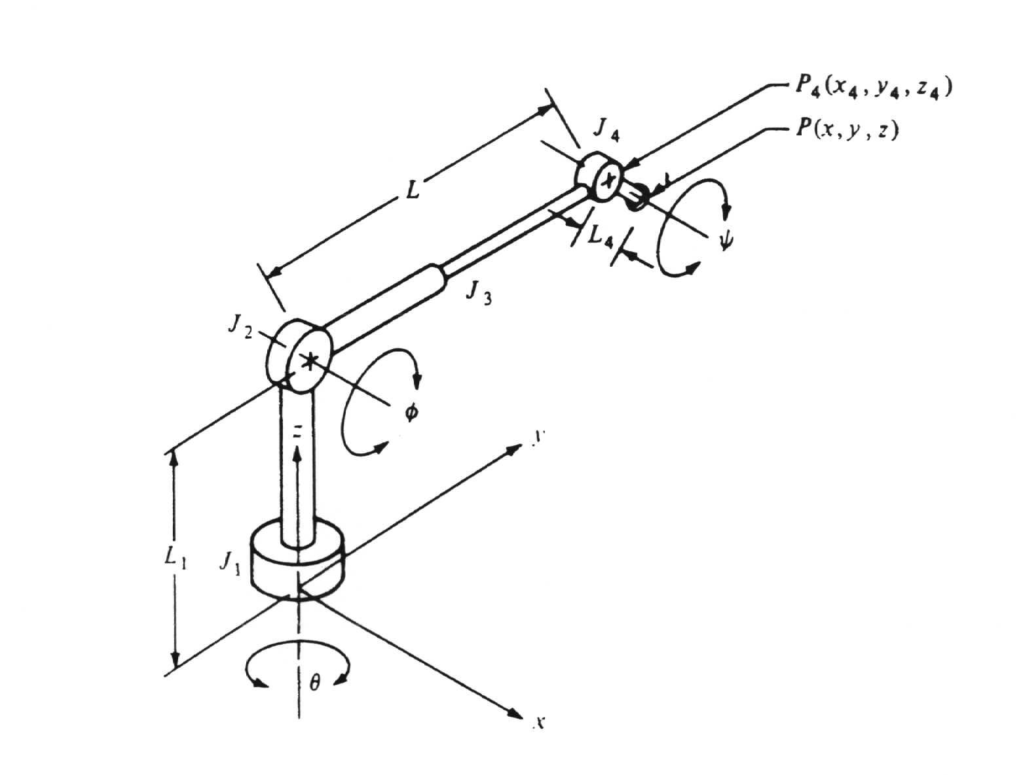

Question # 8 (10 points)

In your laboratory project, you are using three parts made of steel and each has a square base 2.00 inches on a side. The parts have different heights. The height of the first part is 1.0 in., the second is 1.25 in., and the third is 1.5 inches. The parts travel from the part feeder to the robot on a conveyor. You want to classify the parts based on their heights. Each category of parts having the same height will be picked up by the robot and placed in a bin assigned to it in your work cell. Design a sensor system to be used to classify the parts. Illustrate your answer with simplified sketches.

