Homework assignment 4, CIS 427, Fall 2022

**Submission Due: 11:59PM, Nov/29/2022.**

1. (20 points)

A message 1110 0101 0001 1011 is transmitted using the Internet checksum (using 4 bit words). What is the resulting 20 bits message if the internet checksum is put to the end of the message.

1. (30 points, 15 points each)

Suppose three active nodes—nodes A, B, and C—are competing for access to a channel using slotted ALOHA. Assume each node has an infinite number of packets to send. Each node attempts to transmit in each slot with probability p. The first slot is numbered slot 1, the second slot is numbered slot 2, and so on.

* 1. What is the probability that node A succeeds for the first time in slot 5? Hint: Node A succeed for the first time in slot 5 means: (1) A doesn’t succeed for the first 4 slots; and (2) A succeeds in slot 5.
  2. What is the probability that the first success occurs in slot 3? Hint: The first success occurs in slot 3 means no nodes succeed in the first two slots and one node succeeds in slot 3.

1. (30 points) Consider the arrangement of learning bridges shown in the following figure. Assuming all are initially empty, give the tables for each of the bridges B1-B3 after the following transmissions: (1) A sends to B; (2) D sends to B; (3) X sends to D; (4) Y sends to A; (5) F sends to Y; (6) E sends to X;

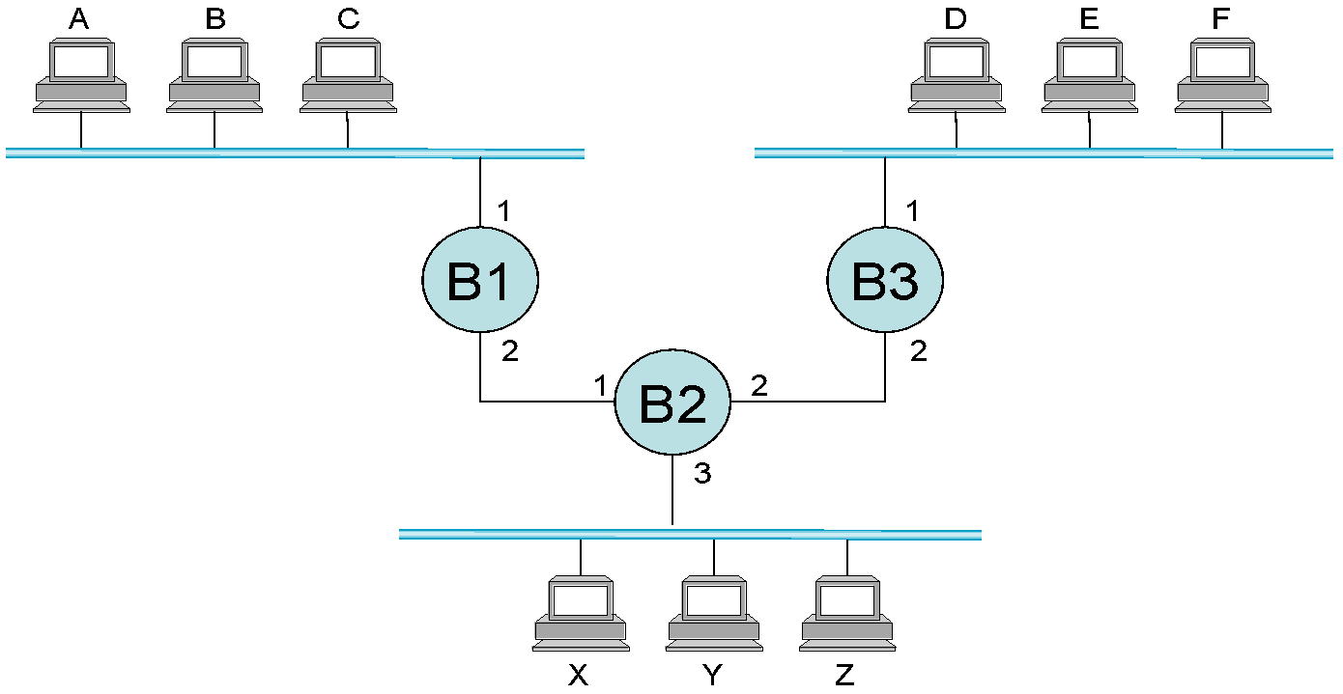

Your answer should look like:

Switch B1: device A, port 1; device X, port 2;

Switch B2: device E, port 2; device C, port 1;

...

1. （20 points, 10 points each）In the graph below, the circles with a cross denote a router and the squares with a cross denote a switch. From left to right we name them S1, R1, S2, R2, S3. The MAC addresses and IP addresses for the interfaces at Host A, both routers, and Host F are given as Mac(device), IP(device), where device can be A, R1, R2, and F.

1. Suppose Host A sends a datagram to Host F. Give the source and destination MAC addresses in the frame encapsulating this IP datagram as the frame is transmitted (i) from A to the left router, (ii) from the left router to the right router, (iii) from the right router to F. Also give the source and destination IP addresses in the IP datagram encapsulated within the frame at each of these points in time.
2. Suppose that all the links between a computer and a switch are 100Mbps, the links between switches and routers are 500 Mbps. How fast can data be transmitted from Subnet 3 to subnet 1 (i.e., any computer in Subnet 3 can be the sender and any computer in subnet 1 can be the receiver)? If we replace S1 with a hub, how fast can data be transmitted from Subnet 3 to subnet 1 now?