This application is a website that provides solutions for optimizing your site for search engines. These solutions are provided by Horiseon.

The URL for the deployed application:

<https://meeday.github.io/Bootcamp-Assignments/Code-Refactoring/Solution/>

This assignment required me to refactor the coding according to the criteria proposed.

One of the criteria is that the source code uses semantic HTML tags.

To meet these criteria:

* I changed the <div> tags into the tags:

<header>

<nav>

<img>

<main>

<section>

<aside>

<footer>

this is highlighted in **GREEN** in the following snapshots

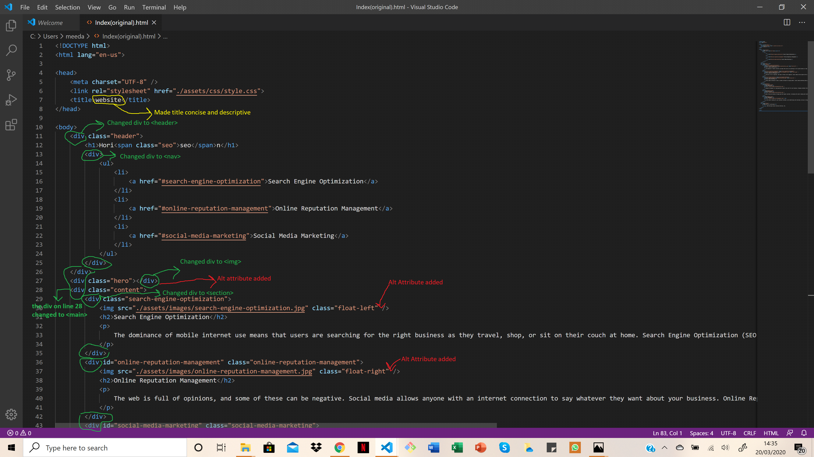

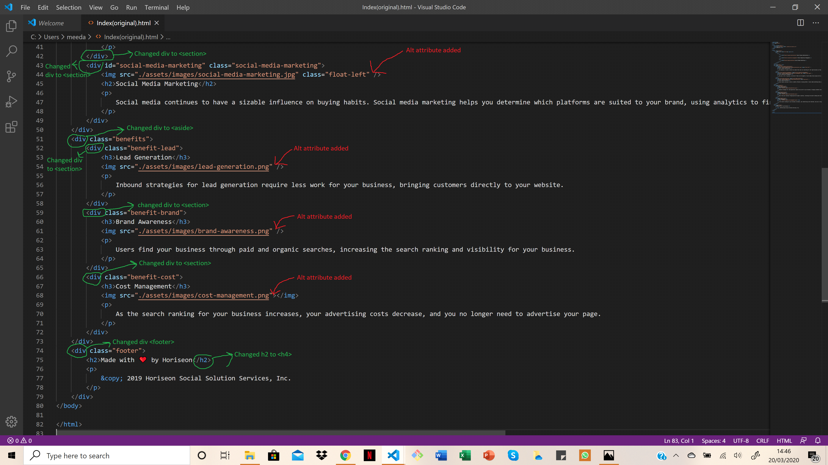

* I added alt attributes to all the images: Shown in **RED** in the above snapshots
* all the heading attributes fall in sequential order except for the heading found within the <footer> tags so I changed that to an <h4> tag (shown in **GREEN** in the above snapshots.
* I also added a concise and descriptive title based on what I understood from the contents of the website Shown in **YELLOW** in the above snapshot. I used the Optimal format provided on: [**https://moz.com/learn/seo/title-tag**](https://moz.com/learn/seo/title-tag)

Primary Keyword - Secondary Keyword | Brand Name

* I found that the elements followed a logical structure independent of styling and positioning so I left the html as it was, However the CSS was longer than was necessary therefore I consolidated some styling in one line of code; there are comments on the CSS file that detail these changes.