


Module Code & Module Title
Level 5 – Network Operating Systems

Assessment Type
Logbook 9
Semester
2023/24 Spring/Autumn

Student Name: Dikshya Sharma
London Met ID: 22067520
College ID: NP01CP4A220029
Assignment Due Date: Monday, December 25, 2023
Assignment Submission Date: Monday, December 25, 2023
Submitted To: Dipeshor Silwal
Word Count (Where Required): 788

I confirm that I understand my coursework needs to be submitted online via Google Classroom under the relevant module page before the deadline in order for my assignment to be accepted and marked. I am fully aware that late submissions will be treated as non-submission and a mark of zero will be awarded.

Table of Contents
To Install Active Directory Domain Services
1.Aim……………. 1
2.Objectives……. 1
3.Steps………….. 1
3.1.Step 1… 1
3.2.Step 2… 2
3.3.Step 3…. 3
3.4.Step 4… 4
3.5.Step 5… 5
3.6.Step 6.. 6
3.7.Step 7.. 7
3.8.Step 8.. 8
3.9.Step 9.. 9
3.10.Step 10 10
3.11.Step 11 11
3.12.Step 12 12
3.13.Step 13 13
3.14.Step 14 14
3.15.Step 15 15
3.16.Step 16 16
3.17.Step 17 17
3.18.Step 18 18
3.19.Step 19 19
4.Conclusion…… 23

Table of Figures
Figure 1: Server Manager Dashboard. 1
Figure 2: Roles And Features Window 2
Figure 3: Installation Type 3
Figure 4: Destination Server 4
Figure 5: Server Roles 5
Figure 6: Features 6
Figure 7: Active Directory Domain Service Window 7
Figure 8: Installation Confirmation 7
Figure 9: Installation 8
Figure 10: Successful Installation 8
Figure 11: Server Manager Dashboard 9
Figure 12: Notification Icon 10
Figure 13: Deployment Confirmation. 11
Figure 14: Domain Controller Options. 12
Figure 15: Dns Options. 13
Figure 16: Netbios Domain Name. 14
Figure 17: Ad Ds Path 15
Figure 18: Review Options. 16
Figure 19:Prerequites Checking. 17
Figure 20: Installation. 17
Figure 21: Server Restarted. 18
Figure 22: Administrator. 18
Figure 23: Powershell. 19

To Install Active Directory Domain Services

Aim
The Aim of this logbook is to document the process of installation of Active Directory Domain Services on Windows Server.

Objectives
The objectives of this logbook are:
- To setup active directory domain controller.
- To install an active directory domain service role on windows server.
- To configure installed active directory service role as domain controller.

Steps
The following steps took place during the installation.

Step 1
The system was logged in to Windows Server 2022 as an administrator and Server Manager was opened.
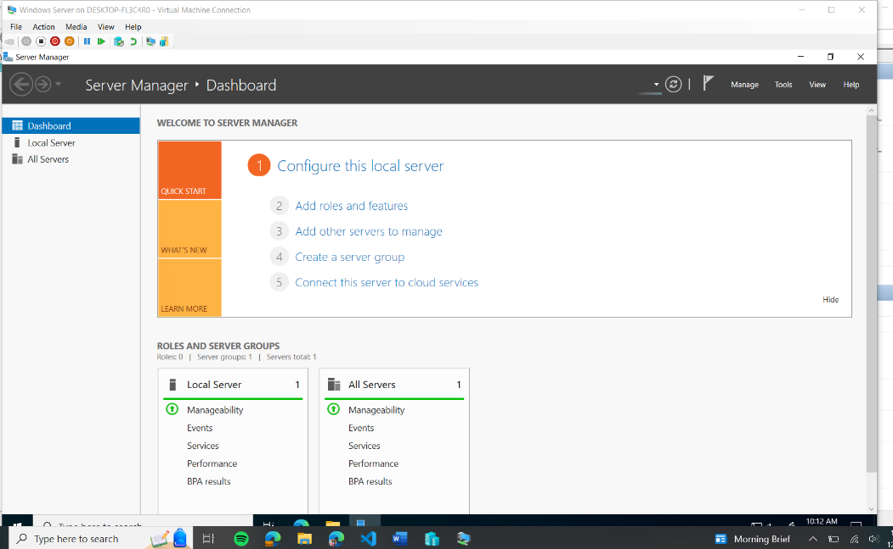
Figure 1: Server Manager Dashboard.

Step 2
“Add Roles and Features” option was clicked from the Server Manager which opened the Add Roles and Features Wizard.
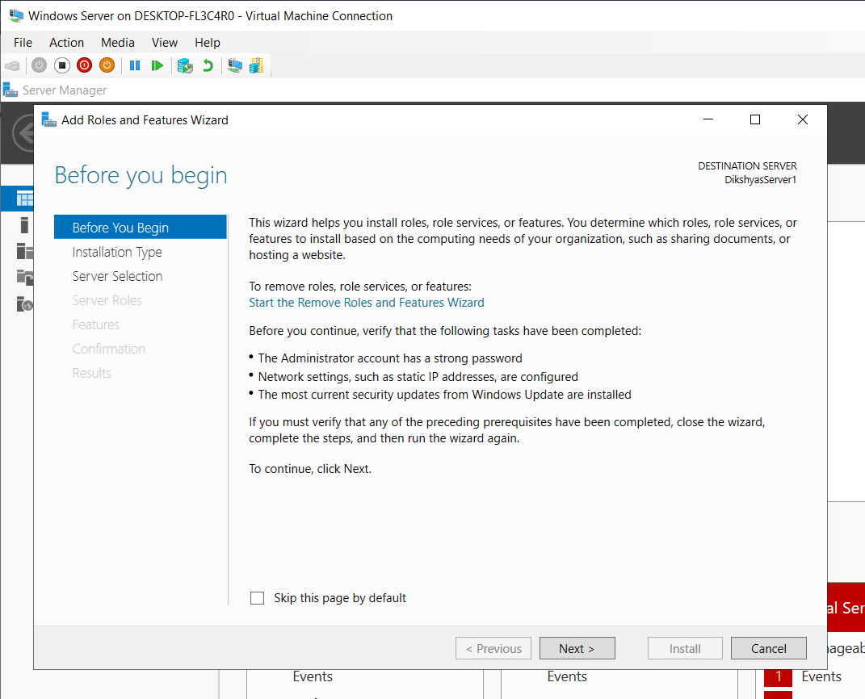
Figure 2: Roles and Features Window

Step 3
After next button was clicked, Installation type was selected to “Role based or feature based installation”.
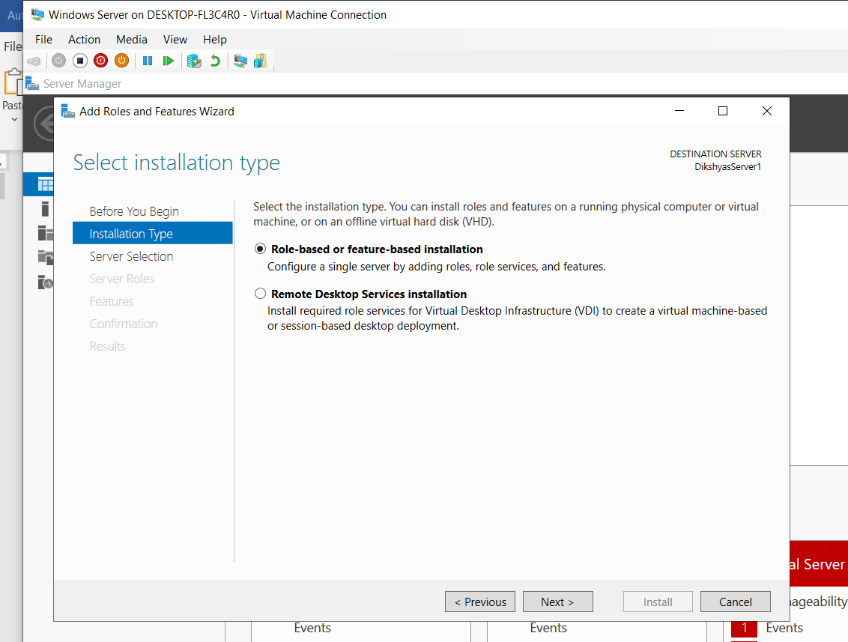
Figure 3: Installation Type

Step 4
Following that, destination server wizard was opened to select the destination which selected as “Select a server from the server pool”.
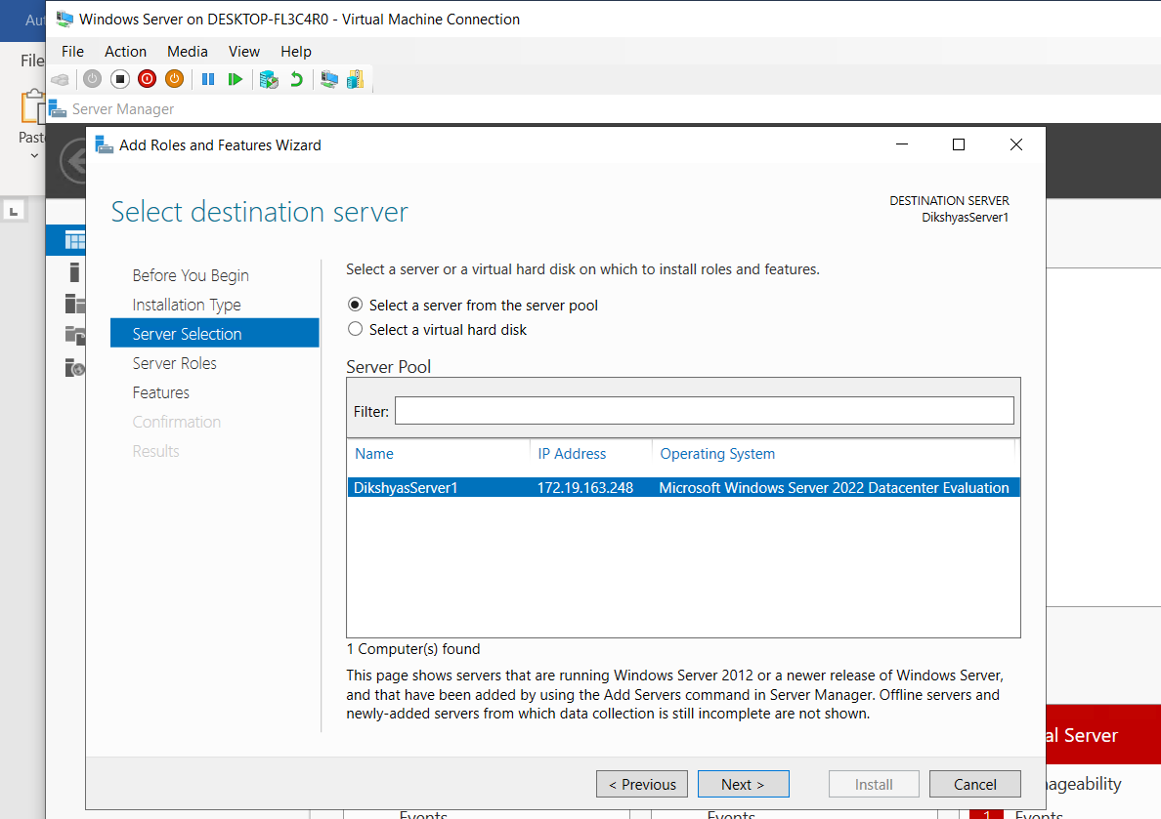
Figure 4: Destination Server

Step 5
From Select server roles menu, “Active Directory Domain Services” was selected.
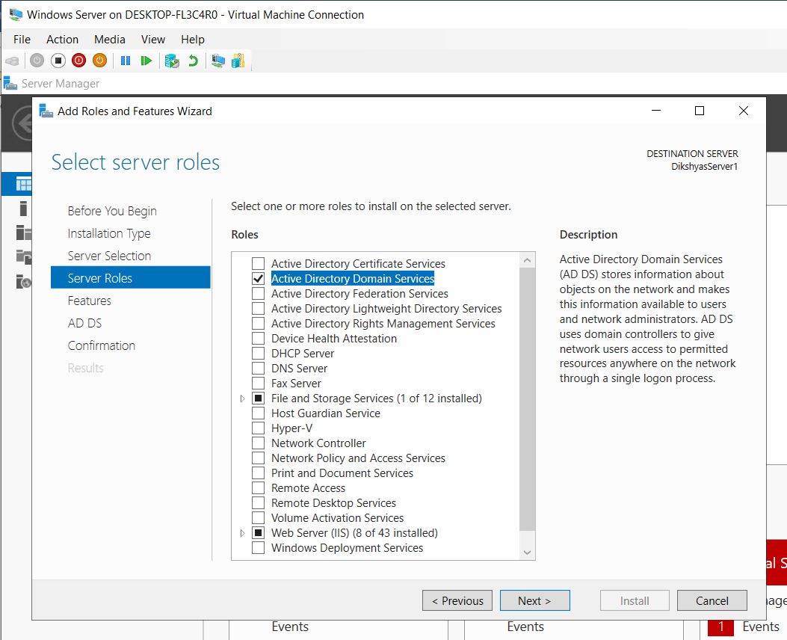
Figure 5: Server Roles

Step 6
Following that, Features was selected to “.NET Framework 3.5 Features”.
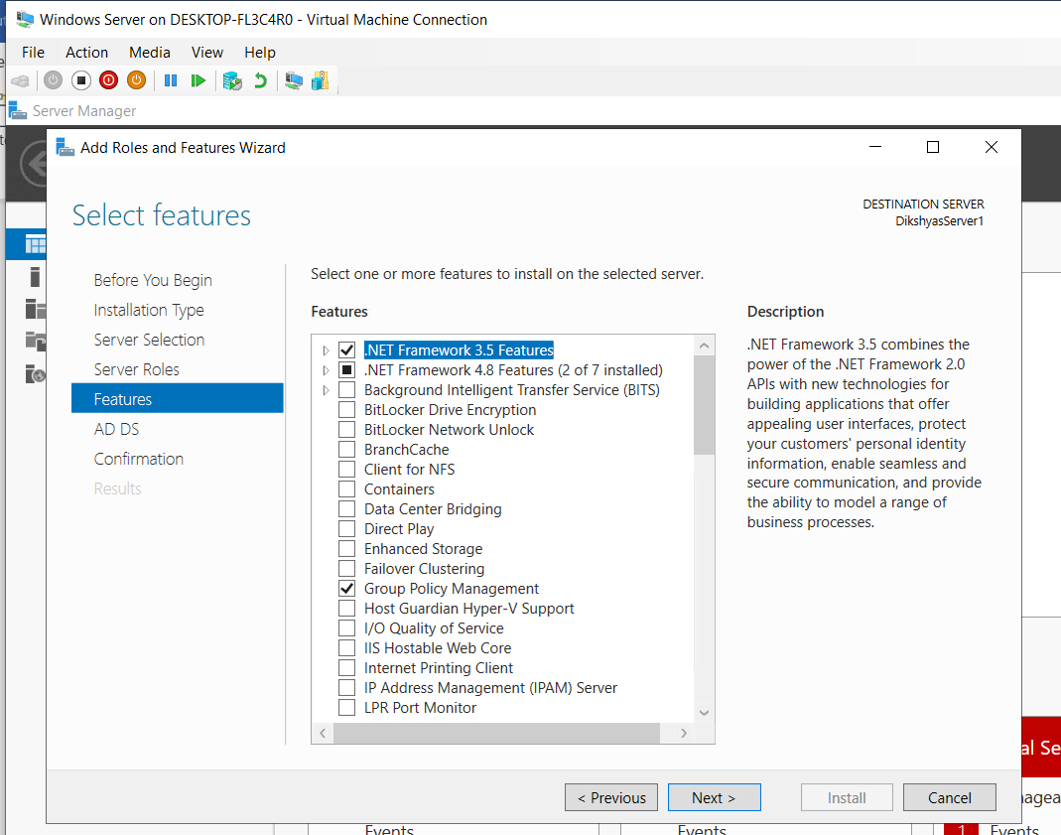
Figure 6: Features

Step 7
Following that, the other options was set to default and next button was clicked.
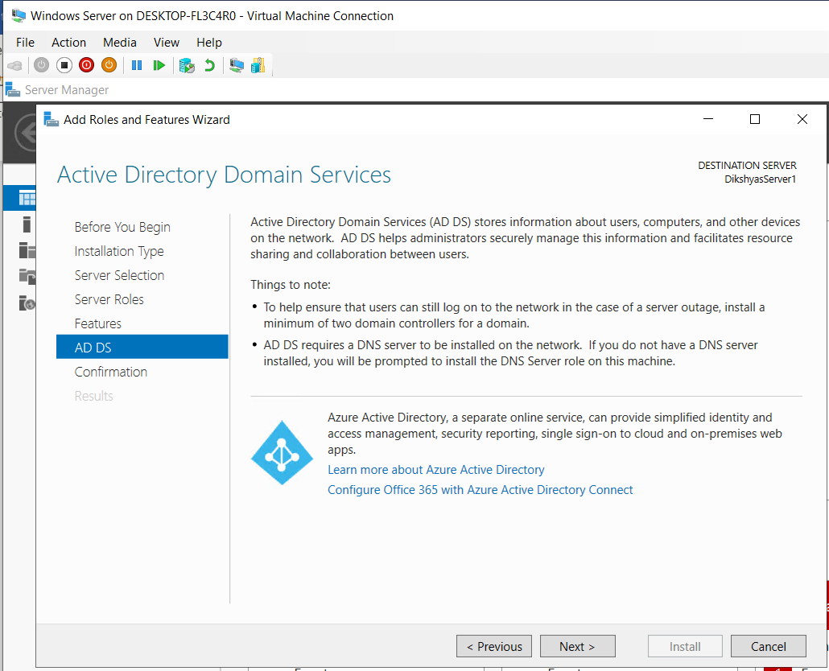

Figure 7: Active Directory Domain Service Window
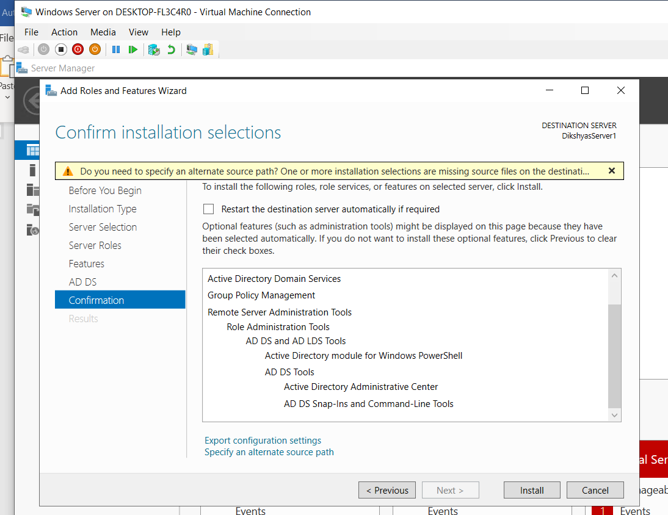
Figure 8: Installation Confirmation

Step 8
Then, “Install” button was selected to start the installation.
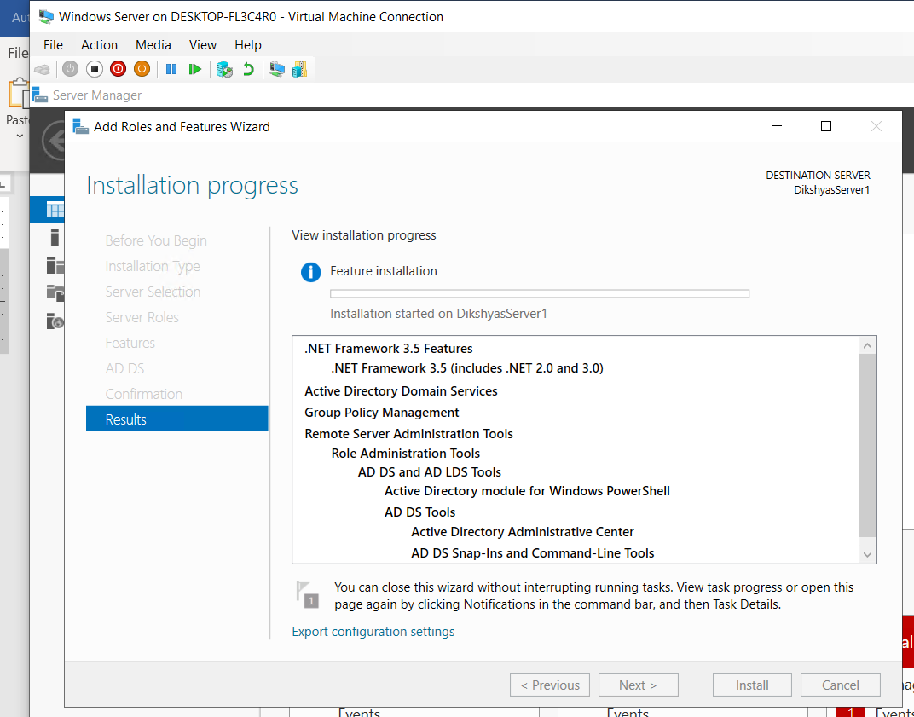

Figure 9: Installation

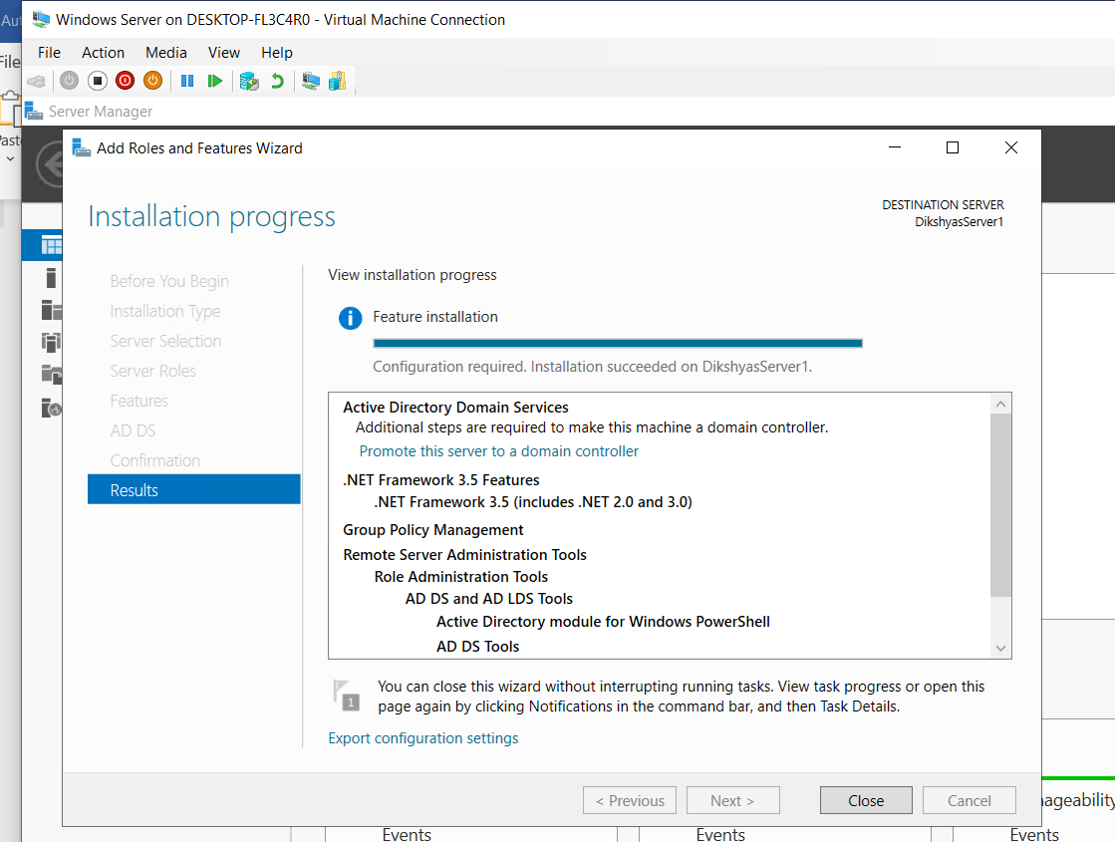
Figure 10: Successful installation

Step 9
After successful installation, close button was selected, and server manager dashboard was opened.
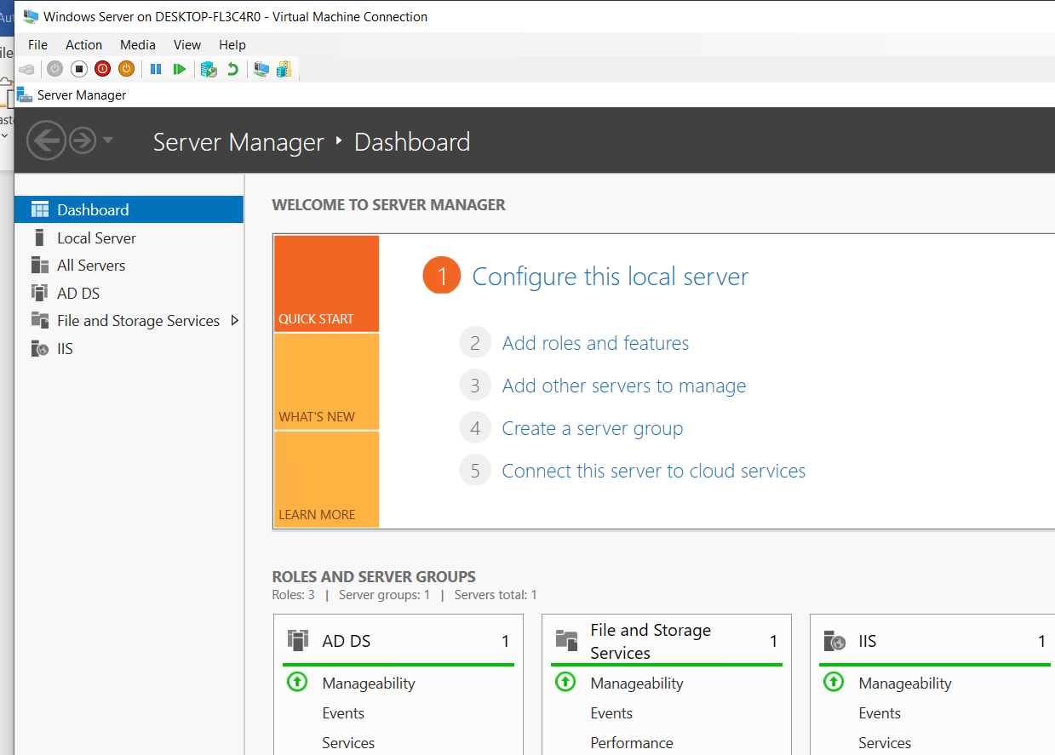
Figure 11: Server Manager Dashboard

Step 10
Following that, yellow notification icon that was seen on the right side of server manager dashboard was clicked and again “promote this server to the domain controller” option was selected.
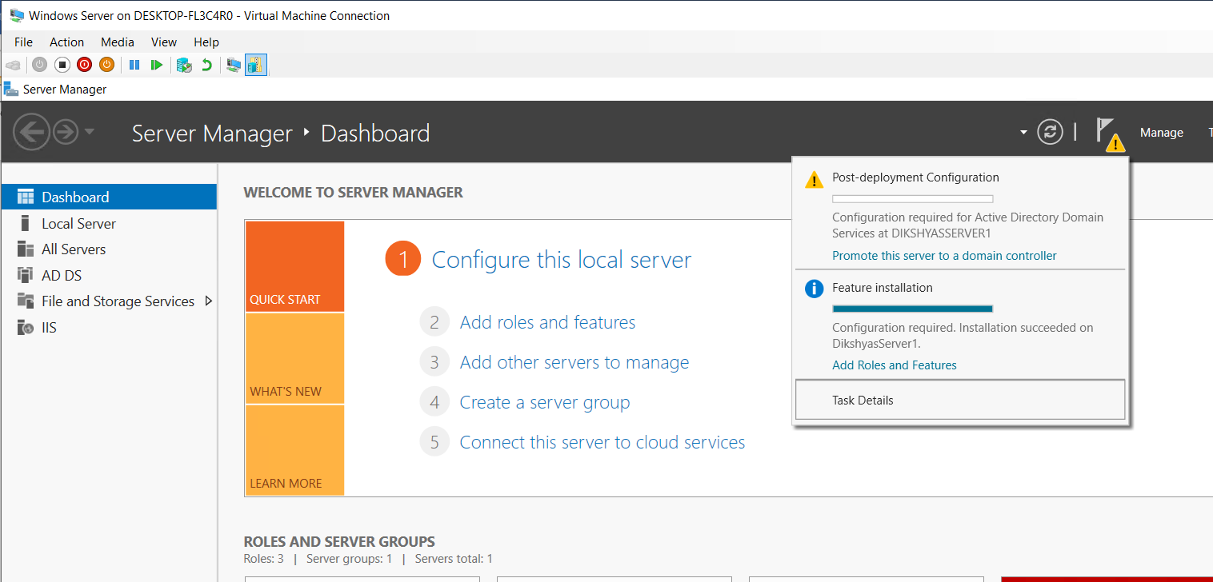
Figure 12: Notification Icon

Step 11
Following that, Deployment Configuration Page was opened. Then, deployment operation was selected to “Add a new forest” and root domain name was given as “dikshya.com”.

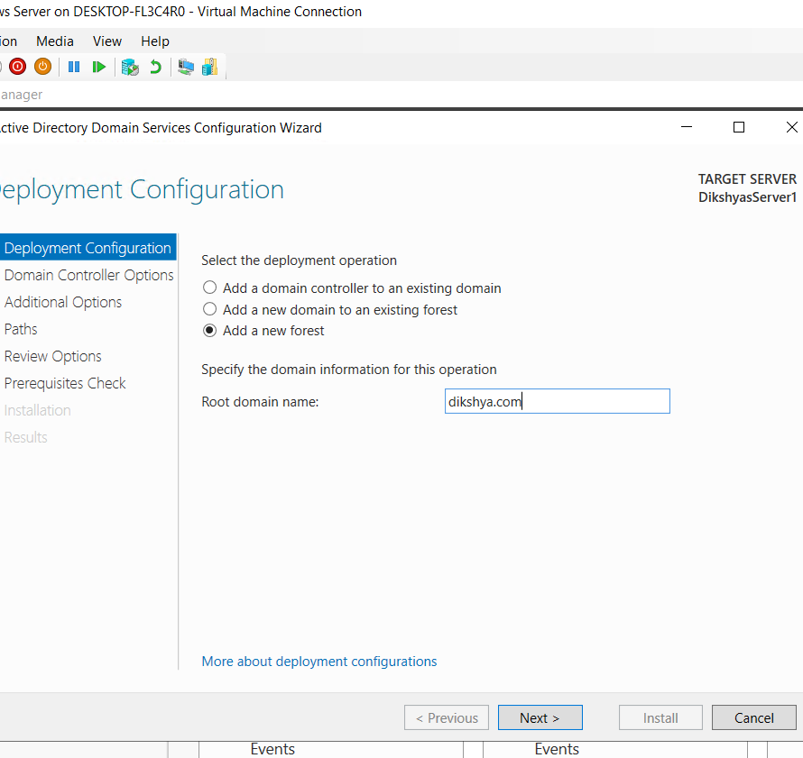
Figure 13: Deployment Confirmation.

Step 12
Then, Domain Controller Options page was opened where password was confirmed.
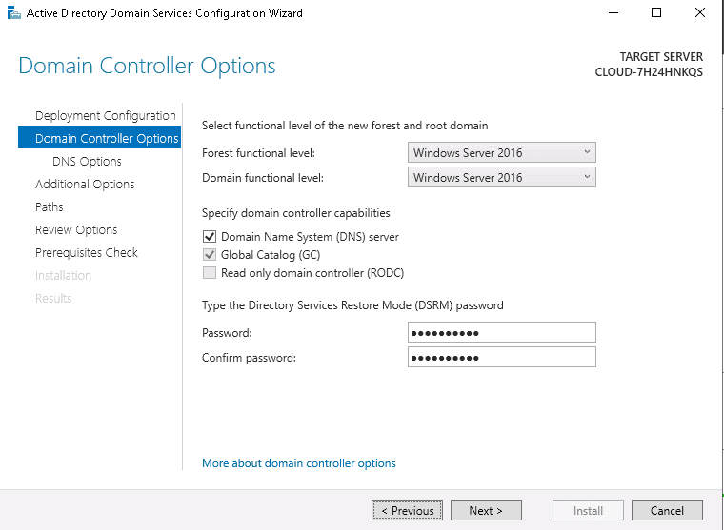
Figure 14: Domain Controller Options.

Step 13
After successfully defining the directory service mode password next button was clicked which opened the DNS options page which was set to default.
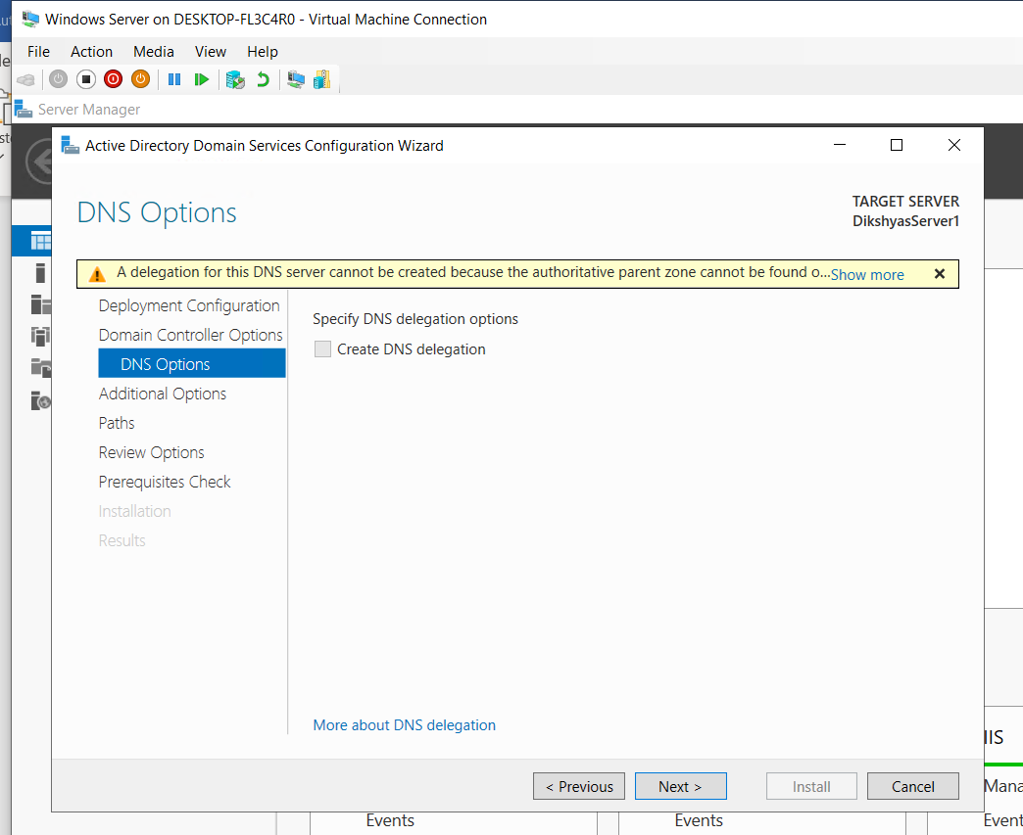
Figure 15: DNS Options.

Step 14
Then, NetBIOS name was shown by default.
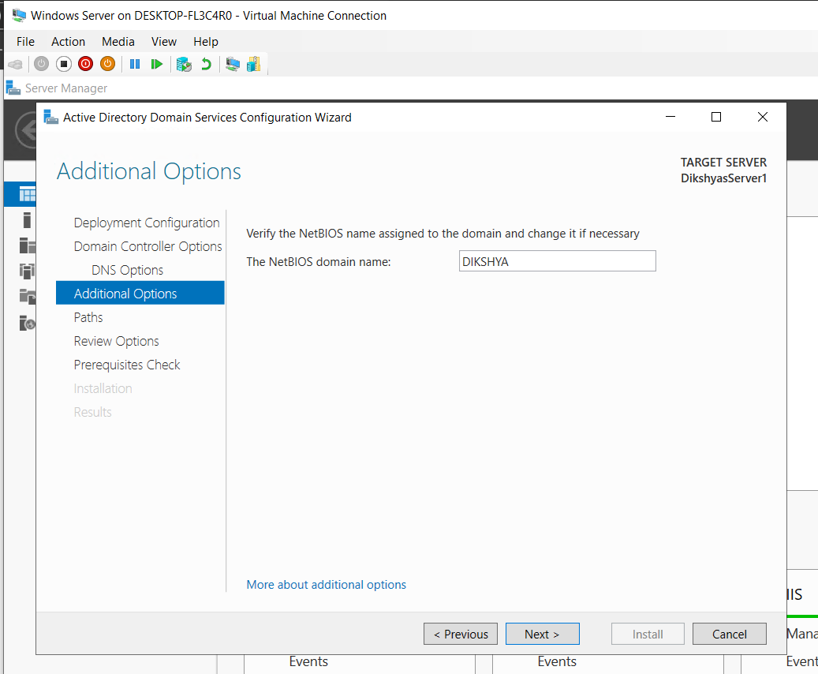
Figure 16: NETBIOS domain name.

Step 15
After that, AD DS database path location was set to default.
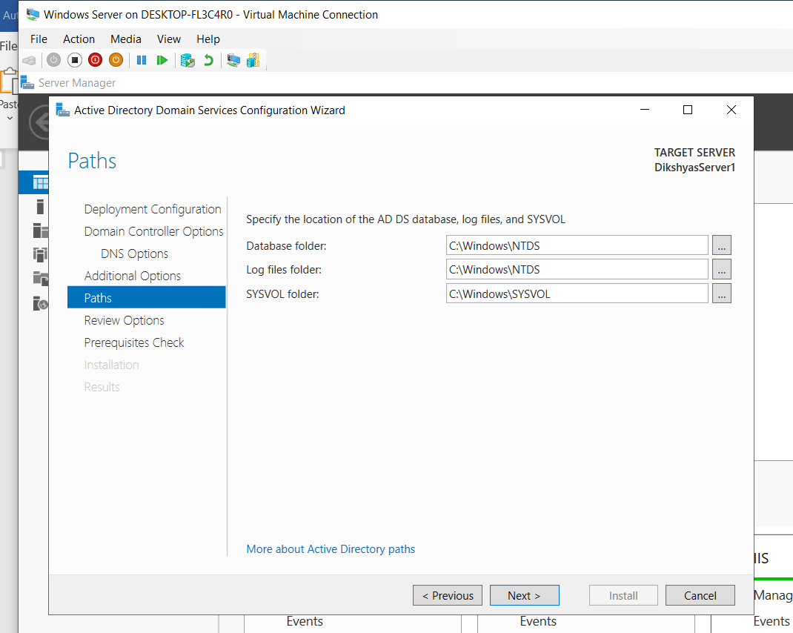
Figure 17: AD DS Path

Step 16
Then, Review options page was opened to review the options selected.
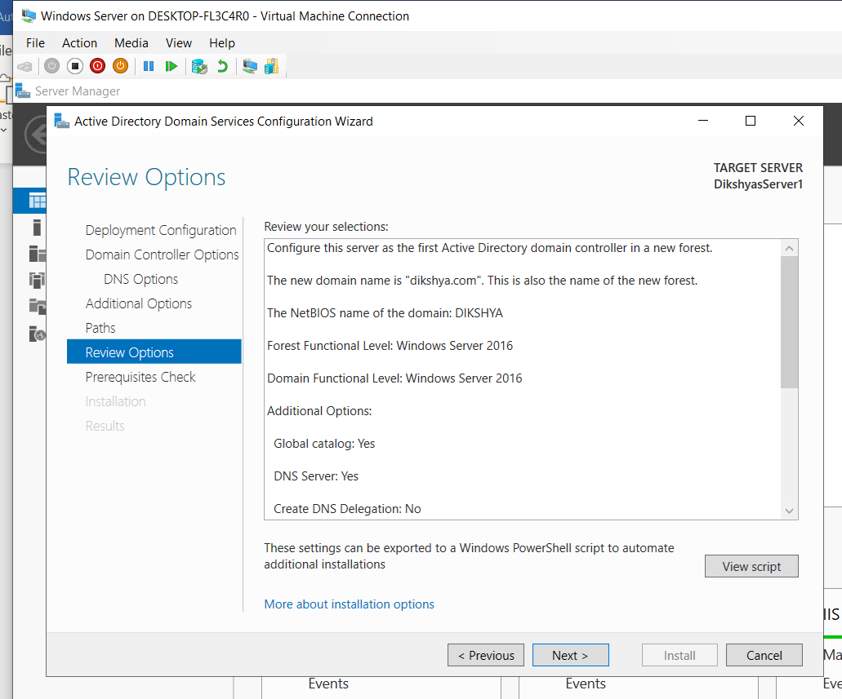
Figure 18: Review Options.

Step 17
After it was reviewed, the prerequisites check page was opened and then checked which was then followed by installation.
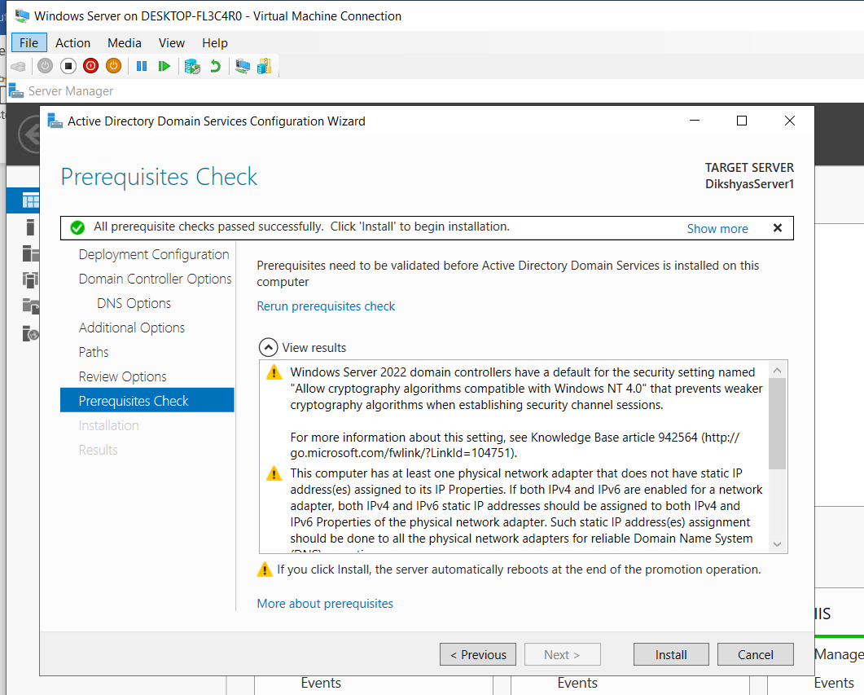
Figure 19:Prerequites checking.
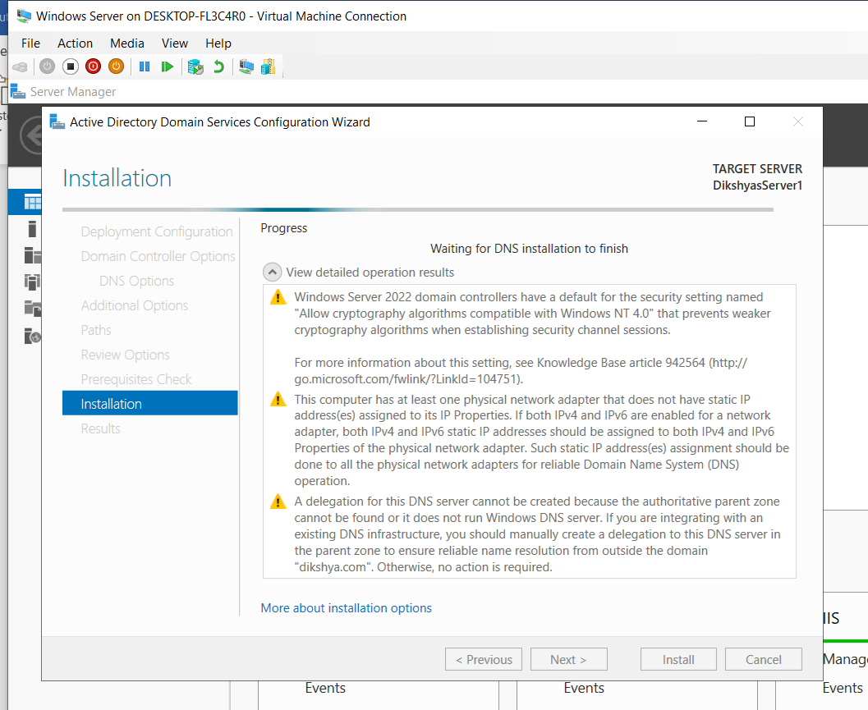
Figure 20: Installation.

Step 18
After installation, the server was restarted.
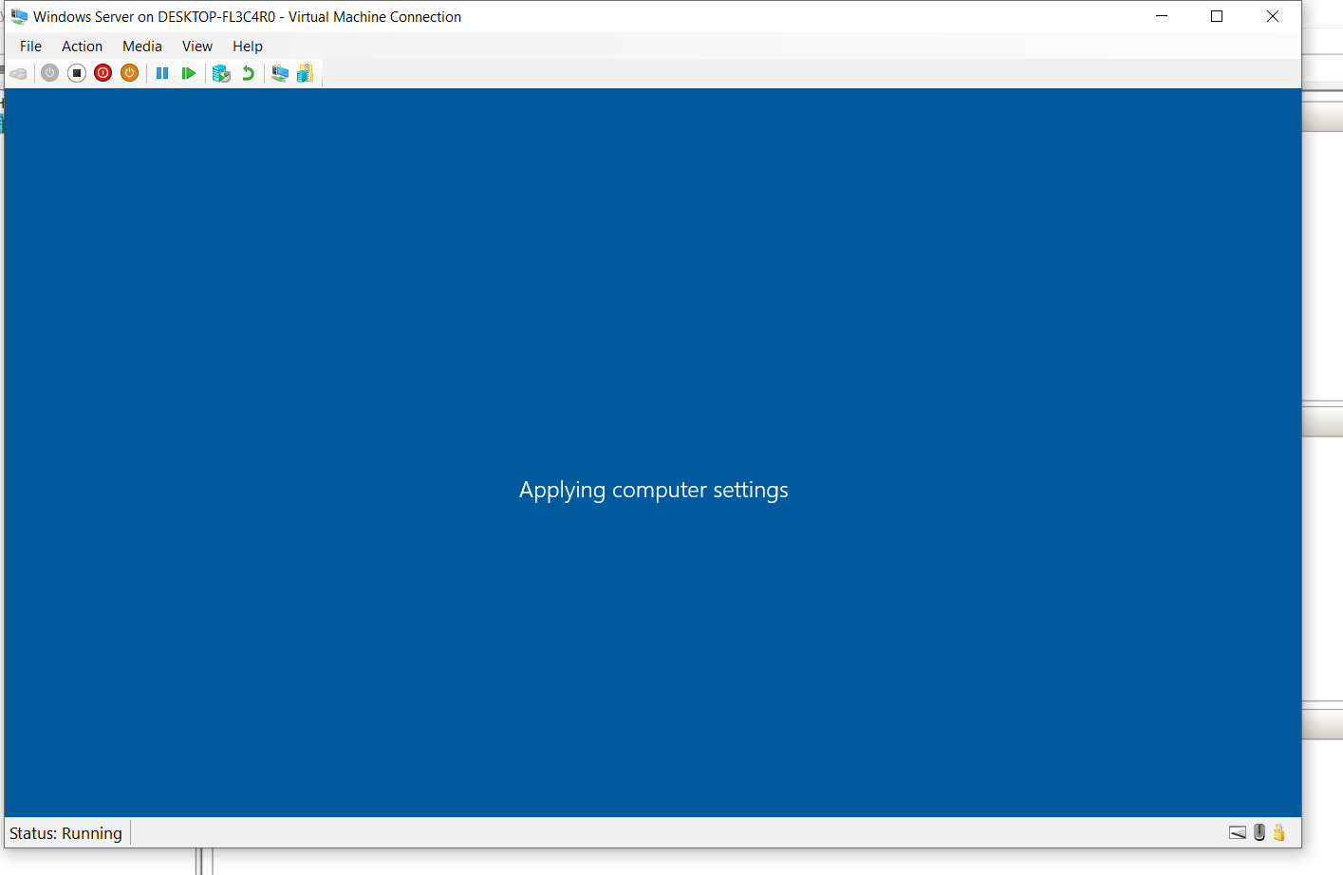
Figure 21: Server Restarted.
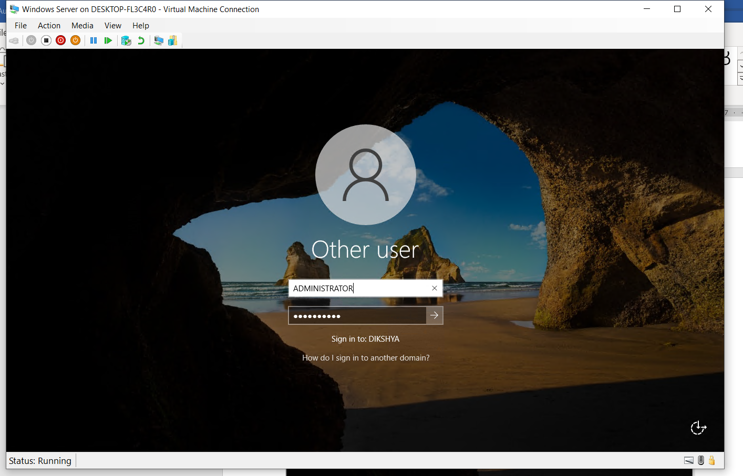
Figure 22: Administrator.

Step 19
Then, Domain controller verification was started to check if it was adequately set or not through PowerShell.
Below are the steps performed.
To confirm the successful installation of the services, the following command was run on Windows PowerShell.
“Get-Service adws,kdc,netlogon,dns”
The command showed the status of all services.
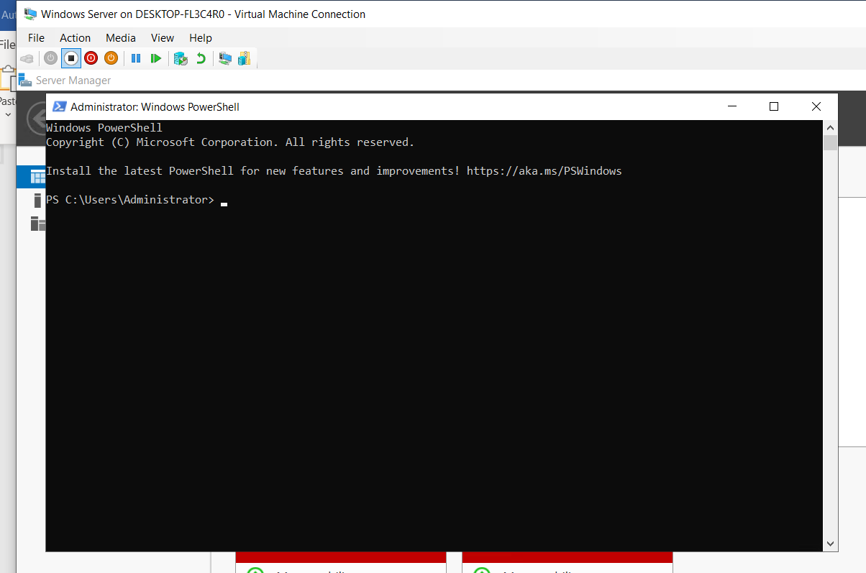
Figure 23: Powershell.

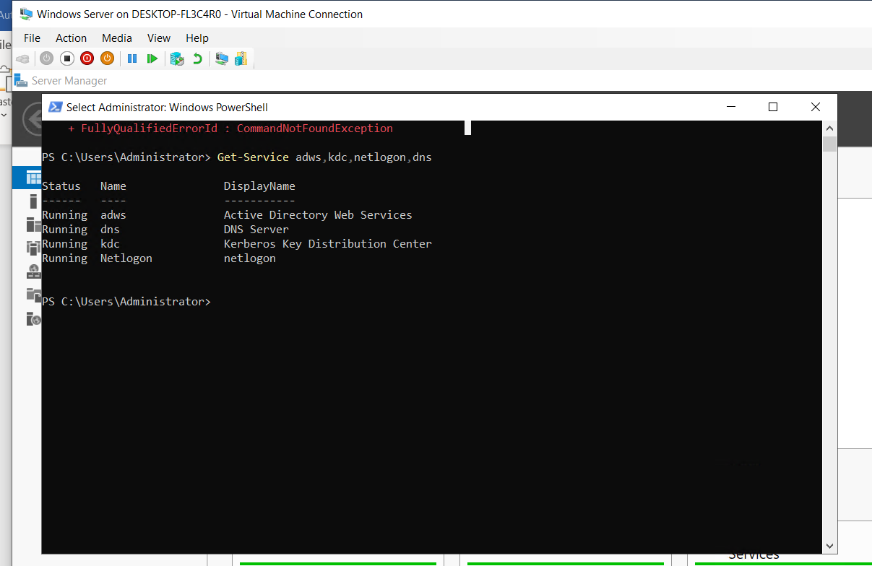

Again, to display all the configuration details of the domain controller, following command was run.
“Get-ADDomainController”
It displayed all the information on the following screen:
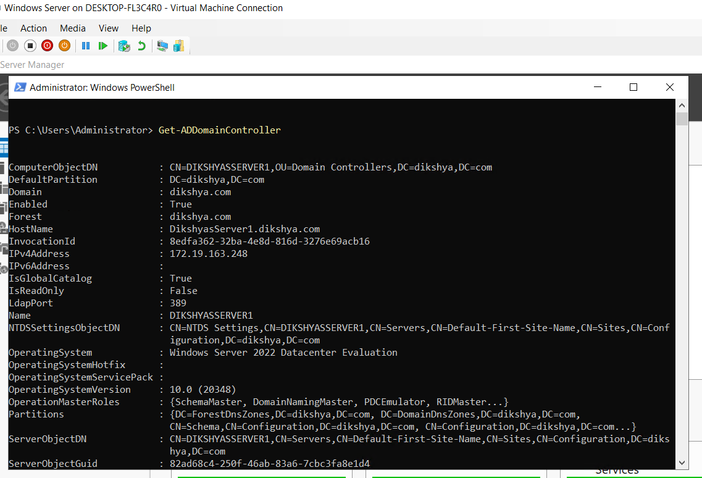
Then, to get detailed information about your domain, following command was run.
“Get-ADDomain mydomain.com”
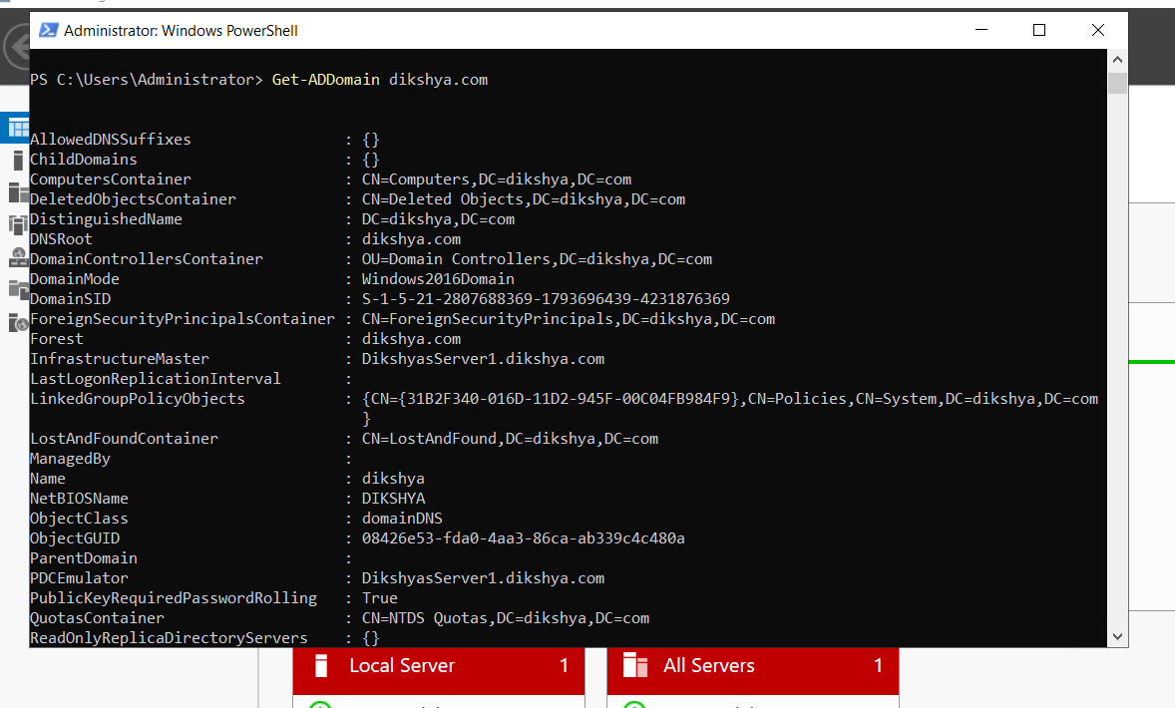

Following that, to display your Active Directory Forest details, following command was run.
“Get-ADForest dikshya.com”
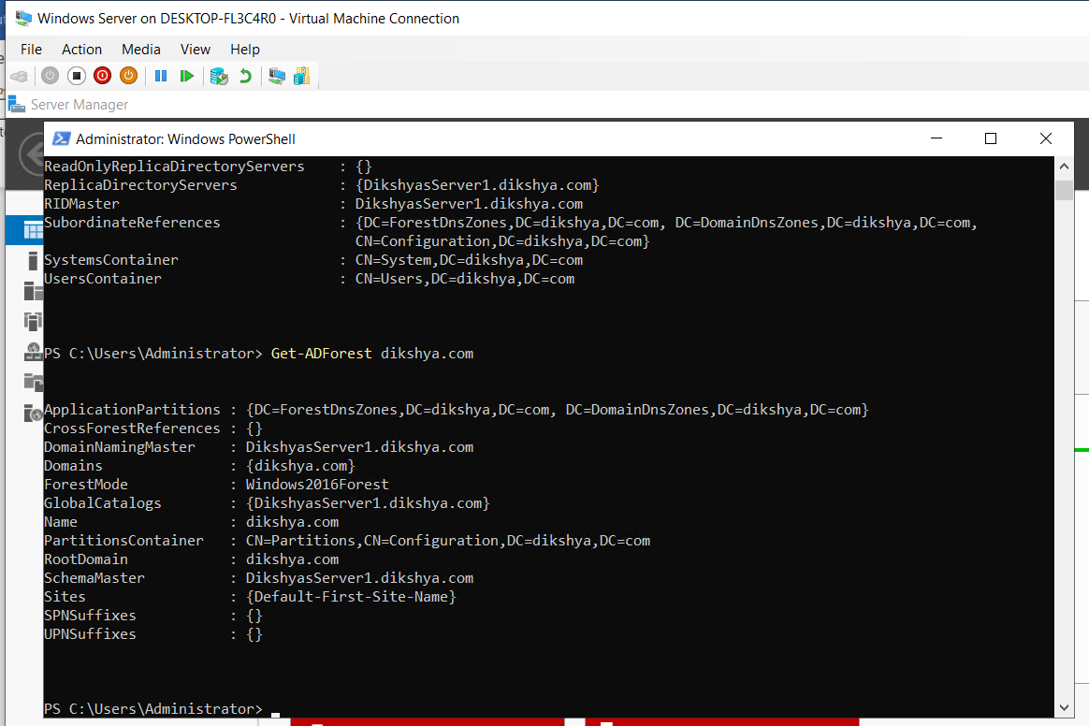

Conclusion
To sum up, the installation of active directory domain service on windows server 2022 was successfully completed following the systematic process. This logbook serves as a comprehensive guide for the installation process as well as record for future reference. The installation process was started by logging in to the windows server and adding several options to it and then verifying the domain controller by running the commands on PowerShell.

