ShopCo Sales Connect

Ridhima Gautam, Meet Patel, Kamaldeep Kaur, Deepthi Rajesh, Srilaxmi Ganjipalli

Course: MGT585: Fundamentals of Business Analytics
Chicago, March 2025

Table of Contents

1. EXECUTIVE SUMMARY 3
2. OBJECTIVE AND QUESTIONS 4
2.1. Project purpose 4
2.1.1. Objective of the project 4
2.1.2. Questions 4
2.1.3. Experiment 4
3. DATA ANALYSIS AND RESULTS 4
3.1. Descriptive Analytics 4
3.2. Predictive Analytics 6
3.2.1. Regression Analysis 6
3.2.2. Clustering analysis 9
4. RECOMMENDATIONS AND CONCLUSION 10

EXECUTIVE SUMMARY (Ridhima Gautam)
“ShopCo Sales Connect” is a Project to analyse the different categories of customers and draw relationship between age and sales.
We have data for 9051 customers out of which around 76% are women and 24% are men with average age of 30.6 years and 32.5 years approximately.
Gender | Number | Average Age
Females | 6913 | 30.6 years
Males | 2138 | 32.5 years
We ran an experiment on 1188 customers to figure out the impact of real time messages on second store sales. 644 customers received the message and the rest 544 did not.
We ran regression analysis and did clustering analysis to conclude that age is a major factor that influences spending, and since older people have more buying power, they are the highest spenders.
Age influences the sales by 28% however, Real-time messages only have a 1.18% influence on the second store's sales.
We can categorize our customers as Young Medium-Spenders, Older High- Spenders & Young Low- Spenders.
Our suggestion is to work out marketing strategies that target different age groups in a unique manner. It is also advised to experiment with the content and personalization of these real-time messages to be able to optimise them for better results. Tracking the performance of these new and enhanced marketing strategies regularly will help us tailor them precisely.
For the younger customers, we must launch gamified promotions with rewards, offer bundles and deals; also, working on the social media presence of ShopCo would impact the sales directly.
As for the older people who are already the highest spenders, we need to focus on retention by upscaling the product lines, offering loyalty incentives and improving the in-store experience.

OBJECTIVE AND QUESTIONS (Kamaldeep Kaur)

Project purpose

Objective of the project
To understand the role of real-time mobile messages on customer’s purchase behavior.

Questions
- Do real time mobile messages lead to the consumer making a second purchase?
- If they didn’t receive a message, do they still make a second purchase?
- How many consumers were able to receive the messages?
- Does age have an affect on the shopping trends?

Experiment
The mall operator is interested in knowing the impact real time promotional messages have on the second purchase by the customers the same day, irrespective of the amount spent. Hence, at ShopCo, an experiment was conducted in the week of Oct 1, 2024, when a group of 9051 consumers received real-time mobile messages promising 1000 loyalty points right after their first purchase, and the rest did not. This experiment would help the management understand the impact of the current promotional strategy and help figure out the marketing strategies moving forward.

DATA ANALYSIS AND RESULTS

Descriptive Analytics (Kamaldeep Kaur/Srilaxmi Ganjipalli)

Descriptive Analytics provides an overview of dataset by summarizing key variables and presenting statistical measures. This analysis helps in understanding patterns related to customer demographics and purchasing behavior.
Categorical Variables:
The dataset includes categorical variables such as gender and loyality status, with the following distribution.
Gender:
Female: 76.4% (6913 customers)
Male: 23.6% (2183 customers)
Loyalty Status:
High Loyalty: 63.8% (5772 customers)
Low Loyalty: 36.2% (3279 customers)

Categorical Variables
Variable | Frequency distribution
Gender: Male | 2183 males –23.6 %
Gender: Female | 6913 females – 76.4 %
Loyalty status: High | 5772 Customers- 63.8 %
Loyalty status: Low | 3279 Customers –36.2 %
Continuous Variables
Variable | Mean | Standard deviation
Age | 31.2 | 7.1
Purchase (second store onwards) | $35.50 | $9.68
Purchase (real-time messages) | 0.5421 | 0.4984353
Table 1: Descriptive analytics of the variables
1. Age Distribution:
The average age of customers is 31.2 years with a Standard deviation of 7.1 years indicating a varied customer age range.
Older individuals tend to spend more on Additional purchases.

2. Purchasing Trends:

Customers spend on average ( Mean) of $35.50 on purchases beyond their initial transaction, with spending varying by approximately (SD) $9.69.

3. Effect of Real-time Messaging:

Around 54.21% of Customers received real-time promotional messages while the remainder did not.

This descriptive analysis highlights important customer trends, emphasizing the need for more targeted marketing strategies. Younger, low-spending customers may require additional incentives, while real-time messaging strategies should be refined to maximize their impact.

Predictive Analytics (Meet Patel)
There is a positive relationship between age and sales from the second store onwards. An R-squared of 0.2803 depicts the age can explain the variability of sales by 28.03%.
The real-time mobile messages have a positive impact on the sales from second sale onwards but there is not a significant impact. R-squared is 0.01178; that means only 1.178% of the sales can be explained by the real-time mobile messages. The real time mobile messages have a real.

Regression Analysis
The variables that we are trying to predict are:
- Dependent Variable: Spending from Second Store Onwards
- Independent Variable: Age
An R-squared value of 0.2803 indicates that age explains 28.03% of the variability in spending from the second store onwards.
- Age has a significant impact on sales (b = 0.682, p < 0.001).
- The positive coefficient suggests that older customers tend to spend more on additional purchases.
- The model fit is statistically significant with F-statistic = 461.8, p-value < 0.001.
Model Diagnostics:
- R-squared: 0.2803
- F-statistic: 461.8
Regression Model:
Y = 14.735 + 0.682(Age) + e
Visualization:
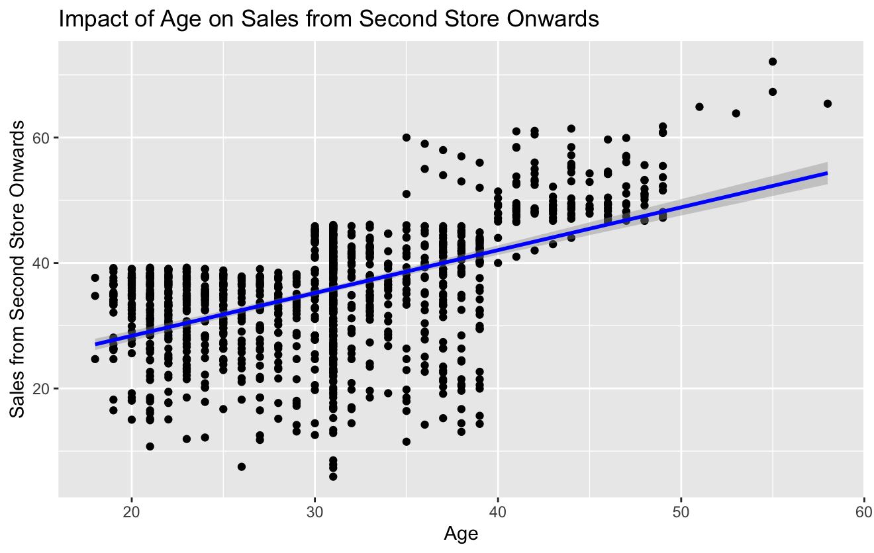
Variable | Regression coefficient | Significance
Intercept | 14.735 | p < 0.05
Age | 0.682 | p < 0.05

Table 2: Results of the regression analysis

Model 2: Spending vs. Real-Time Message
- Dependent Variable: Spending from Second Store Onwards
- Independent Variable: Real-Time Message
An R-squared value of 0.0118 indicates that receiving a real-time message explains 1.18% of the variability in spending from the second store onwards.
- Receiving a real-time message has a significant impact on sales (b = 2.108, p = 0.00018).
- The positive coefficient suggests that customers who received a real-time message tend to spend $2.11 more on additional purchases compared to those who did not receive the message.
- The model fit is statistically significant with F-statistic = 14.14, p-value = 0.00018.
Model Diagnostics:
- R-squared: 0.0118
- F-statistic: 14.14
Regression Model:
Y = 34.357 + 2.108(Realtime message) + e
Visualization:
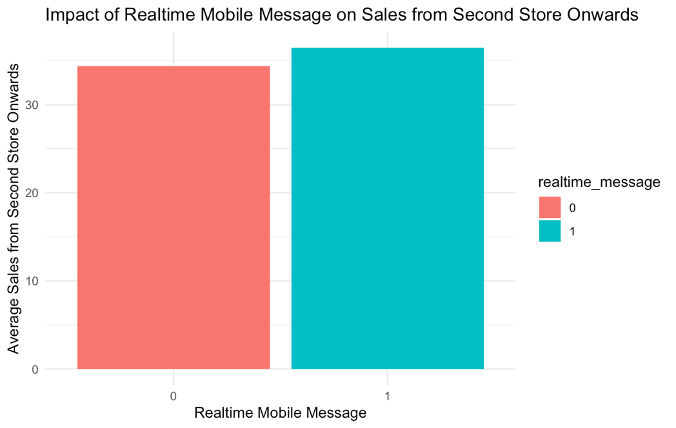
Variable | Regression coefficient | Significance
Intercept | 34.357 | p < 0.05
Real-Time message | 2.108 | p < 0.05

Clustering analysis

Features of Clustering Analysis:
The clustering analysis uses age and spending from the second store onwards as independent variables to segment consumers into different groups based on their purchasing behavior.
Cluster Sizes:
The k-means clustering algorithm identified three distinct clusters:
- Cluster 1: 657 consumers
- Cluster 2: 219 consumers
- Cluster 3: 312 consumers

Results of Profiling:
- Cluster 1 (Young Medium-Spenders): Consumers in this cluster have an average age of 27.6 years and an average spending of $36.82. These consumers are likely price-sensitive but engage in repeat purchases when incentivized.
- Cluster 2 (Older High-Spenders): Consumers in this segment have an average age of 41.9 years and spend the highest, with an average of $48.81. They tend to be loyal customers and respond well to premium product offerings.
- Cluster 3 (Young Low-Spenders): Consumers in this segment have an average age of 28.2 years but spend the least, with an average of $23.38. They may require additional marketing incentives to encourage higher spending.

Within-Cluster Variation:
The within-cluster sum of squares for the three clusters are:
- Cluster 1: 27,355.88
- Cluster 2: 12,059.89
- Cluster 3: 17,478.76
The between-cluster variation accounts for 68.1% of the total variability, indicating distinct customer groupings.

Clustering Model:
The clustering model can be represented as:
Y {Cluster 1, Cluster 2, Cluster 3} = f (Age, Spending from Second Store)
Visualization:
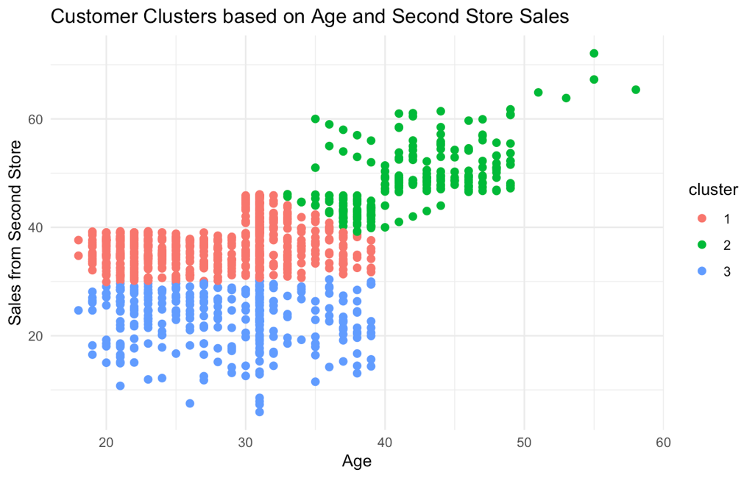

RECOMMENDATIONS AND CONCLUSION (Deepthi Rajesh)
Recommendations:
- Maximize Real-Time Messaging Strategy:
- The regression results show that while real-time messages have a positive impact on second store and higher sales, this impact is relatively minor (R-squared = 0.0118). This suggests while messaging may impact spending, there may be more influential variables.
It is recommended to:
- Tailor messages based on historical purchasing behavior.
- Test different messaging vehicles and rewards (e.g., discount coupons versus loyalty points).
- Run A/B tests to ascertain the most effective messaging strategy.

- Prioritize High-Spending Segments:
- Cluster analysis reveals that elderly customers (Cluster 2) are high-spending, at $48.81 on average.
This implies that:
- Target the segment with upscale product lines through marketing.
- Institute loyalty programs offering extra incentives for repeated purchases.
- Increase store experiences that are segmented and tailored, with suggestions.

- Get Young Low-Spenders to Spend More:
- Cluster 3 is young low-spenders ($23.38 average spend).
- To get this segment to spend more:
- Launch gamified promotions that reward additional purchases.
- Offer bundle deals and discounts to increase the perceived value of purchases.
- Use social media and app-based promotions with younger consumers.

- Leverage Age-Based Pricing Strategies:
- The regression model indicates that age significantly impacts spending behavior. Launching age-based pricing strategies, such as: Special offers for young consumers to attract traffic.
- More advanced rewards for mature consumers with more robust spending tendencies.

- Improve Data Collection and Analytics:
- Since only 1.18% of the variance in spending is accounted for by real-time messages, there are other factors that must be analyzed further. The mall owner needs to:
- Collect more granular data on consumer behavior, including time spent within stores and preferred shopping categories.
- Invest in machine learning models of greater predictive accuracy.
- Incorporate the influence of outside factors like seasonality, economic activity, and competitive prices in the analysis.

Conclusion:
The findings of this study indicate that real-time messaging has a measurable but small influence on consumer purchasing behavior. While older customers naturally possess higher spending habits, younger consumers require more powerful incentives to make larger purchases. To achieve maximum sales and generate consumer engagement, ShopCo needs to adopt a data-driven marketing strategy that personalizes messaging, maximizes customer segmentation, and increases the potency of promotions.
Furthermore, integrating next-generation analytics techniques, such as predictive modeling and machine learning, will give more accurate information about consumer buying behavior. Future studies must be aimed at extrinsic factor analysis, such as product placement, store layout, and comparative price, to achieve a holistic knowledge of variables that influence consumer spending. A sound plan leveraging such knowledge will enable ShopCo to optimize traffic flow, boost revenues, and maintain market dominance in the retail space.

