Building a Modern Streaming Lakehouse: The Ride-Hailing Use Case
The data engineering landscape is undergoing a massive shift. The traditional boundaries between “streaming” (for low-latency operations) and “batch” (for historical analytics) are dissolving. Enter the Streaming Data Lakehouse—an architecture that delivers real-time analytical capabilities directly on top of open table formats like Apache Iceberg, without the need for bespoke, expensive operational databases.
In this post, we’ll dive deep into a complex, real-world use case: Ride-Hailing Surge Pricing and Telemetry Tracking, and explore how we built a complete end-to-end streaming lakehouse to solve it.

The Use Case: Ride-Hailing Telemetry & Surge Pricing
Imagine a ride-hailing platform like Uber or Lyft. At any given second, thousands of drivers are pinging their GPS locations, and thousands of riders are requesting rides. To operate efficiently, the platform must process these streams in real-time to achieve two critical goals: 1. Ride Matching & State Tracking: Instantly match a rider’s request with a nearby driver and track the live state of that ride (Requested -> Accepted -> Completed). 2. Surge Pricing Calculation: Dynamically calculate pricing multipliers continuously based on the real-time supply of drivers versus the demand from riders in specific geographic zones.
Historically, solving this required a complex labyrinth of Kafka streams, NoSQL databases (like Cassandra or DynamoDB) for state tracking, and separate data warehouses for downstream analytics.
With the advent of advanced table formats like Apache Iceberg V2, we can now process these streams and mutate records directly in the data lake, achieving sub-second latency while keeping everything in a unified, open format.

Architectural Overview
We designed a modern, open-source stack that processes these events as they arrive, handles out-of-order data, mutates lakehouse records in real-time, and serves a live React dashboard—all without a traditional database.
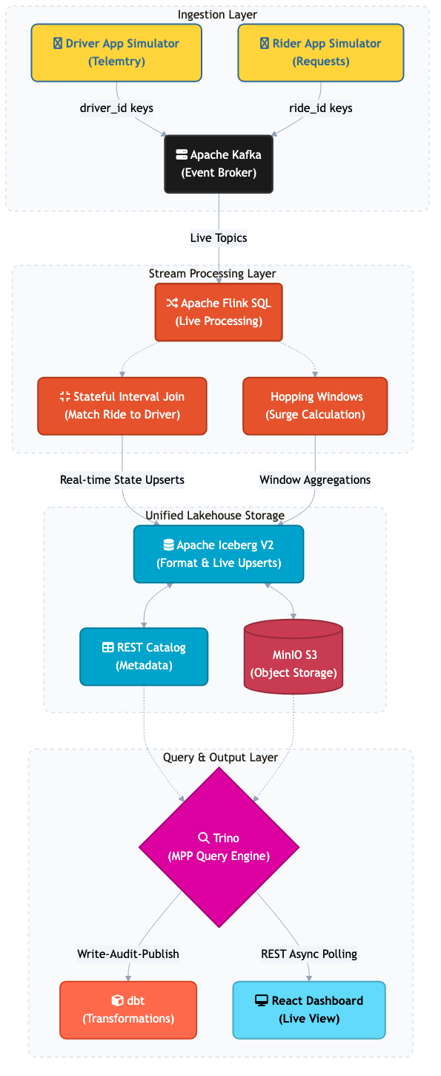
Architecture Diagram

Tools and Functionality Developed
Let’s break down the role of each component and the specific functionalities we developed to conquer this use case.

1. Ingestion: Apache Kafka & Python Producers
To simulate the high-throughput, chaotic nature of mobile telemetry, we built Python producers that continuously push driver_locations and ride_requests into Apache Kafka. - Key-Based Routing: Crucially, we route messages using driver_id and ride_id as Kafka keys. This ensures that state transitions for a single ride arrive at the stream processor in strictly chronological order.

2. Stream Processing: Apache Flink SQL
Apache Flink is the powerful engine executing our continuous queries. We utilized Flink SQL to handle the heavy lifting: - Event-Time Watermarking: Mobile networks are notoriously unreliable. Flink uses a 5-second watermark (WATERMARK FOR event_timestamp AS event_timestamp - INTERVAL '5' SECOND) which allows the system to wait for and gracefully process out-of-order “late” pings without stalling the pipeline. - Stateful Interval Joins: To match riders and drivers, Flink holds streams in state and executes an INTERVAL JOIN. It looks for an ‘ACCEPTED’ ride request and an ‘ON_TRIP’ driver location occurring within 5 minutes of each other, seamlessly matching supply to demand. - Sliding (Hopping) Windows: Flink calculates the “Surge Multiplier” continuously by aggregating the distinct counts of active riders and available drivers using a 60-second lookback window that slides forward every 10 seconds.

3. Unified Storage: Apache Iceberg V2
This is where the lakehouse magic happens. Traditionally, data lakes were append-only. - V2 Format & Live Upserts: We configured our Iceberg tables with 'format-version'='2' and 'write.upsert.enabled'='true'. Flink directly issues Equality Deletes to the lake. When a ride goes from ‘REQUESTED’ to ‘COMPLETED’, Iceberg updates the existing row in place in real-time. - Advanced Features Implemented: - Partition Evolution: We demonstrated shifting a table from daily to hourly partitioning seamlessly without requiring massive rewrites of historical data. - Compaction: Flink checkpointing every 10s creates thousands of tiny files (“the small file problem”). We automated ALTER TABLE ... EXECUTE OPTIMIZE commands to periodically compact these files into optimized blocks behind the scenes. - Time Travel: Because Iceberg tracks snapshots, we configured exact time-travel queries to audit exactly what the surge pricing multiplier was at any given millisecond in the past.

4. Query Engine: Trino
Trino acts as the high-concurrency, massively parallel SQL query engine sitting directly over the Iceberg metadata and MinIO object storage. It serves as the single source of truth, providing rapid query responses to our visualization layer without caching data externally.

5. Analytics & Quality: dbt (Data Build Tool)
We integrated dbt to manage the analytics engineering workflow on top of the raw lakehouse tables: - Custom Macros & Tests: We built Jinja macros to calculate driver payouts dynamically based on surge factors. - WAP Pattern: Integrated strict data quality tests (e.g., asserting unique ride IDs and acceptable state values) using a Write-Audit-Publish pattern to ensure downtown analytics tables are pristine.

6. Serving: React Live Dashboard
Finally, we brought the data to life using a modern Vite + React web application. - The UI polls Trino via an asynchronous REST client. - It translates Flink’s 10-second sliding windows into live-updating KPI cards and a real-time tracking feed of active ride states.

Conclusion
By unifying streaming computation (Flink) with transactional table formats (Iceberg V2) and an MPP query engine (Trino), we built a system that matches the operational low-latency of a NoSQL database with the massive analytical scale of a data warehouse.
The “Streaming Lakehouse” isn’t just a buzzword; it’s a profound simplification of the data stack, allowing organizations to act on live telemetry instantly while simultaneously providing rich, historical analytics from a single, unified storage layer.

