FlowForge: Building a Self-Healing Data Pipeline Platform with Multi-Agent AI Orchestration
When your pipelines break at 3 AM, what if a team of AI agents could diagnose, heal, and restart them — before you even wake up?

Modern data teams are drowning in operational complexity. You have Kafka for streaming, Flink for processing, Iceberg for storage, PostgreSQL and MongoDB for source data, and Redis for state — all stitched together with fragile YAML configs and hope. When a source schema changes, the entire downstream pipeline shatters. When a Flink job OOMs, someone gets paged.
In my previous post, I built a streaming analytics lakehouse and used agentic skills to accelerate development — slash-commands that helped me build faster. This time, the agents aren’t just helpers. They ARE the platform.
I wanted to flip the script entirely: what if you could describe your pipeline in plain English and have a team of AI agents build, monitor, and heal it for you?
So I built FlowForge — a multi-agent AI data pipeline platform where specialized agents collaborate through a shared memory layer, each wielding tools from Model Context Protocol (MCP) servers connected to real infrastructure. Kafka topics get created, Flink SQL gets generated and submitted, PostgreSQL CDC gets configured, and when schema drift happens, the Healer agent detects it and auto-evolves your Iceberg tables — all without human intervention.
Let me walk you through how it works.

The Architecture: Agents All the Way Down
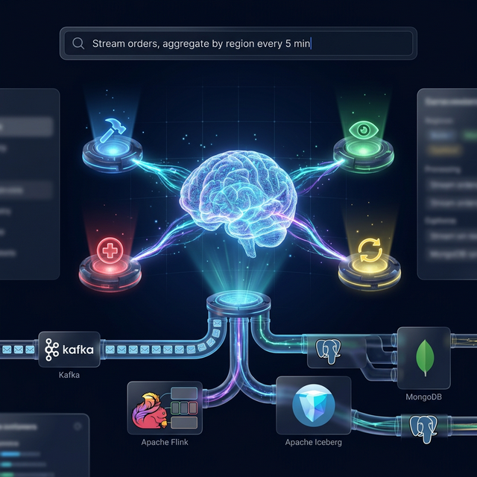
Multi-Agent Orchestration — AI agents coordinating across Kafka, Flink, Iceberg, PostgreSQL, and MongoDB through a natural language interface
The core insight behind FlowForge is separation of concerns through specialization. Instead of one monolithic agent trying to do everything (and hallucinating half of it), I split the responsibilities across four specialist agents, each with a focused role and a curated set of tools:
Agent | Role | What it actually does
🧠 Orchestrator | Coordinator | Receives your natural language request, decomposes it into sub-tasks using LLM reasoning, delegates to specialists, tracks progress, synthesizes results
🔨 Builder | Pipeline Creator | Inspects PostgreSQL schemas, verifies CDC readiness, creates Kafka topics, generates Flink SQL (with LLM assistance), deploys jobs
👁 Monitor | Health Watcher | Continuously checks Flink job states, Kafka throughput, PostgreSQL table health; detects schema drift by comparing current schemas against baselines stored in Redis
🩺 Healer | Self-Healer | Diagnoses Flink job failures by analyzing exceptions, auto-evolves Iceberg table schemas, restarts jobs, escalates issues it can’t fix
The agents communicate through Redis-backed shared memory — pipeline states, task queues, event logs, and agent heartbeats all flow through a central state store. When the Monitor detects schema drift, it doesn’t try to fix it — it emits an event that the Orchestrator picks up and routes to the Healer. This supervisory hierarchy prevents agents from stepping on each other.

The MCP Layer: Agents Need Tools, Not Bash Scripts
Every agent interacts with infrastructure through MCP (Model Context Protocol) servers — a standardized tool interface that abstracts away the raw API calls. I built four:
- PostgreSQL MCP — query(), inspect_schema(), check_cdc_status(), list_tables(), get_sample_data()
- Kafka MCP — list_topics(), create_topic(), produce_message(), consume_messages(), get_topic_info()
- Flink MCP — cluster_overview(), list_jobs(), submit_sql(), get_job_exceptions(), cancel_job()
- MongoDB MCP — list_collections(), find_documents(), aggregate(), get_collection_schema()
Here’s what an MCP server looks like in practice. The PostgreSQL server exposes tools using the @mcp.tool() decorator — each function becomes a tool that any agent can invoke:
from mcp.server.fastmcp import FastMCP
from flowforge.config import config
postgres_mcp = FastMCP(
"FlowForge PostgreSQL MCP",
instructions="MCP server for PostgreSQL — query, schema inspect, CDC setup",
)
def _get_conn():
return psycopg2.connect(
host=config.postgres.host, port=config.postgres.port,
database=config.postgres.database,
user=config.postgres.user, password=config.postgres.password,
)
@postgres_mcp.tool()
def inspect_schema(table_name: str) -> str:
"""Get the full schema of a PostgreSQL table including columns,
types, constraints, and row count."""
conn = _get_conn()
with conn.cursor(cursor_factory=psycopg2.extras.RealDictCursor) as cur:
cur.execute("""
SELECT column_name, data_type, is_nullable, column_default
FROM information_schema.columns
WHERE table_name = %s AND table_schema = 'public'
ORDER BY ordinal_position;
""", (table_name,))
columns = [dict(row) for row in cur.fetchall()]
# ... also fetches primary keys, foreign keys, row count
return json.dumps({"table": table_name, "columns": columns, ...})
@postgres_mcp.tool()
def check_cdc_status() -> str:
"""Check CDC (logical replication) readiness."""
conn = _get_conn()
with conn.cursor(cursor_factory=psycopg2.extras.RealDictCursor) as cur:
cur.execute("SHOW wal_level;")
wal_level = cur.fetchone()["wal_level"]
cur.execute("SELECT pubname, puballtables FROM pg_publication;")
publications = [dict(row) for row in cur.fetchall()]
return json.dumps({"wal_level": wal_level, "cdc_ready": wal_level == "logical"})
The same pattern applies to all four MCP servers — Kafka wraps confluent-kafka, Flink wraps the REST API, MongoDB wraps pymongo. Agents don’t need to know how to connect to Kafka or parse Flink’s REST API — they just call kafka_create_topic("cdc.ecommerce.orders", partitions=3) and the MCP server handles the rest. It’s the same principle as function calling in LLMs, but wired to real infrastructure.
All infrastructure settings (hosts, ports, credentials, LLM provider) are managed through Pydantic BaseSettings with environment variable overrides — POSTGRES_HOST=my-rds.amazonaws.com in your .env file, and the MCP servers pick it up automatically. Zero hardcoded connection strings.

The Natural Language Interface
Here’s what using FlowForge actually looks like. You type:
“Stream orders from Postgres to Iceberg, aggregate by region every 5 minutes”
Under the hood, the Orchestrator uses a carefully crafted LLM prompt to decompose this into sub-tasks:
async def _decompose_request(self, request: str) -> list[AgentTask]:
prompt = f"""You are the Orchestrator of a multi-agent data pipeline platform.
Decompose this user request into specific, actionable sub-tasks:
REQUEST: "{request}"
Available specialist agents:
- BUILDER: Creates pipelines — Kafka topics, Flink jobs, CDC setup, Iceberg tables
- MONITOR: Watches pipeline health — throughput, errors, schema drift, SLAs
- HEALER: Fixes failures — schema drift resolution, job restarts, replays
For each sub-task, specify:
- description: What needs to be done
- agent: Which specialist handles it (builder, monitor, or healer)
- depends_on: List of task indices this task depends on
- priority: 1 (highest) to 10 (lowest)
Return ONLY a JSON array of tasks in execution order."""
response = await self.reason(prompt)
task_defs = json.loads(response)
# Convert to AgentTask objects with dependency tracking
tasks = []
for i, td in enumerate(task_defs):
agent_role = {"builder": AgentRole.BUILDER, "monitor": AgentRole.MONITOR,
"healer": AgentRole.HEALER}.get(td["agent"], AgentRole.BUILDER)
task = AgentTask(
description=td["description"], assigned_to=agent_role,
assigned_by=AgentRole.ORCHESTRATOR, priority=td.get("priority", 5),
depends_on=[task_id_map[dep] for dep in td.get("depends_on", [])],
)
tasks.append(task)
return tasks
The LLM produces a structured task plan:
Task 1: [BUILDER] Inspect PostgreSQL 'orders' table schema
Task 2: [BUILDER] Verify CDC is enabled on orders table
Task 3: [BUILDER] Create Kafka topic 'cdc.ecommerce.orders'
Task 4: [BUILDER] Generate Flink CDC source table SQL
Task 5: [BUILDER] Generate Flink tumbling window aggregation SQL
Task 6: [BUILDER] Create Iceberg sink table for aggregated results
Task 7: [BUILDER] Deploy the full pipeline as a Flink job
Task 8: [MONITOR] Set up health monitoring with baseline schema
Each task is dispatched to the appropriate specialist, executed with real MCP tools, and results flow back to the Orchestrator for synthesis. The entire chain — from natural language to running Flink job — happens autonomously.
Under the hood, each agent imports MCP tool functions directly and registers them as callable capabilities. The Builder, for example, has 11 tools spanning PostgreSQL, Kafka, Flink, and MongoDB — grouped into capabilities like create_streaming_pipeline (which requires pg_inspect_schema + kafka_create_topic + flink_submit_sql) and setup_cdc. This capability model means the Orchestrator knows exactly which agent can handle which sub-task.

Self-Healing Pipelines: The Killer Feature
This is where things get genuinely interesting. In production, the #1 cause of pipeline failures I’ve seen isn’t Kafka going down or Flink running out of memory — it’s schema drift. Someone adds a discount_pct column to the orders table, and suddenly your entire downstream pipeline breaks because the Flink CDC connector doesn’t know about the new field.
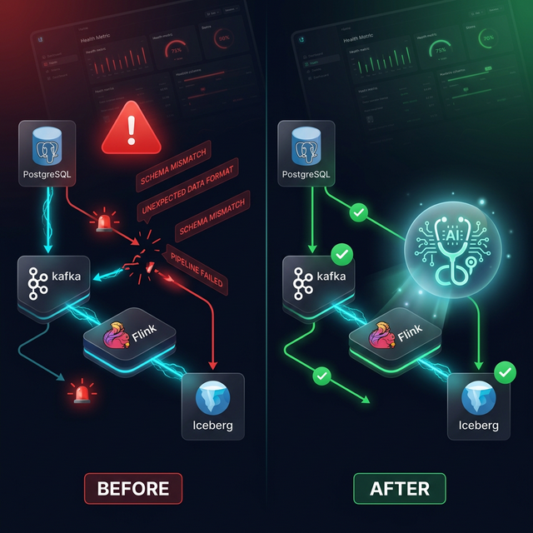
Self-Healing Pipeline — Before and After: The Healer agent automatically detects schema drift and evolves downstream tables
FlowForge handles this automatically through a detect → diagnose → heal → verify loop:
1. Detection (Monitor Agent) The Monitor stores a baseline schema for every tracked table in Redis. On each health sweep, it compares the current schema against baseline. When a new column appears:
# Monitor detects the drift
drift = {
"added": [{"column": "discount_pct", "type": "numeric(5,2)"}],
"removed": [],
"type_changes": []
}
# Emits event → Orchestrator routes to Healer
2. Routing (Orchestrator) The Orchestrator has built-in event handling that auto-routes critical events to the right specialist:
async def handle_agent_event(self, event: dict) -> dict:
event_type = event.get("event_type", "")
severity = event.get("severity", "INFO")
# Auto-respond to critical events
if severity in ("HIGH", "CRITICAL"):
if "SCHEMA_DRIFT" in event_type:
# Route to Healer automatically
heal_task = AgentTask(
description=f"Heal schema drift: {event.get('details', {})}",
assigned_to=AgentRole.HEALER,
assigned_by=AgentRole.ORCHESTRATOR,
priority=1, # Highest priority
context=event.get("details", {}),
)
result = await self._delegate_task(heal_task)
return {"action": "auto_healed", "task": result.result}
3. Diagnosis (Healer Agent) The Healer classifies the change: - Safe (new nullable column) → auto-heal - Caution (type widening) → heal with validation - Dangerous (column removed) → escalate to human
4. Healing For safe changes, the Healer generates and executes the Iceberg ALTER TABLE:
ALTER TABLE iceberg_catalog.ecommerce.orders
ADD COLUMN discount_pct DECIMAL(5,2);
5. Verification The Healer restarts the affected Flink job and asks the Monitor to confirm the pipeline is healthy again. From drift detection to pipeline restoration: ~45 seconds.
You can simulate this yourself via the dashboard’s “Simulate Schema Drift” button — it adds a column to PostgreSQL and you can watch the agent chain react in real time.
Lesson learned: The hardest part wasn’t the detection — it was teaching the Orchestrator when not to auto-heal. Column removals and type narrowing need human judgment. I ended up building a three-tier safety classification (safe → caution → dangerous) so the Healer only auto-heals changes that can’t lose data.

The Dashboard: Not an Afterthought
FlowForge ships with a premium React dashboard (Vite + dark mode glassmorphism) that serves as the primary control surface. Here’s what it looks like with 3 pipelines running:
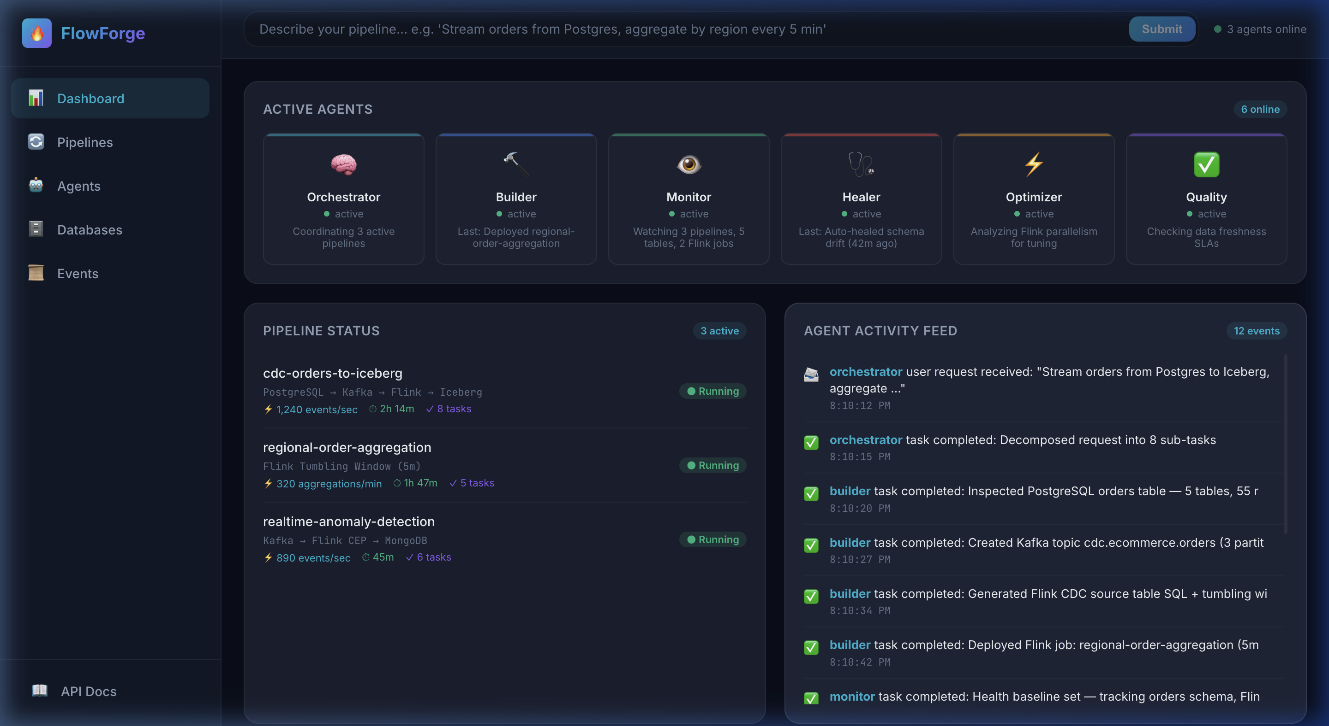
FlowForge Dashboard — 3 running pipelines processing 1,240+ events/sec, 12 agent collaboration events, and all 6 agents actively coordinating
The main dashboard shows all 6 agents with their current tasks, 3 live pipelines with real-time throughput metrics (cdc-orders-to-iceberg at 1,240 events/sec, regional-order-aggregation at 320 aggregations/min, realtime-anomaly-detection at 890 events/sec), and an activity feed tracking every agent action.
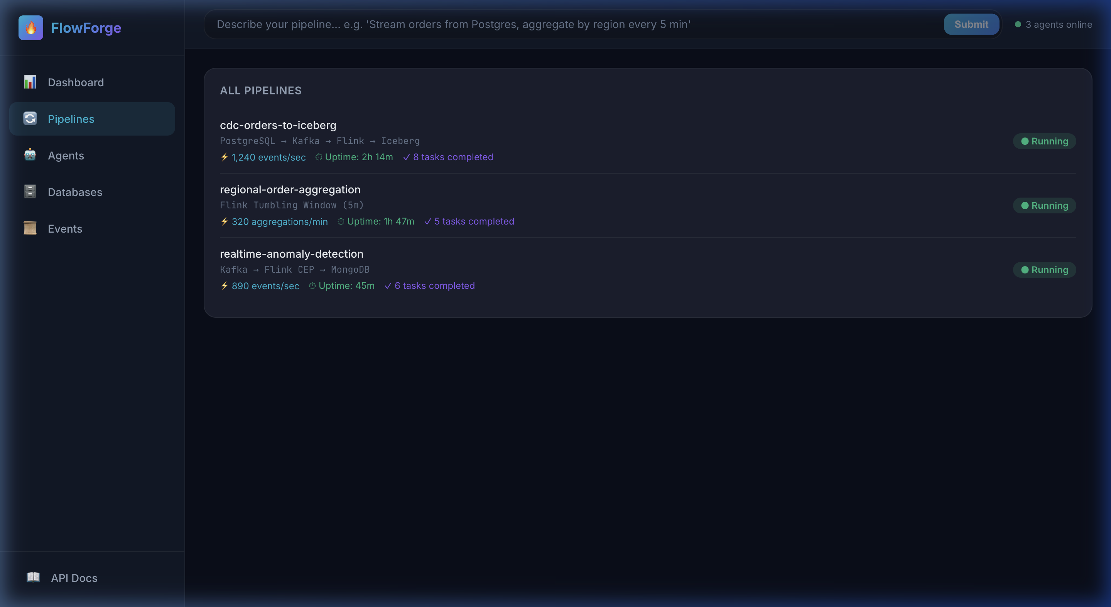
All Pipelines — 3 running pipelines with throughput metrics, uptime, and infrastructure paths
The Pipelines page shows each pipeline’s full data path (e.g., PostgreSQL → Kafka → Flink → Iceberg), live throughput, uptime, and how many agent tasks completed to build it.
But the most compelling view is the Event Log — it tells the full story of multi-agent collaboration, including the self-healing loop in action:
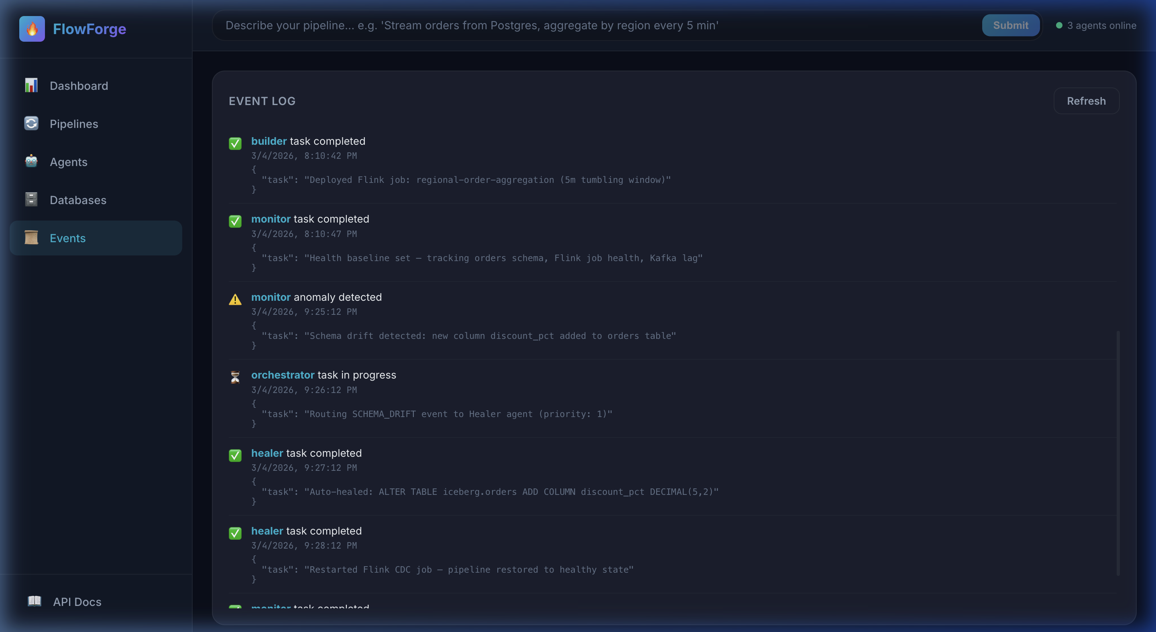
Event Log — Schema drift detected by Monitor, routed to Healer by Orchestrator, auto-healed with ALTER TABLE, pipeline restored
Reading the log, you can trace the complete lifecycle: Orchestrator receives request → Builder inspects schema, creates Kafka topic, generates Flink SQL → Monitor sets baselines → Monitor detects schema drift (⚠️ discount_pct added) → Orchestrator routes to Healer (priority: 1) → Healer auto-heals with ALTER TABLE → Healer restarts Flink job → Monitor verifies all pipelines healthy. The entire self-healing cycle, logged with timestamps.

Running It Yourself
The entire stack runs locally with Docker Compose. One key infrastructure detail — PostgreSQL is configured with logical replication enabled from the start, which is what makes CDC possible:
# docker-compose.yml (excerpt)
postgres:
image: postgres:16
command: > # CDC-critical: enables logical replication at startup
postgres
-c wal_level=logical
-c max_replication_slots=4
-c max_wal_senders=4
Without wal_level=logical, the Builder agent’s check_cdc_status() tool would report CDC as unavailable and pipeline creation fails. This is the kind of infrastructure-level detail that’s easy to miss and hard to debug.
git clone https://github.com/meehirmene/MCP.git && cd MCP
docker compose up -d # Kafka, Flink, Iceberg, PostgreSQL, MongoDB, Redis
python3.10 -m venv .venv && source .venv/bin/activate
pip install -e .
cp .env.example .env # Edit → LLM_API_KEY=your-key
uvicorn flowforge.api_server:app --reload --port 8000
cd dashboard && npm install && npm run dev # Separate terminal
Then open http://localhost:5173 and type: “Stream orders from Postgres to Iceberg, aggregate by region every 5 minutes”
FlowForge supports OpenAI, Google Gemini, Anthropic, and Ollama — switch providers with LLM_PROVIDER=ollama LLM_MODEL=llama3 in your .env file. For fully local development with no API key, Ollama is the way to go.
Resource note: This stack runs 8+ containers. Allocate at least 8–12GB RAM to Docker Desktop.

Beyond the Basics: Skills, Workflows, and What’s Next
Beyond ad-hoc natural language requests, FlowForge includes Skills (structured, reusable patterns like CDC Ingestion, Schema Evolution detection/classification/healing, and Window Aggregation mapping) and Workflows (orchestrated multi-step procedures like /multi-agent-deploy, /multi-agent-incident, and /diagnose-pipeline). These aren’t documentation — they’re executable knowledge that agents consult during task execution.
The v0.1 roadmap includes an Optimizer Agent (auto-tune Flink parallelism and Kafka partitioning), a Quality Agent (data freshness SLAs and anomaly detection), Agent Memory Evolution (learning from past incidents), and Multi-Pipeline Orchestration (managing dependencies between pipelines). The vision: data engineers describe intent, and agents handle everything else.

Key Takeaways
- Specialization over generalization — Four focused agents outperform one omniscient agent. Each has a clear role and scoped toolset.
- MCP as the abstraction layer — Agents interact with infrastructure through standardized tool interfaces, not raw APIs. This makes the system extensible.
- Self-healing is achievable — Schema drift detection + automated evolution + job restart is a closed loop that works today (~45 seconds end-to-end).
- Natural language is the interface — But not a toy interface. The LLM does structured task decomposition, not freeform code generation.
- Local-first development — Everything runs on your laptop with Docker Compose. No cloud accounts required.
The code is open source. Come build with us.
GitHub: meehirmene/MCP

If you found this useful, subscribe for more deep dives into agentic data engineering, streaming architectures, and the intersection of AI and infrastructure.

