CSC3002F - NETWORK ASSIGNMENT REPORT
NET 50
BLYMEE001 | VLJYAQ001 | MNTALL003

Introduction
As a group, we set out to design and implement a Peer-to-Peer (P2P) file-sharing system that uses TCP and UDP sockets. The system attempts to mimic the fundamental characteristics of the BitTorrent protocol's file transfer process. It consists of three primary elements:
- Tracker: Keeps track of certain files along with their available seeders.
- Seeder: Transfers files with other peers.
- Leecher: Downloads files from seeders.
This report outlines our Peer-to-Peer (P2P) file-sharing system's architecture, features, design, functionality, message protocols, sequence diagrams, implementation details, and challenges faced. We also include system output that showcase the application in action.

Aim
- Create a UDP tracker to ensure coordination between the leecher and the seeder.
- Implement the seeder node which registers available files with the tracker (using UDP), and implement the leecher node which connects to the tracker (using UDP).
- Use SHA-256 hashing to split files into file chunks and for file integrity verification.
- Implement the ability for seeder and leecher to support UDP and TCP.
- Allow downloads of all file types.

System Architecture
Our P2P file-sharing system follows a distributed architecture where files are broken into manageable chunks and distributed across multiple peers. We designed the interaction between components as follows:

Tracker (UDP)
Our tracker acts as the main P2P coordinator for the system. Its tasks and responsibilities are:
- Registering seeders: Seeders inform the tracker of the files they are hosting.
- Tracking peers: Seeders notify trackers about their availability using ping messages.
- Providing peers list for leechers: Leechers ask the tracker for a particular file, and it responds with a list of peers who have offered that specific file.
- Handling peer timeouts: The tracker implements a cleanup mechanism that removes peers who haven't sent a ping in the last 5 minutes.

Seeder (TCP)
- Registers itself with the tracker to make its files available.
- Accepts file requests from leechers and transfers file chunks over TCP.
- Computes and verifies hash values to ensure file integrity.
- Sends ping messages to the tracker to maintain its active status.
- Serves multiple leechers using multi-threading.

Leecher (TCP & UDP)
- Downloads file chunks from multiple seeders.
- Ensures file integrity of the downloaded data using hash verification.
- Communicates with the tracker to receive a list of available seeders.
- Can switch to seeder role after a successful download.
- Pre-allocates disk space for the entire file and writes chunks in parallel.

Implementation Details

Simple Configuration System
We implemented a centralized configuration system using a JSON file (config.json) that stores common network parameters:
{
"UDP_IP": "10.0.0.20",
"UDP_PORT": "8500",
"TCP_PORT": "12640"
}
This approach provides flexibility and allows easy modification of network parameters without changing the main code base.
The Tutor/Marker needs to change the necessary IP’s and ports according to your current IP and port. Run ipconfig to obtain your current IP address and replace the UDP_IP.

Tracker Implementation
The tracker is implemented as a multi-threaded UDP server that:
- Maintains a dynamic registry of files and associated seeders
- Uses thread synchronization to prevent race conditions
- Implements automatic cleanup of inactive peers
- Responds to three main message types: registration, ping, and peer list requests

Seeder Implementation
The seeder component:
- Registers all files in the 'downloads' directory with the tracker
- Maintains active status through ping messages
- Uses multi-threading to handle multiple leecher connections
- Computes SHA-256 hashes for file chunks to ensure integrity
- Serves both file metadata (size) and actual file chunks

Leecher Implementation
The leecher:
- Queries the tracker for available seeders
- Retrieves file size information from a seeder
- Divides the download task into 512KB chunks
- Pre-allocates the full file size to prevent fragmentation
- Downloads chunks in parallel using multiple threads
- Verifies each chunk's integrity using SHA-256 hashing
The parallel download implementation is particularly important:
def download_file_in_parallel(filename, peers, file_size):
# Ensure the downloads directory exists
# Create an empty file of the required size
# Divide the file into 512 KB chunks
# Ensure the last chunk doesn't exceed
# Distribute chunks among seeders
# Join them

User Interface
We implemented a simple command-line interface (main.py) that allows users to:
- Start a tracker
- Run as a seeder to share files
- Run as a leecher to download files
- Transition from leecher to seeder after download completion
This approach enables easy testing and demonstration of the system's features.

Core/Additional Features

Chunked File Transfer
To facilitate efficient transfer of files, we split them into fixed sizes (512 KB). During development, we tested multiple file sizes, finally settling at 512 KB. This approach:
- Permits parallel downloads from several hosts
- Makes error recovery easier by allowing particular chunks to be retransmitted

Parallel Downloads
We ensured simultaneous parallel downloading from several seeders was added. Tests proved that this method:
- Improved download rates
- Afforded fall-back should certain peers be lost
- Distributed network load across multiple seeders
Our implementation distributes chunks evenly across available seeders, maximizing network utilization.

Automatic Re-seeding
Our system supports the automatic transition to seeders after a complete file has been downloaded. This feature:
- Grows network capacity on its own
- Ensures that often requested files are more accessible
- Builds a perpetual system that enhances with more usage
The implementation is straightforward:
def run_leecher():
print("Starting leecher...")
os.system("python leecher.py")

# Prompt for re-seeding
reseed = input("Do you want to support seeding for this file? (y/n): ")
if reseed.lower() == "y":
print("Transitioning to a seeder...")
run_seeder() # Re-seed after download

File Integrity Verification
We implemented file integrity verification through SHA-256 hashing, which was challenging to do correctly. Our method:
- Guarantees data is not altered during transfer
- Blocks corrupted download files
- Allows for recognition and replacement of damaged chunks

Protocol Specification

JSON Message Formats - Tracker Communication Protocol (UDP)

Register Message (Seeder -> Tracker)
{
"command": "register",
"filename": "example.mp4",
"port": 12640
}

Ping Message (Seeder -> Tracker)
{
"command": "ping",
"file_id": "example.mp4",
"port": 12640
}

Peer List Request (Leecher -> Tracker)
{
"command": "get_peers",
"filename": "example.mp4"
}

Peer List Response (Tracker -> Leecher)
{
"status": "success",
"peers": [["192.168.1.100", 12640], ["192.168.1.101", 12640]]
}

Message Formats - File Transfer Protocol (TCP)

Chunk Request (Leecher -> Seeder)
"example.mp4,0,524288" // filename,start_byte,end_byte

File Size Request (Leecher -> Seeder)
"example.mp4,0,0" // filename,0,0 indicates size request

File Size Response (Seeder -> Leecher)
"104857600" // File size in bytes

Chunk Response (Seeder -> Leecher)
[SHA-256 hash (64 bytes)][chunk data (variable length)]

Sequence Diagram: Peer States & Communications
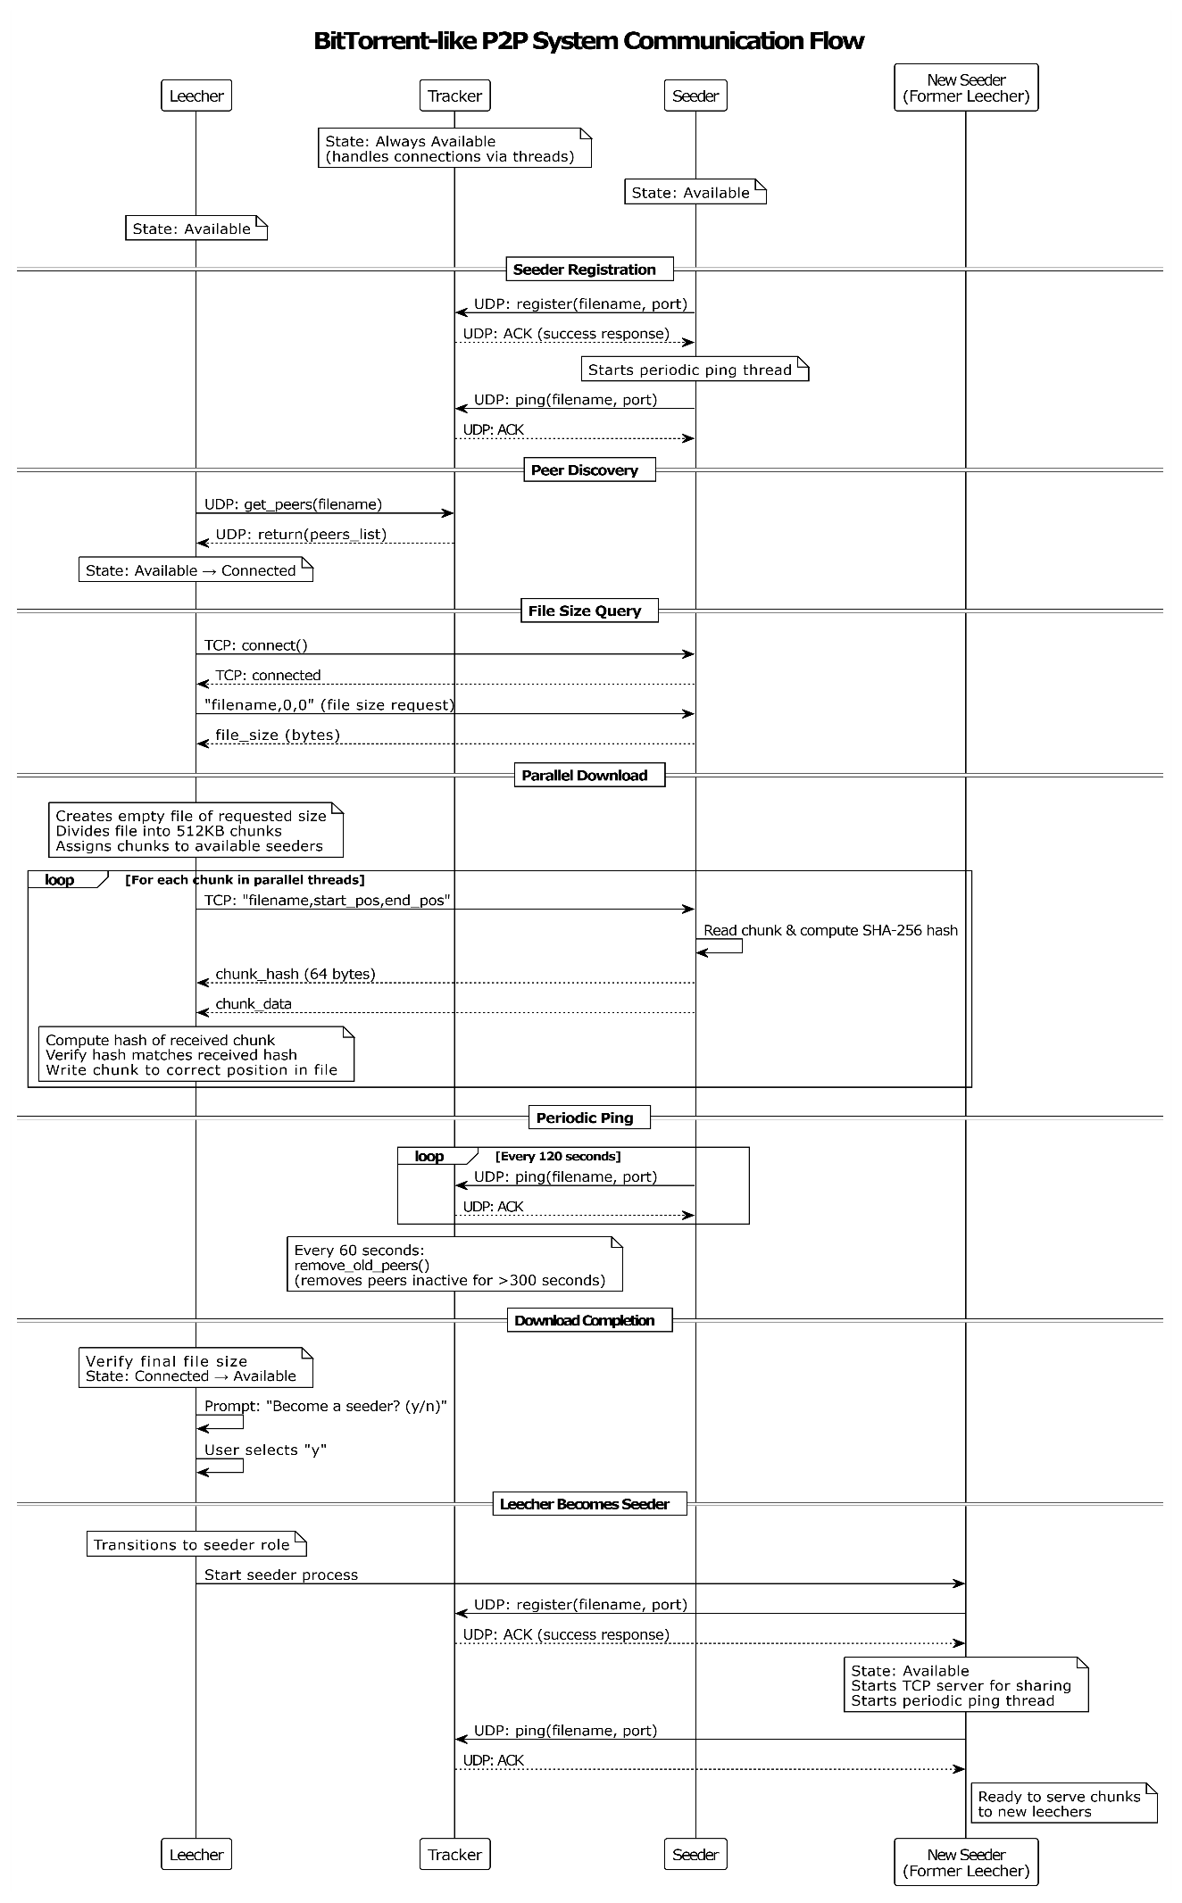

Interaction & Console Output examples

1. Main Program Startup
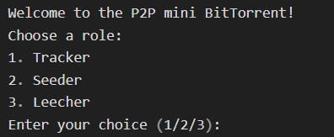

2. Tracker Startup and Operation
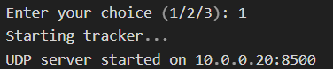

After receiving requests from peers:
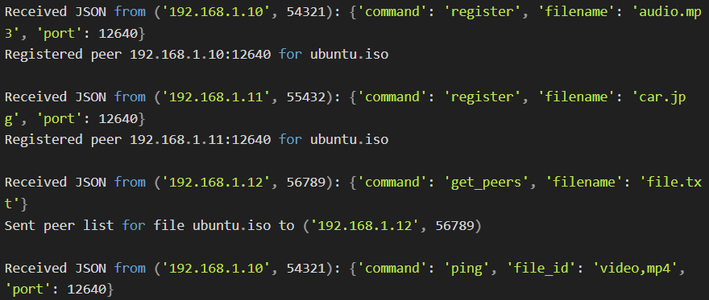

3. Seeder Startup and Operation
When selecting option 2:
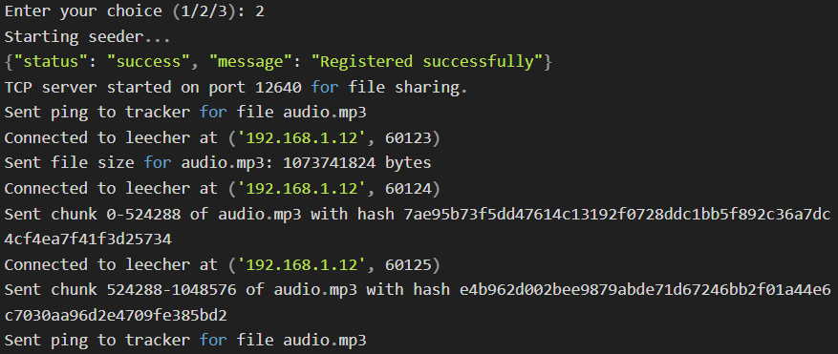

4. Leecher Startup and Operation
When selecting option 3:
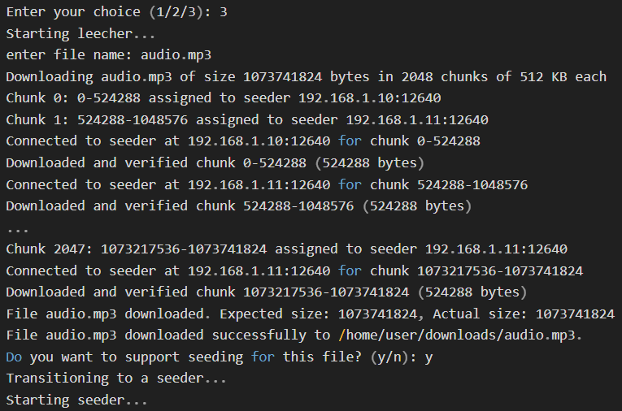

5. Error Scenarios

Tracker not receiving proper JSON:

No seeders available:

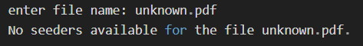

Missing downloads directory for seeder:

6. Complete Flow Example
- Tracker starts first:
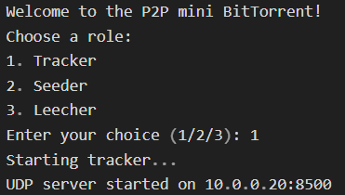
- Initial seeder registers with tracker:
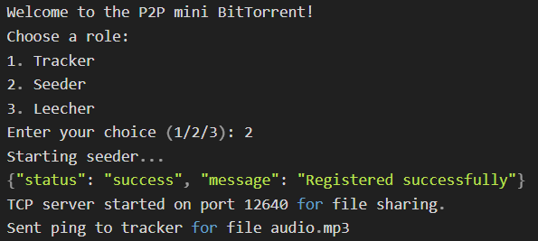

- Tracker logs the registration:
- Leecher requests the file:
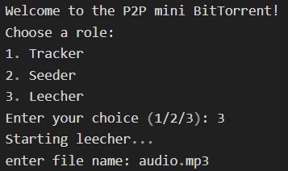
- Tracker logs peer list request:
- Leecher downloads the file:
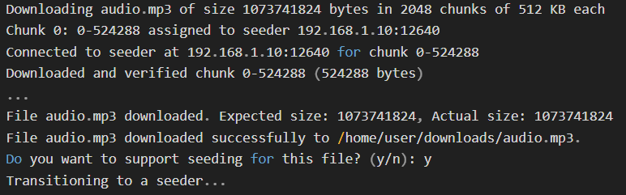
- Seeder logs the chunk requests:
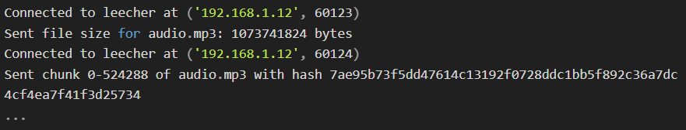
- New leecher becomes seeder:
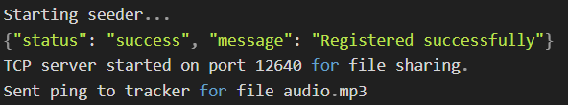
- Tracker logs the new seeder:

Challenges We Faced
- Network Connectivity Issues: Our network system did not connect between peers from one machine to another. We realized that the problem was the port numbers that needed to be changed. After making this change, the problem persisted. We then discovered that one of our machines had a firewall that was preventing peers from connecting to a seeder.
- Cross-Platform Compatibility: We used three machines for testing. One Linux and two Windows systems. This caused many issues, including different versions of Python handling socket closure differently. We had to modify the code to handle these platform differences properly.
- Synchronization Errors: Multiple leechers requesting the same file caused synchronization errors. We resolved this issue by implementing proper multi-threading within the tracker and using locks to protect shared data structures:
- Parallel Download Complexity: One of the main challenges was implementing parallel downloads of 512KB file chunks. In theory, it seemed simple, but in practice, it became very complex. We observed that many threads working in parallel to download chunks faced the problem of completing the downloads in an unsynchronized manner, creating a race condition for writing bytes to the output file.
- File Reassembly Issues: We initially hypothesized that file reassembly would be trivial. However, the downloaded files were completely corrupt because chunks overlapped and there were gaps. After extensive debugging, we took a different approach to chunk management by pre-allocating the entire file and having each thread write to its specific position:
- Hash Verification Challenges: Implementing the hash verification system required careful consideration of how to transmit the hash along with the chunk data. We solved this by sending the hash first, followed by the actual chunk data, and using a fixed hash length (64 bytes for SHA-256).

Conclusion
Our mini-BitTorrent implementation successfully demonstrates the core principles of P2P file-sharing networks. The system efficiently distributes files across multiple peers

