**THE CATHOLIC UNIVERSITY OF EASTERN AFRICA**



**FACULTY OF SCIENCE**

**DEPARTMENT OF COMPUTER AND INFORMATION SCIENCE**

**THE CUEA INDUSTRIAL ATTACHMENT MANAGEMENT SYSTEM**

**BY:**

**NAME: MEEK JEROP KARAN**

**REGISTRATION NUMBER: 1033874**

**A RESEARCH PROJECT SUBMITTED IN PARTIAL FULFILLMENT OF**

**THE REQUIREMENTS FOR THE AWARD OF THE DEGREE**

**BACHELORS OF SCIENCE IN COMPUTER SCIENCE**

**DECLARATION**

# Declaration by candidate

This research project is my original work and has not been presented for award of a degree for any similar purpose in any other institution

Student Name: Meek Jerop

Signature: Date:

# Declaration by Lecturer

This research project has been submitted with my approval as university supervisor

Supervisor Name: Mr. Chris Nandasaba

Signature: Date:

# CHAPTER 1: INTRODUCTION 1.1 MOTIVATION AND BACKGROUND

Industrial attachment is a very crucial part of a student’s academic program which normally lasts for a period of three months where a student is attached to a company or an organization that offers services that are related to the students’ course of study.

It is mandatory for students to do an attachment once in their course period because it will expose the student to demand and challenges of the work place, the student will gain work ethic and practical experience and it will also help the student acquire self-reliance skills before finishing school.

Currently, entries are made manually by the student by using a logbook, there are a number of risks related to the logbook as it is prone to being rained on, getting dust, water, being stolen, data could be erased or totally lost and the student will have to start over again.

When reports about students’ personal details and their attachment locations need to be generated, it takes an extremely long time to produce reports that would be used by the industrial attachment coordinator to allocate institution supervisors to students. At times, these reports are misplaced and tracing them becomes a problem since the system is manual. This has made the process hazardous and has created many loopholes in the entire industrial attachment process. There are also no security measures in place to safe guard the available information.

In this age of information technology, the need for a functional automated record keeping system for the students undergoing their attachment is escalating. This calls for developing a good Industrial Attachment Management System as an answer to the above problems faced by many students in Catholic University

For a successful Industrial Attachment period, the following terms have to be considered:

* 1. Industrial attachment site
  2. An Attachee
  3. Industry supervisor
  4. School supervisor
  5. Logbook

Industrial attachment site – An industry or organization providing an industrial attachment opportunity to an attachee

An Attachee- Is a student who is on attachment and or an attachee to be issued with a logbook, he or she has to pay for industrial attachment fee first. The student is responsible for meeting with the industry supervisor before the internship period to clarify responsibilities and expectations including working hours.

Industry supervisor-This is the person or an employee in industry who has the responsibility of training the attachee and also finding out the progress the attachee is making, interviewing the attachee, orienting interns in their organization, supervising, directing and evaluating attaché’s work, sharing the pros and cons of a career in the field and giving suggestions for entering the profession.

School supervisor-This is the lecturer professor, usually from the department of the student’s major, who will be sent by the university or college to supervise the attachee in between his or her attachment period. The supervisor is also responsible for visiting and addressing issues raised by the attaché and or site supervisor based on the student’s performance and completion of previously agreed upon assignments and marking the Industrial Attachment Report.

Logbook-This is a book where the student records the activities that he or she performs on a daily basis while on attachment. The logbook is divided into days, weeks or months. It is used as a daily diary and the manual entries made by the student includes tasks done, skills learnt and additional comments.

Both the Industry supervisor and the school supervisor are required to periodically review and approve the logged entries and they can also add any additional comments as part of their approval.

On expiry of the attachment period, the school supervisor will do a final review of the logbook then conduct final evaluation of the student by awarding the grades to the student depending on her performance from the logbook.

# 1.2 BACKGROUND OF RESEARCH

Historically, students go for their attachment once they reach third year for the sake of acquisition of practical skills and appropriate work-ethics before entering the labour market. With the increase in number of incoming students, the school does not allocate industrial attachment locations to students therefore a student has to look for an attachment themselves. The students are given logbooks and they are supposed to fill them daily for three months after which they return their logbooks together with a report to the industrial attachment coordinator in school.

The whole procedure is cumbersome both to the industrial attachment coordinator and the student as it involves a lot of paperwork; the student may lose the document as the whole procedure of entering student details is tiring and time-consuming.

Introducing a web-based system for recording all these information by both the student and the supervisor will make work easier and information recorded will be safe and could be used for future reference.

# 1.3 PROBLEM STATEMENT

The following problems have been identified under the current manual process;

Student registration process is cumbersome since students are required to physically present their cheques to confirm payment before proceeding for their attachment and they also have to pick their attachment logbooks physically from their respective faculties. All these procedures are tiresome and students from far counties have a hard time travelling to and fro.

Risks related to the logbook: loss and destruction of the logbook is a common problem as one may physically lose the logbook or misplace it leading to loss of captured information inside the logbook and the student will have to start over again. Moreover, the logbook is prone to being rained on or getting into dust or water leading to destruction of captured information.

School supervisor inconvenience: this is related to the school supervisor having many students who are in different locations to supervise within a short period of time. The supervisor struggles to travel different locations to supervise students’ logbooks.

With all these problems, there has to be an industrial attachment management sytem that lays capabilities for recording all incidences happening that may affect students and it can relay information to the supervisor or to the school on a real-time basis.

# 1.4 AIM OF RESEARCH

The aim of this study is to come up with an Online Industrial Attachment Management

System for the Catholic University f Eastern Africa to have the students and the supervisors’ reports instantly, effectively and efficiently as and when required.

# 1.5 OBJECTIVES OF THE RESEARCH

The main purpose of implementation of the proposed Online Industrial Attachment

Management System is to improve the experience of the students, school supervisors and Industry supervisors during the entire industrial attachment period by providing high-level capabilities. The main goals of the project are:

## 1.4.1 General Objectives

1. To research and determine all the requirements for this system.
2. To review other logbooks and other methods
3. To come up with a new logical view of how the system is built

## 1.4.2 Specific Objectives

1. To provide an online platform for students’ registration where students shall be able to register for their industrial attachments online and all payments will be made and approved online.
2. To provide an online platform where supervisors can be allocated to available students as having all the students and supervisors information online will make it easy to allocate supervisors to students.
3. To provide a platform that can source data to support external examiners like the Commission for University Education and for future reference.

# 1.6 JUSTIFICATION OF THE RESERARCH

The Industrial Attachment management system will be a web-based management system which is developed to solve the problem of dealing with a lot of paperwork, making errors during filling in the logbook, losing the logbook or submitting error prone reports on the logbook. It will enable students to do their attachments from wherever they want without considering distance and the supervisors will supervise students’ logbook from wherever they will be.

This research study is committed to ensure both the students, school supervisor and industrial supervisor have a smooth time while on the attachment period as both the supervisors will be able to monitor the activities of the attachee in real- time. This will ensure efficiency.

# 1.7 SCOPE OF RESEARCH

This study includes the entire process of storing, retrieving and maintaining data of students, school supervisors and industrial supervisors that includes their personal profiles, their respective attachments locations and the status of their industrial attachment. It focuses on accurate and timely generation of students’ reports and data security.

Although this project is limited to developing an Online Logbook for The Catholic University of Eastern Africa only, this is for the purposes of pilot testing and future studies may include other universities, colleges, technical training and various institutions.

# 1.8 RESEARCH ORGANIZATION

**Chapter One:** the research proposal presents and justifies the need to study a research problem and it presents the practical ways in which the proposed study should be conducted.

**Chapter Two:** review of related work compares, contrasts, synthesizes, and provides introspection about the available knowledge for a given topic or field. This section also highlights work done by others that somehow ties in with my own work.

**Chapter Three:** Research methodology is a contextual framework for research which analyses the specific procedures and techniques used to identify, select, process, and analyze information about a topic.

**Chapter Four:** system analysis is the process where facts are collected an, problems are identified and the system is decomposed into its components. System analysis is conducted to study or evaluate a system and its components in order to identify the objects.

**Chapter Five:** System design is where elements of a system like modules, architecture, components and their interfaces and data for a system are defined based on the specified requirements. Different approaches are used like the Bottom-up or top-down approach to take into account related variables of a system.

**Chapter 6:** Implementation system and testing define how the information system should be built, ensure that the information system is operational and used and ensures that the information system meets quality standard.

**Chapter 7:** Conclusions, findings and recommendations interprets the findings of the research and answers the statement of the problem and accepts or rejects the hypothesis.

Recommendations are the researcher’s opinions supported by the research findings.

**CHAPTER TWO: REVIEW OF RELATED WORK**

# 2.1 CHAPTER INTRODUCTION

The literature review is a written overview of major writings and other sources on a selected topic. Sources covered in the review may include scholarly journal articles, books, government reports, Web sites, etc. The literature review provides a description, summary and evaluation of each source.

A literature review is more than a summary of the sources, it has an organizational pattern that combines both summary and synthesis. A summary is a recap of the important information of the source, but a synthesis is a re-organization, or a reshuffling, of that information. It might give a new interpretation of old material or combine new with old interpretations. Or it might trace the intellectual progression of the field, including major debates. And depending on the situation, the literature review may evaluate the sources and advise the reader on the most pertinent or relevant.

In this chapter, we shall go through the overview of an Industrial Attachment Management

System. We shall carry out research to get information about past or current researches on Information Systems, Management Information Systems and Web based databases that are being carried out to solve the Industrial Attachment management problem at hand. We will focus on the concerns and interests of previous researchers at a local and global level with regard to the topic of the study. This topic will be based on the project objectives.

# 2.2 HISTORY OF RESEARCH TOPIC

For the past 36 years, students from the catholic university of eastern Africa have been using manual logbooks .This is a book where a student is required to record all the activities that they perform on a daily basis while on attachment. It is divided into days, weeks or month. It has a section where a student can add the skills and another where a student could add a comment.

For the logbook to be issued in school, first the student has to be present physically to pick the logbook and the student has to present a printed document of the fees structure since the first year in school to the secretary. If the student has cleared fees for the past three years, he or she is given a logbook after which she or he leaves a signature as a confirmation that the logbook has been picked and the attachment period has begun officially.

The student is supposed to go for attachment daily, because the logbook has to be filled on a daily basis. The company supervisor has a section to sign and to comment on the student progress, skills, tasks done or anything that occurred throughout the period. This could also act as a confirmation that the student did the attachment at the stated place an

In between the attachment period, a student is supposed to be supervised by at least two attachment supervisors from their institutions. For supervision, the supervisors will assign marks according to the environment of the student, the skilled learnt and other considerations.

Once the three months are over, a student has to submit a handwritten report together with the logbook to the industrial attachment supervisor in school.

# 2.3: REVIEW OF RELATED PROTOTYPES AND SYSTEMS

## 2.3.1: Case 1: Assessment of Industrial Attachment by Chinhoyi University of Technology’s Undergraduate Degree Programme, Zimbabwe

The study used a cross-sectional survey technique to establish the strengths and weaknesses in the supervision and assessment practices of industrial attachment using 78 academic staff (including 13 industrial attachment coordinators) and 116 forth-year students drawn from six schools. They were required to fill in self-completion questionnaires containing closed and openended items. (Chinyemba & Bvekerwa, 2012)

This supervision activity has strengths including: the process is strong as it gives a student the pressure to learn new things, it is effective as it allows supervisors and mentors to award marks, it helps students to self-analyze their own processes and the assessment was accurate mainly because it was the people from industry who know how the student will be performing.

Eighteen other students indicated that assessment was somewhat good but had more reservations about the process describing it as an “event”. Eleven others students indicated that the assessment was being done late. Thirteen were of the opinion that the assessment was generally good, but indicated that the frequency of assessment was low. They suggested that the number of assessment visits by university lecturers increased at least three times while 27 others described the supervision and assessment as “just” but a process in which lectures only fulfilled their duties.(Chinyemba & Bvekerwa, 2012)

Concerns or Weaknesses of the Supervision and Assessment Activity include:

1. Students faced challenges in getting attachment places and adversely affected timing in carrying out the supervision and assessment programme.
2. Industrial attachment coordinators agreed that the majority of employers were not concerned with assessment due to business imperatives. Academics were not clear whether workplace-based assessments between themselves and industry supervisor were well-coordinated.
3. The student is not part of the assessment discussion between the academic and workplace supervisor.
4. Lecturers are not showing students their marks after assessment.
5. The supervision and assessment activity is not standardized and there are no clear guidelines to assist workplace supervisors.
6. Assessments by different lecturers sometimes cause confusion and misunderstanding of expectations.
7. Assessment is done late and in many of the cases students have had to wait for assessment when the attachment period has gone out especially for those students deployed in areas far away from the college.
8. There is poor coordination between academic supervisor and student before assessment.
9. Employers have not been supplied with assessment guidelines on what the university wants covered by the student in the form of programmes.
10. Students are not being given the opportunity to air their views and concerns with lecturers when they visited.
11. Industry supervisors tend to give personal feelings and opinions when evaluating students.

## 2.3.2: Case 2: Adoption of Web Based Technology to Facilitate Industrial Attachment Schemes in Tertiary Institutions: A Case Takoradi Polytechnic, Ghana

Takoradi Polytechnic is one of the ten tertiary institutions established in Ghana with the mandate under the law to impart students with necessary skills that will make them relevant to be absorbed into productive sectors of the economy. Enshrined in its vision is to churn out middlelevel manpower and researchers to provide support for industries.(Simpson, 2016)

All students are required to undergo industrial attachment before they graduate from the Polytechnic. The attachment lasts for a period of six months. The office is charged with the responsibility to coordinate industrial attachment or internship programmes and industrial visits for staff and students of the institution. It is responsible for seeking placement of students in related industries or organizations to enable them acquaint themselves with current technological transformation in the work environment and in case of any opening anywhere, the office informs the students. This procedure has been eased by allowing students to search for themselves industrial places of interest which is closely linked to the program of study to do their attachment.

Open letters are given to respective students to address to organizations the organizations respond to these letters, acknowledging their readiness to accept students to undertake industrial attachment with them. An Assumption of Duty form (AOD) is given to students before they embark on attachment. This form contains fields that require students to indicate the exact location of their companies, and details of the Industry-based supervisor. Students are expected to assume duty and submit to the Industrial Liaison Office the form with details of the company they are serving at. The completed form must be submitted back to the Industrial Liaison Office in person or via email within two weeks of assuming duty. The forms are compiled and arranged according to geography zones and assigned academic supervisors to do follow-up visits. Students are expected to present to their respective departments comprehensive reports after every attachment exercise for assessment and grading.

The problem with this is:

1. The processes involved in administration, coordination, and supervision of the attachment programme is cost intensive, laborious and time consuming.
2. Large quantities of A4 sheets are procured and used in carrying out the attachment exercise. Printout and photocopies of Attachment letters and Assumption of Duty forms are done in large quantities. These are then supplied to all departments. This has cost implications for the institution.
3. It takes quite some time to complete compilation of information on filled out Assumption of Duty forms submitted to the office. The processes involved include sorting the forms and rekeying of entries on the form to generate final supervision list. There is duplication of effort (rekeying) in generating supervision list for Lecturers/supervisors to use for tracking purposes.

The challenges above have necessitated the need for web-based online computerized system to replace the current processes and operations at the Industrial Office.

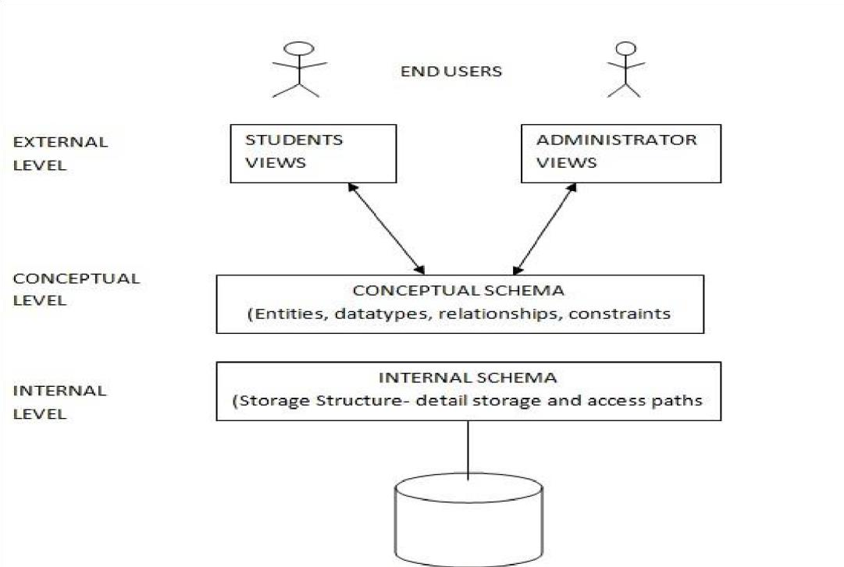

With the implementation of the web based application which will become online platform for use by the Industrial Liaison office and students, administration of industrial attachment programme will become a lot faster and hustle-free. The system is expected to generate report based on the information provided by the students which can be printed out, as and when it is needed. The report generated will be in various formats such as Microsoft Excel for further analysis to be done on it. Since the new system being developed is Web-based (online), students will be able to access the system anywhere once they have internet connectivity. Students can use the system to generate attachment letter and address it to respective companies.(Simpson, 2016)

A prototyping approach was chosen.

Architectural design

The advantage of this is to make administrative coordination of industrial attachment by the Industrial Liaison Office cost effective, effortless in terms of efficiency and also less time consuming.

**2.3.3:** **Case 3: Perception of Industry in Botswana towards Botho University Student Industrial Attachment (SIA) program.**

In August 2011, as part of Botho University’s (BU) focus on employability, the University developed a six month Botho Graduate Profile (BGP) Internship Programme (student industrial attachment). Since the programme was introduced in 2011, the first batch of students to go on the attachment programme in their second year of their study were those studying for Bachelor of Science degree in Computing. Furthermore, it is noteworthy that the programme has since been adopted in other faculties.(Svotwa et al., 2014)

The goal of the programme is to give students an appreciation of the relevance of their curriculum to the job market and to develop essential qualities in students to make them employable. It is a full module and receives grade points just like any other module. Students are expected to submit a 5000 word attachment report which will be assessed and the grades obtained will be taken into consideration for the student to proceed to the Top up programme.

The attachee will be responsible for facilitating regular communication with his/her Attachment Tutor and getting the Weekly Log Book signed on a weekly basis. The Attachment Tutor will make at least two onsite visits and meet with the intern’s supervisor during the internship. Interns are not allowed to change employers once confirmation has been made to Career Services Department by the employer (Career Services department, 2014). The Career Services

Department at BU maintains a database of prospective employers and the Career Services Manager is tasked with the responsibility of placing all third year undergraduate students at different companies in Botswana.(Svotwa et al., 2014)

However, industry has never been afforded the opportunity to provide their sentiments, perceptions and observations of the BU SIA programme. Again, the Faculty of Computing has viewed their relationship with industry as confined to placing students on attachment only.

The conditions for an effective attachment included:

1. Relevance of curricula
2. Quality of available resources
3. Quality of trainers
4. Attitude of students

Challenges to this attachment included:

1. Competition for attachment places from other institutions.
2. Rough and tough work environment for students.
3. Male dominated working environment for female trainees.
4. High expectations by firms accepting attachee

**2.3.4: Case4: Challenges facing induction training programmes for students on industrial attachment in Kenya by Koskey J.A – Maasai Mara University.**

The objective of this study was to determine the challenges facing the induction training programmes for student on industrial attachment in Kenya. The sample groups of 150 students on attachment and 25 workplace supervisors were randomly selected from their respective sampling frames of which self-administered and researcher-administered questionnaires were used to collect data. Interview schedules for key informants in industry were also used to get some data. Quantitative data analysis for the study revealed that some challenges were facing induction training programmes for students on the attachment in Kenya.

The challenges stated were:

1. Student trainees do not have free access to machines and equipment to work with.
2. Student trainees spend a lot of money traveling from their places of residence to workplace.
3. Industries are suspicious of students on the attachment programme.
4. Students spend a lot of time in finding placement for the industrial attachment.
5. Supervision from workplace and training institution supervisors is not effective.

The interviews revealed major issues faced by the students which included: lack of finances to carry out well planned induction training for the students, lack of comprehensive job description for each of these students, and accidents, spoiled work and damage to industry machines & equipment. Challenges encountered by Industries for embracing induction training for the students included: possible expenses in case of accidents to students while being inducted, low production level during the time of induction training, and poor performance, breakage, scrap and wastage of materials during the induction training.

From the findings, the study concluded that there should be more assistance needed (e.g.

reimbursements) for industries to support the induction training programmes for the students. The study did recommend the need for the government to assist in addressing challenges facing induction training programmes in industries in order to support the student attachment programme.

The aim of this research was to examine the perception of industry in Botswana on the BU SIA programme and the challenges industry faces when engaging BU students on industrial attachment.

# 2.4: EMERGING TRENDS AND PATTERNS IN RESEARCH AREA

Additional and continuous training is needed to make acquired skills more adaptable to the changing work environment because there is no actual training that can prepare an individual for the rest of their lives.

In an effort to bridge theory and practice, most universities, colleges and training institutions have incorporated a work-based learning which is the Industrial attachment program where students get attached to firms and industries and the expected outcomes of the program include acquisition of conceptual knowledge that has a practical orientation and a wide application of generic skills that are vital in the modern workplace.

Most institutions provide their students with an industrial attachment logbook which is a document that is divided into days, weeks and months. The student records the activities performed on a daily basis on the attachment. Then the logbook is handed over by the student to school at the end of the attachment period for purposes of evaluation.

Due to the advanced technology, institutions are adopting web based technologies to conduct industrial attachment thereby introducing an Industrial Attachment Management system which allows students to record their daily activities, skills gained online and in real –time. This means that a physical logbook is replaced.

This new technology is effective as it saves on paperwork, records are also not lost in the name of theft of being ruined by water and dust. It helps in distributing supervisors to students and for data storage for future use.

# 2.5: RESEARCH GAP TO BE FILLED BY MY RESEARCH

The purpose of this research is to develop a purposeful model that will make it easier for both the student, the institution supervisor and the company supervisor to conduct the attachment exercise. Thus, proposing an Industrial Attachment Management System which will replace the handbook.

This system will enable students’ record their skills and their daily activities in time, they will not have to carry their logbooks daily to their respective attachment areas as the logbook will be a system that could be accessed on their phones.

The institution supervisor on the other hand will be able to supervise the student from anywhere without having to visit the attachment area. Hence, saving on transport costs, travelling to and fro and being able to supervise multiple students in time.

# 2.6: CHAPTER SUMMARY

After analyzing all these cases, it is clear that they are limited to digitization of industrial attachment records and logbook generations.

The proposed industrial attachment management system seeks to do all that and more by gathering and storing digitally comprehensive students details, industrial attachment supervisors details, company supervisor details including the respective attachment places and it aid sin effective decision-making and analysis.

It also seeks to provide an online platform where students could check their progress during the attachment period and students could update their online logbook in real-time. This will let a student update his or her logbook from wherever they are.

Getting feedback and comments from students and supervisors is important for easy supervision and to just know how the attachment period is going on. The previous cases have not provided this functionality. The proposed system has provided a platform for a student doing the attachment period to provide her feedback as well as comment on the logbook. The same case applies to both the company supervisor and the institution supervisor.

**CHAPTER THREE: RESEARCH METHODOLOGY**

# 3.1: CHAPTER INTRODUCTION

This chapter aims at providing detailed descriptions of the research methodology that was adopted to carry out the research project and to develop the proposed industrial attachment management system based on the researcher’s objectives and the problem in discussion. The methodologies for the literature review, system analysis, system design, implementation and testing will be discussed in this chapter.

# 3.2: METHODOLOGY FOR LITERATURE REVIEW

A literature review can be just a simple summary of the sources, but it usually has an organizational pattern and combines both summary and synthesis. It demands a range of skills, such as learning how to define topics for exploration, acquiring skills of literature searching and retrieval, developing the ability to analyze and synthesize data as well as becoming adept at writing and reporting, often within a limited time scale**.**(Ramdhani et al., 2014)

A literature review refers to the process of identifying the current knowledge including substantive findings, as well as theoretical and methodological contributions to particular topics.

This research will be carried out to obtain information about past or present researches done to solve the problem at hand. We will use secondary sources to carry out our research such as articles, journals, online sources such as websites, as well as tertiary sources such as statistics from different countries within and out of Africa carried out in the area of study, research topics that are from the year 2010 and above and sources below this year will not be used as they are outdated.

# 3.3: METHODOLOGY FOR REQUIREMENTS SPECIFICATIONS, DATA COLLECTON AND ANALYSIS TECHNIQUES

The following methods were carried out for the requirement analysis:

## 3.3.1: Interviews

Interviews are carried out by posing various questions to students, lecturers who conduct the supervision, industrial attachment coordinator and various industry supervisors. This is done in order to collect more information on the industrial attachment in the institution and for research purposes, to gain direct information about the specific topic.

This will be done in the university and in industries that offer attachment to students by asking them how the challenges of the logbook have negatively affected them and how they would like the current system to include in order to remedy this, in order to benefit them and in order to make things easier to them.

## 3.3.2: Questionnaires

In this approach. Printed questionnaires were given to some of the students, lecturers and coordinators to fill in the blank spaces. An online survey link was posted on WhatsApp and Telegram groups in order to get the much-needed feedback anonymously and this really helped the researcher to know the operation of the existing system.

Questionnaires allow system analysts to collect data from large number of people while maintaining uniform response, when dealing with large audience, no other fact finding can tabulate the same facts as efficiently.

Sample questions will include:

1. What is your department as a student or a lecturer?
2. Would you prefer the document which is the manual system or an automated system?
3. Are you able record your activities in a timely manner?
4. Is the document safe?

## 3.3.3: Observation

Observation is the process of closely observing or monitoring someone or something and especially significant details**.**

In most cases, we come to conclusions based on the events that we observe as most people are used to observing events in their daily, personal and professional lives.

Observation technique is a very effective means of depicting how a user does their activities as it gives the researcher a better understanding of what is happening in the culture and lends credence to one’s interpretations of the observation. Participant observation also enables the researcher to collect both quantitative and qualitative data through surveys and interviews.

The researcher moved around the school and to various industrial attachment areas especially during the period when attachment commences to see how he process of issuing logbooks , distributing supervisors and signing of the logbooks is being handled, how reports are being produced and what methods were in place for producing reports. Through observation, the researcher found out how data was collected and methods used for producing reports.

# 3.4: METHODOLOGY FOR SYSTEM ANALYSIS

The current system should be outlined as follows:

The system is unreliable as access to previous records is uncertain. It is so difficult for the project coordinator to trace past records of students who went for attachment and for the supervision lecturers as there is no centralized storage of records. Files are stored in cabinets and drawers making searching a tiresome process.

The process of picking the logbook is timely as students have to queue at the secretary’s office to pick their logbooks and the process of signing and filling in details on paper takes time.

The system inaccurate as students could enter their details more than once or the lecturers may be allocated more students or less students all these is redundant.

There is too much paper work to be done: the student has to print a logbook that will cover at least 12 weeks of attachment, the lecturers need to have at least two checklist sheets per student all these could be easily lost or misplaced as documents are prone to physical lose.

Report processing is untimely as one has to fill in details from a specific location this hinders decision making and its time consuming.

# Data flow diagram of the current system

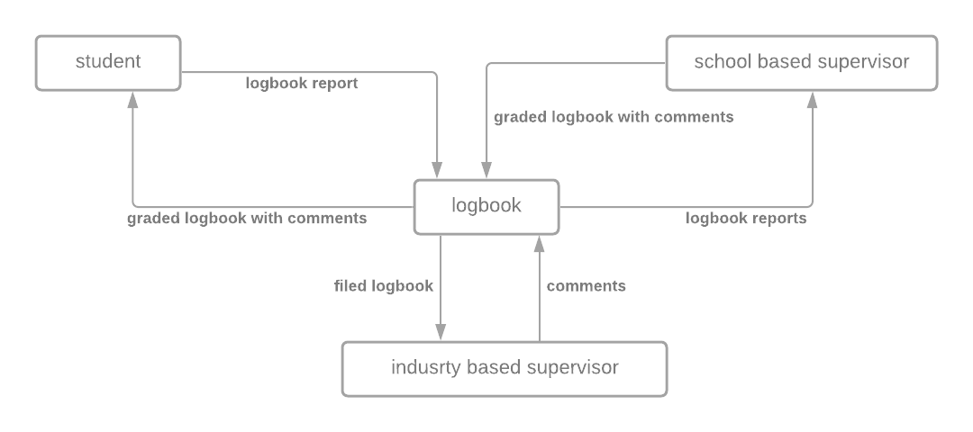

**Flow charts for the current system**

# Issuing of student logbook flowchart

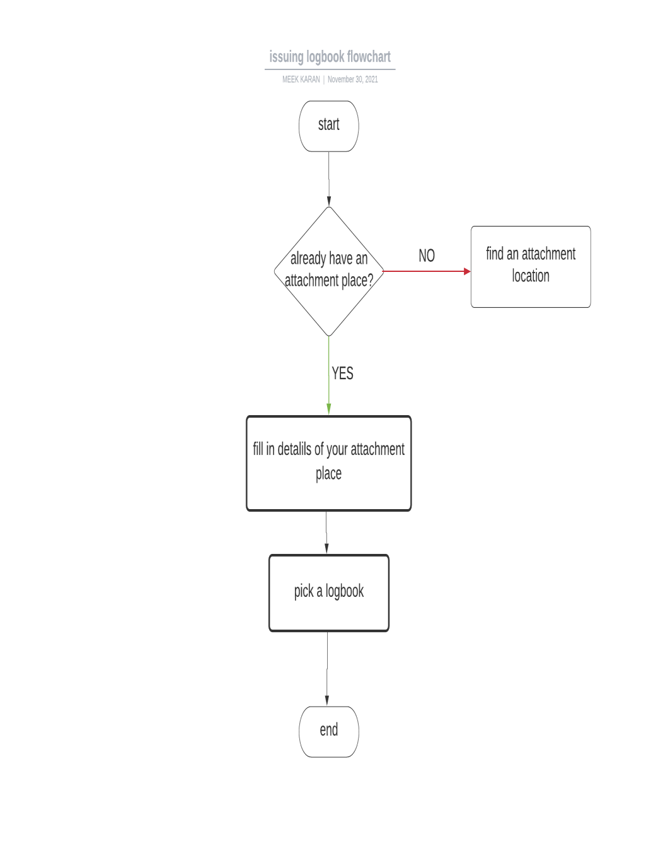

# Attachment coordinator flowchart

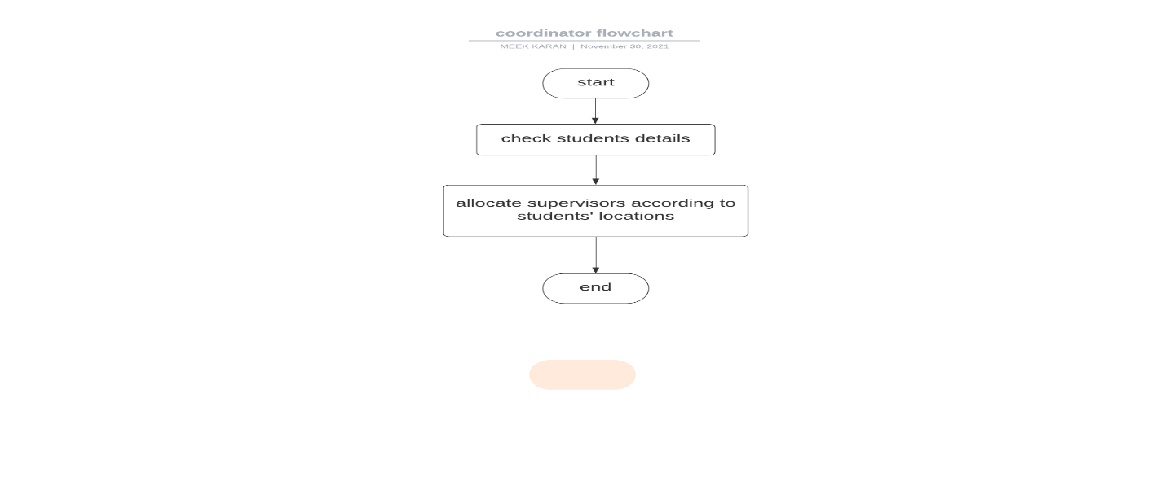

# 3.5: METHODOLOGY FOR SYSTEM DESIGN

The analysis of the requirement acquired has led to the development of an online-based system for managing records within the institution.

The database will be developed using MySQL and PHPMyAdmin.

The programming framework of the system will be done using HTML, CSS, PHP and JavaScript.

There will be removal of redundancies by normalization of the data in order to get the right material to be entered into the tables to be used for the system.

The system design objectives include:

1. Usability
2. Performance
3. Reliability
4. Software architecture

# Data flow Diagram for the proposed system

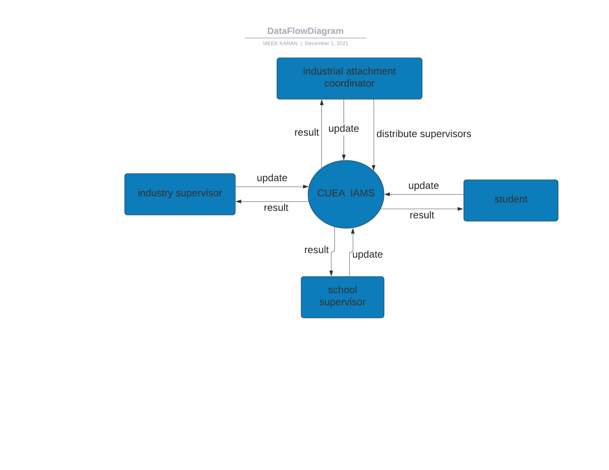

# 3.6: METHODOLOGY FOR SYSTEM IMPLEMENTATION

**The tools and techniques used in this project are as follows:**

1. Local hosting: XAMPP/WAMPP
2. Coding: Visual Studio Code
3. Database: MySQL
4. Creating UML Diagrams: Lucid chart and Microsoft Visio

**Techniques used:**

1. **Front-End:** HTML, CSS, JavaScript, JQuery

## 2. Back-End: PHP

3. **Database:** MySQL and PHPMyAdmin

**Resources Needed:**

1. **Processor:** Intel core 13, Dual-core CPU or higher
2. **SSD:** Minimum 256 GB
3. **RAM:** 4GB or higher

# 3.7: METHODOLOGY FOR SYSTEM TESTING

System testing is concerned with testing an entire system based on its specifications, and involves several activities such as functional testing (testing from behavioral descriptions of the system) and performance testing (response time and resource utilization) [5]. In other words, the implementation under test is compared to its intended specification.(Briand & Labiche, 2001)

Some of the testing which will be discussed at a later chapter are:

**3.7.1: Acceptance Testing**

Acceptance testing is a method for system testing which is used to examine whether or not the final piece of software is ready for delivery. This testing involves ensuring that the final product is in compliance with the original criteria of the business and it should also meet the user’s needs. This whole process requires that the product be tested both internally and externally. Moreover, you will need to get it into the hands of your end users personal testing and for beta testing.

**3.7.2: Unit Testing**

Unit test is the testing of a single C function in isolation, using a test harness to provide inputs to the function under test, collect and then check the outputs produced. Called functions are normally replaced by test stubs to provide complete control(Briand & Labiche, 2001)

In this testing methodology, the system will be broken down into smaller modules by the developer then by using sample data, test each system separately, each module at a time. After which the modules will be integrated and tested as a whole. This whole process is necessary to help the developer classify modules then single out th ones that need to be corrected or the once that need improvement. The process is also important as it will help to gauge the functionalities and independence of different modules.

The testing methodologies are: Functional Testing and Non-Functional testing under which you know have the different types of testing as listed above.

**3.8: METHODOLOGY FOR SYSTEM DEPLOYMENT**

System deployment involves assembling and transforming a whole packaged form into a working state that is operational. It’s about converting a product from a development or temporary state to a permanent and desired state. System deployment is every single activity that will eventually make the software system available for use.

**3.9: CHAPTER SUMMARY**

This chapter explains the various techniques that the researcher used for data collection, for analysis and for requirements specifications.

For data collection, the researcher interviewed various students and lecturers about the current system and the use of questionnaires also helped gather information there.

The analysis of the system was checked by coming up with flowcharts and entity relationship diagrams for the system. The design and implementation techniques included using specific programming languages to come up with the system and using various testing techniques like unit testing to test the system and check whether it’s working well.

**CHAPTER FOUR: SYSTEM ANALYSIS (CURRENT SYSTEM)**

**4.1 CHAPRET INTRODUCTION**

System analysis is the process of collecting facts, interpreting facts, problem identification and decomposing a system into smaller components.

It specifies what the system should do and it provides a variety of design methods, analytical tools and it evaluates the techniques

Main purpose of conducting system analysis is to be able to study a system and it parts to identify its objectives. System analysis is a problem solving techniques as it improves the system and it ensures that every component in the system is working efficiently to accomplish its purpose.

**4.2: DESCRIPTION OF CURRENT SYSTEM**

The current system could be outlined as follows:

Strengths

1. The current system records the details of students going for their attachment including their attachment regions and their starting and ending date.
2. The system records the details of lecturers needed to supervise the students together with the students they will supervise.
3. The system keeps records of previous attachment sessions for the purpose of reference.

Weaknesses

1. The current system is very unreliable as it’s uncertain to access previous records. Tracing past records is a challenge as there is no centralized storage of records. Searching for documents is also tiresome as files are stored in drawers and cabinets.
2. Accessibility of resources is limited to only one industrial attachment coordinator therefore everything has to be dealt in one office or by one person.
3. Due to too much paperwork to be done, there is wastage of resources and a lot of labor is redirected into searching for important files.
4. The current system is inaccurate as it follows redundancy.
5. Untimely report production and processing is another problem associated with this current system and this hinders decision-making.
6. Allocating supervisors to students is another big issue as there is a lot of clashing and one supervisor being allocated more students that another which leads to a lot of confusion and delays in students’ supervision.

**4.3: FEASIBILITY STUDY**

**4.3.1: Technical Feasibility**

The university would comfortably adapt to the proposed system as there is enough resources to set it up and to accommodate the new system. The hardware would replace the space that was previously occupied by manual filling cabinets. The institution would require to set up their own database server together with the server host or another option would be to use hosting providers.

The system would be viable as the same data that was handled before will be maintained the only difference is the previous one was manual whereas the new system is a different and an automated format.

**4.3.2: Economic Feasibility**

The online industrial attachment management system is meant to save on a lot of costs including the costs of purchasing of record books, printing logbooks and filling cabinets. The researcher found out that the institution required to purchase a desktop and set up a network to facilitate the system. This makes the system economically viable as it reduces on the costs required for the implementation.

**4.3.3: Operational Feasibility**

The research will come up with a user-friendly platform. The design is based on current online industrial attachment record filling system that will have functionalities fit to assist both the students and the supervisors to have an easy time navigating through the system and be able to use it accurately without compromising the data security.

**4.3.4: Schedule Feasibility**

The whole project is scheduled to take a span of six months until it is complete. The project is divided into phases; from the initialization phase to the implementation phase. This is to ensure an easy transition from one stage to another.

The initial phase involves gathering the requirements of the systems, followed by analysis of the system and designing of the system, coding, testing the system and finally maintenance and implementation of the entire system.

This research project is viable as it will only take a few months to develop a system which is effective and efficient.

**4.4: DATA I/O ANALYSIS**

The current industrial attachment management system is a manual file based system that uses physical records written down on paper. Data captured in this system include:

1. Students’ details: name. registration number and email
2. School supervisor details
3. Attachment details: region, address, name
4. Logbook
5. Attachment period: month and year

The student has to fill in a form about the attachment region, attachment supervisor, company name, company address then the form is taken to the attachment coordinator who will record the students’ details then use the information to assign supervisors to students.

These documents to be easily lost or misplaced as they are many. Data can be easily deleted or added without a trace as the physical files have no secure log of who accessed them. There is absence of data security as anyone who can get access to the physical files can alter data that has been stored in those files.

**4.5: PROCESS LOGIC DESIGN OF CURRENT SYSTEM**

**Data Flow Diagram of Current System**

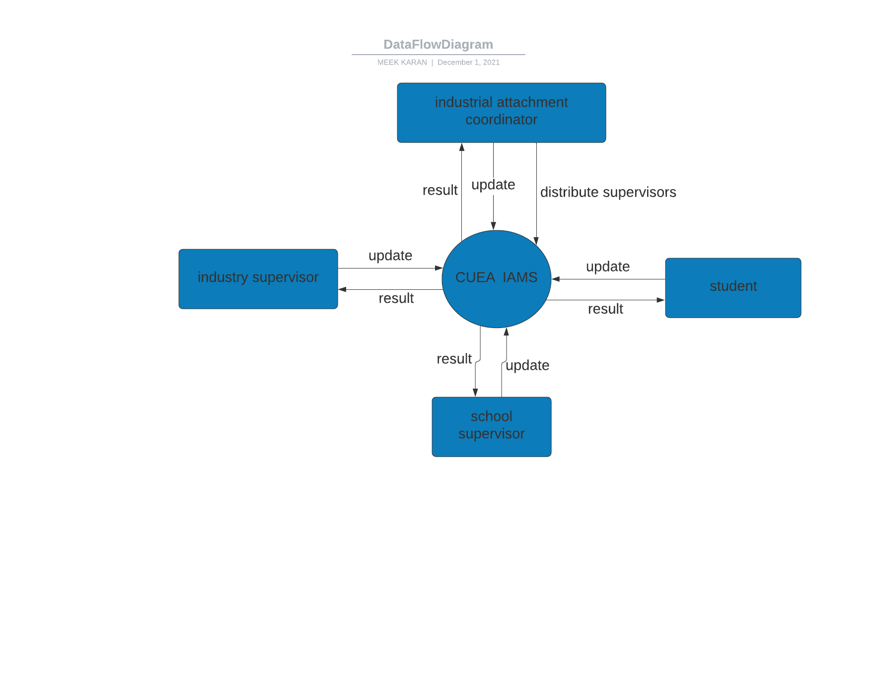

**UML diagram showing current system processes**

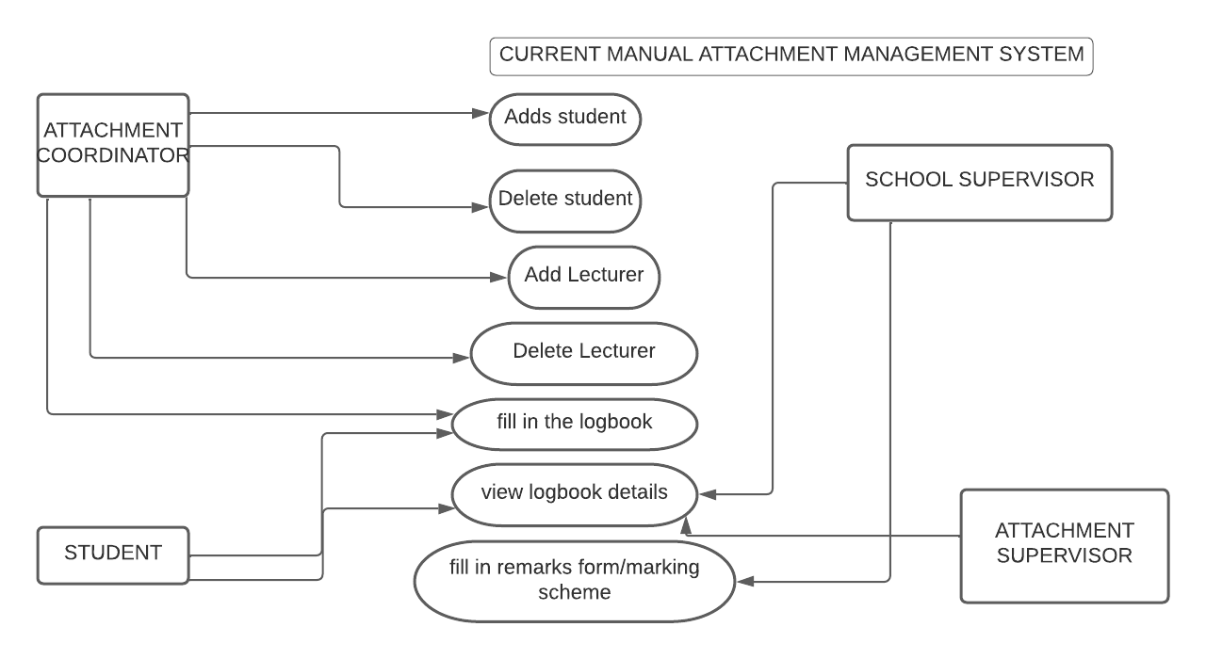

**4.5: CHAPTER SUMMARY**

This chapter is about how the current system works, the strengths and the weaknesses of the system it also explains how data is circulated within the system: who is in charge of information, how information is received and how information is sent. with the help of data flow diagrams and uml diagrams we can see how the students do relate with the supervisors and how the school supervisor relates with the attachment supervisor and how the coordinator interacts with both the supervisors and the students.

**CHAPTER 5: SYSTEM DESIGN OF THE PROPOSED SYSTEM**

**5.1: INTRODUCTION**

The high-level strategy for solving an [information flow] problem and building a solution .Includes decisions about organization of functionality. Allocation of functions to hardware, software and people. Other major conceptual or policy decisions that are prior to technical design.(Engineering, n.d.)

System design is the process of defining elements in a system in terms of their modules, their components, its architecture and their interfaces based on specific requirements. It involves defining, developing and designing systems which satisfies the specific requirements and specific needs of an organization or any business.

**5.2: THE PROPOSED SYSTEM**

With the deficiencies of the current manual system, this proposed system will provide a single integrated system where all the students, institution supervisors and company supervisors’ information will be stored in a single centralized system. The students will have their personal identification details on the system. They will be able to view their logbooks online, and record them online, they will also be able to submit their reports online without having to submit them physically to the office. Both supervisors will be able to view their personal details, view the students’ logbooks and be able to leave a comment. The attachment coordinator will be able to assign supervisors from the system and he could view all the details of each individual. Maintenance of these records will be easier and so efficient compared to the manual system.

**Advantages of proposed system**

1. Efficient organization of records belonging to all the users of the system.
2. The student is able to fill in the logbook I anytime and anywhere.
3. The lecturer can view the details of the logbook in time.
4. Data security is enhanced as not all users have access to the same information.
5. Information lookup is easy.
6. Data collected from this system could be used for further analysis : analyzing the companies where students go mostly for future reference

**Disadvantages of proposed system**

1. Problem of high initial cost of implementing the system as necessary hardware and software needs to be purchased.

**5.3: REQUIREMENT ANALYSIS**

**REFERENCES**

1. Chinyemba, F., & Bvekerwa, S. (2012). Assessment of Industrial Attachment: Issues and

Concerns of Chinhoyi University of Technology’s Undergraduate Degree Programme, Zimbabwe. *Online Submission*, *12*, 985–996.

1. Simpson, T. (2016). *Adoption of Web Based Technology to Facilitate Industrial Attachment Schemes in Tertiary Institutions : A Case Takoradi*. 66–84.
2. Svotwa, T. D., Rudhumbu, N., & Chikari, G. (2014). Perceptions of industry in Botswana towards Botho University student industrial attachment (SIA) programme. *The Business & Management Review*, *5*(2), 205–216.

https://search.proquest.com/docview/1559079412?accountid=39660%0Ahttp://otago.hosted .exlibrisgroup.com/openurl/OTAGO/OTAGO_SERVICES_PAGE?url_ver=Z39.882004&r ft_val_fmt=info:ofi/fmt:kev:mtx:journal&genre=article&sid=ProQ:ProQ%3Aabiglo bal&atitle=Perceptions+

4.Briand, L., & Labiche, Y. (2001). A UML-based approach to system testing. In *Lecture Notes in Computer Science (including subseries Lecture Notes in Artificial Intelligence and Lecture Notes in Bioinformatics)* (Vol. 2185). https://doi.org/10.1007/3-540-45441-1_15 Ramdhani, A., Ramdhani, M., & Amin, A. (2014). Writing a literature review research paper: A step-by-step approach. *International Journal of Basic and Applied Science*, *3*(1), 47–56.

5.Briand, L., & Labiche, Y. (2001). A UML-based approach to system testing. In *Lecture Notes in Computer Science (including subseries Lecture Notes in Artificial Intelligence and Lecture Notes in Bioinformatics)* (Vol. 2185). https://doi.org/10.1007/3-540-45441-1_15

Engineering, A. S. (n.d.). *System Design*. 1–27.