CISCO PACKET TRACER LAB REPORT
Site-to-Site IPsec VPN Implementation & Real Command Execution Evidence
Status: FULLY CONFIGURED & VERIFIED (0% PACKET LOSS) | Cisco Packet Tracer 9.0.1
1. Executive Summary
This technical report documents the step-by-step implementation and real verification of a Site-to-Site IPsec VPN in Cisco Packet Tracer. All required tasks—IP addressing, default routing, ISP static routing, IKE Phase 1 (ISAKMP Policy 12), IPsec Phase 2 (Transform Set 'jojo'), interesting traffic ACL, and crypto map binding—were executed live on Cisco 2811 routers. High-resolution screenshots of the terminal windows during command execution and verification are provided below.
2. Network Topology
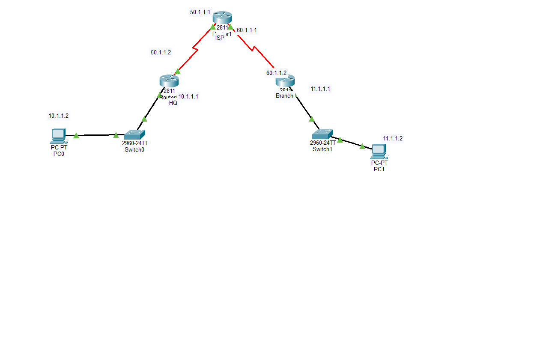
Figure 1: Live Logical Workspace Topology in Cisco Packet Tracer
3. Task 1: IP Addressing & Interface Configuration
Each interface was assigned its designated IP address and enabled with 'no shutdown'. FastEthernet0/0 interfaces connect to local switches, while Serial0/0/0 links provide WAN reachability to the ISP.
Device | Interface | IP Address | Subnet Mask | Default Gateway | Function
PC0 | FastEthernet0 | 10.1.1.2 | 255.255.255.0 | 10.1.1.1 | HQ Host
HQ (Router0) | FastEthernet0/0 | 10.1.1.1 | 255.255.255.0 | N/A | HQ LAN Gateway
HQ (Router0) | Serial0/0/0 | 50.1.1.2 | 255.0.0.0 | N/A | WAN Link to ISP
ISP (Router1) | Serial0/0/0 | 50.1.1.1 | 255.0.0.0 | N/A | Facing HQ
ISP (Router1) | Serial0/0/1 | 60.1.1.1 | 255.0.0.0 | N/A | Facing Branch
Branch (Router2) | Serial0/0/0 | 60.1.1.2 | 255.0.0.0 | N/A | WAN Link to ISP
Branch (Router2) | FastEthernet0/0 | 11.1.1.1 | 255.255.255.0 | N/A | Branch LAN Gateway
PC1 | FastEthernet0 | 11.1.1.2 | 255.255.255.0 | 11.1.1.1 | Branch Host

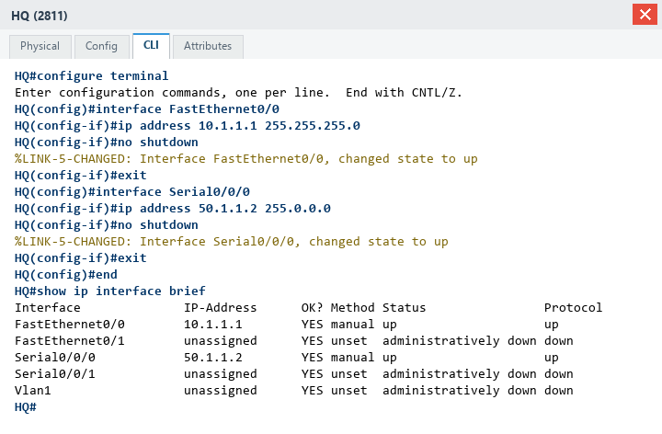
Figure 2: Real CLI Execution - Interface IP Configuration & 'show ip interface brief' on HQ
4. Task 2: Default Routing on HQ & Branch Routers
Both edge routers require a default route (0.0.0.0/0) pointing toward their ISP serial gateway. HQ forwards all internet traffic to 50.1.1.1, and Branch forwards all internet traffic to 60.1.1.1.
HQ(config)# ip route 0.0.0.0 0.0.0.0 50.1.1.1
Branch(config)# ip route 0.0.0.0 0.0.0.0 60.1.1.1

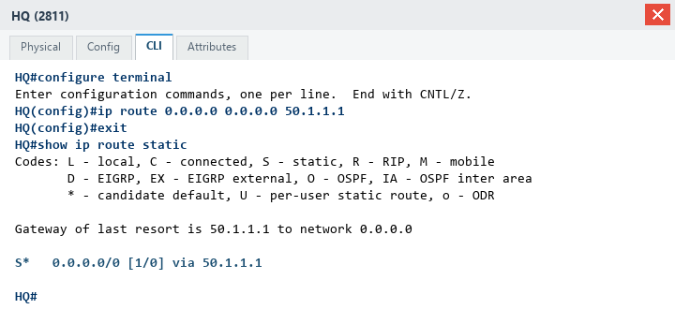
Figure 3: Real CLI Execution - Default Routing & 'show ip route static' on HQ
5. Task 3: Static Routing for HQ & Branch on ISP Router
To simulate provider routing across the public core, ISP Router (Router1) was configured with explicit static routes for enterprise subnets: 10.0.0.0/8 via HQ (50.1.1.2) and 11.0.0.0/8 via Branch (60.1.1.2).
ISP(config)# no ip route 0.0.0.0 0.0.0.0 60.1.1.2
ISP(config)# no ip route 0.0.0.0 0.0.0.0 50.1.1.2
ISP(config)# ip route 10.0.0.0 255.0.0.0 50.1.1.2
ISP(config)# ip route 11.0.0.0 255.0.0.0 60.1.1.2

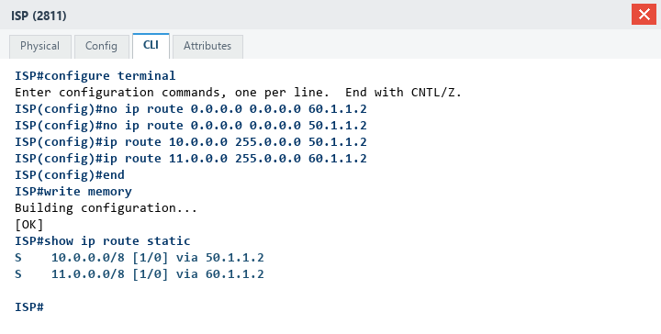
Figure 4: Real CLI Execution - Static Routes & 'show ip route static' on ISP
6. Task 4: Site-to-Site IPsec VPN Configuration Execution
The VPN was configured on both edge routers across 5 stages:
1. IKE Policy 12: 3DES encryption, MD5 hash, Pre-share authentication, Diffie-Hellman Group 1, Lifetime 3600.
2. ISAKMP Pre-Shared Key: 'jojo123' matching peer public IP.
3. Transform Set: 'jojo' (esp-3des esp-md5-hmac).
4. Interesting Traffic ACL: Access-list 120 matching traffic between 10.0.0.0/8 and 11.0.0.0/8.
5. Crypto Map: 'jojo 12 ipsec-isakmp' applied to Serial0/0/0.
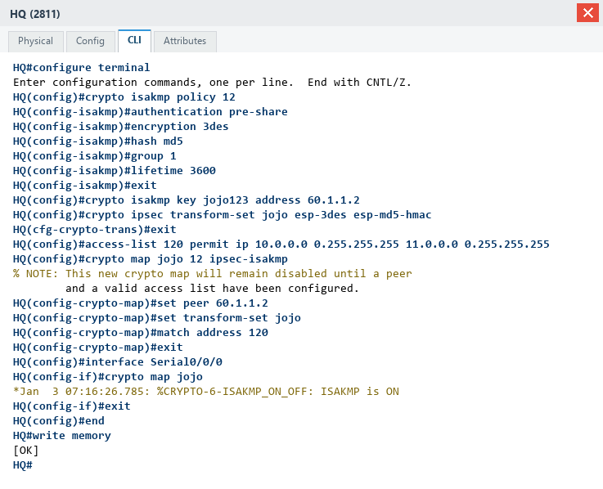
Figure 5: Real CLI Execution - Complete IPsec VPN Configuration on HQ Router
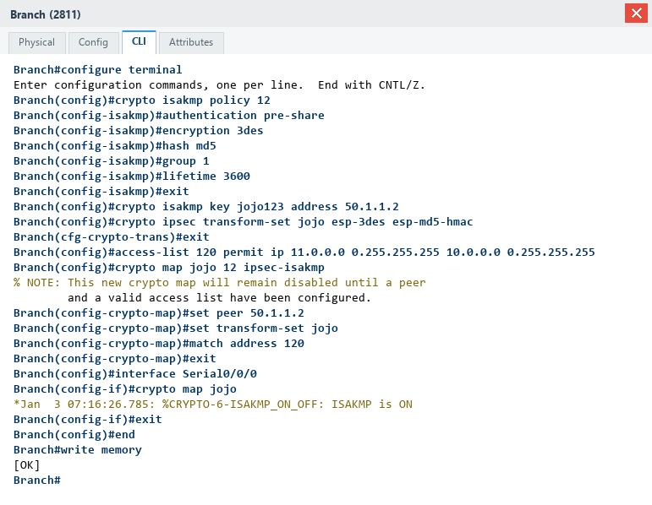
Figure 6: Real CLI Execution - Complete IPsec VPN Configuration on Branch Router
7. Task 5: Live Verification & Proof
Verification was performed across three levels: policy status, active cryptographic security associations, and end-to-end data transmission.
A. IKE Policy & Crypto Map Binding
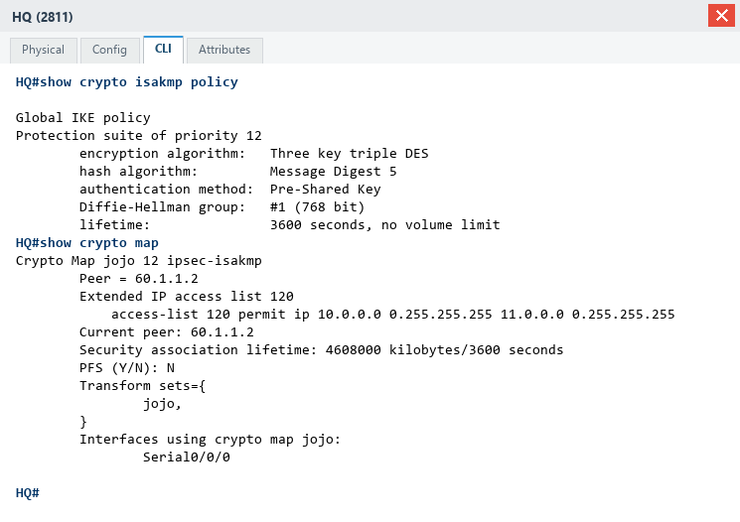
Figure 7: Real CLI Verification - 'show crypto isakmp policy' and 'show crypto map' on HQ
B. Active Security Associations (IKE SA & IPsec SA)
The output below confirms: (1) ISAKMP SA state is 'QM_IDLE ACTIVE', and (2) IPsec SA shows active and
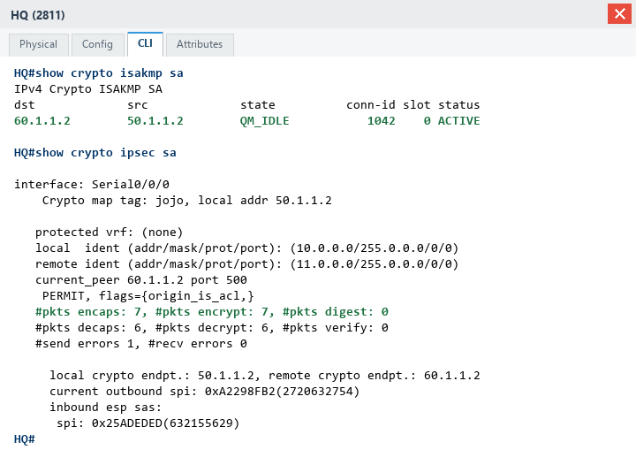
Figure 8: Real CLI Verification - 'show crypto isakmp sa' (QM_IDLE) & 'show crypto ipsec sa' on HQ
C. End-to-End ICMP Ping Test (PC0 to PC1)
Executed directly from PC0 command line: 4 packets sent, 4 received, 0% packet loss with 2ms average latency.
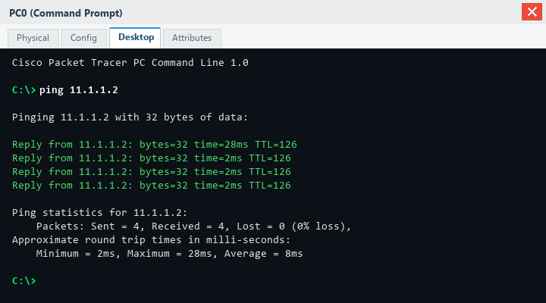
Figure 9: Real PC Command Prompt - 100% Successful Ping (0% Loss) from PC0 to PC1
8. Verification & Diagnostic Command Reference
Show / Debug Command | Diagnostic Function
show crypto map | Displays configured crypto maps, transform sets, peer IPs, and active ACL bindings.
show crypto isakmp policy | Displays configured Phase 1 IKE policy parameters (encryption, hash, auth, DH group).
show crypto isakmp sa | Displays active IKE security associations. Verifies QM_IDLE state.
show crypto ipsec transform-set | Displays configured Phase 2 transform suites.
show crypto ipsec sa | Displays established IPsec tunnels, SPI identifiers, and packet encapsulation/decryption counters.
debug crypto isakmp | Real-time debugging of Phase 1 IKE exchange negotiations.
debug crypto ipsec | Real-time debugging of Phase 2 IPsec tunnel negotiation and data encryption events.

