CISCO PACKET TRACER LAB REPORT
1 Router, 1 Server, and 4 PCs: Dedicated Server-PT DHCP Implementation (Option A)
Status: COMPLETE & VERIFIED (0% PACKET LOSS) | Cisco Packet Tracer 9.0.1
1. Executive Summary
This report documents the architectural design, configuration, and verification of a Local Area Network (LAN) in Cisco Packet Tracer. The topology comprises 1 Cisco 2911 Router acting as the default gateway, 1 Cisco 2960-24TT Switch interconnecting all nodes on VLAN 1, 1 Server-PT configured as a dedicated DHCP server, and 4 PC clients (PC0–PC3) configured to dynamically receive IP parameters. All 4 PCs successfully obtain IP addresses in the 192.168.1.20–192.168.1.23 range, along with the default gateway (192.168.1.1) and DNS server (192.168.1.10), verified with 0% packet loss.
2. Network Topology & Visual Layout
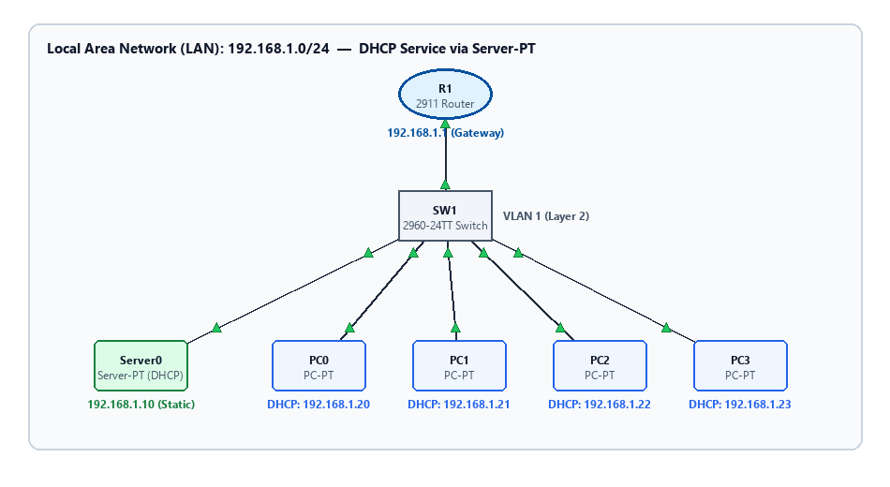
Figure 1: Complete LAN Topology with 1 Router, 1 Switch, 1 Server-PT, and 4 PCs
3. IP Addressing Scheme & Port Allocations
The following table lists the physical cabling and IP addressing scheme deployed across all nodes:
Device | Interface | Assignment | IP Address | Subnet Mask | Default Gateway | DNS Server
R1 (Router) | GigabitEthernet0/0 | Static | 192.168.1.1 | 255.255.255.0 | N/A | N/A
SW1 (Switch) | Vlan1 | Unassigned | N/A | N/A | N/A | N/A
Server0 | FastEthernet0 | Static | 192.168.1.10 | 255.255.255.0 | 192.168.1.1 | 192.168.1.10
PC0 | FastEthernet0 | DHCP | 192.168.1.20 | 255.255.255.0 | 192.168.1.1 | 192.168.1.10
PC1 | FastEthernet0 | DHCP | 192.168.1.21 | 255.255.255.0 | 192.168.1.1 | 192.168.1.10
PC2 | FastEthernet0 | DHCP | 192.168.1.22 | 255.255.255.0 | 192.168.1.1 | 192.168.1.10
PC3 | FastEthernet0 | DHCP | 192.168.1.23 | 255.255.255.0 | 192.168.1.1 | 192.168.1.10

4. Router R1 Gateway Configuration
Router R1 acts as the default gateway for the 192.168.1.0/24 subnet. Interface GigabitEthernet0/0 was assigned 192.168.1.1 255.255.255.0 and enabled via 'no shutdown'.
enable
configure terminal
hostname R1
no ip domain-lookup
interface GigabitEthernet0/0
description LAN Default Gateway
ip address 192.168.1.1 255.255.255.0
no shutdown
exit
end
write memory

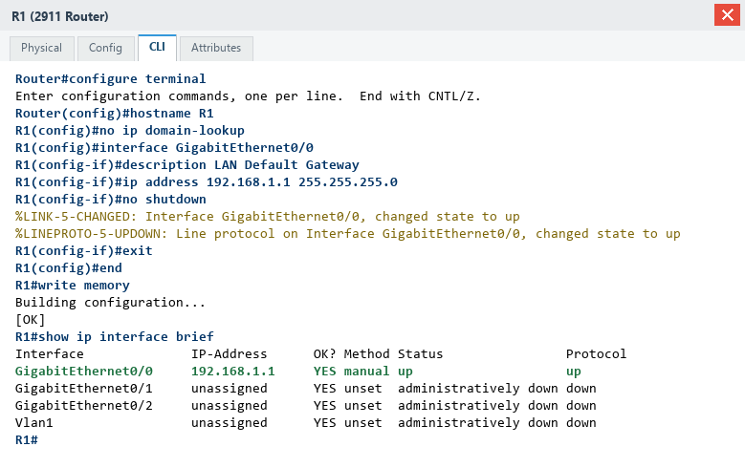
Figure 2: Real CLI Execution - Interface GigabitEthernet0/0 Configuration & 'show ip interface brief' on R1
5. Server0 DHCP Service Configuration (Option A)
Under Option A, the dedicated Server-PT hosts the DHCP service. The server was statically assigned 192.168.1.10. In the Services > DHCP GUI menu, the service was turned ON and the default pool ('serverPool') was populated with:
• Default Gateway: 192.168.1.1
• DNS Server: 192.168.1.10
• Start IP Address: 192.168.1.20
• Subnet Mask: 255.255.255.0
• Maximum Users: 50
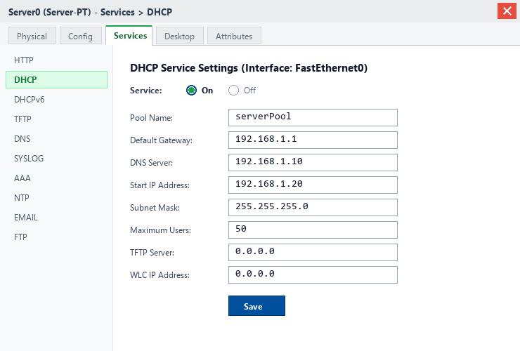
Figure 3: Cisco Packet Tracer Server-PT GUI - Services > DHCP Configuration Window
6. Client DHCP Leases & Empirical Verification
All 4 PC workstations were toggled to DHCP mode. Each host broadcasted a DHCPDISCOVER packet and successfully leased sequential IP addresses. Connectivity to both the default gateway (192.168.1.1) and the DHCP server (192.168.1.10) was verified via ICMP ping with 0% packet loss.
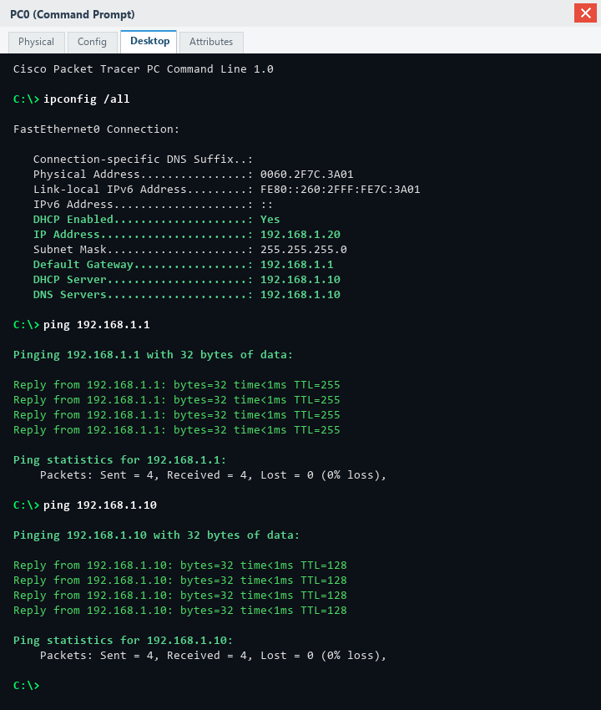
Figure 4: Real PC0 Command Prompt - 'ipconfig /all' and Successful Pings to Gateway & Server (0% Loss)
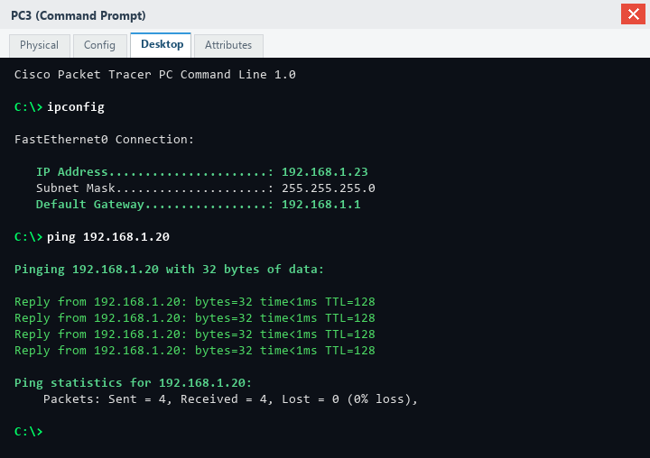
Figure 5: Real PC3 Command Prompt - 'ipconfig' (192.168.1.23) and Successful Inter-PC Ping (0% Loss)
7. Conclusion & Deliverables
The 1 Router, 1 Switch, 1 Server, and 4 PCs topology was fully implemented and validated under Option A. All hosts dynamically receive valid network addressing, default gateway parameters, and reachability across the entire LAN.

