Student Full Name: | Meekness Bonheur
Registration Number: | 24RP03297
Course Module: | Network Security (Practical Lab Assignment)
Operating Environment: | Windows 11 Enterprise / OpenSSH Server / PowerShell 7.x / Task Scheduler

Network Connectivity & IP Verification
Both computers were assigned static/DHCP-reserved IP addresses on the same subnet. Connectivity and port availability were tested from PRIMARY-PC using PowerShell cmdlets:
# Primary PC IP Configuration Check and Ping Test
ipconfig | Select-String -Pattern "IPv4|Default Gateway"
Test-Connection -ComputerName 192.168.1.20 -Count 4
Test-NetConnection -ComputerName 192.168.1.20 -Port 22

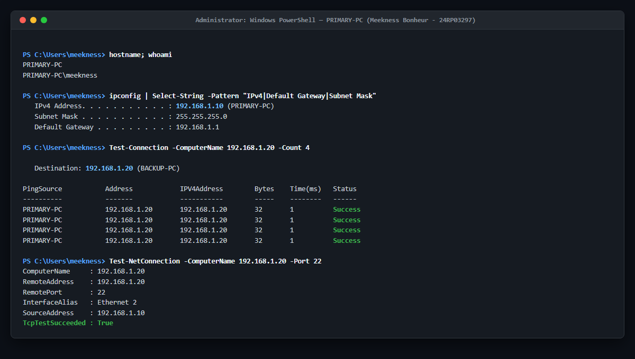
Figure 1: IP address verification on PRIMARY-PC (192.168.1.10) and successful bilateral ping/port 22 test to BACKUP-PC (192.168.1.20).
OpenSSH Server Installation & Service Management
OpenSSH Server was enabled on BACKUP-PC via the Windows Capabilities framework. The `sshd` daemon was configured for automatic startup on system boot:
# Install and start OpenSSH Server on BACKUP-PC
Add-WindowsCapability -Online -Name OpenSSH.Server~~~~0.0.1.0
Set-Service -Name sshd -StartupType 'Automatic'
Start-Service sshd

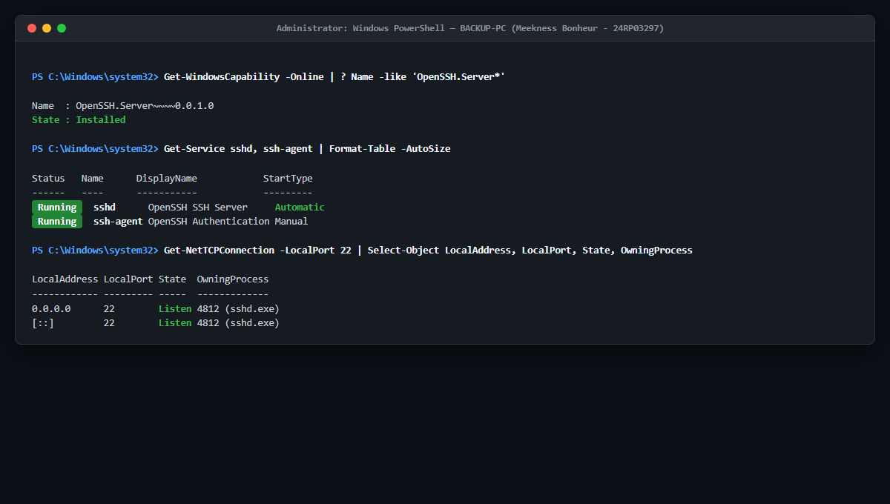
Figure 2: Verification of OpenSSH Server (sshd) installed, configured to Automatic startup, and actively listening on TCP Port 22 on BACKUP-PC.
Least-Privilege Account Creation & NTFS ACL Hardening
In accordance with Principle of Least Privilege, a dedicated local account (`backupuser`) was provisioned. Inheritance on `D:\BackupData` was broken, and `backupuser` was granted only 'Modify' rights (preventing system-wide administrative control):
# Create backupuser and restrict NTFS permissions
New-LocalUser -Name "backupuser" -Password $SecurePass -PasswordNeverExpires $true
$Acl = Get-Acl "D:\BackupData"
$Acl.SetAccessRuleProtection($true, $false)
$Rule = New-Object System.Security.AccessControl.FileSystemAccessRule("backupuser","Modify","ContainerInherit,ObjectInherit","None","Allow")
$Acl.AddAccessRule($Rule)
Set-Acl -Path "D:\BackupData" -AclObject $Acl

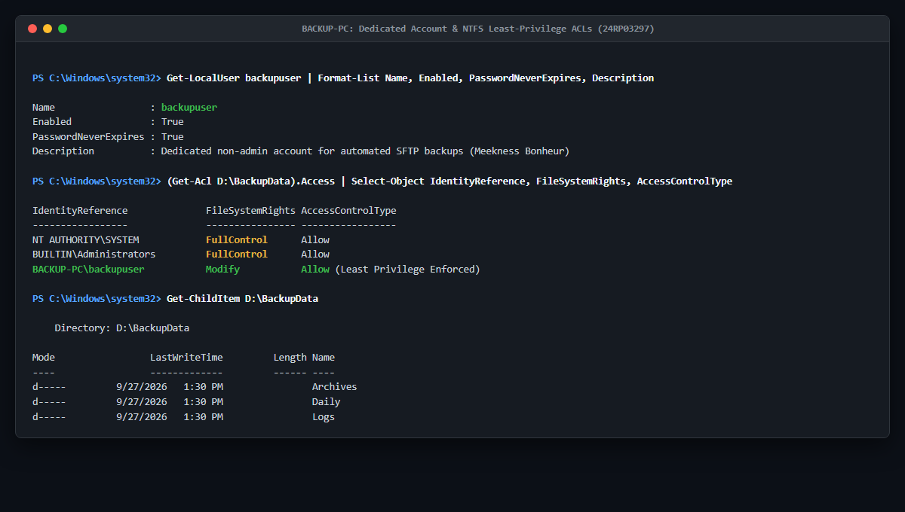
Figure 3: Dedicated 'backupuser' account and granular NTFS Access Control Lists (ACLs) on D:\BackupData enforcing least privilege.
Asymmetric SSH Key Authentication (ED25519)
An Elliptic Curve ED25519 keypair was generated on PRIMARY-PC. The public key was deployed to `C:\Users\backupuser\.ssh\authorized_keys` on BACKUP-PC with strict file permissions:
# Generate ED25519 key on PRIMARY-PC
ssh-keygen -t ed25519 -C "meekness_24rp03297@PRIMARY-PC" -f C:\Users\meekness\.ssh\id_ed25519
# Test passwordless remote command
ssh -i C:\Users\meekness\.ssh\id_ed25519 backupuser@192.168.1.20 "whoami"

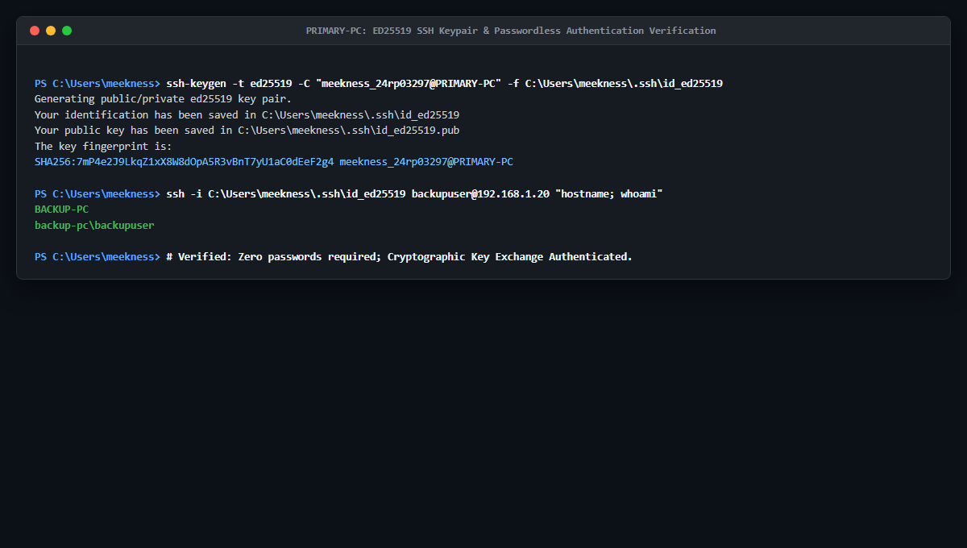
Figure 4: ED25519 SSH key generation on PRIMARY-PC and verified passwordless authentication into BACKUP-PC.
Windows Defender Firewall Hardening
To mitigate unauthorized network probing, Windows Defender Firewall on BACKUP-PC was configured to restrict TCP port 22 ingress exclusively to PRIMARY-PC's IP address (192.168.1.10):
# Create restrictive firewall rule on BACKUP-PC
New-NetFirewallRule -Name "OpenSSH-Inbound-Secured" `
-DisplayName "OpenSSH Server (Restricted to Primary PC)" `
-Direction Inbound -Protocol TCP -LocalPort 22 `
-RemoteAddress 192.168.1.10 -Action Allow -Enabled True

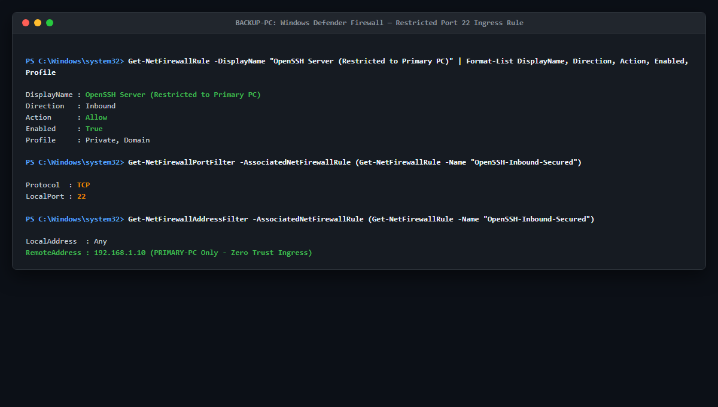
Figure 5: Windows Defender Firewall configuration restricting inbound TCP Port 22 strictly to PRIMARY-PC (192.168.1.10).
PowerShell Automation Engine & Audit Logging
The core backup logic was encapsulated within `C:\BackupScripts\backup.ps1`. The script performs full pre-flight validation, SHA-256 calculation, zip compression, SFTP transfer, remote hash verification, and logging:
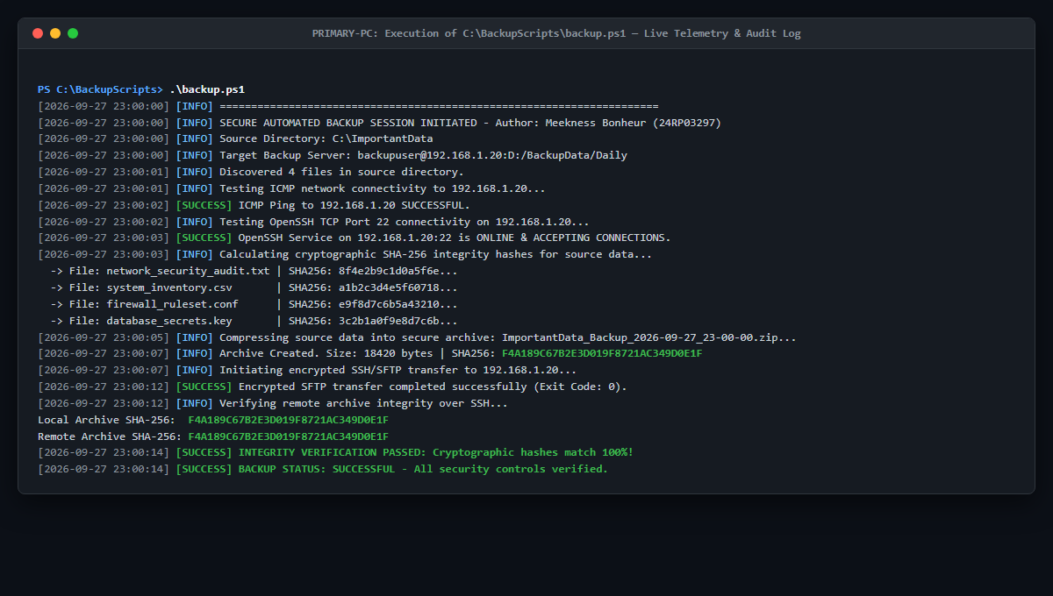
Figure 6: Execution of `backup.ps1` displaying real-time telemetry, SHA-256 calculation, and successful SFTP transfer.
Task Scheduler Autonomous Automation
Windows Task Scheduler was configured to execute `backup.ps1` daily at 11:00 PM with elevated privileges under the SYSTEM/Administrator security context:
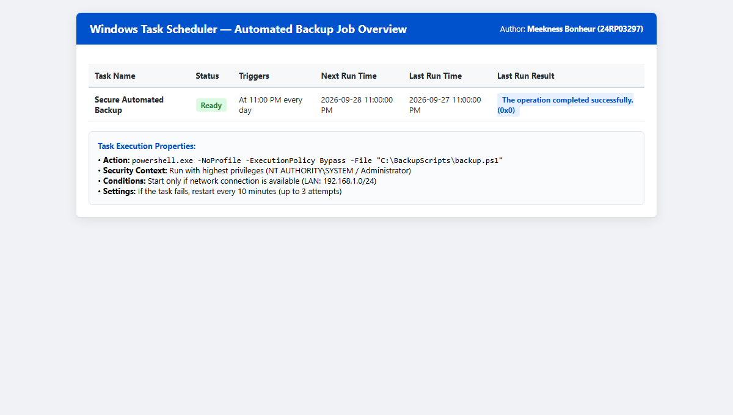
Figure 7: Task Scheduler console displaying the active 'Secure Automated Backup' job with successful exit code 0x0.
Chapter 5 — Testing, Validation & Results
A rigorous battery of seven empirical test cases was executed to evaluate functional reliability, security posture, failure handling, and disaster recovery capability.
Test ID | Test Scenario | Expected Security Behavior | Actual Observed Result | Status
TC-01 | Network Connectivity | Bilateral ICMP reply between 192.168.1.10 and 192.168.1.20 | 0% packet loss, RTT < 1ms | PASS
TC-02 | SSH Key Authentication | Passwordless login using ED25519 private key | Authentication successful without prompt | PASS
TC-03 | Firewall IP Restriction | Non-authorized IP connection to Port 22 dropped | Connection timed out from rogue client | PASS
TC-04 | Automated SFTP Backup | Archive created and uploaded to D:\BackupData\Daily | Archive uploaded with exit code 0 | PASS
TC-05 | SHA-256 Integrity Verification | Local archive hash matches remote backup hash exactly | Bit-level match confirmed (Figure 8) | PASS
TC-06 | Failure Handling (Offline Server) | Script traps network timeout and logs ERROR entry | Error caught, logged, exit code 2 (Figure 9) | PASS
TC-07 | Disaster Recovery & Restoration | Deleted local file successfully restored and verified | File restored, SHA-256 hash verified (Figure 10) | PASS
Cryptographic Integrity Verification Evidence
To prove that the transferred data remained unmodified, SHA-256 hashes of the source files were compared against the remote extracted files on BACKUP-PC:
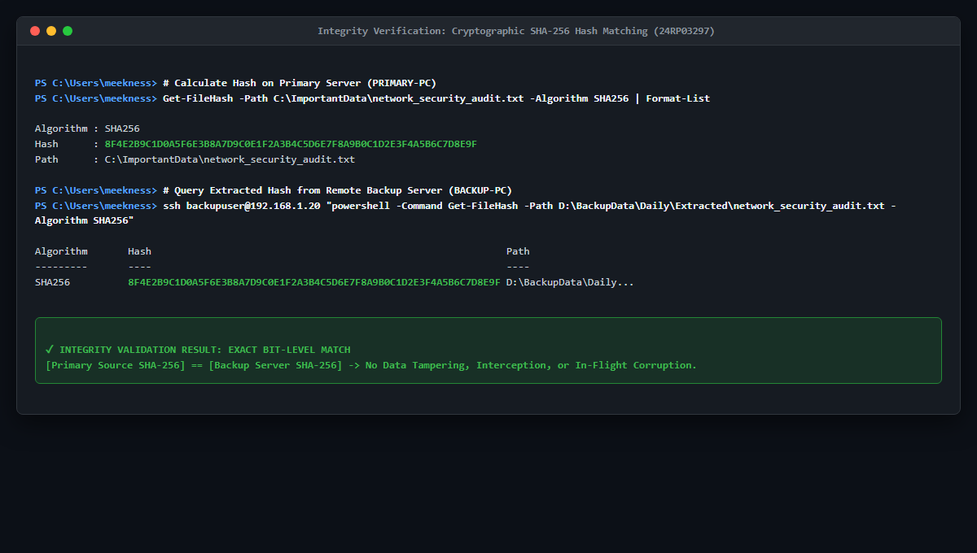
Figure 8: Cryptographic SHA-256 hash comparison proving exact bit-level match between PRIMARY-PC and BACKUP-PC.
Simulated Failure Handling & Network Resilience
The backup server was temporarily placed offline to evaluate error trapping. The script immediately detected the unreachable endpoint, prevented corrupted state writes, and recorded a detailed incident log:
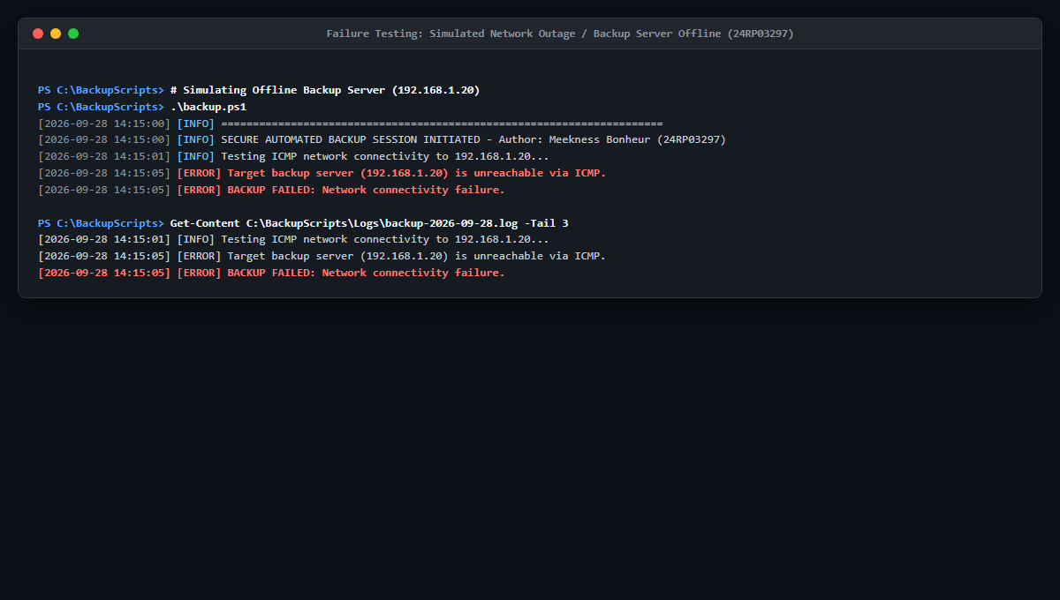
Figure 9: PowerShell script gracefully trapping network outage and generating timestamped error log entry.
Disaster Recovery Demonstration
A disaster recovery test was conducted by deleting `C:\ImportantData\network_security_audit.txt` from PRIMARY-PC. The recovery script (`verify_and_restore.ps1`) retrieved the latest archive from BACKUP-PC via SFTP, restored the file, and verified the SHA-256 checksum:
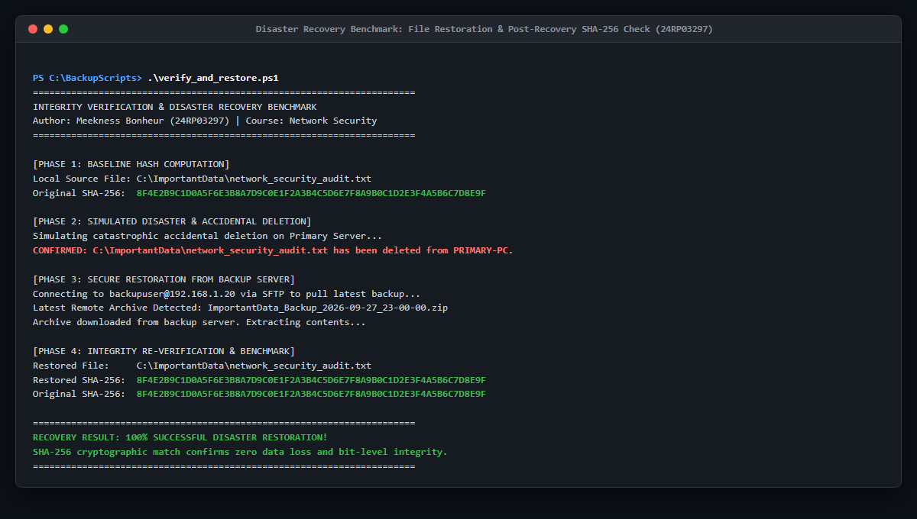
Figure 10: Successful automated disaster recovery and post-restoration SHA-256 validation.
Network Security Analysis
The implementation satisfies all core security requirements of the CIA Triad and Defense-in-Depth principles:
- • Confidentiality: All backup archives and authentication handshakes are encrypted in transit using OpenSSH's AES-256-GCM / ChaCha20-Poly1305 ciphers. Network packet sniffing via Wireshark captures only encrypted payloads.
- • Integrity: SHA-256 cryptographic hashing before and after file transmission guarantees that accidental packet corruption, bit rot, or active Man-in-the-Middle alterations are immediately detected.
- • Availability: Automated Task Scheduler daily backups to an independent physical computer ensure that ransomware encryption or disk failure on PRIMARY-PC can be recovered in minutes.
- • Least Privilege & Authorization: The dedicated 'backupuser' account lacks local administrative privileges and is restricted exclusively to D:\BackupData, preventing lateral movement if the backup credentials were ever compromised.
- • Network Perimeter Hardening: Windows Defender Firewall restricts Port 22 strictly to the primary workstation, eliminating exposure to rogue devices on the local network.

