**User Manual**

Login form:

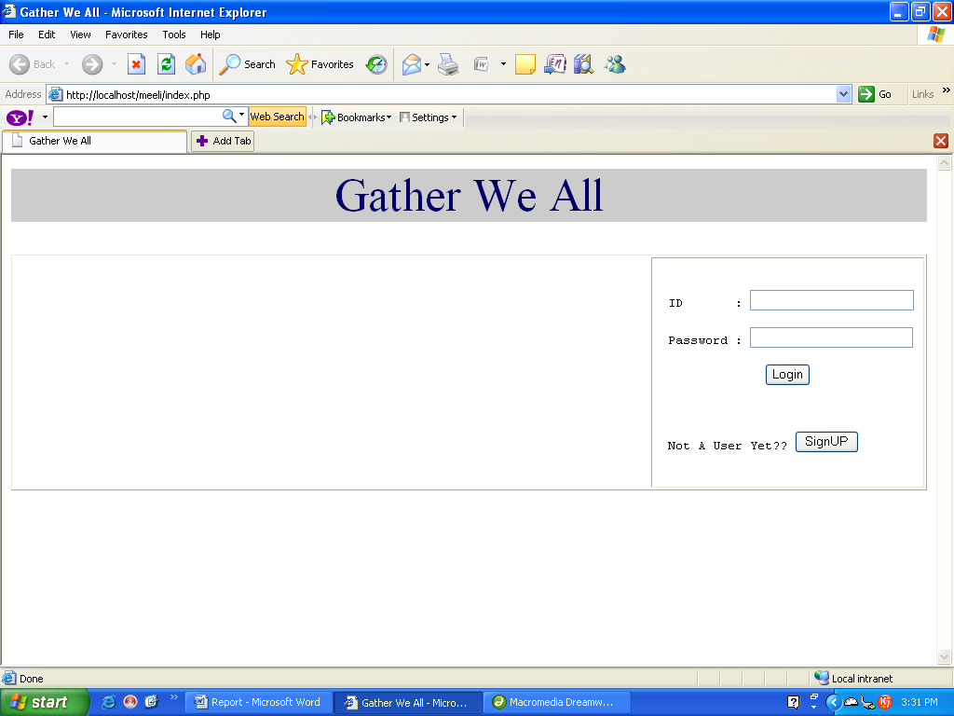

User Home:

If the user is a valid user then the User-home will be displayed as shown below:

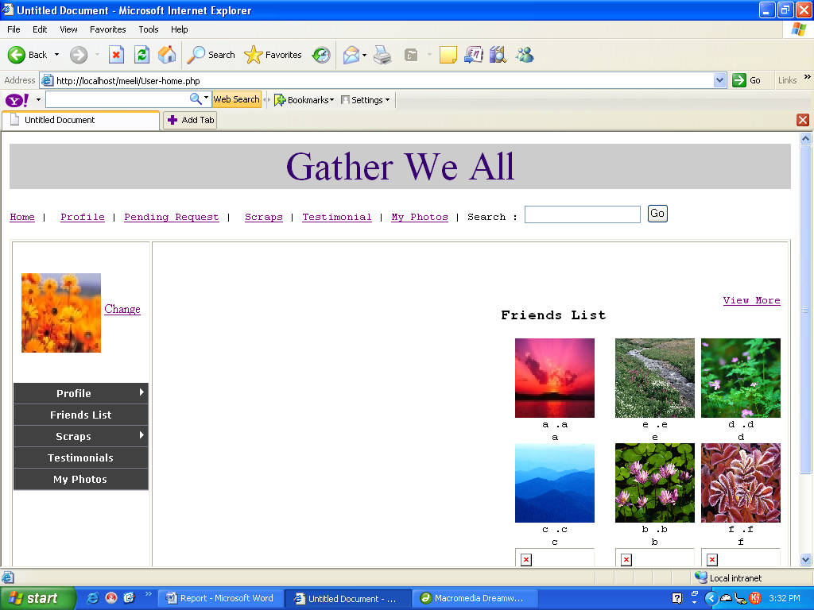

And If not then :

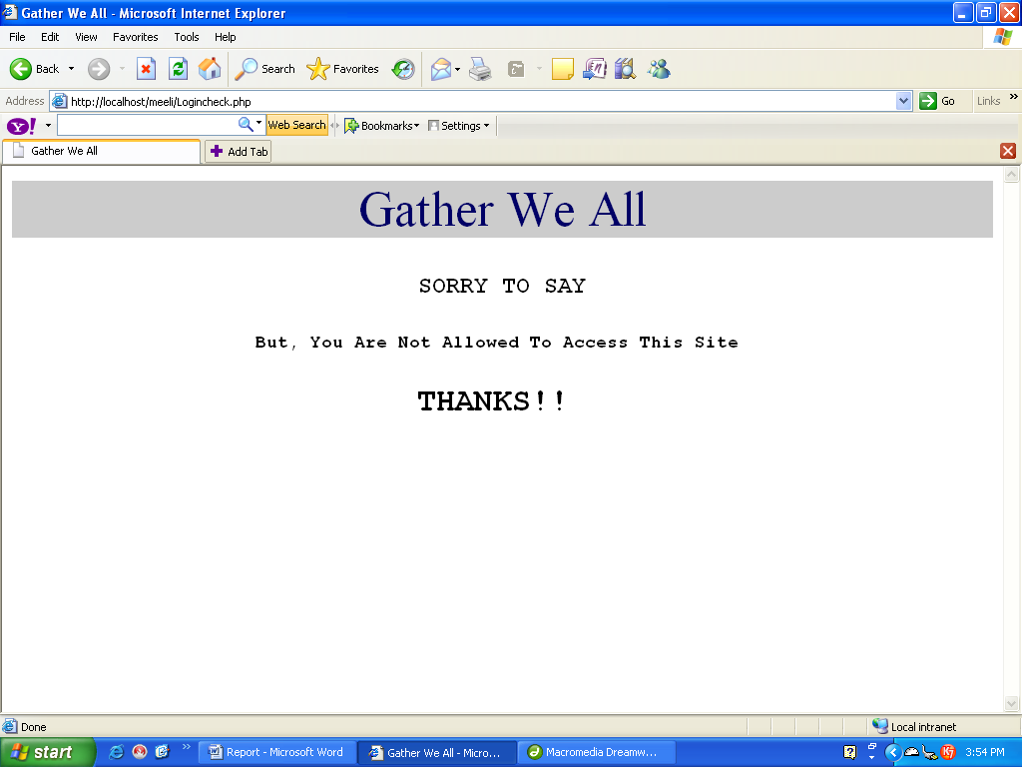

Registration:

In Case you want to be a new user u need register yourself.

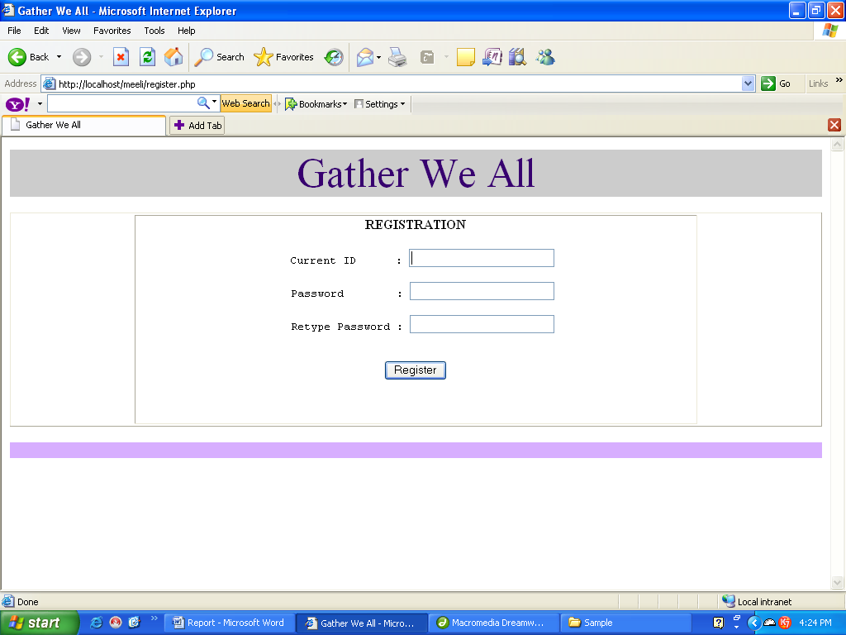

View Profile:

Once the user has successfully logged in the he is permitted to view his profile just by clicking on the Profile button placed either on top or on the left hand side.

The user can view any of the “Social”, ”Professional” or “Personal” profile.

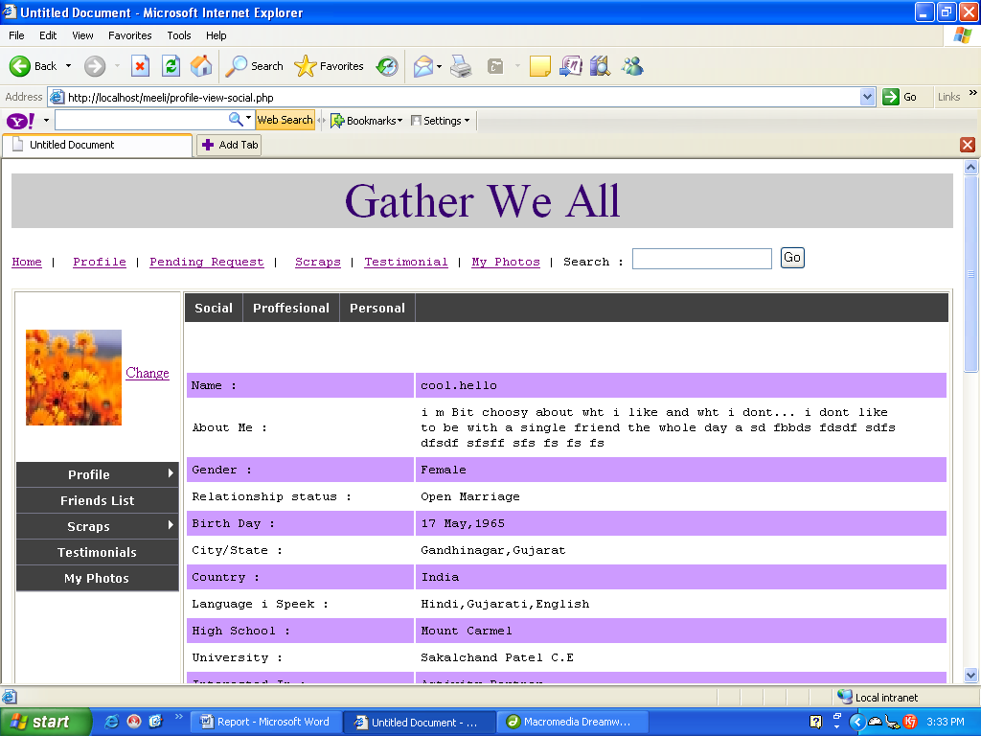

Update Profile:

The user is also permitted to update the details of his profile. In this case the profile is divided into five parts. So the user can make appropriate changes and then just by clicking on the “update” button at the bottom can make changes in their profile.

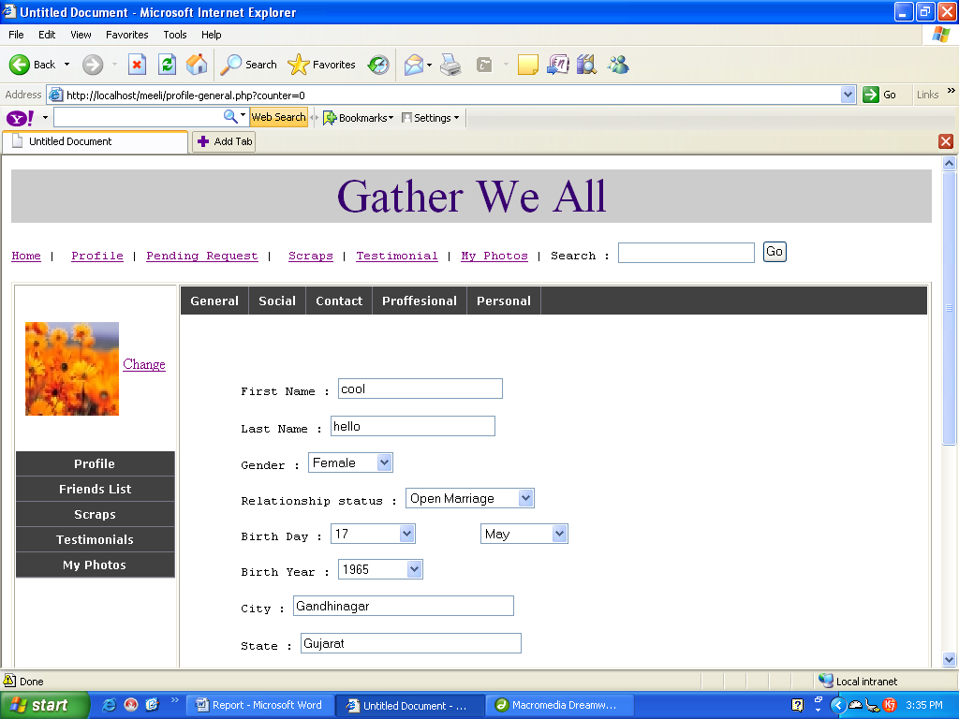

View scraps:

A valid user can also view the messages sent by other friends to him just in one click on the button ‘Scraps.’ In case of any problem he can even delete the useless message.

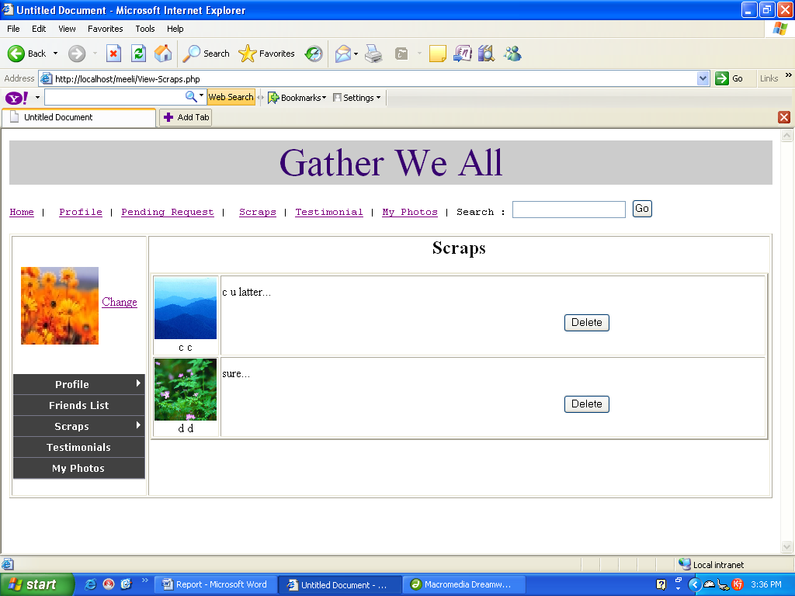

Write Scraps:

The User can write a message to one or more friends by following path ”Scraps->Write scraps->Write to One/Write to Many” on the left hand side Scraps menu.

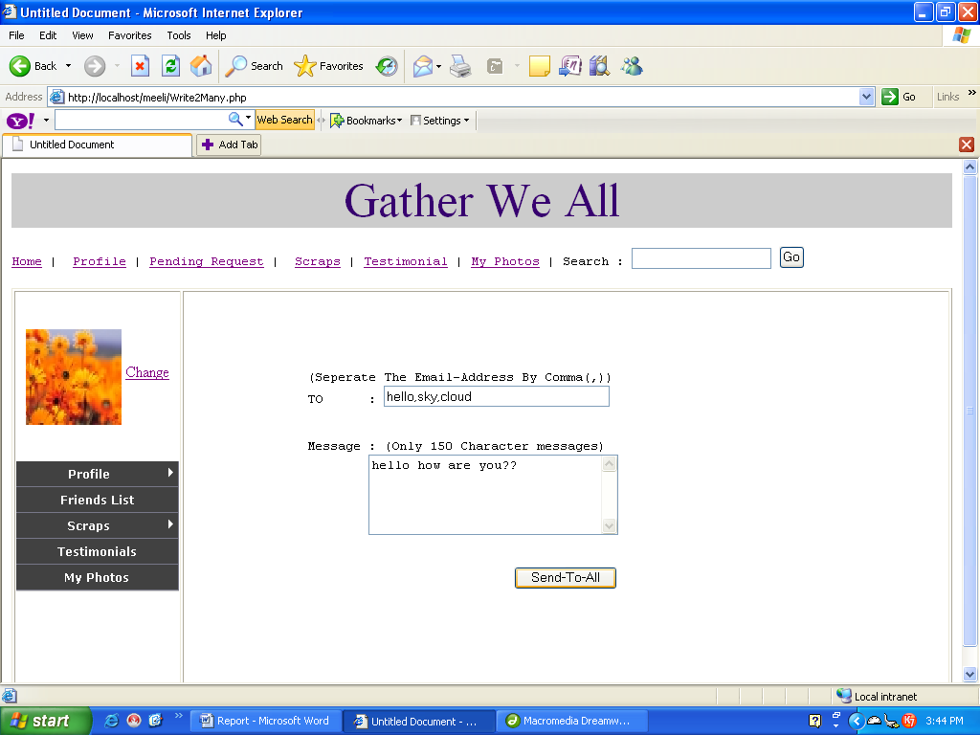

Search friend:

User can make a search for his/her friend by just specifying the “First Name” ,” Last name” or “Email Id” of the friend & then clicking on the “Go” button on the top.

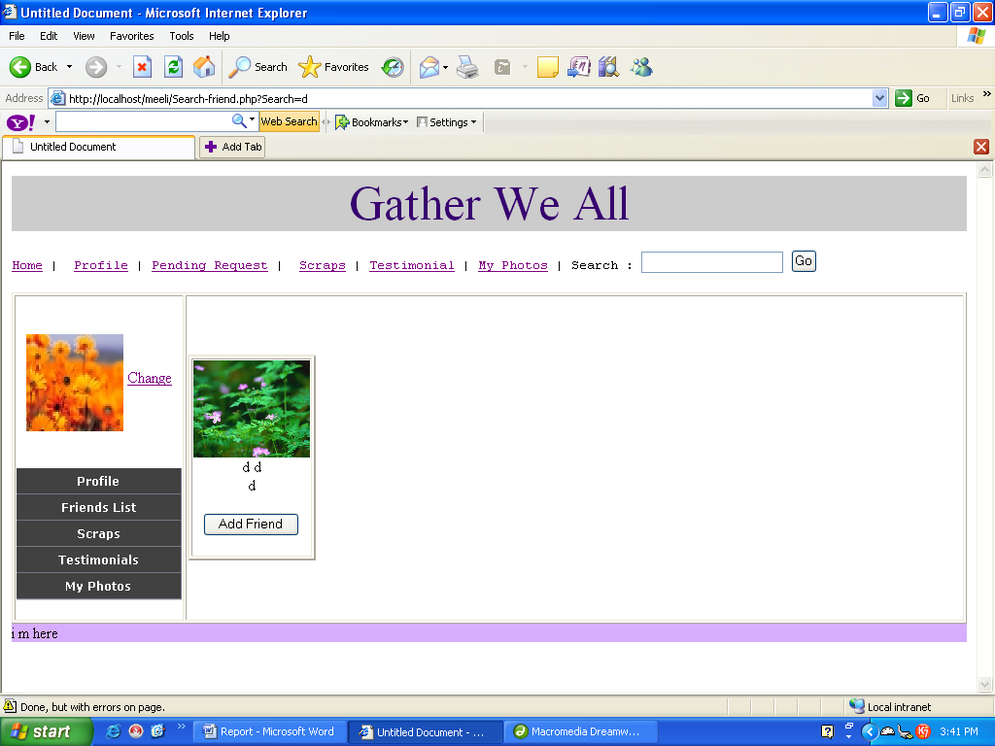

Friends Request:

If the specified person is not in your friends list then in that case you can also add him as a friend by just pressing “Add Friend” button. In case the person is not in your friends list the following message will be displayed.

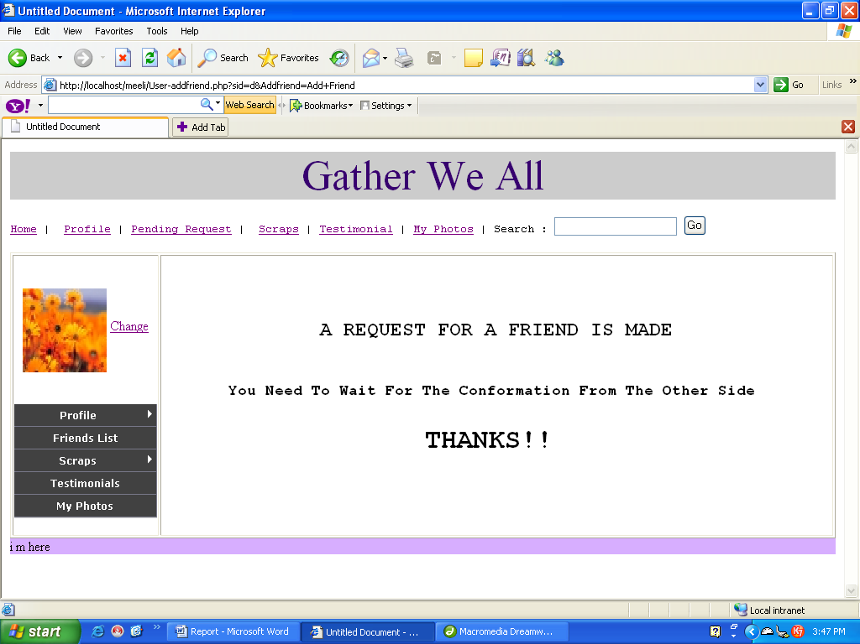

Pending Request:

The Friends Request made by others can be viewed by pressing “Pending Request” button. In case you want to e his friend just click on “Accept Request” button. This will add both of you in each others friends list.

