**Goal and Results**

Shared Economy also termed as collaborative consumption is one of the upcoming business concept. Rise of independent workers associated with job security leads to the rise of shared economy, although the increase of independent workers in U.S. is expected to reach 40% by 2020. Statistics and success of Uber and RideShare worked as an inspiration and motivation in building Student Accommodation System.

Student Accommodation System (SAS) is a user-friendly application which uses shared economy concept to provide a secure and cheap accommodation to students and staff members visiting Lexington campus. The initial plan of SAS included features for local as well as visiting staff/students of Student Family, but with careful consideration and discussion to initially focus on a single aspect of the application which facilitates most of the customers.

We have completed building first prototype of the application which provides user features like new user registration, checking out available accommodation options in Lexington, registering a new hotel room as a host, making the booking for the room as a guest and logout from a user account. Some of the screenshots of the prototype for the already registered user are as follows:

* User Login and registration

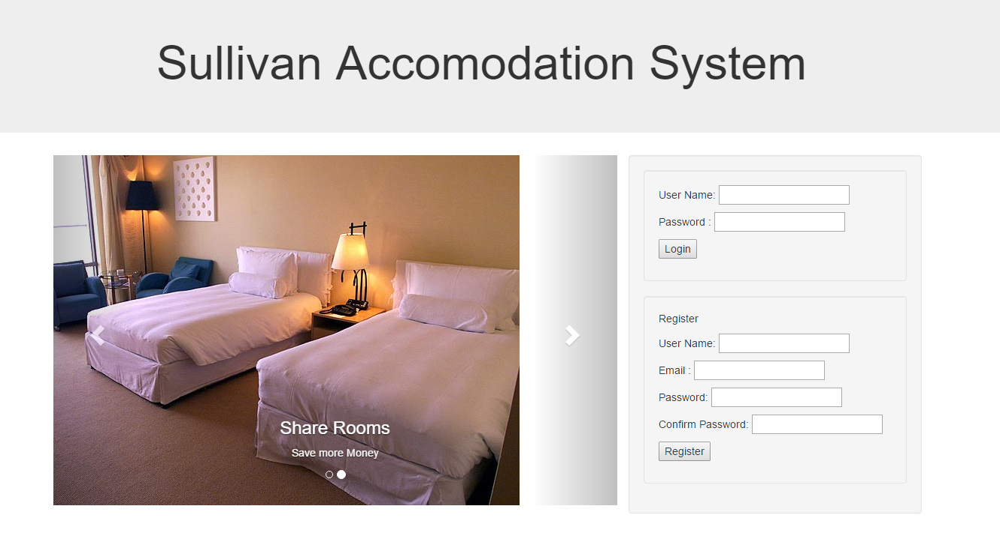

* User Home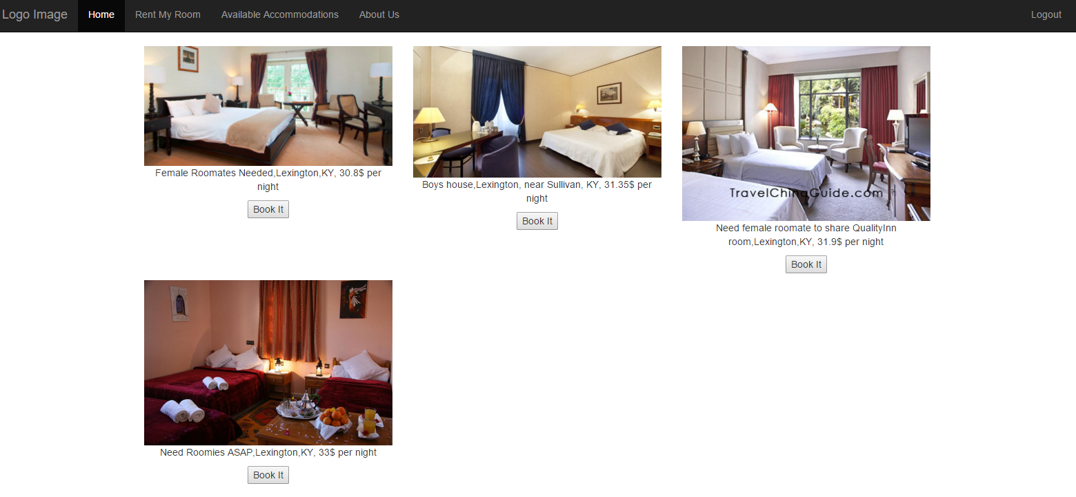
* Rent My Room

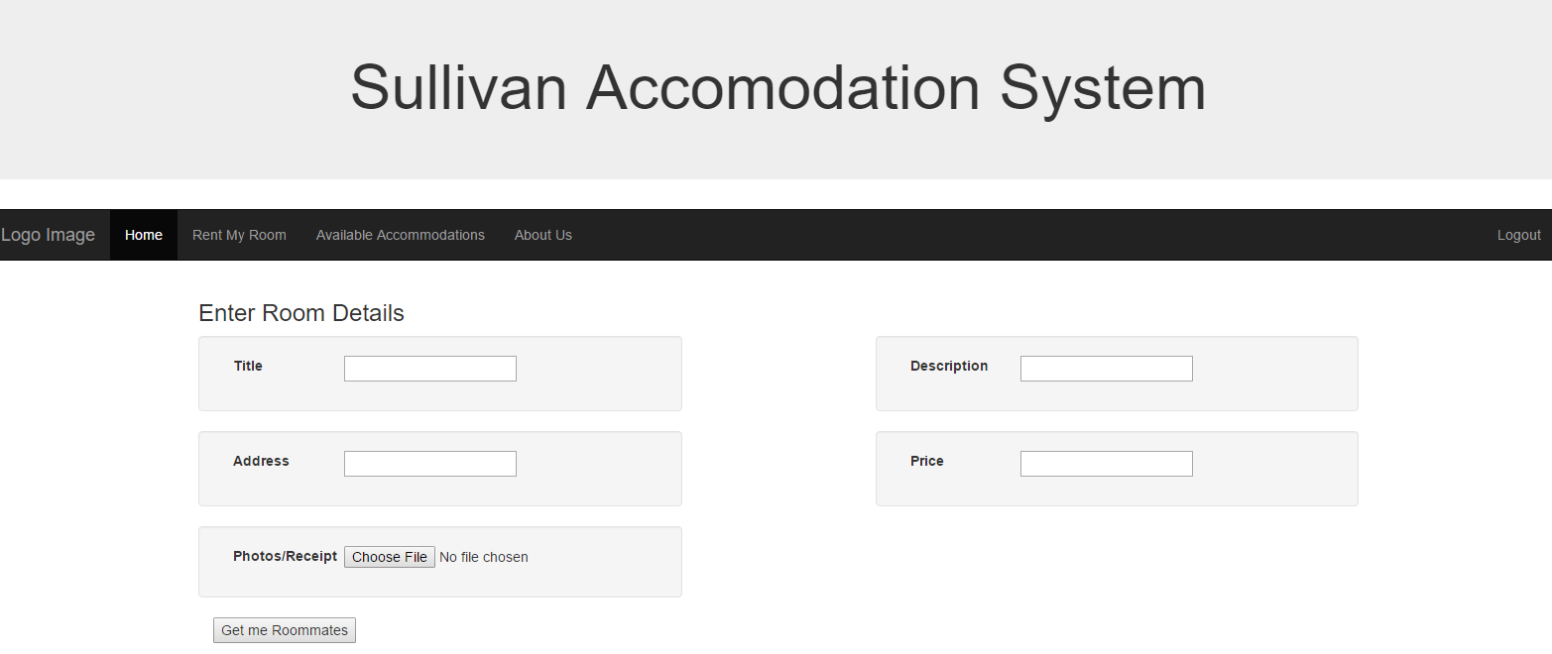

* 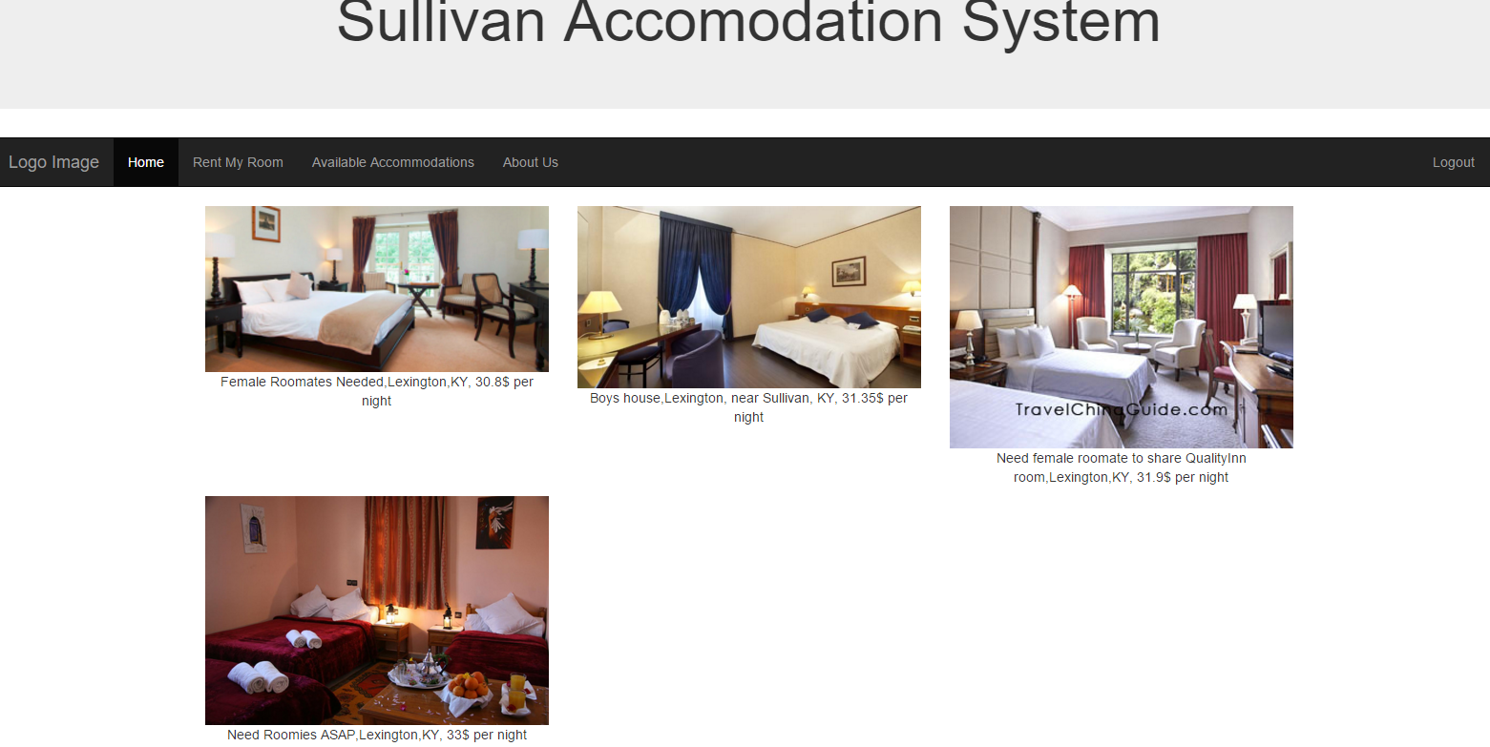Available Accommodation
* About Us

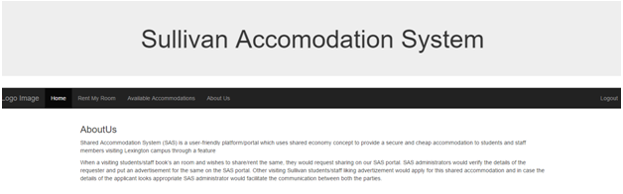

Administrator of this website will have special privileges to approve or disapprove a new user or an advertised room. This feature is mainly built to provide a secure staying environment to the SAS users. Hence, as an administrator, one can review details of the new user and approve them, check the details of the new available room and advertise that. We also included financial model in our application and built it as a part of our prototype. Screenshots of the administrator account look like follows:

* 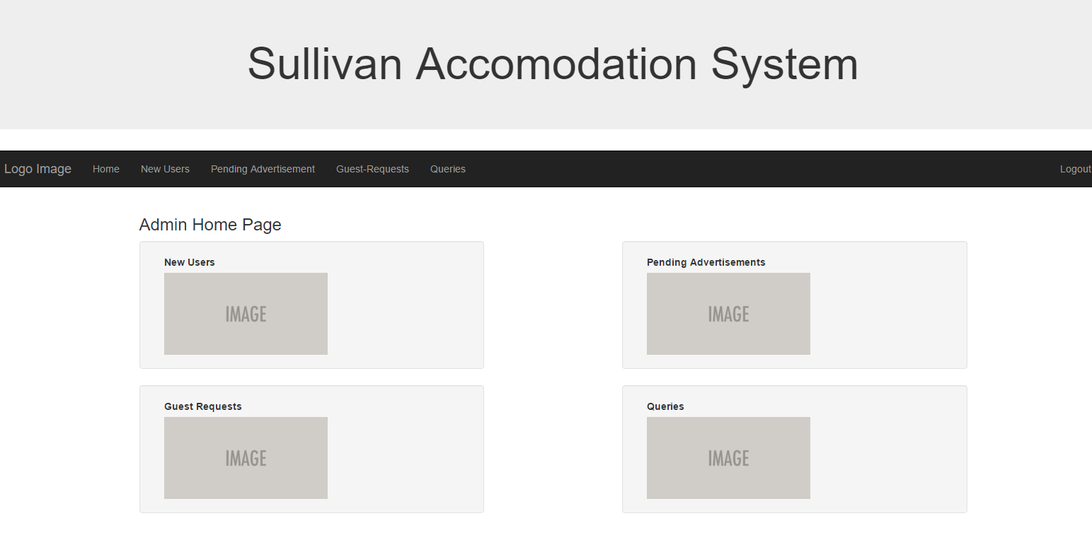Admin Home
* New Pending Users

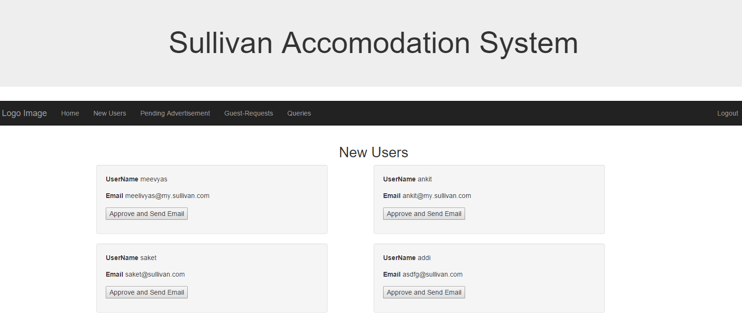

* Pending Advertisement

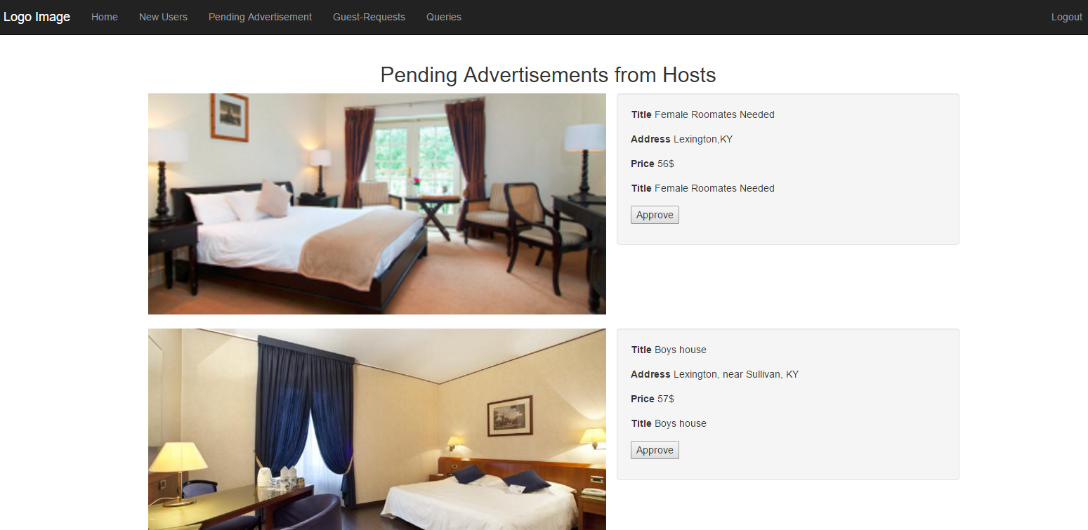

**Impact of SAS**

Gone are the days when you have to make trips to the local travel agency to reserve airfares or book a hotel for the night. Today, if you have a credit card handy and access to the Internet, you can finalize your travel plans within minutes. Take advantage of some of the benefits of online reservations and shared economy to save both time and money, to ensure a stress-free stay.

* The booking process in any booking reservation system is very quick. User can search, select and complete the booking by payment through credit card. User also gets the PNR or voucher confirmation immediately.
* Our reservation systems are available round the clock. You need to do an urgent booking at mid night?  No problem, the system can do the work for you.
* Our Reservation system takes preventive care of credit card information and doesn’t store the classified information. An online booking system now hosts websites to facilitate many hotel and motel websites, a secure online transaction system and a reservation system. Thus the critical information is always safeguarded
* The accuracy of bookings in our system is much higher as user can validate every information at multiple stages before the actual checkout happens.
* The greatest benefit of our reservation system is that it greatly reduces time constraints of being available to take a reservation.  The online reservation is all about the touch of the button or click of the mouse to save time and energy. It simply reduces the duration of the task which normally is time consuming.
* It's simple for travelers to change or cancel online reservations. Instead of calling the hotel or airline and waiting for a customer service representative to help you through the process, booking online means you can do it wherever you have Internet access.

**Process Improvements and contribution to success and failure**.

Most of the process improvement (making it bug free) would be done even before the website is launched for a pilot run, just for the selected few students of CPT class. The possibility of having minor problems after the pilot run cannot be denied, and hence the feedback from the initial users is the key to complete bug free website.

Thus, the feedback, and improvement suggestions from the initial user students would definitely help creating a website, which will certainly be a money saver for the host as well as guest, plus making a minor profit margin for the SAS team.

While working on debugging the website and collecting the feedback from fellow students, there are certainly few challenges that come across as we try to progress through this venture. Most important is that all three of us are full time professionals and dedicating a whole lot of time is very challenging though not impossible. Also, we personally meet once a month and it becomes difficult to coordinate most of the things offline, without meeting in person. These challenges even though are posing as small hindrances for now, but we are taking them as stepping stone to success. And we would meticulously try to come out with flying colors at the end of this big venture.