Multi-Agent AI: The Next Frontier in Intelligent Sales Recommender System

Introduction
Traditional propensity-to-buy models for B2B sales teams are monolithic and stagnant, unable to adapt to real-time signals or capture the multifaceted nature of enterprise buying decisions. Our multi-agentic framework for B2B recommendation systems addresses these limitations head-on.
By synthesizing diverse data sources—firmographic and technographic data, workforce analytics, growth indicators, product usage patterns, unstructured call transcripts, third-party buyer intent signals, engagement metrics, and macroeconomic trends—the system answers three critical questions: Who to target, What to sell, and How to engage. It delivers ranked, contextual next-best-actions (NBAs) and account/product recommendations that empower enterprise sales teams with actionable intelligence.
Given the complexity and interconnected nature of these data streams, a multi-agent AI architecture is the optimal solution. Specialized agents analyze their respective domains and collaborate to generate unified, precise recommendations that drive sales performance with real-time, data-driven guidance.

Multi-Agent Decomposition
Using a multi-agent architecture makes the system modular, interpretable, and maintainable. Each agent is a logical service/process with a clear responsibility and model(s).
- Data Agent
  - Purpose: ingest, validate, normalize, and enrich raw data sources (CRM, intent, payroll, economic).
  - Responsibilities: de-dup, entity resolution (account matching), time alignment, feature categorization
- Feature Agent
  - Purpose: compute & serve features to models and UI (user interface)
  - Responsibilities: windowed/time snapshot of aggregations, derived signals (growth percentiles & percentages, salary trend features, benefit features and other workforce composition features) and storing them to feature store
- Signal Agent
  - Purpose: real-time buyer intent handling (3rd party buyer intent data, site visits, inbound form fills) and other pertaining data
  - Responsibilities: map signals to priority scores, maintain time-decayed engagement metrics.

- LLM Agent
  - Purpose: process unstructured call data and notes from calls (clients and prospects)
  - Responsibilities: topic detection, sentiment, objection extraction, action items, call score (buying intent).
- Candidate Gen Agent
  - Purpose: generate plausible recommendations (accounts/products/contacts/plays) for scoring.
  - Methods: graph neighbors, embedding similarity (company embeddings), rule filters (financial fit), collaborative filtering.
- Ranking Agent
  - Purpose: final ranking of candidates.
  - Models: ensemble (gradient boosted trees for feature importance + neural ranker / transformer for context & interactions).
    - Output: top-k NBA(Next Best Action) with scores and confidence intervals.
- Explainer Agent
  - Purpose: produce human-readable rationales and suggested talking points.
  - Methods: SHAP, PDP or LIME for feature attributions, LLM to convert signals into playbooks and email templates.
- Sales Assistant Agent (UX)
  - Purpose: UI layer that interacts with sales rep (in CRM), surfaces recommendations, lets rep log outcomes & feedback.
- Orchestration & Policy Agent
  - Purpose: manage business rules, guardrails (no recommendations for blacklisted accounts; contract boundaries), rate limits, experiment sequence
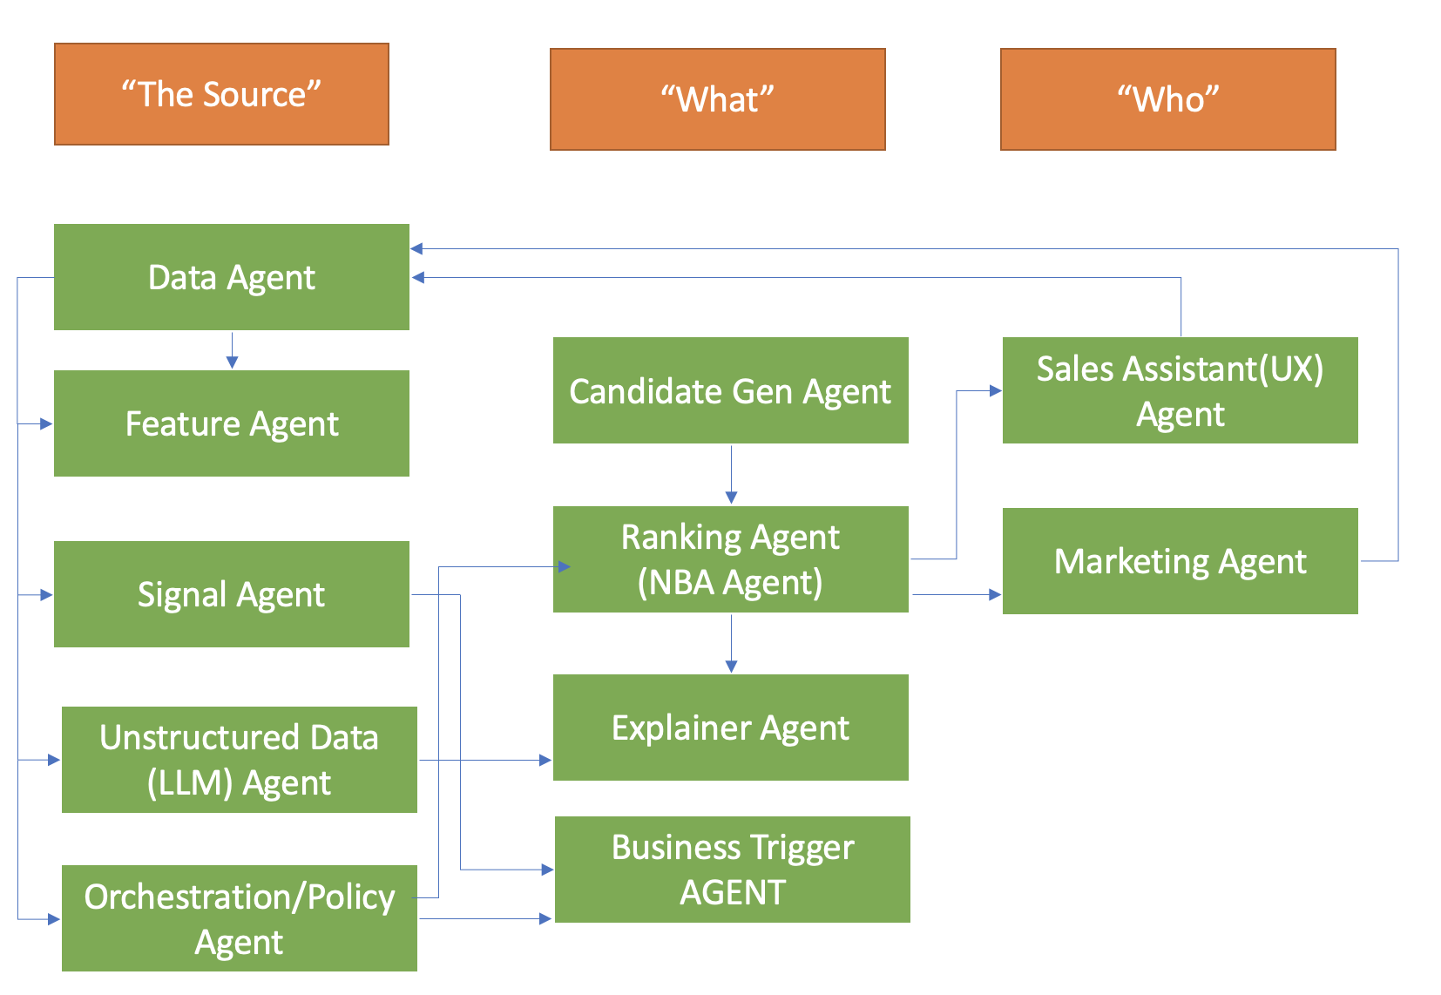

Data Sources & Feature Examples

Raw sources
- CRM: account metadata, opportunity stage, activity logs, owner, last contact
- Firmographic: industry (NAICS), revenue band, HQ location, subsidiaries.
- Technographic: HR/Payroll systems in use integration depth, other notable technographic landscape
- Workforce composition: employee count, avg salary, gender mix, diversity metrics, benefit participation rate.
- Growth signals: employee growth rate (1/3/12 month), salary growth, hiring velocity.
- Product data: product usage metrics, module adoption, license churn risk, support tickets.
- Unstructured call data: audio → call transcripts, sentiment, topics, objections.
- Third-party intent: Buyer intent topics & intent scores per company and time window.
- Economic: regional unemployment, industry growth rates, CPI, sectoral forecasts.

Examples of engineered features
- emp_growth_3m_pct, emp_growth_12m_pct (numeric)
- avg_salary_change_6m
- benefit_participation_rate_delta (current vs prior period)
- bombora_intent_topic_sales_hr (max/min score over 7 days)
- call_intent_score = weighted sum(topic match to product + positive sentiment + call time from buyer)
- technographic_overlap_score = count of complementary systems that suggest easier integration
- time_since_last_demo_days
- pipeline_momentum = sum(opportunity_amount * stage_weight over 90 days)
- region_macro_risk_index mapped from economic indicators

Candidate Generation & Recommendation Types
- Account prioritization: which accounts to call today (rank accounts by combined propensity).
- Product cross-sell/up-sell candidates: which module to propose based on workforce composition and product fit.
- Contact + Channel suggestions: which buyer personas (HR Director, CFO) and channel (email, phone, InMail) to use.
- Playbook & talking points: tailored scripts based on recent call topics and intent signals.
- Timing recommendations: "engage now" vs "wait (signals decaying)".

Candidate generation methods:
- Heuristics & business rules (MVP).
- Similarity search (company embeddings from features + intent embeddings+engagement embeddings).
- Graph traversal (accounts ↔ products ↔ similar accounts).
- Collaborative filtering on past wins by company archetype.

Modeling approach
- Baseline / Heuristics: rule-based scoring to get quick wins (e.g., Bombora intent > threshold & emp_growth>10% => high priority).
- Supervised propensity model (binary): predicts probability of opportunity creation / conversion within X days. Model types: LightGBM / XGBoost trained on historic labeled outcomes.
- Ranking model: LambdaMART or pairwise ranking (XGBoost/LightGBM ranker) or neural ranker; objective optimized for NDCG or business metric proxy.
- Uplift / Causal model: estimate incremental impact of contacting vs not contacting (to avoid wasting rep time).
- Sequence & survival models: predict time-to-close and next best action sequencing (e.g., RNN/Transformer over event sequences, or survival analysis).
- NLP models:
  - ASR → LLM or transformer for call analysis.
  - Topic models (BERTopic) or transformer classifiers for intent, objection, and product mention extraction.
  - Use embeddings (sentence transformers) for semantic matching between transcripts, intent topics, and product catalog.
- LLM for explanations & playbooks: use prompt templates with top features & SHAP attributions, PDP plots or LIME to render short scripts and email templates.

Offline evaluation & business KPIs

ML metrics
- AUC-ROC for propensity models.
- Calibration (reliability curves).

Business metrics (most important)
- Lift in meetings set, revenue lift, win rate on recommended accounts.
- Time-to-close reduction.
- Sales rep productivity: deals closed per rep, activities per win.
- Pipeline coverage improvement and forecast accuracy.

Evaluation strategy:
- Offline cross validation, time-split evaluation.
- Small controlled online experiments (A/B testing by region/rep) with proper randomization and gating via Orchestration agent.
- Uplift/counterfactual measurement when possible (holdout groups).

Serving modes & latency
- Real-time (sub-200ms): score a single account/contact on demand (for UI). Keep model light or use cached model; Feature Agent must support online lookups.
- Batch nightly: re-score all accounts for next-day prioritization (large scale ranking).
- Streaming: immediate alerts when Bombora intent spikes or major product event occurs; push to reps.

UX / Sales & Marketing integration
- In-CRM panel (e.g.Salesforce): Top 5 recommended accounts + why + next action buttons (Schedule meeting, send template, assign SDR/BDR).
- Playbook modal: contextualized script + objection handlers + suggested collateral.
- Rep feedback widget: thumbs up/down per rec + quick reason -> feeds training labels.
- Integration with Marketing campaign canvas (e.g. Eloqua) to orchestrate campaigns etc
- Manager dashboard: recommend coverage gaps, pipeline heatmap, model performance & lift by segment.
- Outbound automation: suggested email templates & sequences created by LLM using factual constraints.

Explainability & trust
- For each recommendation show: top 5 contributing features, confidence, last supporting signal (e.g., Buyer Intent: "Payroll software interest - 72 score; employee growth +18% last 3 months; recent call: mentioned "benefits admin").
- Provide counterfactual suggestions: “If benefit participation rate was > X, product Y would move to top-3.”
- Track and display model drift and feedback loop transparency.

Monitoring & MLOps
- Model performance: daily/weekly drift checks (feature distribution, prediction drift).
- Business signal monitors: conversion rate per cohort, top reasons, campaign lift.
- Data latency & freshness alerts.
- Retraining policy: scheduled (weekly/monthly) + retrain on drift trigger.

Conclusion
The proposed multi-agent AI framework for sales recommendations leverages specialized agents to create an intelligent, transparent, and adaptive system for enterprise B2B sales and marketing teams. Each agent plays a distinct role: from data ingestion and feature engineering to signal detection, candidate generation, ranking, and explainability. By incorporating large language models (LLMs) and economic, firmographic, and behavioral signals, the system provides dynamic, context-aware recommendations that evolve with market conditions and client needs.
The inclusion of the Explainer Agent ensures interpretability and trust, while the Sales and Marketing Assistant (UX) Agent bridges AI intelligence with human in the loop decision-making. This architecture not only enhances productivity and precision in targeting but also democratizes AI insights across sales and marketing organizations. And thus turning complex data ecosystems into actionable, transparent, and scalable sales intelligence.

Works Cited
Adomavicius, Gediminas, and Alexander Tuzhilin. “Context-Aware Recommender Systems.” Recommender Systems Handbook, edited by Francesco Ricci et al., Springer, 2011, pp. 385–412.
Burke, Robin. "Hybrid Recommender Systems: Survey and Experiments." User Modeling and User-Adapted Interaction, vol. 12, no. 4, 2002, pp. 331–70.
Hu, Ning, Eric Koh, and Haijing Ma. "Beyond the Click: The Power of B2B Buyer Intent Data in Digital Marketing." Journal of Business Research, vol. 114, 2020, pp. 407–17.
Jennings, Nicholas R., Katia Sycara, and Michael Wooldridge. "A Roadmap of Agent Research and Development." Autonomous Agents and Multi-Agent Systems, vol. 1, no. 1, 1998, pp. 7–38.
Maynard, Diana, and Sophia Ananiadou. "Natural Language Processing, Knowledge Extraction and Semantic Web." Current Opinion in Computer Science, vol. 1, no. 3, 2008, pp. 268–75.
Voss, Christopher, and Lydia Zomerdijk. "Next Generation of Customer Relationship Management: Next Best Activity." European Management Journal, vol. 25, no. 2, 2007, pp. 115–21.
Bommasani, Rishi, et al. On the Opportunities and Risks of Foundation Models. Stanford University, Center for Research on Foundation Models, 2021.
Borge-Holthoefer, Javier, and Alex Arenas. “Semantic Networks: Structure and Dynamics.” Entropy, vol. 12, no. 6, 2010, pp. 1264–1302.
Breiman, Leo. “Random Forests.” Machine Learning, vol. 45, no. 1, 2001, pp. 5–32.
Chen, Tianqi, and Carlos Guestrin. “XGBoost: A Scalable Tree Boosting System.” Proceedings of the 22nd ACM SIGKDD International Conference on Knowledge Discovery and Data Mining, 2016, pp. 785–794.
Huang, Po-Sen, et al. “Learning Deep Structured Semantic Models for Web Search Using Clickthrough Data.” Proceedings of the 22nd ACM International Conference on Information & Knowledge Management (CIKM), 2013, pp. 2333–2338.
OpenAI. GPT-4 Technical Report. OpenAI, 2023.
Rashid, Al Mamunur, et al. “Getting to Know You: Learning New User Preferences in Recommender Systems.” Proceedings of the 7th International Conference on Intelligent User Interfaces (IUI), 2002, pp. 127–134.
Salesforce. Einstein AI for Sales: Product Overview. Salesforce, 2024.
Scholz, Roland W., and Olaf Renn. “Participatory Modelling for Designing Sustainable Pathways.” Environmental Modelling & Software, vol. 150, 2022, p. 105339.
Vaswani, Ashish, et al. “Attention Is All You Need.” Advances in Neural Information Processing Systems (NeurIPS), 2017.
Zhao, Wayne Xin, et al. “Recommender Systems with Large Language Models (LLMs): A Survey.” arXiv preprint arXiv:2305.19860, 2023.

