

Penetration Test Project

7COM1068 - Penetration Testing

Group ID: 1

Team Members:
Name | Student ID
Meena Ramesh | 16082676
Chethan Bommasandra Manjaiah | 24171271
Pavan Davangere Vageesh | 23072485
Bhanu Prakash Gandikota | 25043981
Swathi Mulaka | 25041595

Contents

1. Executive Summary
2. Attack Details & Mitigation
2.1 Attack 1 — Unauthorised Remote Root Access via Backdoor Service (TCP Port 12345)
2.2 Attack 2 — Web Directory Exposure Leading to Credential Compromise and Privilege Escalation
2.3 Attack 3 — Local Privilege Escalation via Linux Kernel Vulnerability
2.4 Attack 4 — Unauthenticated Database Access Leading to System-Level Privilege Escalation
2.5 Attack 5 — Web Application Compromise via Weak Credentials and Remote Code Execution
3. Activity Log
4. Group Management
Reference

Executive Summary
Target | MiddleEarth Server — 192.168.3.1
Assessment Type | Grey-Box Penetration Test
Period | March – April 2026
Operating System | Damn Vulnerable Linux — BackTrack 2.0
Conducted By | ConsultantPros — Pentest Team 1

This report presents the results of a grey-box penetration test conducted by ConsultantPros Pentest Team 1 against the target server MiddleEarth (192.168.3.1) between March and April 2026. The objective of this assessment was to identify and exploit security weaknesses that could allow unauthorised administrative or root-level access to the system. The findings provide an overview of the current security posture of the server and highlight the potential risks to the organisation.

During the assessment, we determined that the target system is a Damn Vulnerable Linux (DVL) environment running on Linux kernel 2.6.20. The system was found to be operating with an outdated and unsupported software stack, including Apache 1.3.37, PHP 4.4.4, OpenSSH 4.4 with SSHv1 enabled, Samba 3.0.14a, and MySQL 5.0.24a. These components are no longer maintained and contain well-known security vulnerabilities. In addition, several services were misconfigured, which further increased the exposure of the system to potential attacks. Initial reconnaissance using Nmap identified six open TCP ports on the target server: 22 (SSH), 80 (HTTP/Apache), 139 and 445 (Samba), 3306 (MySQL), and port 12345.

One of the most critical findings was the presence of the backdoor service on port 12345, which provided immediate root access through a simple netcat connection without requiring any authentication. This vulnerability alone allows an attacker to compromise the system within seconds completely. We also discovered a publicly accessible web directory at /true/ that exposed sensitive credential files and a password-protected archive. By cracking the archive using a dictionary available on the server, we were able to obtain valid SSH credentials for all four user accounts on the system. From these accounts, root privileges could be obtained due to a SUID misconfiguration on /usr/bin/find.In addition, the MySQL service was accessible without a password, which allowed us to interact with the database and execute commands that ultimately resulted in root access. We also identified a vulnerable WordPress installation where it was possible to upload a PHP reverse shell, providing remote command execution on the server. This access could again be escalated to root through the same SUID misconfiguration. Finally, the Linux kernel version running on the system (2.6.20) is vulnerable to the known privilege escalation vulnerability CVE-2009-2692 (sock_sendpage), which provides another independent method to gain root access from a local user account.

Overall, the findings demonstrate a significant breakdown in fundamental security controls, including authentication, access control, patch management, and system hardening. During testing, we observed that an attacker with basic technical knowledge and commonly available tools could gain full control of the system within minutes of obtaining network access.

The business risk associated with this system is therefore considered critical, as successful exploitation could lead to :

- data breaches
- full system compromise
- service disruption
- potential reputational damage to the organisation.

Immediate remediation is strongly recommended. The system should either be decommissioned or rebuilt using a secure and updated configuration. In addition, all credentials associated with this system should be treated as compromised and must be reset.

Risk Rating | Business Impact
Critical | Immediate full system compromise

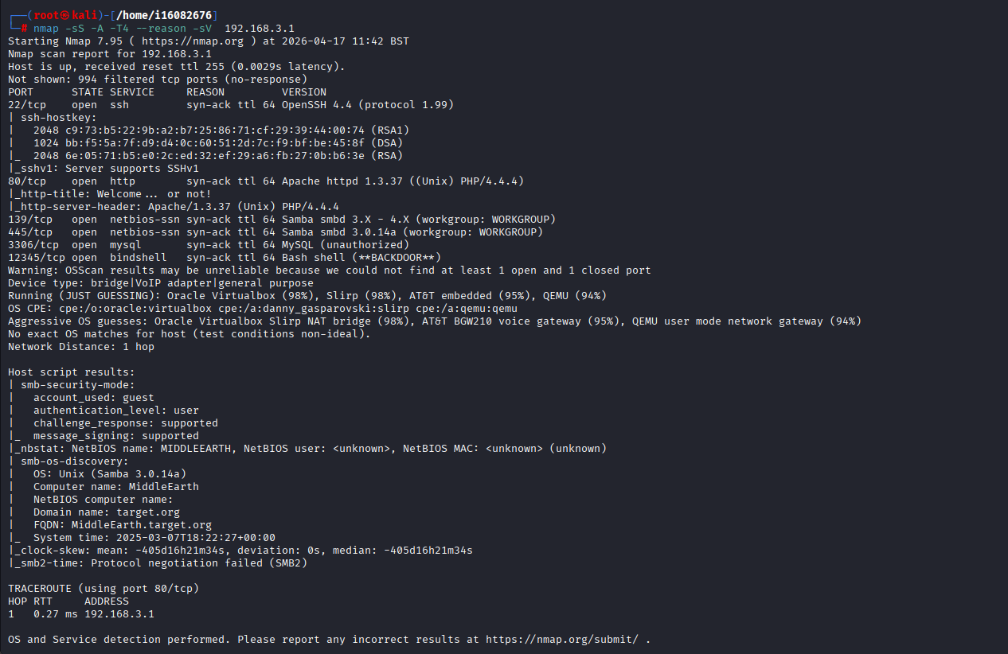
Figure 1 : Nmap full scan — 192.168.3.1

2. Attack Details & Mitigation
The five unique attacks resulted in root access to the target IP 192.168.3.1. The vulnerabilities scanning, discovery, exploitation with full commands and output evidence, and mitigation are given below:

2.1 Attack 1 — Unauthorised Remote Root Access via Backdoor Service (TCP Port 12345)

Vulnerability discovery:

Vulnerability | Type | Severity
Pre-installed unauthenticated bash backdoor on TCP 12345 | Backdoor / Unauthorised Access | Critical

Tools Used:
- Nmap
- Netcat
- Bash (bind shell interaction)

Technical Explanation:

We identified a bind shell listening on TCP port 12345 that allowed remote users, even without prior authentication, to directly obtain a root shell. This represents a critical backdoor vulnerability, as it provides unrestricted access with no authentication or access control mechanisms in place.
During scanning, we performed an Nmap service detection scan against the target, which clearly identified and flagged port 12345 as a backdoor service.

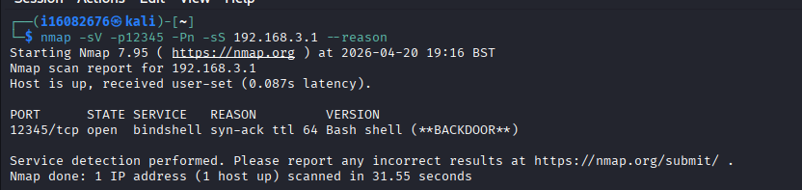
Figure 2 :Nmap scanning of port 12345
Exploitation:
We used Netcat to connect directly to the bind Bash backdoor on the target system. The connection was established without any authentication requirements, meaning no username, password, or cryptographic key was needed to gain access. 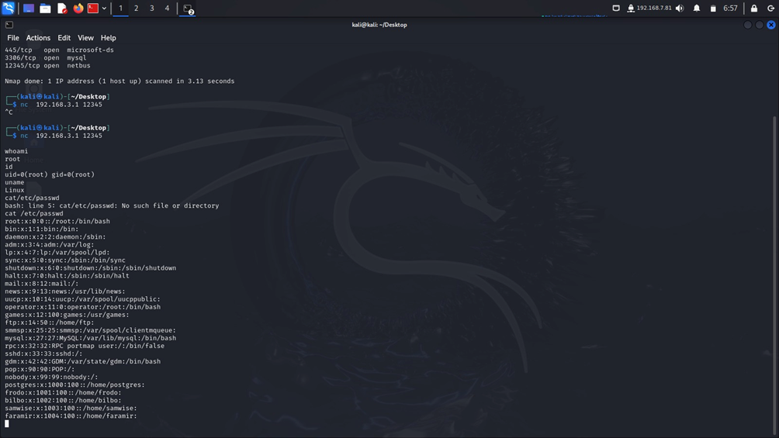Figure 3 :Bind bash backdoor exploitation – connected as root user
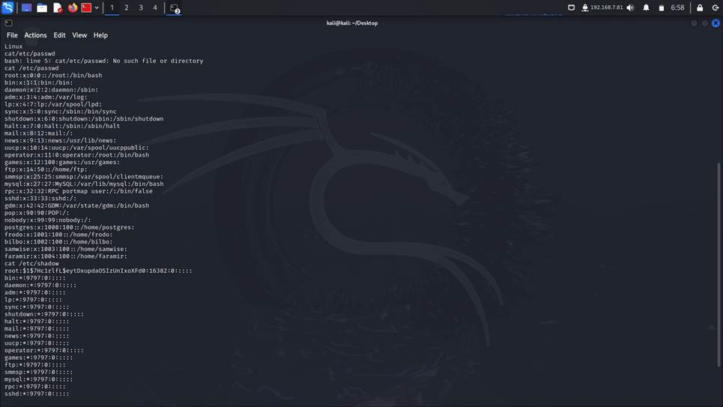
Figure 4 :Accessing etc/passwd as root user

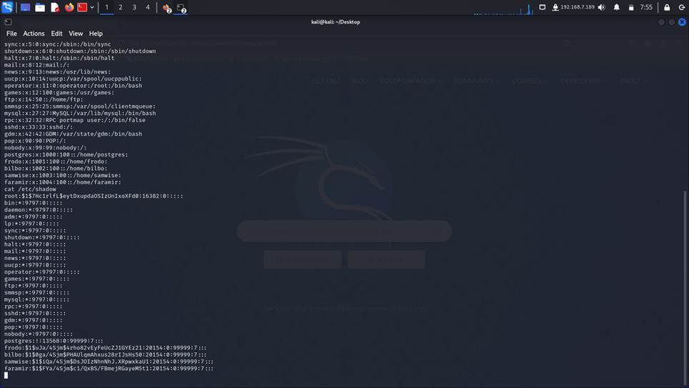
Figure 5: Accessing etc/shadow as root user
Mitigation
- Immediately terminate the backdoor process: kill $(lsof -t -i:12345)
- Remove any associated binary or startup script from /etc/init.d/, /etc/rc.local, or cron
- Implement iptables firewall rules to block all unauthorised inbound ports (NIST, 2023)
- Rebuild the system from a known-clean baseline (Kim, 2018)

2.2 Attack 2 — Web Directory Exposure Leading to Credential Compromise and Privilege Escalation

Vulnerability discovery:
Vulnerability | Type | Severity
Apache directory listing enabled on /true/ | Misconfiguration | Critical
Sensitive credential files publicly accessible via HTTP | Information Disclosure | Critical
SUID bit set on /usr/bin/find — any user can escalate to root | Privilege Escalation | Critical

Tools Used:
- Nmap
- Apache HTTP Server (web service enumeration context)
- Dirb / Directory enumeration tools
- Wget
- John the Ripper
- Zip utilities (unzip)
- SSH client
- Linux SUID binary exploitation (find)
- Bash shell
Technical Explanation:
Apache directory listing was enabled, which exposed sensitive files on the web server, including a password-protected archive. We found that the archive used weak encryption, which we were able to crack to recover valid SSH credentials. We also identified a misconfigured SUID binary (find), which we exploited to escalate privileges and obtain root access on the system.
Scanning :
Nmap scan was done on port 80 to find out the vulnerabilities in the target machine 192.168.3.1
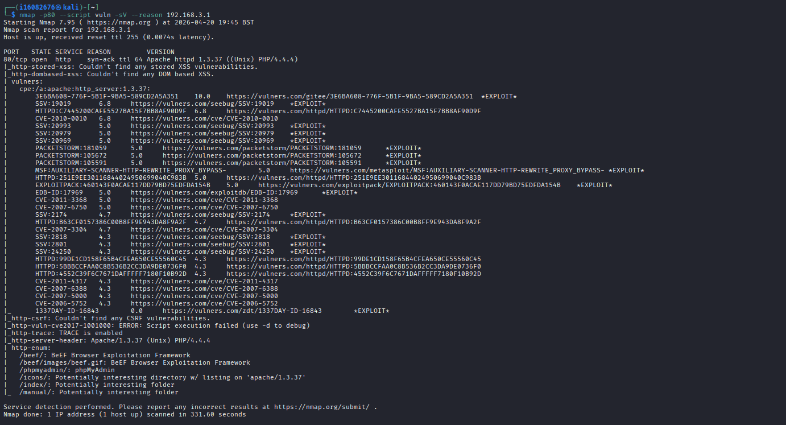
Figure 6 :port 80 vulnerability scan using Nmap
Port 80 enumeration:
On Port 80, I performed directory enumeration using the following command to identify what targets are running show in the figures.
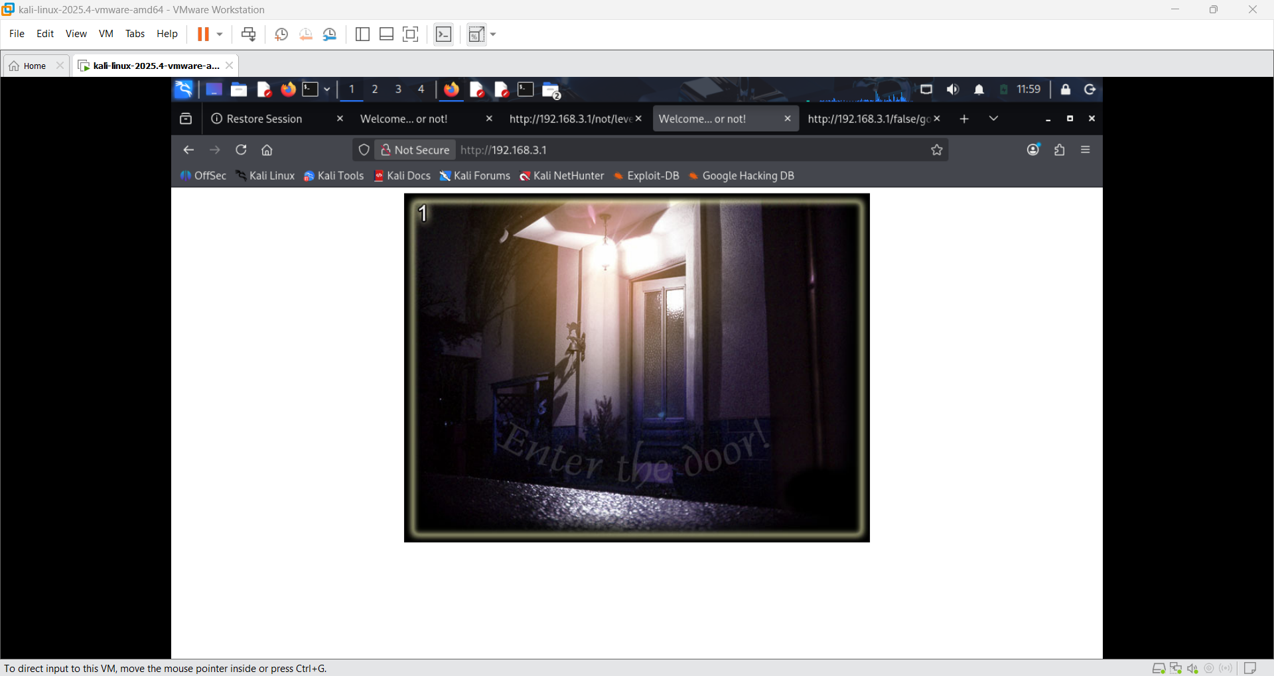
Figure 7 : http welcome page of the target IP
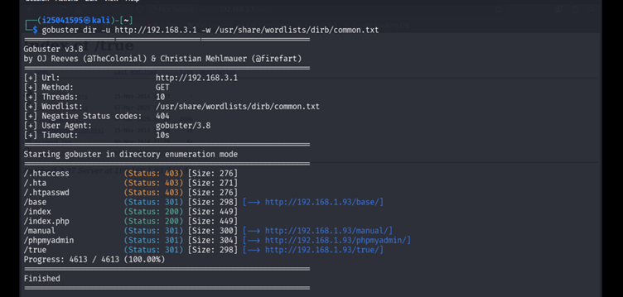
Figure 8: HTTP enumeration

After continuous verification of all directories on port 80, we found the user credentials in the true directory.
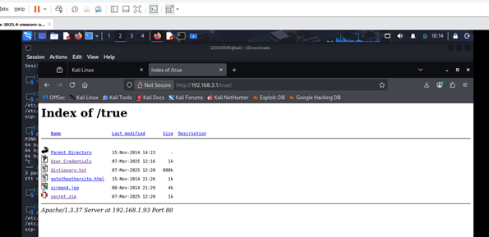
Figure 9: HTTP true directory
Download dictionaries and secret.zip files by using wget command
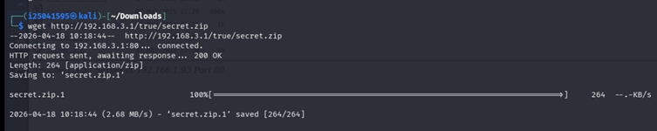
Figure 10: Wget secret.zip
User credential file cracking
We used John the Ripper to perform a brute-force (dictionary-based) attack in order to recover the password of a protected ZIP file containing sensitive data. By systematically testing entries from a wordlist, we were able to successfully identify the correct passphrase.Using this approach, we discovered the secret key: “snorekeling” which opened the unzipped secret.zip.
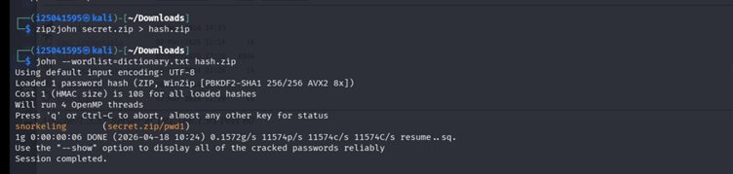
Figure 11: Zip file password cracked – using John
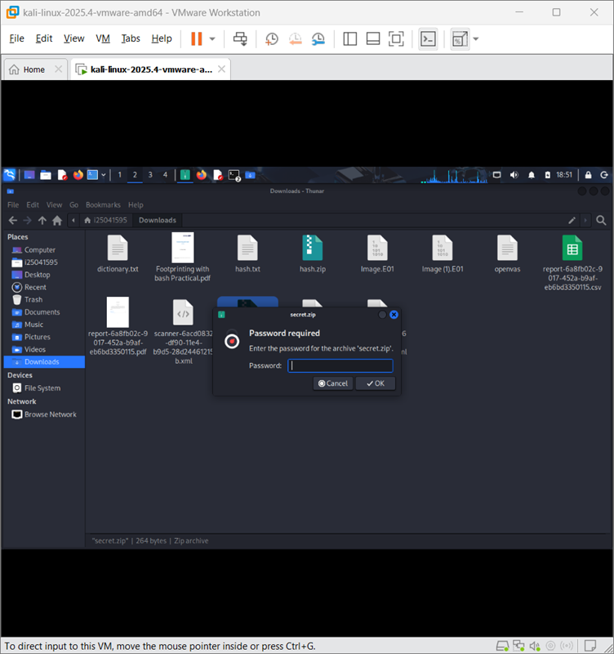
Figure 12 :Secret file cracked
The password file has the ssh user credential which we verified after we logged in successfully.
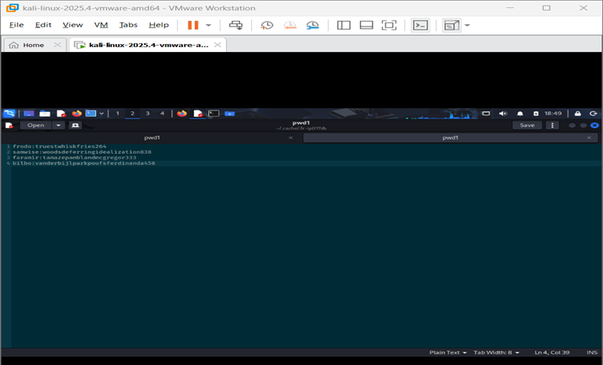
Figure 13: pwd1.txt - ssh user credential
We connected the target IP 192.168.3.1 via SSH as a user Frodo
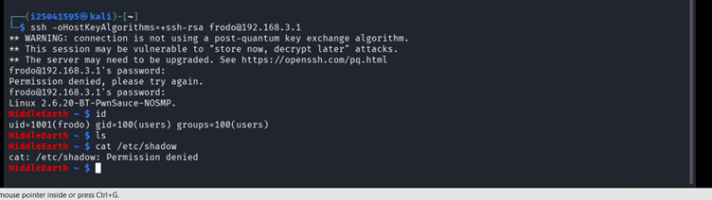
Figure 14: SSH login as non-root user (Frodo)
Exploitation:

- We began by using the SSH credentials recovered from the cracked password-protected archive to log in as the user Frodo. At this stage, Frodo had limited user privileges, but the access provided a foothold into the system and an opportunity for further escalation.

- We then identified that the SUID bit was incorrectly set on the /usr/bin/find binary. This misconfiguration allowed us to escalate privileges from the Frodo user to root. By leveraging the SUID-enabled binary, we executed the following command:
find . -exec /bin/sh -p \; -quit
This command executed a shell with root privileges, leading to full system compromise.
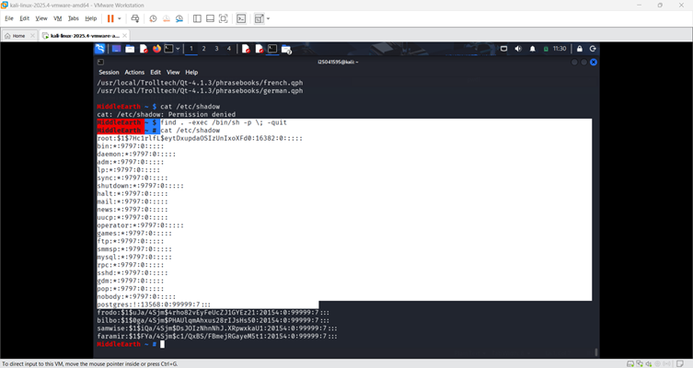
Figure 15 :Privilege Escalation to root access
Mitigation:
- Disable Apache directory listing: add 'Options -Indexes' to httpd.conf (Apache, 2023)
- Remove all credential files and archives from web-accessible directories immediately
- Enforce strong, unique passwords — implement and enforce a password policy(NCSC, 2021)
- Audit all SUID binaries regularly: find / -perm -4000 2>/dev/null (GTFOBins, 2024)

2.3 Attack 3 — Local Privilege Escalation via Linux Kernel Vulnerability
Vulnerability Discovery

Vulnerability | Type | Severity | CVE
Linux kernel 2.6.20 sock_sendpage() NULL pointer dereference | Kernel Privilege Escalation | Critical | (CVE-2009-2692, 2009)

Tools Used:
- SSH client
- uname / system information commands
- searchsploit (Exploit-DB)
- Metasploit Framework (reference/validation context)
- scp (secure file transfer)
- gcc (GNU Compiler Collection)
- Linux shell (Bash)

Technical Explanation:
We identified that the Linux kernel version is affected by a NULL pointer dereference vulnerability, which can be exploited by local users to execute arbitrary code at the kernel level. This flaw could allow us to escalate privileges and gain full root access on the system (MITRE, 2009).
Kernel enumeration:
We obtained the kernel version after successfully logging in via SSH, using credentials acquired during Attack 2. After gaining access as the user bilbo, we inspected the system to gather further information about the underlying operating system and kernel version.

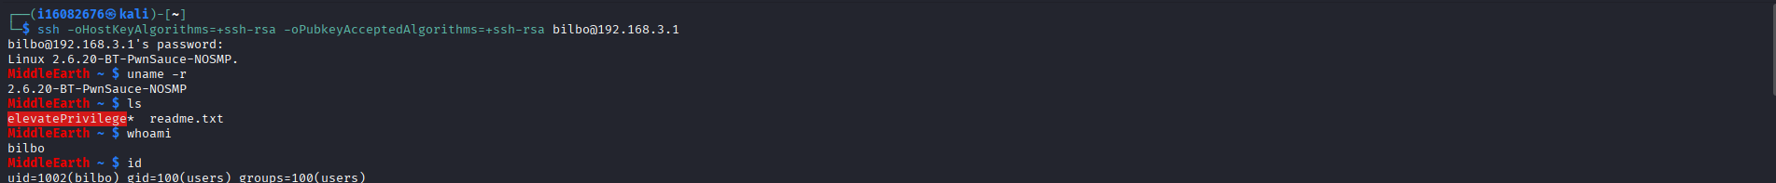
Figure 16: Kernel version obtained
We used the searchsploit command to identify available local privilege escalation exploits for kernel version 2.6.x within the Exploit Database and Metasploit framework. This search returned multiple relevant exploit options.From the results, we selected three potential exploits and tested them sequentially to evaluate their effectiveness against the target system.

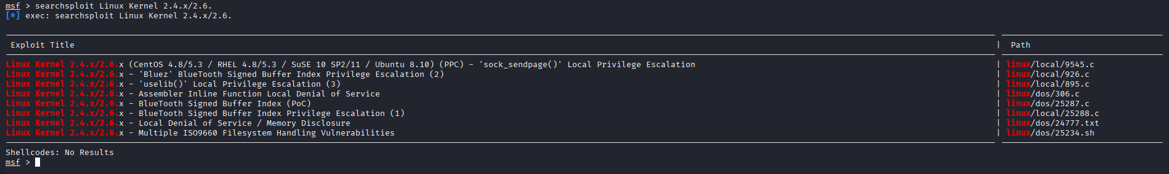
Figure 17: searchsploit ran for the kernel version
After several unsuccessful attempts with other exploits, we found that exploit 9545.c (sock_sendpage) was effective. This exploit successfully bypassed existing restrictions and allowed us to escalate privileges, ultimately gaining root-level access on the target system.

Exploitation:
- Get the exploit file on the attacker's machine by executing the searchsploit path
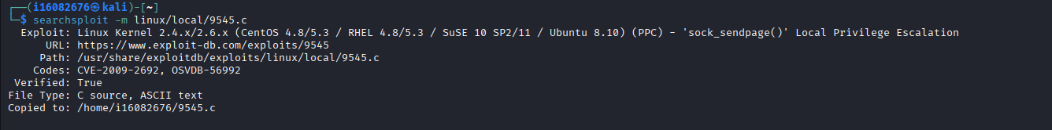
Figure 18 :Searchsploit file path
- Securely copy the file to the target machine using scp command.

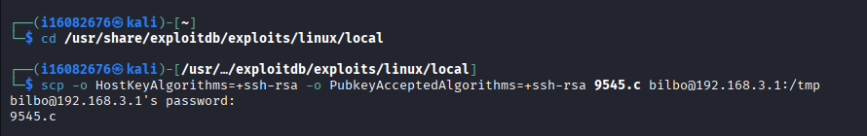
Figure 19 :scp command executed
- Verified the 9545.c which is copied from the attacker machine
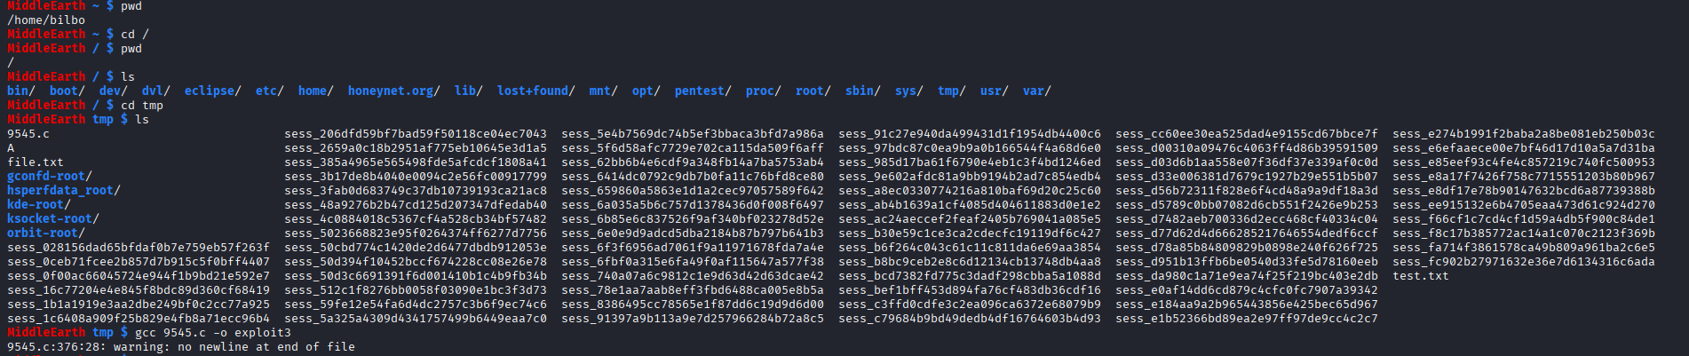
Figure 20 :Verified the 9545.c
- Compiled and ran the 9545.c file using gcc 9545.c -o exploit3 command and ./exploit3

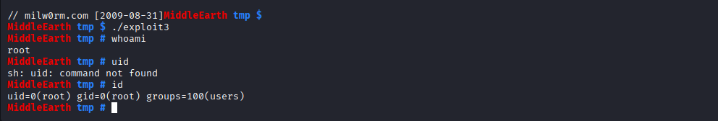
Figure 21: Non-User is elevated to root user
Mitigation:
- Upgrade kernel to a supported version (Linux Foundation, 2026)
- Apply patch management processes
- Use access control mechanisms (SELinux/AppArmor)(Red Hat, 2022)

2.4 Attack 4 — Unauthenticated Database Access Leading to System-Level Privilege Escalation
Vulnerability Discovery :
Vulnerability | Type | Severity
MySQL root account has no password — local unauthenticated access | Missing Authentication | Critical
MySQL client shell escape (\!) allows OS command execution | Insecure Configuration | Critical
Tools Used :
- Nmap
- SSH client
- MySQL / mysql client
- MySQL shell escape (\!)
- Linux shell (Bash)
- SUID binary exploitation (find)

Technical Explanation:

We discovered that the MySQL root account was configured without a password, which allowed unrestricted access to the database service. This misconfiguration significantly reduced the security barrier and enabled us to interact with the database without authentication.

Additionally, the MySQL client permitted operating system command execution. When combined with a misconfigured SUID binary, this capability contributed to successful privilege escalation, ultimately resulting in full root-level access on the system.
Scanning and enumeration of port 3306:
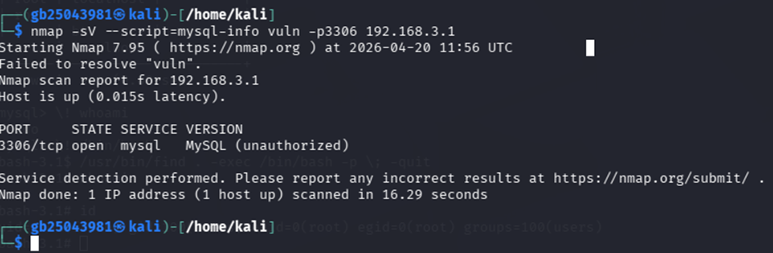
Figure 22 :nmap scan for port 3306 vulnerability
The scan confirmed that port 3306 was open and running the MySQL service. Although the exact version was not fully identified, the service was flagged as unauthorised, indicating a potential security misconfiguration.
Exploitation:
- After gaining SSH access as the user bilbo (obtained in Attack 2) on the target IP 192.168.3.1, we discovered that MySQL was accessible without requiring a password. This was further validated using the mysqladmin command, which confirmed successful connection to the database service without authentication.

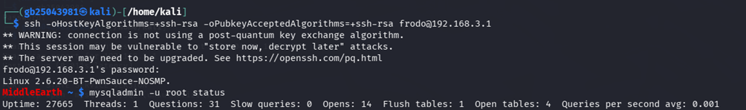
Figure 23: SSH login as frodo user
- The mysqladmin check confirmed that the MySQL root account was accessible without requiring a password, highlighting a critical authentication weakness in the database configuration.
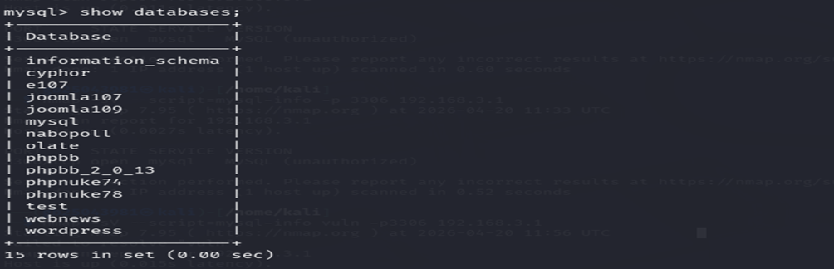
Figure 24: MYSQL database
- We executed the SHOW DATABASES; command, which revealed multiple application-related databases on the system. This indicates a significant risk of sensitive data exposure, as the databases may contain confidential information that could be further leveraged for exploitation or privilege escalation.

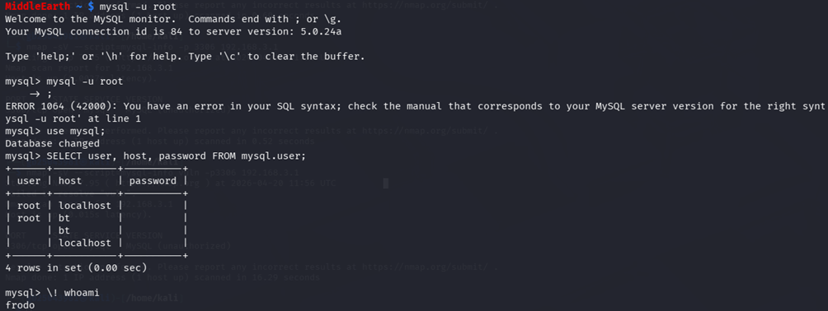
Figure 25: Logged in as root user in mysql
- We were able to log directly into MySQL as the root user without providing a password, confirming a severe authentication misconfiguration. Further inspection of the user table revealed empty password fields, which significantly weakens database security and exposes the system to unauthorised access and potential data compromise.

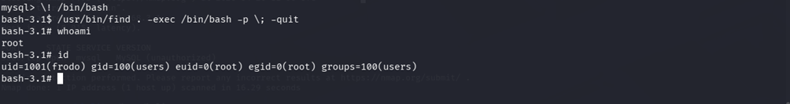
Figure 26 :Privilege escalation to root access for the user Frodo

- Using the MySQL shell escape technique in combination with the misconfigured SUID find binary, we were able to escalate privileges and obtain a root shell. This confirmed a complete system compromise with full administrative-level access.
Mitigation:
- Set a strong MySQL root password immediately. (MySQL, 2023)
- Disable MySQL shell escape by restricting execute permissions on the mysql binary for non-DBAs
- Run MySQL as a dedicated non-privileged service account — not as the system root user(CIS, 2023)
- Remove SUID bit from /usr/bin/find: chmod u-s /usr/bin/find(GTFOBins, 2024)

2.5 Attack 5 — Web Application Compromise via Weak Credentials and Remote Code Execution
Vulnerabilities Discovered:
Vulnerability | Type | Severity
WordPress admin password hash (MD5) exposed in MySQL wp_users | Credential Exposure | Critical
Weak WordPress admin password 'toor' — crackable by john | Weak Password | Critical
Web server directory world-writable — PHP reverse shell injectable | Insecure File Permissions | Critical
SUID bit set on /usr/bin/find — escalation from nobody to root | Privilege Escalation | Critical

Tools Used :
- MySQL / MariaDB client
- SSH client
- John the Ripper
- WordPress (web application interface)
- Web browser (admin panel / source code inspection)
- Linux shell (Bash)
- Python (PTY shell upgrade: pty.spawn)
- SUID binary exploitation (/usr/bin/find)
- Netcat (listener for reverse shell)

Technical Explanation:
We identified weak WordPress credentials that were stored using MD5 hashing, which is inherently insecure. By cracking these hashes, we successfully recovered valid login details and gained administrative access to the WordPress dashboard. Further investigation revealed that certain web directories were improperly configured with write permissions. This allowed us to upload and execute a PHP reverse shell, establishing remote code execution on the server.

Finally, through a misconfigured SUID binary, we were able to escalate privileges from a low-privileged user to root, resulting in full administrative control over the system.
Exploitation:
MySQL was accessed as the root user, as confirmed in Attack 4. We found that the database was exposed in a way that allowed any SSH user to connect without a password, representing a critical authentication misconfiguration.

This unrestricted access enabled us to enumerate the WordPress database. During this process, we identified that the wp_users table contained a hashed credential belonging to the administrator account.
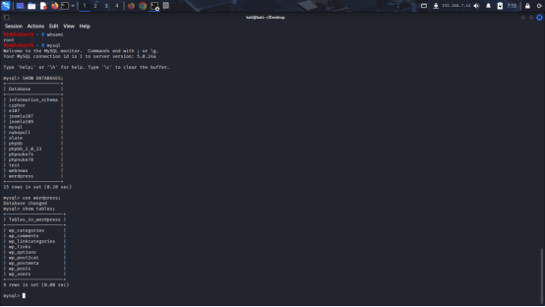
Figure 27: MySQL database accessed as root
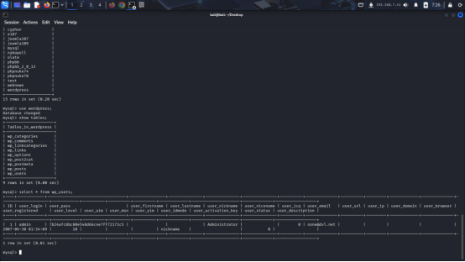
Figure 28: Listing WordPress database tables
- We used John the Ripper to crack the MD5 hash to get the password for the admin WordPress user.

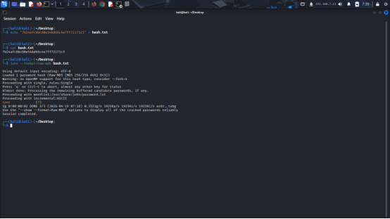
Figure 29 :Password cracked
- While examining the WordPress database through MySQL, we enumerated the wp_posts table. From this table, we were able to identify the link to the WordPress admin page, which could be used to access the administrative login interface.
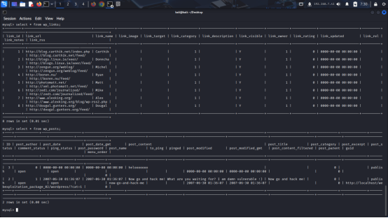
Figure 30: Listing tables in the WordPress database
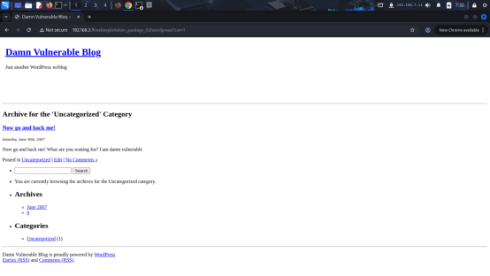
Figure 31: Damn vulnerable blog
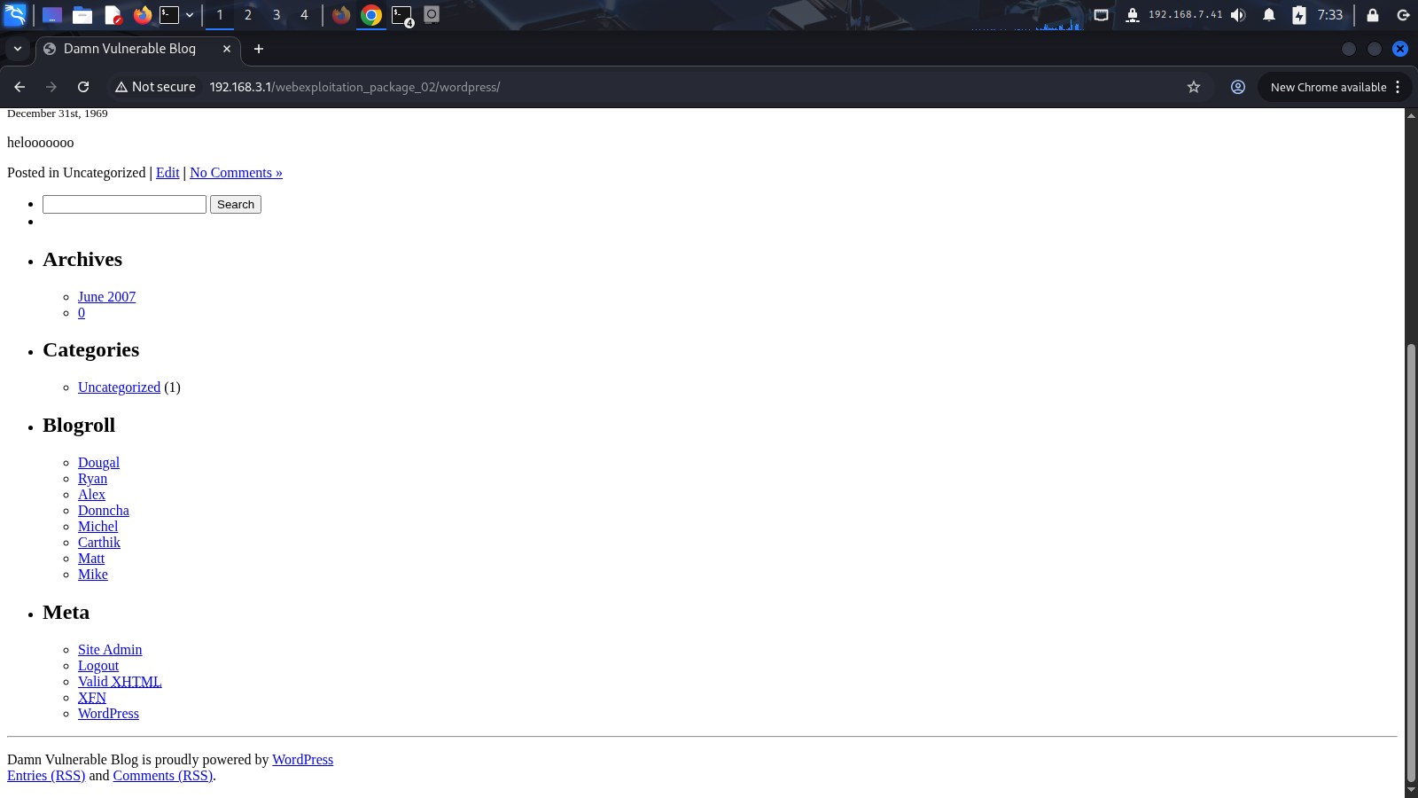
Figure 32: site admin page

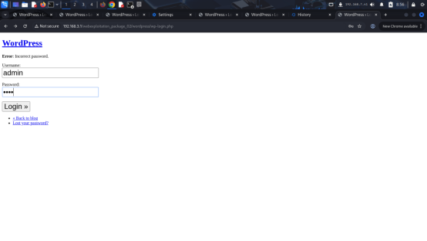
Figure 33: WordPress login page with username "admin" and password "toor"
- This ultimately led us to the WordPress admin interface, where we were granted elevated privileges over the website. From this level of access, we were able to perform administrative actions and gain significant control over the site’s configuration and content.

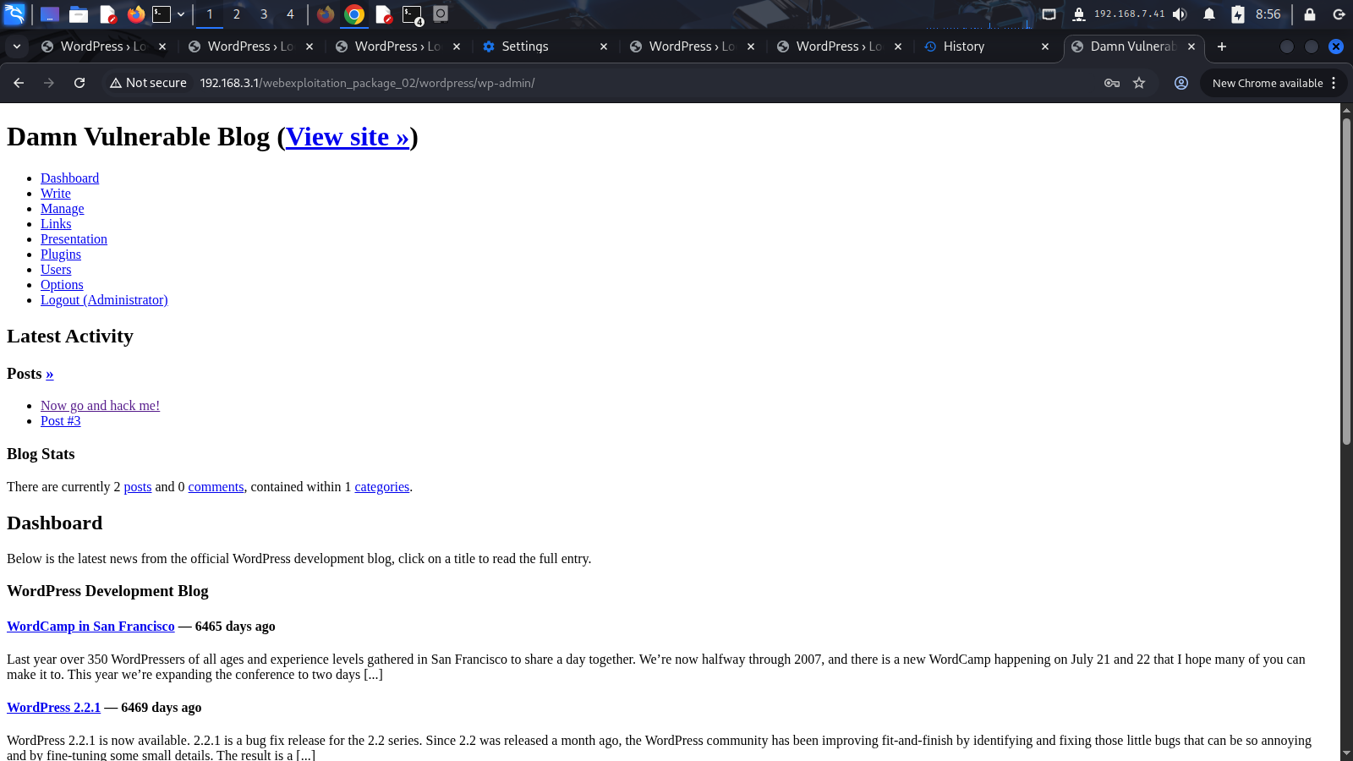
Figure 34: DAMN vulnerable admin dashboard

- We continued exploring the WordPress dashboard and navigated through the available pages on the website. This led us first to the Themes section; however, the installed themes were not editable due to permission restrictions.We then moved on to the Plugins section, but we found that the plugins were also locked down and not directly editable from the interface.
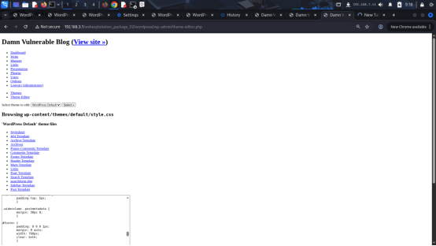
Figure 35: DAMN vulnerable Themes page

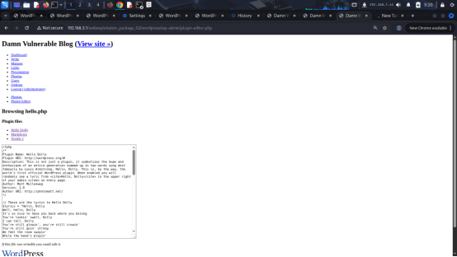
Figure 36: DAMN vulnerable plugins page

- After gaining user-level access, we further inspected the website’s files and directory structure. While reviewing the WordPress installation, we examined the source code of the webpage, specifically the index.php file.
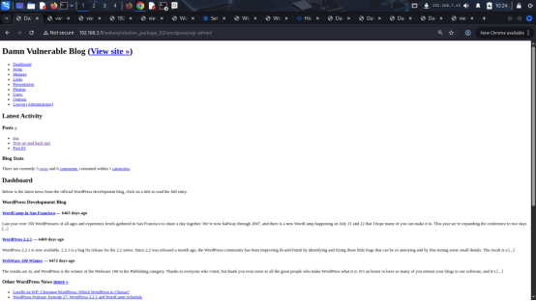
Figure 36: DAMN vulnerable index.php

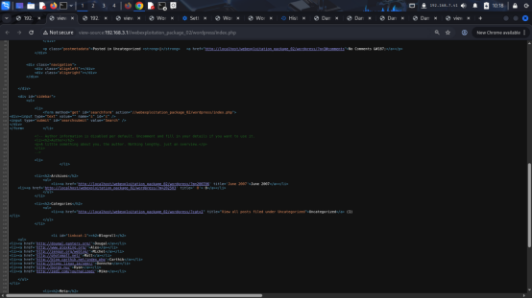
Figure 37: DAMN vulnerable index.php source code

- In the page source code, we came across a commented-out section related to author details:
<!-- Author information is disabled per default. Uncomment and fill in your details if you want to use it.
<li><h2>Author</h2> <p>A little something about you, the author. Nothing lengthy, just an overview.</p> </li> -->

- Although it looked harmless at first, this comment made us curious about how the site was structured behind the scenes. We used SSH user and explored the website’s directory structure further.During this exploration, we identified areas where files could potentially be modified. This raised a concern, as any writable web file could be leveraged to insert malicious code, such as a reverse shell, which could ultimately lead to remote access to the system.
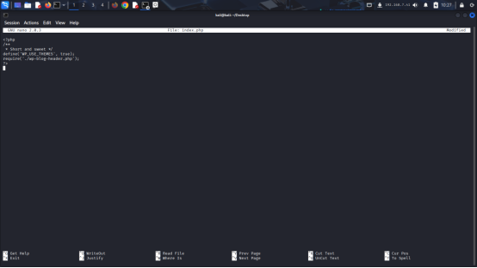
Figure 38: index.php file in directories

- We edited the index.php file by inserting a reverse shell payload and configuring it with our local machine’s IP address and port 7777. This modification allowed the target system to initiate an outbound connection back to our listener upon execution.

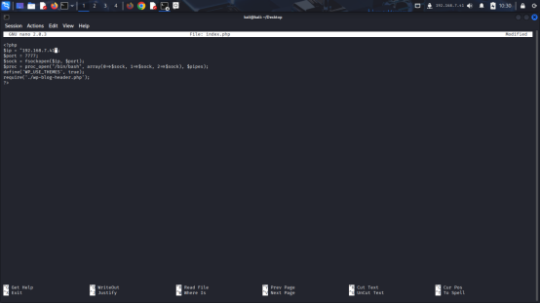

Figure 39: index.php file with reverseshell

- We configured a listener on our local machine on port 7777 to receive an incoming connection.

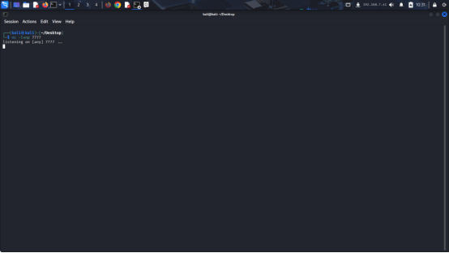
Figure 40:listening port at 7777
Catching the Reverse Shell and Escalating to Root:

- After updating the relevant file on the target system, the payload was executed, resulting in the target initiating a connection back to our machine. The connection was successfully established on port 7777, providing an interactive session for post-exploitation analysis and we used python -c 'import pty; pty.spawn("/bin/bash") to get proper view of shell script.

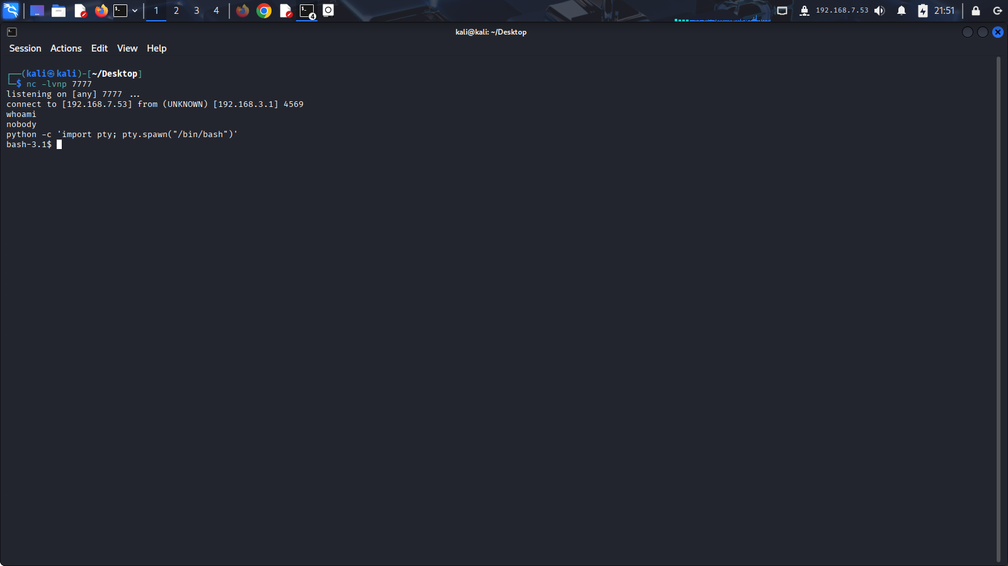
Figure 41:got access as nobody

- Even the nobody user was found to have the same privilege-related limitations as the other SSH users, indicating a consistent lack of proper privilege separation across user accounts.

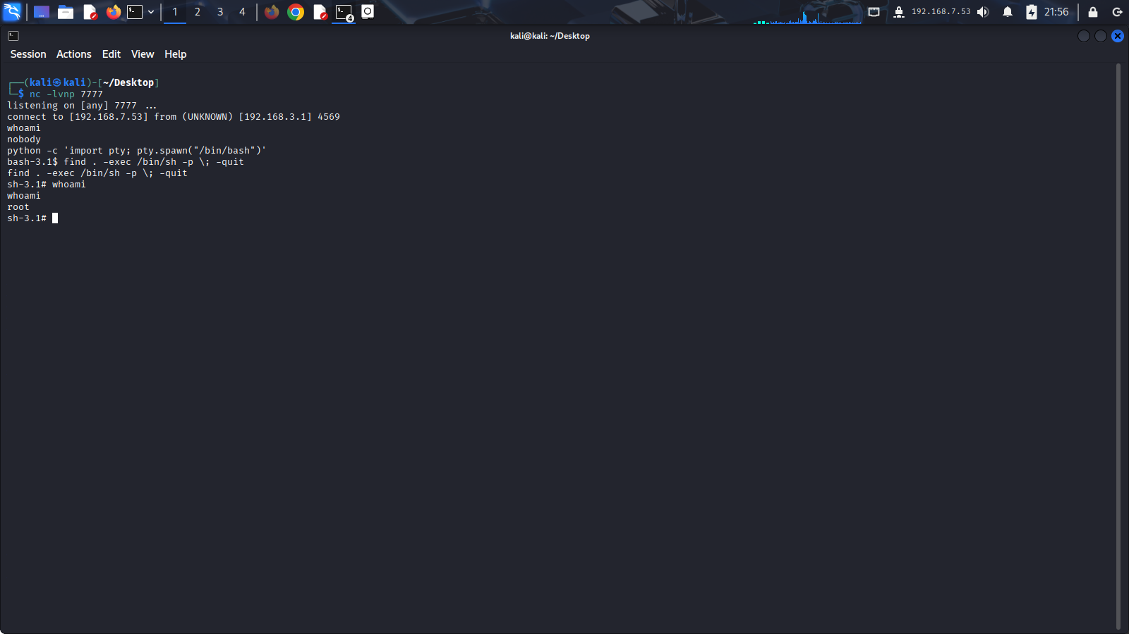

Figure 42: used find . -exec /bin/sh -p \; -quit to get root access

Mitigation:
- Set strong, unique passwords for accounts (NCSC, 2021)
- Use bcrypt or Argon2 for WordPress password hashing — not MD5 (OWASP, 2021)
- Implement file integrity monitoring (AIDE or Tripwire) to detect unauthorised file creation (Kim, 2018)

3. Activity Log:
The group’s Activity Log is available on Canvas Group discussion under the section titled “Assignment 2 – Penetration Test Project Activity Log”, and feedback in "Weekly Monitoring Marking" along with marking records.

Group Management:

a) Management of group work and the roles of each member:
The group work was managed through structured task allocation and continuous coordination to ensure the smooth execution of penetration testing activities. Meena Ramesh and Chethan acted as team coordinators, responsible for allocating tasks and attacks to each member, managing the weekly activity log on Canvas, coordinating exploitation activities, and overseeing privilege escalation checks. They also ensured that each member consistently documented their evidence to demonstrate individual contribution. Pavan was responsible for scanning and enumeration, Bhanu handled vulnerability scanning and identification, and Swathi was responsible for evidence collection and attack documentation. This clear role distribution ensured that all phases of the penetration testing lifecycle were effectively covered.

b) Training logbook evidence, feedback, and performance appraisal:
Based on the Canvas training logbook and weekly instructor feedback, the group demonstrated gradual improvement in both technical execution and documentation quality. Early feedback highlighted weaknesses in aligning scanning outputs with exploitation planning, which was addressed through improved group coordination and structured discussions. Instructor feedback also helped improve the clarity, consistency, and justification of evidence submitted on Canvas. From a personal perspective, I actively contributed throughout the project and was responsible for documenting Attack 3 – Local Privilege Escalation via Linux Kernel Vulnerability. Through this task and feedback received, I improved my ability to interpret system-level vulnerabilities and better understand the progression from exploitation to privilege escalation. This experience also strengthened my technical confidence and contributed to the overall effectiveness of the group’s attack workflow.

c) Valuable and detrimental behaviours observed in the team:
A key strength of the team was consistent participation and strong willingness to collaborate during technical challenges, particularly when interpreting scan results and mapping vulnerabilities to exploitation paths. The group also demonstrated effective peer support, which contributed to improved understanding of penetration testing concepts across members. However, a minor limitation observed was inconsistency in the speed of documentation and evidence collection during the initial stages, which occasionally delayed reporting. This issue was gradually improved through better coordination, clearer task ownership, and real-time updating of the activity log.

d) Learning outcomes from group work experience:
This group project developed a stronger understanding of structured penetration testing workflows, including scanning, vulnerability assessment, exploitation, privilege escalation, and reporting. It highlighted the importance of clear role allocation, continuous communication, and maintaining accurate and timely documentation throughout the project lifecycle. I also learned how critical it is to connect technical findings with proper evidence collection and structured reporting. In future group work, I will carry forward improved coordination practices, better time management, and a more systematic approach to both technical execution and documentation quality.

Reference:
- Apache (2023) core - Apache HTTP Server Version 2.4. Available at: https://httpd.apache.org/docs/2.4/mod/core.html#options (Accessed: 14 April 2026).
- CIS (2023) CIS Benchmarks®. Available at: https://www.cisecurity.org/cis-benchmarks (Accessed: 10 April 2026).
- CVE-2009-2692 (no date) CVE Record: CVE-2009-2692. Available at: https://www.cve.org/CVERecord?id=CVE-2009-2692 (Accessed: 10 April 2026).
- GTFOBins (2024) find | GTFOBins SUID Privilege Escalation Techniques. Available at: https://gtfobins.org/gtfobins/find/ (Accessed: 15 April 2026).
- Kim, D. and S. (2018) Fundamentals of Information Systems Security. . Available at: https://www.scirp.org/reference/referencespapers?referenceid=2805255 (Accessed: 18 April 2026).
- Linux Foundation (2026) The Linux Kernel Archives - Releases. Available at: https://www.kernel.org/category/releases.html (Accessed: 10 April 2026).
- MySQL (2023) MySQL :: MySQL 8.0 Reference Manual :: 8 Security. Available at: https://dev.mysql.com/doc/refman/8.0/en/security.html (Accessed: 11 April 2026).
- NCSC (2021) Password administration for system owners | National Cyber Security Centre. Available at: https://www.ncsc.gov.uk/collection/passwords (Accessed: 12 April 2026).
- NIST (2023) SP 800-41 Rev. 1, Guidelines on Firewalls and Firewall Policy | CSRC. Available at: https://csrc.nist.gov/pubs/sp/800/41/r1/final (Accessed: 12 April 2026).
- OWASP (2021) Password Storage - OWASP Cheat Sheet Series. Available at: https://cheatsheetseries.owasp.org/cheatsheets/Password_Storage_Cheat_Sheet.html (Accessed: 06 April 2026).
- Red Hat (2022) Using SELinux | Red Hat Enterprise Linux | 8 | Red Hat Documentation. Available at: https://docs.redhat.com/en/documentation/red_hat_enterprise_linux/8/html/using_selinux/index (Accessed: 1s0 April 2026).

