**Meenakshi Nagarajan**

**Assignment 1**

**STT4110/6110**

1. Consider the simple linear filter with weights $a_{j}={\left(2q+1\right)}^{-1}, -q≤j≤q$
2. $\sum_{j=-q}^{q}{a_{j}m_{t-j}}$ = $m_{t}$, where $m_{t}=C_{0}+C_{1}t$

$Substituting the given values we get$,

$=\sum_{j=-q}^{q}{{\left(2q+1\right)}^{-1}}$. $( C_{0}+C_{1}\left(t-j\right))$

$=\frac{1}{2q+1}(C_{0}\left(2q+1\right)+C_{1}\sum_{j=-q}^{q}{(t-j))}$

$=C_{0}+\frac{C_{1}}{2q+1}(t\left(2q+1\right)-\sum_{j=-q}^{q}{j}$)

$=C_{0}+C_{1}t-C_{1}/(2q+1)(\sum_{j=1}^{q}{j}+\sum_{j=1}^{q}{-j})$

$=C_{0}+C_{1}t$

$=m_{t}$

1. If $Z_{t}$, t = 0, $±1, ±2…,$ are independent random variables with mean 0 and variance $σ^{2}$ and $A_{t}= \sum_{j=-q}^{q}{a_{j}}.Z_{t-j}$. Show that E $A_{t}=0, Var(A_{t})$ = $\frac{σ^{2}}{2q+1}$.

$μ_{t}=$ E ( $A_{t})$ = E $[\sum_{j=-q}^{q}{a_{j}}.Z_{t-j}]$

= $\sum_{j=-q}^{q}{a_{j}}.E\left(Z_{t-j}\right)=0$

so that $μ_{t}=0$

$Var(A_{t})$ = $\sum_{j=-q}^{q}{a_{j}^{2}}.Var(Z_{t-j}$)

$=\frac{1}{{\left(2q+1\right)}^{2}}$ $\sum_{j=-q}^{q}{σ^{2}}$

$=\frac{σ^{2}}{2q+1}$

1. We use “WN” to indicate White noise. Consider $X_{t}=m_{t}+W_{t} with m_{o}=0, m_{t}=m_{t-1}+b_{t-1}+V_{t}, b_{0}=0, b_{t}=b_{t-1}+ U_{t}, where$

{$U_{t}$} $∼$ WN(0, $σ_{U}^{2}$)

{$V_{t}$} $∼$ WN(0, $σ_{V}^{2}$)

{$W_{t}$} $∼$ WN(0, $σ_{W}^{2}$)

1. Is { $Y_{t}\}$ = {$X_{t}-X_{t-1}\} stationary?$ Explain

= E($X_{t})-E(X_{t-1}\})$

= E($m_{t}+W_{t})-E(m_{t-1}+W_{t-1})$

= $E\left(m_{t}\right)+E\left(W_{t}\right)-E\left(m_{t-1}\right)-E(W_{t-1})$

= $E\left(m_{t}\right)- E\left(m_{t-1}\right)$

= E($m_{t-1}+b_{t-1}+V_{t})-E(m_{t-1})$

= $E\left(m_{t-1}\right)+E\left(b_{t-1}\right)+E\left(V_{t}\right)-E\left(m_{t-1}\right)$

= $E\left(b_{t-1}\right)$

{$Y_{t}\} is stationary when t=1$, E($b_{0})=0$

if t>1, it results in a constant. Therefore, it is stationary

Cov($Y_{t},Y_{t-k)})=Cov(X_{t}-X_{t-1},X_{t-k}-X_{t-k-1})$

= $Cov\left(X_{t},X_{t-k}\right)+Cov\left(X_{t},{-X}_{t-k-1}\right)+Cov\left(-X_{t-1},X_{t-k}\right)+Cov(-X_{t-1},-X_{t-k-1})$

= $Cov\left(X_{t},X_{t-k}\right)-Cov\left(X_{t},{-X}_{t-k-1}\right)-Cov\left(X_{t-1},X_{t-k}\right)+Cov(X_{t-1},X_{t-k-1})$

= $γ_{k}-γ_{k+1}-γ_{k-1}+γ_{k}$

= $2γ_{k}-γ_{k+1}-γ_{k-1}$

Since it depends only on lag k, we can conclude saying that ${\{Y}_{t}\}$ is stationary

1. Is { $Z_{t}\}$ = {$X_{t}-{2X}_{t-1}+X_{t-2}\} stationary?$ Explain

E( $Z_{t})$ =E(( $X_{t})$- 2($X_{t-1})$ + $X_{t-2}$)) = E($X_{t})-2E(X_{t-1})$ +E($X_{t-2})$

=E($m_{t}+W_{t})-2E(m_{t-1}+W_{t-1})$ +E($m_{t-2}+W_{t-2})$

=E($m_{t-1}+b_{t-1}+V_{t}+W_{t})$-2E($m_{t-2}+b_{t-1}+V_{t-1}+W_{t-1}$)+E($m_{t-3}+b_{t-3}+V_{t-2}+W_{t-2})$)

= E($m_{t-1})+E(b_{t-1})+{E(V}_{t})+E(W_{t})-2E(m_{t-2})-2E(b_{t-1})-2E(V_{t-1})-2E(W_{t-1})+E(m_{t-3})$ +E($b_{t-3})+E(V_{t-2}$)+E($W_{t-2})$

= E($m_{t-1})+E\left(b_{t-1}\right)-2E\left(m_{t-2}\right)-2E\left(b_{t-1}\right)+E\left(m_{t-3}\right)+E(b_{t-3})$

For all values of t, { $Z_{t}\}$ is constant. if t=1, we get E($m_{0})+E\left(b_{0}\right)-2E\left(m_{-1}\right)-2E\left(b_{0}\right)+E\left(m_{-2}\right)+E(b_{-2})$

= 0+0 $-2\left(m_{-1}\right)+m_{-2}+b_{-2}$

= $-2\left(m_{-1}\right)+m_{-2}+b_{-2}$ which is constant

$Cov\left(Z_{t},Z_{t-k}\right)=Cov\left(X_{t}-{2X}_{t-1}+X_{t-2},X_{t-k}-{2X}_{t-k-1}+X_{t-k-2}\right)$

$=Cov\left(X_{t},X_{t-k}\right)-2Cov\left(X_{t},X_{t-k-1}\right)+Cov\left( X_{t},X_{t-k-2}\right)-2Cov\left(X_{t-1},X_{t-k}\right)+4Cov\left(X_{t-1},X_{t-k-1}\right)-2Cov\left(X_{t-1}, X_{t-k-2}\right)+Cov\left(X_{t-2},X_{t-k}\right)-2Cov\left(X_{t-2}{,X}_{t-k-1}\right)+Cov(X_{t-2},X_{t-k-2})$

$= γ_{k}-2γ_{k+1}+γ_{k+2}-2γ_{k+1}+4γ_{k+2}-2γ_{k+1}+γ_{k-2}-2γ_{k-1}-γ_{k}$

$=-6γ_{k+1}+5γ_{k+2}+γ_{k-2}-2γ_{k-1}$

Only depends on time lag k, hence its stationary



1.3) Simulate a completely random process of length 48 with independent, normal values. Plot the time series plot. Does it look “random”? Repeat this exercise several times with a new simulation each time.

**R Script**

> a=rnorm(48)

> plot.ts(a,ylab="1 Random")

> a=rnorm(48)

> plot.ts(a,ylab="2 Random")

> a=rnorm(48)

> plot.ts(a,ylab="3 Random")

> a=rnorm(48)

> plot.ts(a,ylab="4 Random")

> a=rnorm(48)

> plot.ts(a,ylab="5 Random")

**Output**

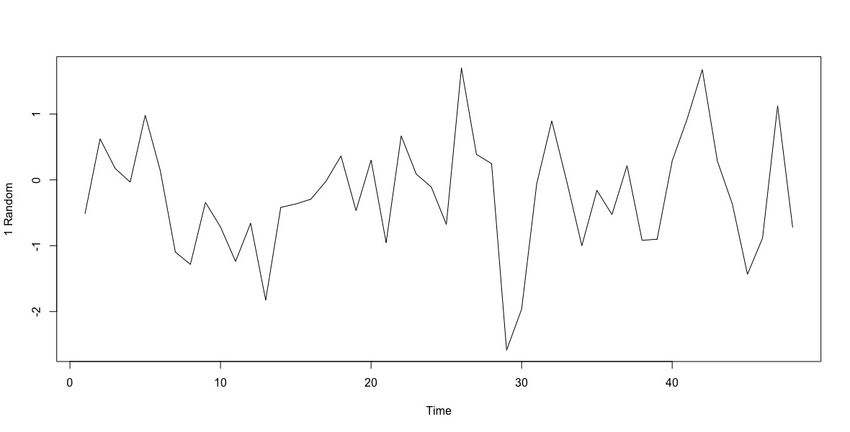

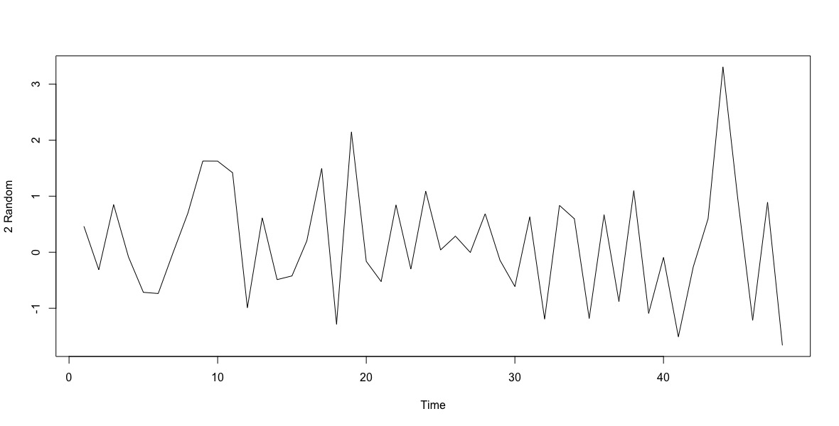

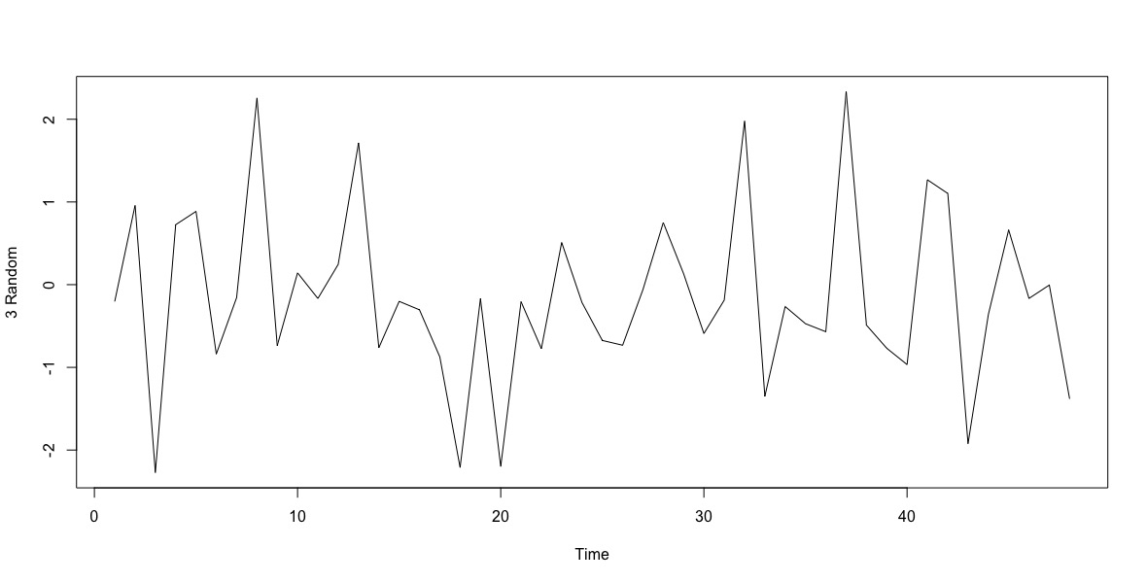

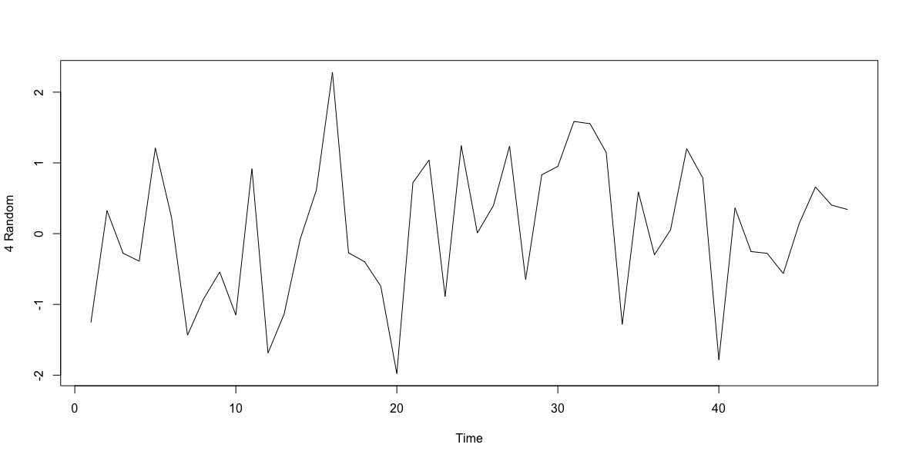

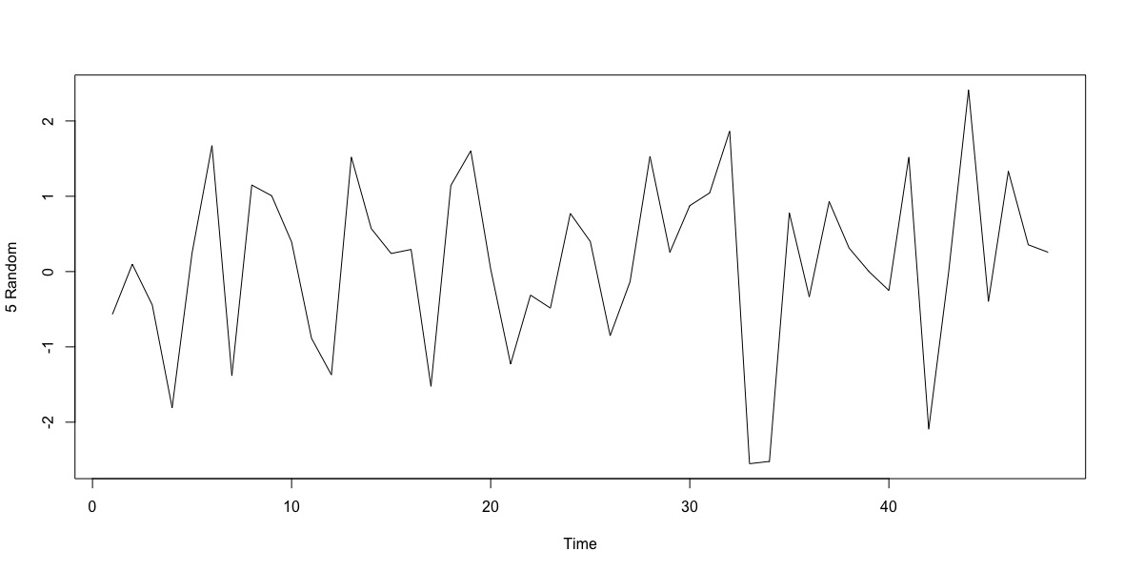

From the plots, we can see that there is no visible pattern here.

1.4) Simulate a completely random process of length 48 with independent, chi-square distributed values, each with 2 degrees of freedom. Display the time series plot. Does it look “random” and non normal? Repeat this exercise several times with a new simulation each time.

**R Script**

> plot.ts(rchisq(48, 2),ylab="1 Random")

> plot.ts(rchisq(48, 2),ylab="2 Random")

> plot.ts(rchisq(48, 2),ylab="3 Random")

> plot.ts(rchisq(48, 2),ylab="4 Random")

> plot.ts(rchisq(48, 2),ylab="5 Random")

**Output**

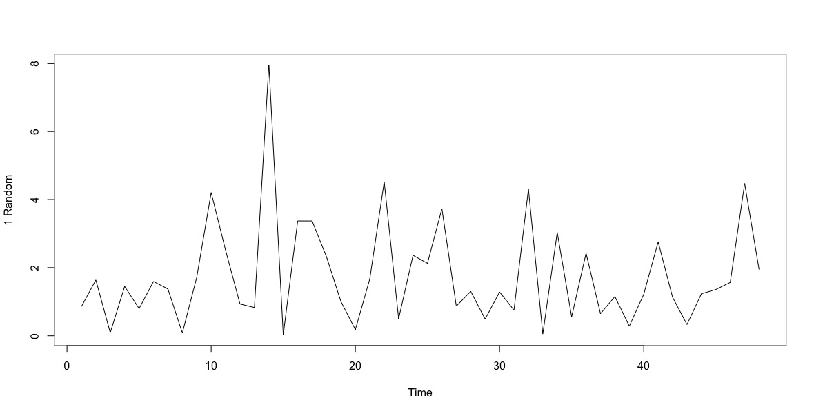

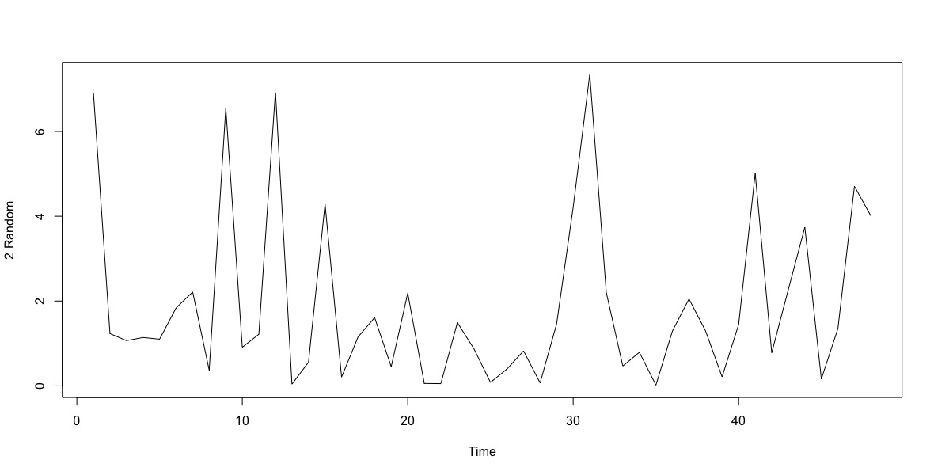

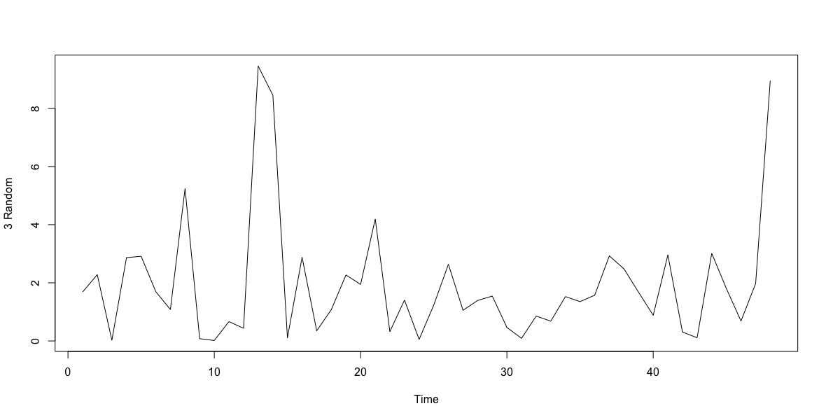

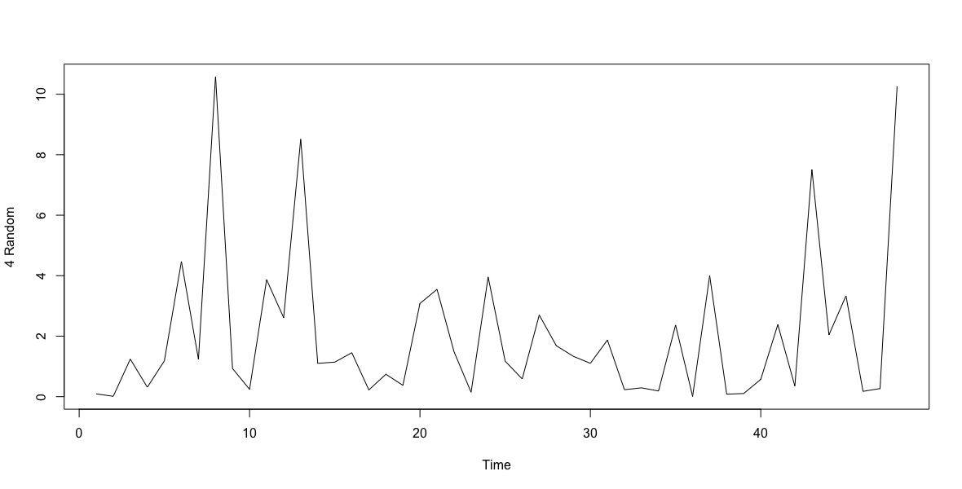

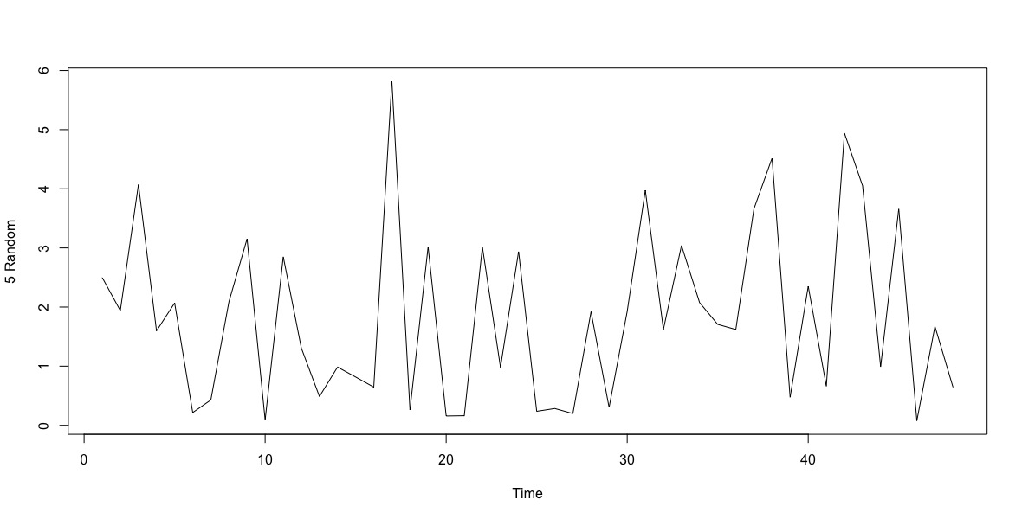

Though the process is non-normal, it appears to be random.

2.1) Suppose $E(X) = 2$, $Var(X) = 9$, $E(Y) = 0$, $Var(Y) = 4$, and $Corr(X,Y) = 0.25.$

Find: (a) $Var(X + Y).$  
(b) $Cov(X, X + Y).$  
(c) $Corr(X + Y, X - Y).$

$Var(X+Y) = Var(X)+Var(Y) +2*Cov(X,Y)$

$corr\left(X,Y\right)=\frac{cov\left(X,Y\right)}{\sqrt{Var\left(X\right)*Var(Y)}}$

$0.25=\frac{cov\left(X,Y\right)}{\sqrt{9*4}}$

$0.25*6=cov\left(X,Y\right)$

$cov\left(X,Y\right)=1.5$

$Var(X+Y) = Var(X) + Var(Y) + 2*Cov(X,Y)$

$= 9+4+2*1.5$

= **16**

(b) $cov\left(X,X+Y\right)= Cov\left(X,X\right)+Cov\left(X,Y\right)$

$= Var(X)+Cov(X,Y)$

$=9+1.5$

$=10.5$

(c) $Corr(X + Y, X - Y)$ = $\frac{cov\left(X+Y,X-Y\right)}{\sqrt{var\left(X+Y\right)*var(X-Y)}}$

$cov\left(X+Y,X-Y\right)=cov\left(X,X\right)-cov\left(X,Y\right)+cov\left(Y,X\right)-cov\left(Y,Y\right)$ (Linear property of covariance)

$=var\left(X\right)-cov\left(X,Y\right)+cov\left(X,Y\right)-var(Y)$

$=var\left(X\right)-var(Y)$

$=9-4$

$=5$

$var\left(X+Y\right)=16$

$var\left(X-Y\right)=var\left(X\right)+var\left(Y\right)-2cov(X,Y)$

$=9+4-2*1.5=10$

$Corr\left(X + Y, X - Y\right)=\frac{5}{\sqrt{16*10}}$ = **0.3953**

2.12) Suppose that $Y_{t}=e_{t}-(e_{t-12})$. Show that {$Y_{t}$} is stationary and that, for $k > 0$, its   
autocorrelation function is nonzero only for lag $k = 12$.

$e_{t}\sim WN(0,{σ^{2}}_{e}$)

$Y_{t}=e_{t}-(e_{t-12})$

${E(Y}_{t})={E(e}_{t})-E\left(e_{t-12}\right)=0-0=0$

$which is free of time t.$

$cov\left(Y_{t},Y_{t-k}\right)=cov(e_{t}-e_{t-12},e_{t-k}-e_{t-k-12})$

$=cov\left(e_{t}{,e}_{t-k}\right)-cov\left(e_{t}{,e}_{t-k-12}\right)-cov\left(e_{t-12},e_{t-k}\right)+cov(e_{t-12},e_{t-k-12})$

$=2cov\left(e_{t}{,e}_{t-k}\right)-cov\left(e_{t}{,e}_{t-k-12}\right)-cov(e_{t},e_{t-k-12})$

$=2γ_{e}\left(k\right)-γ_{e}\left(k-12\right)-γ_{e}\left(k+12\right)$

$=\{2{σ^{2}}_{e},k=0, -{σ^{2}}_{e}, if k=±12$ independent of t

$Therefore, Y_{t} is stationary$

For $K>0,k≠12,$ $γ_{y}\left(k\right)$ = 0, $ρ\left(k\right)=0$

$K=0,12$ $ρ\left(0\right)=1$ $ρ\left(12\right)=$