**Meenakshi Nagarajan**

**Assignment 3**

**STT4110/6110**

1. Sketch the autocorrelation functions for the following MA(2) models with parameters as specified:

Consider the moving average process of order 2:

*Yt* = *et* –θ1*et*–1 –θ2*et*–2

Theoretical autocorrelation function is as follows,

$ρ_{1}=\frac{-θ_{1}+θ_{1}θ_{2}}{1+θ_{1}^{2}+θ_{2}^{2}}$

$ρ_{2}=\frac{-θ_{2}}{1+θ_{1}^{2}+θ_{2}^{2}}$, $ρ_{k}=0, for k=3,4….$

Using R-code, we obtain the sketch of ACF functions and the values of theoretical autocorrelation function

$θ1 = 0.5 and θ2 = 0.4$

library(ggplot2)  
library(grid)  
par(mfrow=c(1,1))  
acfma1 <- ARMAacf(ma=c(0.5,0.4),lag.max=5)  
print(acfma1)

## 0 1 2 3 4 5   
## 1.0000000 0.4964539 0.2836879 0.0000000 0.0000000 0.0000000

lags <- 0:5  
plot(lags,acfma1,type="h",main="ACF for MA(2) with θ_1=0.5 and θ_2=0.4")  
abline(h=0)

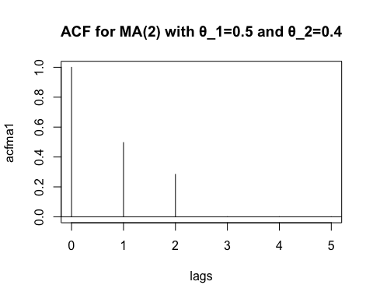

$θ1 = 1.2 and θ2 = - 0.7$

par(mfrow=c(1,1))  
acfma2 <- ARMAacf(ma=c(1.2,-0.7),lag.max=5)  
print(acfma2)

## 0 1 2 3 4 5   
## 1.0000000 0.1228669 -0.2389078 0.0000000 0.0000000 0.0000000

lags <- 0:5  
plot(lags,acfma2,type="h",main="ACF for MA(2) with θ_1=1.2 and θ_2=-0.7")  
abline(h=0)

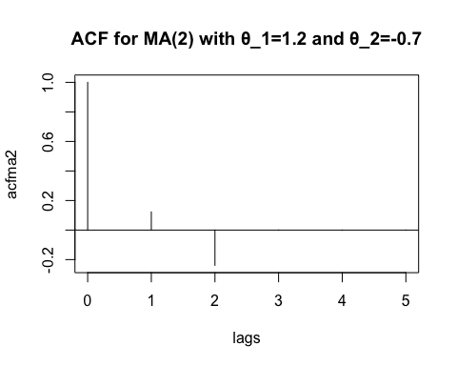

$θ1 = -1 and θ2 = - 0.6$

par(mfrow=c(1,1))  
acfma3 <- ARMAacf(ma=c(-1,-0.6),lag.max=5)  
print(acfma3)

## 0 1 2 3 4 5   
## 1.0000000 -0.1694915 -0.2542373 0.0000000 0.0000000 0.0000000

lags <- 0:5  
plot(lags,acfma3,type="h",main="ACF for MA(2) with θ_1=-1 and θ_2=-0.6")  
abline(h=0)

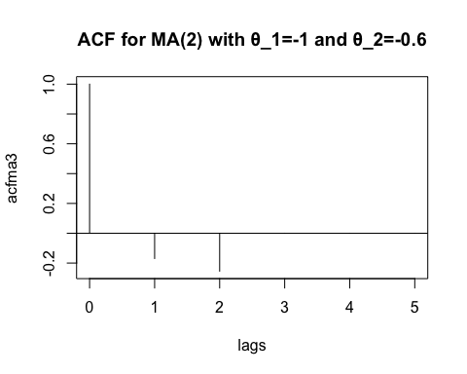

1. Show that when θ is replaced by 1/θ, the autocorrelation function for an MA(1) process does not change.

MA(1) model is $Y_{t}=e_{t}-θe_{t-1}$

$γ\left(k\right)=ρ\left(k\right)=0, K≥2$

$γ\left(0\right)={σ^{2}}_{e}(1+{\left(\frac{1}{θ}\right)}^{2})$

$γ\left(1\right)={σ^{2}}_{e}\left(-\frac{1}{θ}\right)=-\frac{{σ^{2}}_{e}}{θ}$

$ρ\left(1\right)=\frac{γ\left(1\right)}{γ\left(0\right)}$ $=\frac{-\frac{{σ^{2}}_{e}}{θ}}{{σ^{2}}_{e}\left(1+{\left(\frac{1}{θ}\right)}^{2}\right)}=-\frac{\frac{{σ^{2}}_{e}}{θ}}{\frac{{σ^{2}}_{e}}{θ^{2}}\left(θ^{2}+1\right)}=-\frac{\frac{{σ^{2}}_{e}}{θ}}{\frac{{σ^{2}}_{e}}{θ}\left(\frac{\left(θ^{2}+1\right)}{θ}\right)}$

$=-\frac{1}{\frac{\left(θ^{2}+1\right)}{θ}}$

$=-\frac{θ}{θ^{2}+1}$

Hence proved

1. Calculate and sketch the autocorrelation functions for each of the following AR(1) models. Plot for sufficient lags that the autocorrelation function has nearly died out.

$ρ_{k}=\frac{γ_{k}}{γ_{0}}=ϕ^{k} for k=1,2,3….$

1. φ1 = 0.6.

library(ggplot2)  
library(grid)  
par(mfrow=c(1,1))  
acfar1 <- ARMAacf(ar=0.6,lag.max=10)  
print(acfar1)

## 0 1 2 3 4 5   
## 1.000000000 0.600000000 0.360000000 0.216000000 0.129600000 0.077760000   
## 6 7 8 9 10   
## 0.046656000 0.027993600 0.016796160 0.010077696 0.006046618

lags <- 0:10  
plot(lags,acfar1,type="h",main="ACF for AR(1) with phi=0.6")  
abline(h=0)

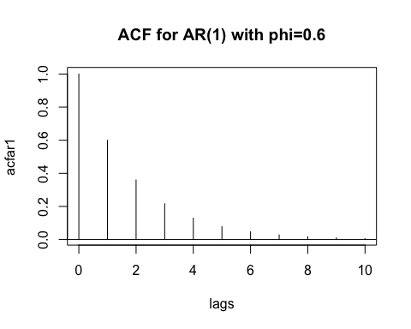

b) φ1 = −0.6.

library(ggplot2)  
library(grid)  
par(mfrow=c(1,1))  
acfar2 <- ARMAacf(ar=-0.6,lag.max=10)  
print(acfar2)

## 0 1 2 3 4   
## 1.000000000 -0.600000000 0.360000000 -0.216000000 0.129600000   
## 5 6 7 8 9   
## -0.077760000 0.046656000 -0.027993600 0.016796160 -0.010077696   
## 10   
## 0.006046618

lags <- 0:10  
plot(lags,acfar2,type="h",main="ACF for AR(1) with phi=-0.6")  
abline(h=0)

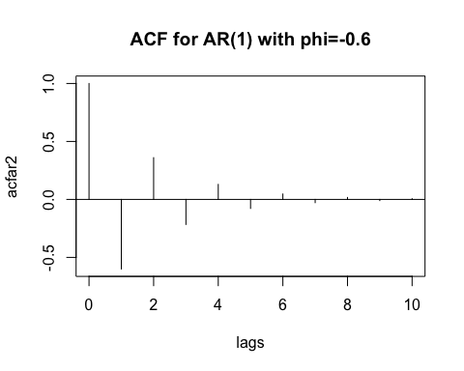

c) φ1 = 0.95. (Do out to 20 lags.)

library(ggplot2)  
library(grid)  
par(mfrow=c(1,1))  
acfar3 <- ARMAacf(ar=0.95,lag.max=20)  
print(acfar3)

## 0 1 2 3 4 5 6   
## 1.0000000 0.9500000 0.9025000 0.8573750 0.8145062 0.7737809 0.7350919   
## 7 8 9 10 11 12 13   
## 0.6983373 0.6634204 0.6302494 0.5987369 0.5688001 0.5403601 0.5133421   
## 14 15 16 17 18 19 20   
## 0.4876750 0.4632912 0.4401267 0.4181203 0.3972143 0.3773536 0.3584859

lags <- 0:20  
plot(lags,acfar3,type="h",main="ACF for AR(1) with phi=0.95")  
abline(h=0)

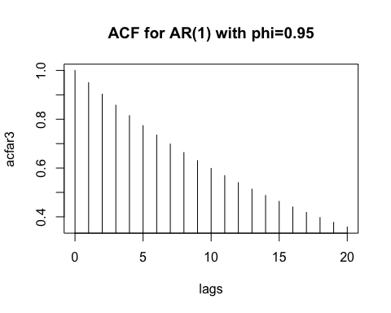

d) φ1 = 0.3.

library(ggplot2)  
library(grid)  
par(mfrow=c(1,1))  
acfar4 <- ARMAacf(ar=0.3,lag.max=10)  
print(acfar4)

## 0 1 2 3 4 5   
## 1.0000e+00 3.0000e-01 9.0000e-02 2.7000e-02 8.1000e-03 2.4300e-03   
## 6 7 8 9 10   
## 7.2900e-04 2.1870e-04 6.5610e-05 1.9683e-05 5.9049e-06

lags <- 0:10  
plot(lags,acfar4,type="h",main="ACF for AR(1) with phi=0.3")  
abline(h=0)

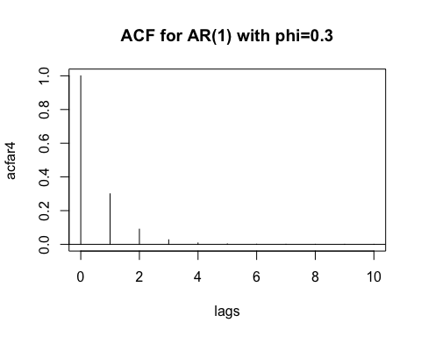

1. Sketch the autocorrelation functions for each of the following ARMA models:
2. ARMA(1,1) with φ = 0.7 and θ = 0.4. **(b)** ARMA(1,1) with φ = 0.7 and θ = −0.4.

$ρ_{k}=\frac{\left(1-θϕ\right)\left(ϕ-θ\right)}{1-2θϕ+θ^{2}}ϕ^{k-1} for k≥1$

1. ARMA(1,1) with φ = 0.7 and θ = 0.4.

library(ggplot2)  
library(grid)  
par(mfrow=c(1,1))  
arma <- ARMAacf(ar=0.7,ma=-0.4,lag.max=10)  
print(arma)

## 0 1 2 3 4 5   
## 1.00000000 0.36000000 0.25200000 0.17640000 0.12348000 0.08643600   
## 6 7 8 9 10   
## 0.06050520 0.04235364 0.02964755 0.02075328 0.01452730

lags <- 0:10  
plot(lags,arma,type="h",main="ACF for ARMA with phi=0.7 and theta=0.4")  
abline(h=0)

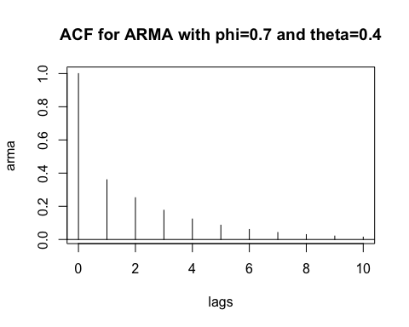

1. ARMA(1,1) with φ = 0.7 and θ = − 0.4.

par(mfrow=c(1,1))  
arma <- ARMAacf(ar=0.7,ma=0.4,lag.max=10)  
print(arma)

## 0 1 2 3 4 5   
## 1.00000000 0.81860465 0.57302326 0.40111628 0.28078140 0.19654698   
## 6 7 8 9 10   
## 0.13758288 0.09630802 0.06741561 0.04719093 0.03303365

lags <- 0:10  
plot(lags,arma,type="h",main="ACF for ARMA phi=0.7 and theta=-0.4")  
abline(h=0)

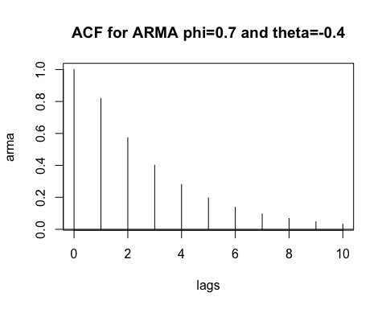

1. Consider a process that satisfies the zero-mean, “stationary” AR(1) equation *Yt* =  φ*Yt* − 1 + *et* with −1 < φ < +1. Let *c* be any nonzero constant, and define *Wt* = *Yt* + *c $ϕ$ t*.
   1. Show that $E\left(W_{t}\right)=cϕ^{t}$

$E\left(W_{t}\right)=E(Yt + cϕt)$

$=E\left(Yt \right)+ c(φt)$

$=0+c(ϕt)$ (Process is zero mean)

$=c\left(ϕt\right)$

1. Show that {*Wt*} satisfies the “stationary” AR(1) equation *Wt* = φ*Wt* − 1 + *et*.

$W_{t}= Yt + c ϕ t$

$=ϕY_{t-1}+e_{t}+cϕ^{t}$

$=ϕ\left(Y_{t-1}+cϕ^{t-1}\right)+e_{t}$

$=ϕW_{t-1}+e_{t}$

1. Is {Wt} stationary?

$E\left(W_{t}\right)= c\left(ϕt\right)$ is not constant in time, therefore it is not stationary

1. Suppose that {Yt} is an AR(1) process with −1 < φ < +1.
2. Find the auto covariance function for Wt = ∇Yt = Yt − Yt−1 in terms of φ and σe2.

Wt = ∇ ${ Y}_{t}$ = $Y_{t}$ − $Y_{t-1}$

$=ϕ\left(Y_{t-1}\right)+e_{t}-Y_{t-1}$

$=(ϕ-1)\left(Y_{t-1}\right)+e_{t}$

auto-covariance is

$γ_{k}=E[\left(W_{t}-E\left(W_{t}\right)\right)-\left(W_{t-k}-E\left(W_{t-k}\right)\right)]$

$E\left(W_{t}\right)=0$

$γ_{k}=E[W_{t}W_{t-k}]$

$γ_{k}=E[\left(\left(ϕ-1\right)\left(Y_{t-1}\right)+e_{t}\right)\left(\left(ϕ-1\right)\left(Y_{t-k-1}\right)+e_{t-k}\right)]$

$γ_{k}={\left(ϕ-1\right)}^{2}E\left[Y_{t-1}Y_{t-k-1}\right]+E\left[e_{t}e_{t-k}\right]+\left(ϕ-1\right)E\left[Y_{t-1}e_{t-k}\right]+\left(ϕ-1\right)E[Y_{t-k-1}e_{t}]$

$γ_{k}={\left(ϕ-1\right)}^{2}E\left[Y_{t-1}Y_{t-k-1}\right]+0+0+0$

${ γ}_{k}={\left(ϕ-1\right)}^{2}E\left[Y_{t-1}Y_{t-k-1}\right]$

if $k$ = 0

${ γ}_{0}={\left(ϕ-1\right)}^{2}Var(Y)$

${ γ}_{0}=\frac{{\left(1-ϕ\right)}^{2}σ^{2}}{1-ϕ^{2}}$

${ γ}_{0}=\frac{\left(1-ϕ\right)σ^{2}}{1+ϕ}$

if $k$ = 1

${ γ}_{1}={\left(ϕ-1\right)}^{2}E[Y_{t-1}Y_{t-2}]$

${ γ}_{1}={\left(ϕ-1\right)}^{2}E[(ϕY_{t-1}+e_{t-1})Y_{t-2}]$

${ γ}_{1}={ϕ\left(ϕ-1\right)}^{2}E[(Y_{t-2}+e_{t-1})Y_{t-2}]$

${ γ}_{1}={ϕ\left(ϕ-1\right)}^{2}E[(Y_{t-2}Y_{t-2}]$

${ γ}_{1}={ϕ\left(ϕ-1\right)}^{2}Var(Y)$

${ γ}_{1}=\frac{{ϕ\left(1-ϕ\right)}^{2}σ^{2}}{1-ϕ^{2}}$

${ γ}_{1}=\frac{ϕ\left(1-ϕ\right)σ^{2}}{1+ϕ}$

1. In particular, show that $Var(Wt) = 2 σe2 /(1+φ).$

$Var\left(W_{t}\right)=E(W_{t}W_{t})$

$Var\left(W_{t}\right)=E[(\left(ϕ-1\right)Y_{t-1}+e_{t})((ϕ-1)Y_{t-1}+e_{t})]$

$Var\left(W_{t}\right)={\left(ϕ-1\right)}^{2}Var\left(Y_{t}\right)+Var(e_{t})$

$Var\left(W_{t}\right)=\frac{{\left(1-ϕ\right)}^{2}σ^{2}}{1-ϕ^{2}}+σ^{2}$

$Var\left(W_{t}\right)=\frac{\left(1-ϕ\right)σ^{2}}{1+ϕ}+σ^{2}$

$Var\left(W_{t}\right)=\frac{\left(1-ϕ\right)σ^{2}+\left(1+ϕ\right)σ^{2}}{1+ϕ}$

$Var\left(W_{t}\right)=\frac{2σ^{2}}{1+ϕ}$

1. Suppose that {Yt} is an AR(1) process with ρ1 = φ. Define the sequence {bt} as bt =Yt −φYt+1.
   1. Show that Cov(bt,bt − k) = 0 for all t and k.

* 1. Show that *Cov*(*bt*,*Yt* + *k*) = 0 for all *t* and *k* > 0.

$Cov\left(b_{t},Y_{t+k}\right)=Cov(Y_{t}-ϕY_{t+1},Y_{t+k})$

$=Cov(Y_{t},Y_{t+k})-ϕCov(Y_{t+1},Y_{t+k})$

$=Cov(Y_{t},Y_{t+k})-ϕCov(Y_{t+1},Y_{t+k})$

= $\frac{σ_{e}^{2}}{1-ϕ^{2}}(ϕ^{k}-ϕϕ^{k-1})$

= $\frac{σ_{e}^{2}}{1-ϕ^{2}}(ϕ^{k}-ϕ^{k})$

= $0$