**Meenakshi Nagarajan**

**Assignment 5**

**STT4110/6110**

5.1 Identify the following as specific ARIMA models. That is, what are *p*, *d*, and *q* and what are the values of the parameters (the φ’s and θ’s)?

**(a)** *Yt* = *Yt* − 1 − 0.25*Yt* − 2 + *et* − 0.1*et* − 1.

**(b)** *Yt* = 2*Yt* − 1 − *Yt*−2 + *et*.

**(c)** *Yt* = 0.5*Yt* − 1 − 0.5*Yt* − 2 + *et* − 0.5*et* − 1+ 0.25*et* − 2.

*Solution:*

1. *Yt* = *Yt* − 1 − 0.25*Yt* − 2 + *et* − 0.1*et* – 1

We can write this process as.



$Y_{t}-Y_{t-1}+0.25Y_{t-2}=e_{t}-0.1e_{t-1}$

AR(2) stationary conditions are as follows,

ϕ1 + ϕ2 < 1, ϕ2 − ϕ1 < 1, |ϕ2| < 1

From the above equation, we can see that,

$ϕ_{1}=1,ϕ_{2}=-0.25$

$ϕ_{1}+ϕ_{2}=1-0.25< 1$

$ϕ_{2}-ϕ_{1}=-0.25-1=-1.25<1$

$\left|ϕ_{2}\right|=\left|0.25\right|<1$

This equation satisfies the AR(2) stationary conditions. Zero differences of {$W_{t}\}$ follow

a MA(1) model $p=2, q=1, d=0$**.**



$ϕ_{1}=1,ϕ_{2}=-0.25,θ_{1}=0.1$

$Y_{t}=2Y_{t-1}-Y_{t-2}+e_{t}$

From the above equation, we can see that,

$ϕ_{1}=2,ϕ_{2}=-1$

$ϕ_{1}+ϕ_{2}=2-1=$ 1

$ϕ_{2}-ϕ_{1}=-1-2=-3<1$

$\left|ϕ_{2}\right|=\left|1\right|=1$

This equation doesn’t satisfy the AR(2) stationarity condition. The equation can be re-

written as,

$Y_{t}-2Y_{t-1}+Y_{t-2}=e_{t}$

$(1-2B+B^{2})Y_{t}=e_{t}$

$(1-B)(1-B)Y_{t}=e_{t}$

As, ${\left(1-B\right)}^{2}Y_{t}=W_{t}$, we can write the equation as,

$W_{t}=e_{t}$

two differences of {$W_{t}\}$ follow a MA(0) model with $p=0, q=0, d=2$

1. *Yt* = 0.5*Yt* − 1 − 0.5*Yt* − 2 + *et* − 0.5*et* − 1+ 0.25*et* − 2.

From the above equation we can see that,

$ϕ_{1}=0.5,ϕ_{2}=-0.5, θ_{1}=0.5, θ_{1}=0.5, θ_{2}=-0.25$

$ϕ_{1}+ϕ_{2}=0.5-0.5=0$

$ϕ_{2}-ϕ_{1}=-0.5-0.5= -1$

$\left|ϕ_{2}\right|=\left|0.5\right|=0.5$

This equation satisfy the AR(2) stationarity condition

This equation can be written as,

$Y_{t}-0.5Y_{t-1}+0.5Y_{t-2}=e_{t}-0.5e_{t-1}+0.25e_{t-2}$

$(1-0.5B+0.5B^{2})Y_{t}=(1-0.5B+0.25B^{2})e_{t}$

Zero differences of {$W_{t}\}$ follow a MA(2) model with $p=2, q=2, d=0$

**5.2** For each of the ARIMA models below, give the values for *E*(∇*Yt*) and *Var*(∇*Yt*).

**(a)** *Yt* = 3 + *Yt* − 1 + *et* − 0.75*et* – 1

**(b)** *Yt* = 10 + 1.25*Yt* − 1 − 0.25*Yt* − 2 + *et* − 0.1*et* – 1

**(c)** *Yt* = 5 + 2*Yt* − 1 − 1.7*Yt* − 2 + 0.7*Yt* − 3 + *et* − 0.5*et* − 1+ 0.25*et* − 2.

*Solution:*

$Y_{t}=3+Y_{t-1}+e_{t}-0.75e_{t-1}$

$Y_{t}-Y_{t-1}=3+e_{t}-0.75e_{t-1}$

$E$ (∇ $Y_{t})$ = $E(3+e_{t}-0.75e_{t-1})$

= $(3) +E(e_{t})-0.75E(e_{t-1})$

= 3

$Var\left(Y_{t}\right)=3+σ_{e}^{2}-0.75σ_{e}^{2}=3+0.25σ_{e}^{2}$

$Y_{t}=10+1.25Y_{t-1}-0.25Y_{t-2}+e_{t}-0.1e_{t-1}$

This can be re-written as,

$\left(1-1.25B+0.25B^{2}\right)Y_{t}=10+(1-0.1B)e_{t}$

(∇ $Y_{t})=(1-B)Y_{t}$

$\left(1-1.25B+0.25B^{2}\right)(1-B)Y_{t}=10t+(1-0.1B)e_{t}$

$\left(1-1.25B+0.25B^{2}\right)μ=10t+(1-0.1B)e_{t}$

$c=\frac{μ}{(1-ϕ_{1}-ϕ_{2}…ϕ_{p})}$

$10t=\frac{μ}{1-1.25+0.25}$

$μ=(10t)(0)$

$μ=0$

$Var\left(Y_{t}\right)=\left[10t+\left(1-0.1B\right)σ_{e}^{2}\right]{\left(1-1.25B+0.25B^{2}\right)}^{-1}$

$Var\left(Y_{t}\right)=\left[10t+θ\left(B\right)σ_{e}^{2}\right]{\left(ϕ\left(B\right)\right)}^{-1}$

$Var\left(Y_{t}\right)={\left(ϕ\left(B\right)\right)}^{-1}\sum_{t=0}^{∞}{10t}+{\left(ϕ\left(B\right)\right)}^{-1} θ\left(B\right)σ_{e}^{2}$

1. *Yt* = 5 + 2*Yt* − 1 − 1.7*Yt* − 2 + 0.7*Yt* − 3 + *et* − 0.5*et* − 1+ 0.25*et* – 2

$This can be rewritten as,$

$\left(1-2B+1.7B^{2}-0.7B^{3}\right)Y_{t}=5t+(1-0.5B+0.25B^{2})et$

$ϕ\left(B\right)(1-B)Y_{t}=5t+θ\left(B\right)et$

$\left(1-2B+1.7B^{2}-0.7B^{3}\right)μ=5t+(1-0.5B+0.25B^{2})et$

$c=\frac{μ}{(1-ϕ_{1}-ϕ_{2}…ϕ_{p})}$

$5t=\frac{μ}{1-2+1.7-0.7}$

$μ=E\left(Y_{t}\right)=0$

$Var\left(Y_{t}\right)=[5t+θ\left(B\right)σ_{e}^{2}]{\left(ϕ\left(B\right)\right)}^{-1}$

$Var\left(Y_{t}\right)={\left(ϕ\left(B\right)\right)}^{-1}\sum_{t=0}^{∞}{5t}+{\left(ϕ\left(B\right)\right)}^{-1} θ\left(B\right)σ_{e}^{2}$

**5.7** Consider two models:

A: *Yt* =0.9*Yt*−1 +0.09*Yt*−2 +*et*. B: *Yt* = *Yt* − 1 + *et* − 0.1*et* − 1.

**(a)** Identify each as a specific ARIMA model. That is, what are *p*, *d*, and *q* and what are the values of the parameters, φ’s and θ’s?

**(b)** In what ways are the two models different?

**(c)** In what ways are the two models similar? (Compare ψ-weights and  π-weights.)

*Solution:*

1. For Model A,

$Y_{t}=0.9Y_{t-1}+0.09Y_{t-2}+e_{t}$

AR(2) stationary conditions are as follows,

ϕ1 + ϕ2 < 1, ϕ2 − ϕ1 < 1, |ϕ2| < 1

From the above equation, we can see that,

$ϕ1 + ϕ2=0.99 < 1$

$ϕ2 - ϕ1=-0.81 < 1$

$\left|ϕ2\right|=\left|0.09\right|=0.09$

This equation satisfies the AR(2) stationary conditions. Zero differences of {$W_{t}\}$ follow a MA(0) model $p=2, q=0, d=0$**.**

For Model B,

$Y_{t}=Y_{t-1}+e_{t}-0.1e_{t-1}$

This equation can be re-written as,

$Y_{t}-Y_{t-1}=e_{t}-0.1e_{t-1}$

$(1-B)Y_{t}=(1-0.1B)e_{t}$

$W_{t}=(1-0.1B)e_{t}$

The first difference of { $W_{t}\}$ follows MA(1) model with parameter $θ=0.1$. This is a ARIMA(0,1,1)

1. Model A follows AR(2) process with ϕ1=0.9 & ϕ2=0.09 and Model B follows IMA (1,1) process with $θ=0.1$
2. Both the models are not stationary or invertible.

ψ0=1,ψ1=φ1,ψ2 = φ12+φ2

$0.9Y_{t-1}+0.09Y_{t-2}+e_{t}=Y_{t-1}+e_{t}-0.1e_{t-1}$

$(0.9B+0.09B^{2}$) $Y_{t}=-e_{t}$

ψ0=1, ψ1= $1+ϕ=0.9,$ $ψ_{2}=ϕ=-0.09$

$π_{0}=1$

**5.12** The data file SP contains quarterly Standard & Poor’s Composite Index stock price values from the first quarter of 1936 through the fourth quarter of 1977.

(a)  Display and interpret the time series plot for these data.

(b)  Now take natural logarithms of the quarterly values and display and the time  series plot of the transformed values. Describe the effect of the logarithms on  the behavior of the series.

(c)  Calculate the (fractional) relative changes, (Yt − Yt − 1)/Yt − 1, and compare  them to the differences of (natural) logarithms, ∇log(Yt). How do they com-  pare for smaller values and for larger values?

*Solution:*

library("TSA")

## Loading required package: leaps

## Loading required package: locfit

## locfit 1.5-9.1 2013-03-22

## Loading required package: mgcv

## Loading required package: nlme

## This is mgcv 1.8-17. For overview type 'help("mgcv-package")'.

## Loading required package: tseries

##   
## Attaching package: 'TSA'

## The following objects are masked from 'package:stats':  
##   
## acf, arima

## The following object is masked from 'package:utils':  
##   
## tar

data(SP)  
plot.ts(SP)

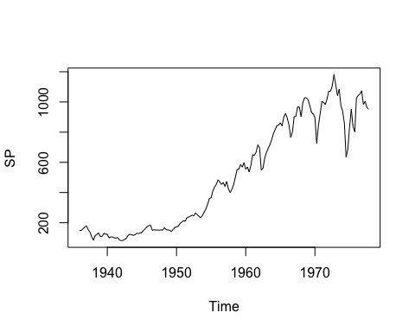

The plot shows an exponential trend which seems to level off after 1970

splog<-log(SP)  
plot.ts(splog,ylab=expression(log(value)))

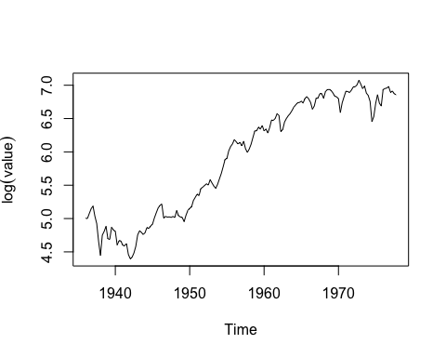

After taking log, the transformed series is more linear. We could still see the exponential pattern

SPdiff<-diff(SP)/lag(SP,1)  
SPlogdiff<-diff(log(SP))  
ts.plot(SPdiff,SPlogdiff,ylab="Sales",gpars=list(col=c("black","red")))

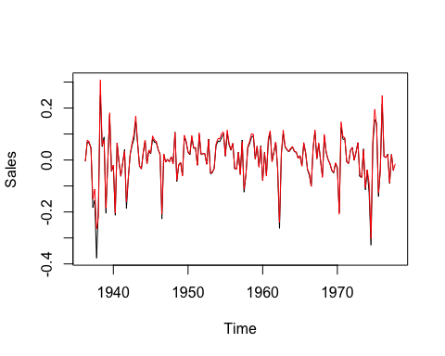

There seems to be little difference between the series and only so for the higher numbers of sales.

**5.15** Quarterly earnings per share for the Johnson & Johnson Company are given in the data file named JJ. The data cover the years from 1960 through 1980.

(a) Display a time series plot of the data. Interpret the interesting features in the plot.

(b)  Use software to produce a plot similar to Exhibit 5.11, on page 102, and determine the “best” value of λ for a power transformation of these data.

(c)  Display a time series plot of the transformed values. Does this plot suggest  that a stationary model might be appropriate?

(d)  Display a time series plot of the differences of the transformed values. Does  this plot suggest that a stationary model might be appropriate for the differences?

*Solution:*

library(TSA)

## Loading required package: leaps

## Loading required package: locfit

## locfit 1.5-9.1 2013-03-22

## Loading required package: mgcv

## Loading required package: nlme

## This is mgcv 1.8-17. For overview type 'help("mgcv-package")'.

## Loading required package: tseries

##   
## Attaching package: 'TSA'

## The following objects are masked from 'package:stats':  
##   
## acf, arima

## The following object is masked from 'package:utils':  
##   
## tar

#plot time series of JJ data  
data(JJ)  
plot.ts(JJ)

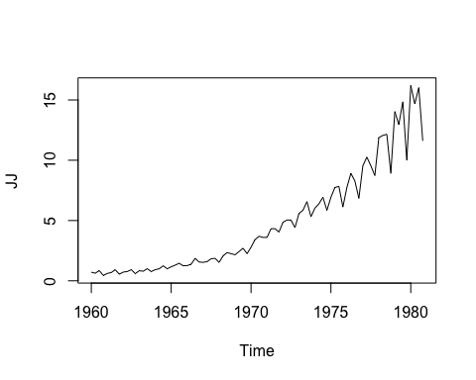

The plot shows a exponential trend and the higher values displays more variation than lower values.

#Log-likelihood vs. Lambda  
BoxCox.ar(JJ)

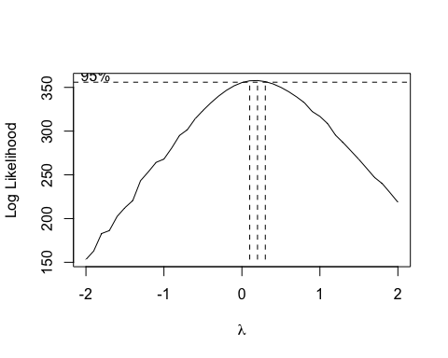

The 95% confidence interval of lambda contains the value of 0.2 near its center and suggests that logarithmic transformation lambda=0.2 for these data

#Transform the data and plot the time series  
JJtransform<-JJ^0.2  
JJtransform<-JJtransform-1  
JJtransform<-JJtransform/0.2  
ts.plot(JJtransform)

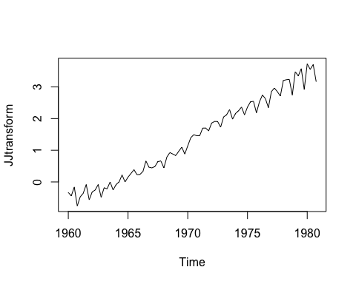

This plot shows a linear trend with non-constant variance and hence this is not considered to be stationary

#Plot the time series of differences of transformed data  
ts.plot(diff(JJtransform))

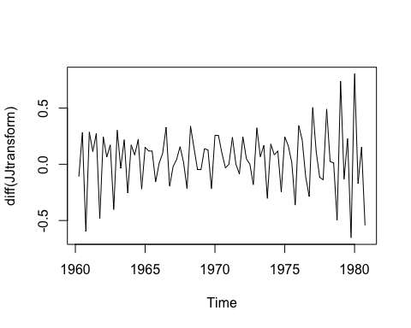

This time plot is roughly horizontal with constant variance with some cyclic behavior. Therefore, a stationary model might be appropriate for the differences