**Meenakshi Nagarajan**

**Assignment 6**

**STT4110/6110**

**6.1** Verify equation (6.1.3) on page 110 for the white noise process.

*Solution:*

Equation 6.1.3 is,

$${Var(r}_{k})≈\frac{1}{n} and corr\left(r_{k},r_{j}\right)≈0for k≠j$$

$c_{ij}=\sum_{k=-∞}^{∞}{(ρ_{k+i}ρ_{k+j}+ρ_{k-i}ρ_{k+j}-2ρ_{i}ρ_{k}ρ_{k+j}-2ρ_{j}ρ_{k}ρ_{k+i}+2ρ_{i}ρ_{j}ρ_{k}^{2})}$

For white noise, ρ(k) = 0 for all k, then cij = 0∀ i $≠$ j and

$Var(r_{k}) ≈\frac{1}{n}ckk$

where $ckk=\sum_{i=-∞}^{∞}{(ρ_{i+k}ρ_{i+k}+ρ_{i-k}ρ_{i+k}-2ρ_{k}ρ_{i}ρ_{i+k}-2ρ_{k}ρ_{i}ρ_{i+k}+2ρ_{k}ρ_{k}ρ_{i}^{2})}$

$ckk=\sum_{i=-∞}^{∞}{(ρ_{i+k}^{2}+ρ_{i-k}ρ_{i+k}-4ρ_{k}ρ_{i}ρ_{i+k}+2ρ_{k}^{2}ρ_{i}^{2})}$

= $\left\{\begin{aligned}1+0-0+0 i+k=0⟹i,k≠0 \\ 0 k=i \end{aligned}\right.$

$=\frac{1}{n}, k=1,2,…$

**6.12** From a time series of 100 observations, we calculate r1 = −0.49, r2 = 0.31, r3 = −0.21, r4 = 0.11, and |rk| < 0.09 for k > 4. On this basis alone, what ARIMA model would we tentatively specify for the series?

*Solution:*

Approximate margin of error bounds for $r_{k} is ±\frac{2}{\sqrt{100}}=±0.2$

Therefore, from the given $r_{k}$ values we might consider MA(2) or MA(3) as possible models.

If MA(2) is tentatively assumed, Equation 6.1.11 on page 112, gives,

$$Var\left(r_{k}\right)=\frac{1}{n}\left[1+2\sum_{j=1}^{q}{ρ_{j}^{2}}\right] k>q$$

We can replace $ρ^{'}s by r^{'}s and take the square root to obtain estimated standard error of r_{k}$

$Var\left(r_{3}\right)=\frac{1}{100}[1+2\sum_{j=1}^{2}{r_{j}^{2}}]$

$Var\left(r_{3}\right)=\frac{1}{100}[1+2{(\left(-0.49\right)}^{2}+{\left(0.31\right)}^{2})]$

$Var\left(r_{3}\right)=0.016724$

$\sqrt{Var\left(r_{3}\right)}=\sqrt{0.016724 }=0.129$

Estimated Standard Error = $0.129$

“A test of the hypothesis that the series is MA(*q*) could be carried out by comparing *rk* to plus and minus two standard errors. We would reject the null hypothesis if and only if *rk* lies outside these bounds.”

The bounds obtained are $±2*0.129=±0.258$. The value $r_{k}=-0.21$ lies within the bounds therefore null hypothesis is not rejected. We tentatively assume, MA(2) model for the series.

**6.13** A stationary time series of length 121 produced sample partial autocorrelation of  φ^11 = 0.8, φ^22 = −0.6, φ^33 = 0.08, and φ^44 = 0.00. Based on this information alone, what model would we tentatively specify for the series?

*Solution:*

k>p, ±2⁄ $\sqrt{n}$ can be used as critical limits on φ^kk to test the null hypothesis that an AR(p) model is correct.

$Here, n=121$

$⇒±\frac{2}{\sqrt{121}}=0.18$

Therefore, AR(2) model could be tentatively specified.

**6.17** Consider an AR(1) series of length 100 with φ = 0.7.

(a) Would you be surprised if r1 = 0.6?  (b) Would r10 = −0.15 be unusual?

*Solution:*

1. Equation 6.1.5, in page 111 says,

$$Var\left(r_{1}\right)≈\frac{1-ϕ^{2}}{n}$$

$$=\frac{1-{\left(0.7\right)}^{2}}{100}$$

$$=0.0051$$

$$\sqrt{Var(r_{1})} =\sqrt{0.0051}=0.071$$

Therefore, $r_{1}=0.6$ is less than two standard deviations from φ = 0.7. We should not be surprised at all

1. Would r10 = −0.15 be unusual?

For an AR(1) with φ = 0.7 and n=100,

$$Var\left(r_{k}\right)≈\frac{1}{n}\left[\frac{1+ϕ^{2}}{1-ϕ^{2}}\right]for large k$$

$$Var(r_{10})≈\frac{1}{100}\left[\frac{1+0.49}{1-0.49}\right]$$

$$Var(r_{10})≈0.029$$

$\sqrt{Var(r_{10})}=0.170$

Thus, r10 = −0.15 is less than one standard deviation and away from its approximate mean $ρ_{10}=ϕ^{10}={\left(0.7\right)}^{10}=0.028$. It is unusual.

* 1. Simulate a mixed ARMA(1,1) model of length n = 100 with φ = 0.8 and θ = 0.4.

(a)  Calculate and plot the theoretical autocorrelation function for this model. Plot sufficient lags until the correlations are negligible.

(b)  Calculate and plot the sample ACF for your simulated series. How well do the values and patterns match the theoretical ACF from part (a)?

(c)  Calculate and interpret the sample EACF for this series. Does the EACF help you specify the correct orders for the model?

(d)  Repeat parts (b) and (c) with a new simulation using the same parameter values and sample size.

(e)  Repeat parts (b) and (c) with a new simulation using the same parameter values but sample size n = 48.

(f)  Repeat parts (b) and (c) with a new simulation using the same parameter values but sample size n = 200.

*Solution:*

library(ggplot2)  
library(grid)  
library(TSA)

## Loading required package: leaps

## Loading required package: locfit

## locfit 1.5-9.1 2013-03-22

## Loading required package: mgcv

## Loading required package: nlme

## This is mgcv 1.8-17. For overview type 'help("mgcv-package")'.

## Loading required package: tseries

##   
## Attaching package: 'TSA'

## The following objects are masked from 'package:stats':  
##   
## acf, arima

## The following object is masked from 'package:utils':  
##   
## tar

lags <- 0:20  
arma<-ARMAacf(ar = 0.8, ma = 0.4, lag.max = 20, pacf = FALSE)  
print(arma)

## 0 1 2 3 4 5   
## 1.00000000 0.88000000 0.70400000 0.56320000 0.45056000 0.36044800   
## 6 7 8 9 10 11   
## 0.28835840 0.23068672 0.18454938 0.14763950 0.11811160 0.09448928   
## 12 13 14 15 16 17   
## 0.07559142 0.06047314 0.04837851 0.03870281 0.03096225 0.02476980   
## 18 19 20   
## 0.01981584 0.01585267 0.01268214

plot(lags,arma,type="h",main="ACF for ARMA phi=0.8 and theta=0.4")  
abline(h=0)

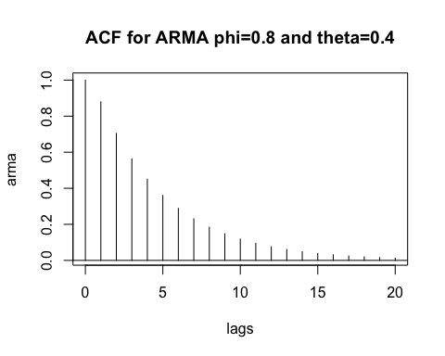

par(mfrow=c(1,1))  
arma.sim<-arima.sim(model=list(ar=c(0.8),ma=c(0.4)),n=100)   
sampleacf<-acf(arma.sim,xaxp=c(0,20,10))

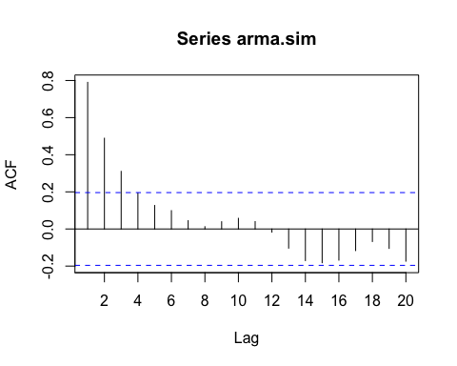

print(sampleacf)

##   
## Autocorrelations of series 'arma.sim', by lag  
##   
## 1 2 3 4 5 6 7 8 9 10   
## 0.790 0.489 0.310 0.194 0.127 0.099 0.045 0.012 0.039 0.057   
## 11 12 13 14 15 16 17 18 19 20   
## 0.040 -0.017 -0.103 -0.170 -0.182 -0.168 -0.116 -0.068 -0.105 -0.174

*Comment:*

*Here the theoretical value at lag 1 is 0.88. However, the sample ACF at lag 1 is 0.790. We can see that sample ACF and theoretical ACF closely matches at first lag. However, for the following lags, the theoretical ACF decays slower than the sample ACF.*

c)

eacf(arma.sim)

## AR/MA  
## 0 1 2 3 4 5 6 7 8 9 10 11 12 13  
## 0 x x x o o o o o o o o o o o   
## 1 x o o o o o o o o o o o o o   
## 2 x x o o o o o o o o o o o o   
## 3 x x o o o o o o o o o o o o   
## 4 x x o o o o o o o o o o o o   
## 5 x o o o o o o o o o o o o o   
## 6 x x o o o o o o o o o o o o   
## 7 x x o o o o o o o o o o o o

*A mixed model with q=1 and with p=1 or 5 would be more appropriate*

d)

arma.sim1<-arima.sim(model=list(ar=c(0.8),ma=c(0.4)),n=100)   
sampleacf1<-acf(arma.sim1,xaxp=c(0,20,10))

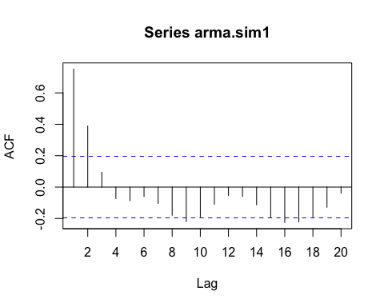

print(sampleacf1)

##   
## Autocorrelations of series 'arma.sim1', by lag  
##   
## 1 2 3 4 5 6 7 8 9 10   
## 0.752 0.389 0.094 -0.073 -0.087 -0.061 -0.105 -0.179 -0.220 -0.190   
## 11 12 13 14 15 16 17 18 19 20   
## -0.109 -0.053 -0.060 -0.113 -0.195 -0.226 -0.222 -0.190 -0.128 -0.039

eacf(arma.sim1)

## AR/MA  
## 0 1 2 3 4 5 6 7 8 9 10 11 12 13  
## 0 x x o o o o o o x o o o o o   
## 1 x x o x o o o o o o o o o o   
## 2 o o o o o o o o o o o o o o   
## 3 o o o o o o o o o o o o o o   
## 4 o o o o o o o o o o o o o o   
## 5 x x o o o x o o o o o o o o   
## 6 x x x o x o o o o o o o o o   
## 7 o o o o x o o o o o o o o o

*Comment:*

*Here the theoretical value at lag 1 is 0.88 and the sample ACF at lag 1 is 0.752. We can see that sample ACF and theoretical ACF closely matches at first lag. However, for the following lags, the theoretical ACF decays slower than the sample ACF. For higher lags i.e after lag 3, the values are negative.*

*The EACF doesn’t help to specify the correct orders for the model. It has a value at p = q= 1and not a zero.*

e)

arma.sim2<-arima.sim(model=list(ar=c(0.8),ma=c(0.4)),n=48)   
sampleacf2<-acf(arma.sim2,xaxp=c(0,20,10))

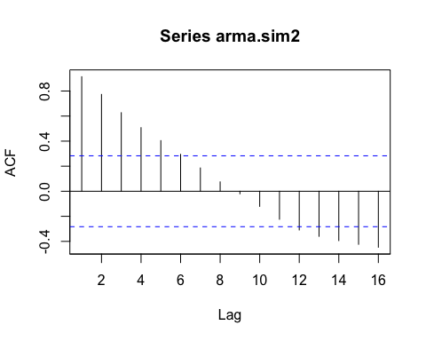

print(sampleacf2)

##   
## Autocorrelations of series 'arma.sim2', by lag  
##   
## 1 2 3 4 5 6 7 8 9 10   
## 0.914 0.773 0.627 0.508 0.404 0.294 0.186 0.075 -0.020 -0.121   
## 11 12 13 14 15 16   
## -0.224 -0.309 -0.360 -0.394 -0.423 -0.447

eacf(arma.sim2)

## AR/MA  
## 0 1 2 3 4 5 6 7 8 9 10 11 12 13  
## 0 x x x x x o o o o o o o x x   
## 1 x o o o o o o o o o o o o o   
## 2 o o o o o o o o o o o o o o   
## 3 o o o o o o o o o o o o o o   
## 4 x x o o o o o o o o o o o o   
## 5 x x o o o o o o o o o o o o   
## 6 o x o o o o o o o o o o o o   
## 7 o x o o o o o o o o o o o o

*Comment:*

*Here the theoretical value at lag 1 is 0.88 and the sample ACF at lag 1 is 0.914. We can see that sample ACF and theoretical ACF closely matches at shorter lags until 8. For higher lags i.e after lag 9, the values are negative. Both theoretical and sample ACF decays slower in this case*

*The EACF helps to specify the correct orders for the model. A mixed model with q=1 and with p= 1 or 2 or 3 would be more appropriate*

f)

arma.sim3<-arima.sim(model=list(ar=c(0.8),ma=c(0.4)),n=200)   
sampleacf3<-acf(arma.sim3,xaxp=c(0,20,10))

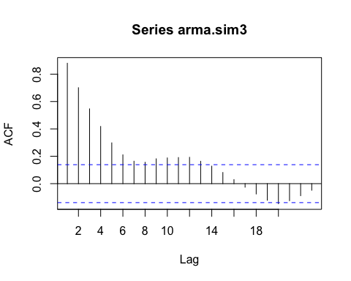

print(sampleacf3)

##   
## Autocorrelations of series 'arma.sim3', by lag  
##   
## 1 2 3 4 5 6 7 8 9 10   
## 0.880 0.701 0.546 0.418 0.298 0.211 0.164 0.156 0.182 0.188   
## 11 12 13 14 15 16 17 18 19 20   
## 0.191 0.193 0.164 0.128 0.082 0.030 -0.026 -0.076 -0.121 -0.147   
## 21 22 23   
## -0.124 -0.088 -0.048

eacf(arma.sim3)

## AR/MA  
## 0 1 2 3 4 5 6 7 8 9 10 11 12 13  
## 0 x x x x x x x x x x x x x o   
## 1 x o o o o o x o o o o x o o   
## 2 o x o o o o o x o o o x o o   
## 3 x o o o o o o x x o o o o o   
## 4 x x o x o o o x o o o o o o   
## 5 x x o x o o o o o o o o o o   
## 6 x x o x o o o o o o o o o o   
## 7 x o o x o o o o o o o o o o

*Comment:*

*Here the theoretical value at lag 1 is 0.88 and the sample ACF at lag 1 is 0.88. We can see that sample ACF and theoretical ACF matches at lag 1. For the other shorter lags until 7 the values closely match. For higher lags (i.e) after lag 8, we can see an alternating and tapering pattern. However, theoretical pattern decays slower than sample ACF.*

*The EACF doesn’t help to specify the correct orders for the model. The upper left-hand vertex doesn’t contain the triangle of zeros.*