**Meenakshi Nagarajan**

**Assignment 7**

**STT4110/6110**

6.29 Simulate a mixed ARMA (1,1) model of length *n* = 60 with φ = 0.4 and θ = 0.6.

**(a)**Calculate and plot the theoretical autocorrelation function for this model. Plot sufficient lags until the correlations are negligible.

**(b)**Calculate and plot the sample ACF for your simulated series. How well do the values and patterns match the theoretical ACF from part (a)?

**(c)**Calculate and interpret the sample EACF for this series. Does the EACF help you specify the correct orders for the model?

**(d)**Repeat parts (b) and (c) with a new simulation using the same parameter values and sample size.

**(e)**Repeat parts (b) and (c) with a new simulation using the same parameter values but sample size *n* = 36.

**(f)**Repeat parts (b) and (c) with a new simulation using the same parameter values but sample size *n* = 120.

*Solution:*

library(ggplot2)  
library(grid)  
library(TSA)

## Loading required package: leaps

## Loading required package: locfit

## locfit 1.5-9.1 2013-03-22

## Loading required package: mgcv

## Loading required package: nlme

## This is mgcv 1.8-17. For overview type 'help("mgcv-package")'.

## Loading required package: tseries

##   
## Attaching package: 'TSA'

## The following objects are masked from 'package:stats':  
##   
## acf, arima

## The following object is masked from 'package:utils':  
##   
## tar

lags <- 0:10  
arma<-ARMAacf(ar = 0.4, ma = 0.6, lag.max = 10, pacf = FALSE)  
print(arma)

## 0 1 2 3 4   
## 1.0000000000 0.6739130435 0.2695652174 0.1078260870 0.0431304348   
## 5 6 7 8 9   
## 0.0172521739 0.0069008696 0.0027603478 0.0011041391 0.0004416557   
## 10   
## 0.0001766623

plot(lags,arma,type="h",main="ACF for ARMA phi=0.4 and theta=0.6")  
abline(h=0)

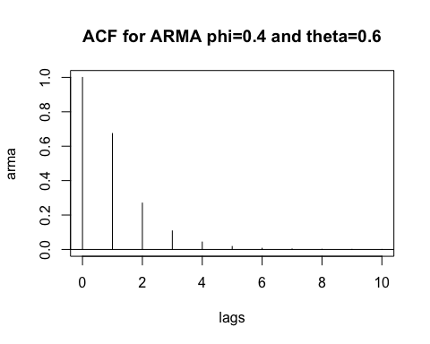

par(mfrow=c(1,1))  
arma.sim<-arima.sim(model=list(ar=c(0.4),ma=c(0.6)),n=60)   
sampleacf<-acf(arma.sim,xaxp=c(0,20,10))

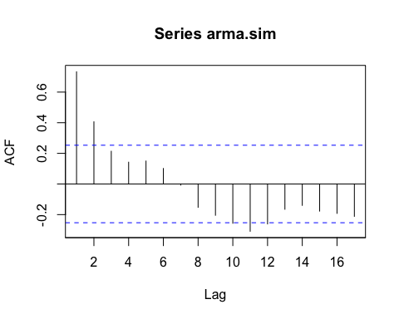

print(sampleacf)

##   
## Autocorrelations of series 'arma.sim', by lag  
##   
## 1 2 3 4 5 6 7 8 9 10   
## 0.733 0.406 0.214 0.142 0.150 0.101 -0.007 -0.153 -0.204 -0.257   
## 11 12 13 14 15 16 17   
## -0.309 -0.261 -0.165 -0.140 -0.177 -0.192 -0.211

eacf(arma.sim)

## AR/MA  
## 0 1 2 3 4 5 6 7 8 9 10 11 12 13  
## 0 x x o o o o o o o o x o o o   
## 1 x o o o o o o o o o o o o o   
## 2 o o o o o o o o o o o o o o   
## 3 x o o o o o o o o o o o o o   
## 4 x o x o o o o o o o o o o o   
## 5 x x x o o o o o o o o o o o   
## 6 x o x o o o o o o o o o o o   
## 7 x o o x o o o o o o o o o o

arma.sim1<-arima.sim(model=list(ar=c(0.4),ma=c(0.6)),n=60)   
sampleacf1<-acf(arma.sim1,xaxp=c(0,20,10))

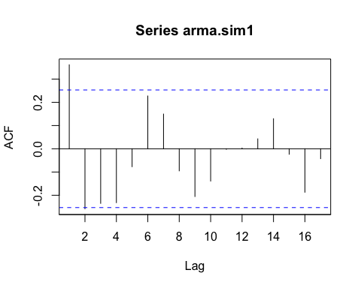

print(sampleacf1)

##   
## Autocorrelations of series 'arma.sim1', by lag  
##   
## 1 2 3 4 5 6 7 8 9 10   
## 0.361 -0.258 -0.235 -0.232 -0.077 0.227 0.149 -0.095 -0.206 -0.139   
## 11 12 13 14 15 16 17   
## -0.002 0.003 0.043 0.129 -0.024 -0.187 -0.043

eacf(arma.sim1)

## AR/MA  
## 0 1 2 3 4 5 6 7 8 9 10 11 12 13  
## 0 x o o o o o o o o o o o o o   
## 1 x x o o o x o o o o o o o o   
## 2 o x o o o o o o o o o o o o   
## 3 o x x o o o o o o o o o o o   
## 4 x o o o o o o o o o o o o o   
## 5 o o o o x o o o o o o o o o   
## 6 x o o o x o o o o o o o o o   
## 7 x o o o x o o o o o o o o o

arma.sim2<-arima.sim(model=list(ar=c(0.4),ma=c(0.6)),n=36)   
sampleacf2<-acf(arma.sim2,xaxp=c(0,20,10))

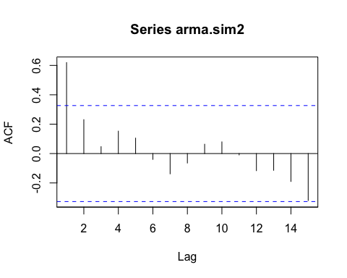

print(sampleacf2)

##   
## Autocorrelations of series 'arma.sim2', by lag  
##   
## 1 2 3 4 5 6 7 8 9 10   
## 0.619 0.231 0.047 0.153 0.105 -0.040 -0.138 -0.064 0.064 0.079   
## 11 12 13 14 15   
## -0.009 -0.117 -0.114 -0.190 -0.320

eacf(arma.sim2, ar.max = 7, ma.max = 10)

## AR/MA  
## 0 1 2 3 4 5 6 7 8 9 10  
## 0 x o o o o o o o o o o   
## 1 x o o o o o o o o o o   
## 2 o o x o o o o o o o o   
## 3 o x o o o o o o o o o   
## 4 x x o o o o o o o o o   
## 5 x o o o o o o o o o o   
## 6 x o o o o o o o o o o   
## 7 x o o o o o o o o o o

arma.sim3<-arima.sim(model=list(ar=c(0.4),ma=c(0.6)),n=120)   
sampleacf3<-acf(arma.sim3,xaxp=c(0,20,10))

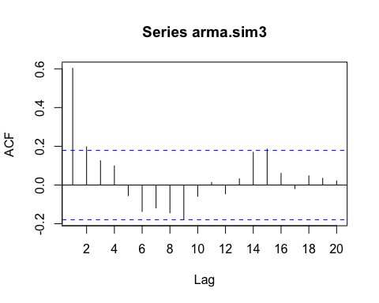

print(sampleacf3)

##   
## Autocorrelations of series 'arma.sim3', by lag  
##   
## 1 2 3 4 5 6 7 8 9 10   
## 0.603 0.197 0.125 0.099 -0.055 -0.137 -0.119 -0.144 -0.178 -0.058   
## 11 12 13 14 15 16 17 18 19 20   
## 0.013 -0.045 0.032 0.170 0.186 0.060 -0.018 0.048 0.035 0.021

eacf(arma.sim3)

## AR/MA  
## 0 1 2 3 4 5 6 7 8 9 10 11 12 13  
## 0 x x o o o o o o o o o o o o   
## 1 x x o o o o o o o o o o o o   
## 2 x x o o o o o o x o o o o o   
## 3 x o x x o o o o o o o o o o   
## 4 x o o o o o o o o o o o o o   
## 5 x x o o o o o o o o o x o o   
## 6 x o x o o o x o o o o o o o   
## 7 x o o x o o o o o o o o o o

* 1. From a series of length 100, we have computed r1 = 0.8, r2 = 0.5, r3 = 0.4, Y = 2, and a sample variance of 5. If we assume that an AR(2) model with a constant term is appropriate, how can we get (simple) estimates of φ1, φ2, θ0, and σe2 ?

*Solution:*

$\hat{ϕ_{1}}=\frac{r_{1}\left(1-r_{2}\right)}{1-r_{1}^{2}}$

$=\frac{0.8\left(1-0.5\right)}{1-{\left(0.8\right)}^{2}}=1.11$

$\hat{ϕ_{2}}=\frac{\left(r_{2}-{(r}_{1})^2 \right) }{1-r_{1}^{2}}$

$=\frac{0.5-{0.8}^{2}}{1-{\left(0.8\right)}^{2}}=-0.389$

We have $\hat{θ_{0}}=\hat{μ}\left(1-\hat{ϕ_{1}}-\hat{ϕ_{2}}\right)=2\left(1-1.11-\left(-0.389\right)\right)=0.558$. Finally, from

* 1. Assuming that the following data arise from a stationary process, calculate method-of-moments estimates of μ, γ0, and ρ1: 6, 5, 4, 6, 4.

*Solution:*

$\overline{Y}=μ=\frac{1}{n}\sum_{t=1}^{n}{Y_{t}}$

$μ=\frac{6+5+4+6+4}{5}=5$

$γ_{0}=s^{2}=\sum_{i=1}^{n}{\frac{{\left(X_{i}-\overline{X}\right)}^{2}}{n-1}}$

$=\frac{{(\left(6-5\right)}^{2}+{\left(5-5\right)}^{2}+{\left(4-5\right)}^{2}+{\left(6-5\right)}^{2}+{\left(4-5\right)}^{2})}{5-1}$

$=1$

$ρ_{1}=\frac{s}{\sqrt{n}}=\frac{1}{\sqrt{5}}=0.4472$

7.3 If {Yt} satisfies an AR(1) model with φ of about 0.7, how long of a series do we need to estimate φ = ρ1 with 95% confidence that our estimation error is no more than ±0.1?

*Solution:*

For AR(1): $Var\left(\hat{ϕ}\right)≈\frac{1-ϕ^{2}}{n}$

$S.D=\sqrt{(1-{0.7}^{2})/n}$

$0.1=\sqrt{(1-{0.7}^{2})/n}$

$0.1=0.71/\sqrt{n}$

$0.1=\frac{2\left(0.71\right)}{\sqrt{n}}$

$0.1=\frac{1.42}{\sqrt{n}}$

$\sqrt{n}=14.2$

n=202