**Meenakshi Nagarajan**

**Assignment 8**

**STT4110/6110**

7.3 If {Yt} satisfies an AR(1) model with of about 0.7, how long of a series do we need to estimate $ϕ=ρ_{1 }$ with 95% confidence that our estimation error is no more than 0.1?

*Solution:*

$\left(\hat{ϕ}\right)± Z_{α/2}.\sqrt{Var\left(\hat{ϕ}\right)}$

$Z_{α/2}.\sqrt{Var\left(\hat{ϕ}\right)}=0.1$

1.96 $\sqrt{Var\left(\hat{ϕ}\right)}=0.1$

Where AR(1): $Var\left(\hat{ϕ}\right)≈\frac{1-ϕ^{2}}{n}$

$S.D=\sqrt{(1-{0.7}^{2})/n}$

$0.1=\sqrt{(1-{0.7}^{2})/n}$

$0.1=0.71/\sqrt{n}$

$0.1=\frac{2\left(0.71\right)}{\sqrt{n}}$

$0.1=\frac{1.42}{\sqrt{n}}$

$\sqrt{n}=14.2$

n=202

7.5 Given the data Y1 = 10, Y2 = 9, and Y3 = 9.5, we wish to fit an IMA(1,1) model without a constant term.

(a) Find the conditional least squares estimate of $θ$ (Hint: Do Exercise 7.4 first.)  (b) Estimate $σ_{e}^{2}$

*Solution:*

*IMA(1,1) model can be written as,*

*Yt* = *Yt*–1 +*et* – $θ$*et*–1

$e_{t}=Y_{t}-Y_{t-1}+θe_{t-1}$

Assume, $Y_{0}=0$ ( no constant term)

$e_{1}=Y_{1}-Y_{0}+θe_{0}$ = 10 $-Y_{0}$ = 10

$e_{2}=Y_{2}-Y_{1}+θe_{1}$ = $9-10+θ(10)$ = $-1+θ(10)$

$e_{3}=Y_{3}-Y_{2}+θe_{2}$ = $9.5-9+θ(-1+θ\left(10\right))$ = $0.5+θ(-1+θ(10))$

$S_{c}=e_{1}^{2}+e_{2}^{2}+e_{3}^{2}$

$=100 +{\left(-1+10θ\right)}^{2}+{\left(0.5+θ\left(-1+10θ\right)\right)}^{2}$

$\frac{{∂S}_{c}}{∂θ}=0 +2\left(-1+10θ\right)+2\left(0.5+θ\left(-1+10θ\right)\right)$

$=-2+20θ+1+2θ\left(-1+10θ\right)$

$=-2+20θ+1-2θ+20θ^{2}$

$=-1+18θ+20θ^{2}$

$\frac{{∂^{2}S}_{c}}{∂θ^{2}}=18+40θ$

Solve the derivative

$18+40θ=0$

$θ=-0.45$**< 0**

$\hat{θ}=-0.45 is the minimzer of{ S}_{c}$ and therefore LSE for $θ$ is $\hat{θ}=-0.45$

By equation 7.1.7,

$S^{2}=\frac{1}{n-1}{\sum_{t=1}^{n}{\left(Y_{t}-\overline{Y}\right)}}^{2}$

$S^{2}=\frac{1}{3-1}\{{\left(Y_{1}-\overline{Y}\right)}^{2}+{\left(Y_{2}-\overline{Y}\right)}^{2}+{\left(Y_{3}-\overline{Y}\right)}^{2}\}$

$S^{2}=\frac{1}{2}\{{\left(10-9.5\right)}^{2}+{\left(9-9.5\right)}^{2}+{\left(9.5-9.5\right)}^{2}\}$

$S^{2}=\frac{1}{2}\{{\left(0.5\right)}^{2}+{(0.5)}^{2}\}$

$S^{2}=\frac{1}{2}\{0.5\}$

$S^{2}=0.25$

$S=0.5$

By equation 7.1.9, $σ_{e}^{2}=\frac{S^{2}}{1+{\hat{θ}}^{2}}=\frac{0.25}{1+0.2025}=\frac{0.25}{1.2025}=0.2079$

7.7 Verify Equation (7.1.4) on page 150.

*Solution:*

$\hat{θ}=\frac{-1+\sqrt{1-4{\left(r_{1}\right)}^{2}}}{2r_{1}}$

From equation 4.2.2, we have,

$ρ_{1}=-\frac{θ}{1+θ^{2}}$

Equating $ρ_{1} to r_{1}$, we get

$r_{1}=-\frac{θ}{1+θ^{2}}$

$r_{1}\left(1+θ^{2}\right)= -θ$

$r_{1}+r_{1}θ^{2}+θ=0$

$r_{1}(1+θ^{2}+\frac{1}{r_{1}}θ)=0$

$1+θ^{2}+\frac{1}{r_{1}}θ=0$

This is of a quadratic equation form $1-θ_{1}x-θ_{2}x^{2}=0$

$θ_{1}=-\frac{1}{r_{1}}$ $θ_{2}=-1$

Solving the equation for the roots $\frac{(-1/r_{1})±\sqrt{{\left(-\frac{1}{r_{1}}\right)}^{2}-4}}{2}$

Roots are $-\frac{1}{2r_{1}}±\sqrt{\frac{1-4r_{1}^{2}}{4r_{1}^{2}}}$

$=-\frac{1}{2r_{1}}±\sqrt{\frac{1}{4r_{1}^{2}}-1}$

On further calculation,

$=-\frac{1}{2r_{1}}±\sqrt{\frac{1-4r_{1}^{2}}{4r_{1}^{2}}}$

$=-\frac{1}{2r_{1}}±\left(\frac{1}{2r_{1}}\right)\sqrt{1-4r_{1}^{2}}$

$=-\frac{1}{2r_{1}}(1±\sqrt{1-4r_{1}^{2}})$

$=\frac{-1+\sqrt{1-4r_{1}^{2}}}{2r_{1}}$

Hence proved

7.13 Simulate an AR(1) series with = 0.8 and n = 48.

(a)  Find the method-of-moments estimate of $ϕ$

(b)  Find the conditional least squares estimate of and compare it with part (a).

(c)  Find the maximum likelihood estimate of and compare it with parts (a) and  (b).

(d)  Repeat parts (a), (b), and (c) with a new simulated series using the same  parameters and same sample size. Compare your results with your results  from the first simulation.

*Solution:*

Simulate an AR(1) series with = 0.8 and n = 48.

library(ggplot2)  
library(grid)  
library(TSA)

## Loading required package: leaps

## Loading required package: locfit

## locfit 1.5-9.1 2013-03-22

## Loading required package: mgcv

## Loading required package: nlme

## This is mgcv 1.8-17. For overview type 'help("mgcv-package")'.

## Loading required package: tseries

##   
## Attaching package: 'TSA'

## The following objects are masked from 'package:stats':  
##   
## acf, arima

## The following object is masked from 'package:utils':  
##   
## tar

par(mfrow=c(1,1))  
set.seed(4321)  
arma.sim<-arima.sim(list(ar=0.8),n=48)

1. Find the method-of-moments estimate of phi

acf<-acf(arma.sim)

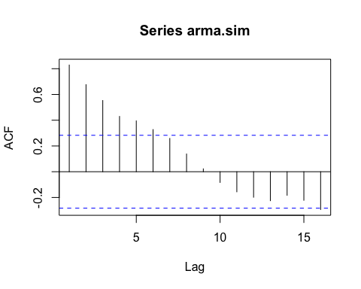

print(acf[1])

##   
## Autocorrelations of series 'arma.sim', by lag  
##   
## 1   
## 0.829

For this AR(1) series the estimates are quite close

1. Find the conditional least squares estimate of and compare it with part (a).

arima(arma.sim,order=c(1,0,0),method='CSS')$coef[1]

## ar1   
## 0.8367125

1. Find the maximum likelihood estimate of and compare it with parts (a) and (b).

arima(arma.sim,order=c(1,0,0),method='ML')$coef[1]

## ar1   
## 0.849501

All the methods provides approximately similar results for this AR(1) series

1. Repeat parts (a), (b), and (c) with a new simulated series using the same parameters and same sample size. Compare your results with your results from the first simulation.

par(mfrow=c(1,1))  
set.seed(4000)  
arma.sim1<-arima.sim(list(ar=0.8),n=48)

acf1<-acf(arma.sim1)

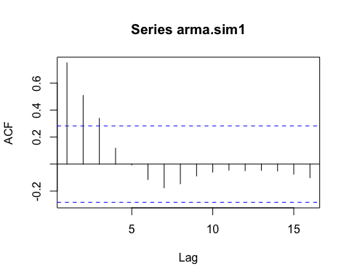

print(acf1[1])

##   
## Autocorrelations of series 'arma.sim1', by lag  
##   
## 1   
## 0.75

arima(arma.sim1,order=c(1,0,0),method='CSS')$coef[1]

## ar1   
## 0.7521422

arima(arma.sim1,order=c(1,0,0),method='ML')$coef[1]

## ar1   
## 0.7374492

The results from first and second simulation are not close to each other

7.17 Simulate an ARMA(1,1) series with = 0.7, = 0.4, and *n* = 72.

**(a)**Find the method-of-moments estimates of $ϕ$ and $θ$.

**(b)**Find the conditional least squares estimates of $ϕ$ and $θ$ and compare them with  part (a).

**(c)**Find the maximum likelihood estimates of $ϕ$ and $θ$ and compare them with  parts (a) and (b).

**(d)**Repeat parts (a), (b), and (c) with a new simulated series using the same  parameters and same sample size. Compare your new results with your results  from the first simulation.

*Solution:*

Simulate an ARMA(1,1) series with phi=0.7 and theta=0.4, and n=72

library(ggplot2)  
library(grid)  
library(TSA)

## Loading required package: leaps

## Loading required package: locfit

## locfit 1.5-9.1 2013-03-22

## Loading required package: mgcv

## Loading required package: nlme

## This is mgcv 1.8-17. For overview type 'help("mgcv-package")'.

## Loading required package: tseries

##   
## Attaching package: 'TSA'

## The following objects are masked from 'package:stats':  
##   
## acf, arima

## The following object is masked from 'package:utils':  
##   
## tar

par(mfrow=c(1,1))  
set.seed(54321)  
arma.sim<-arima.sim(list(ar=0.7,ma=-0.4),n=72)

1. Find the method-of-moments estimates of theta and phi

acf(arma.sim)$acf

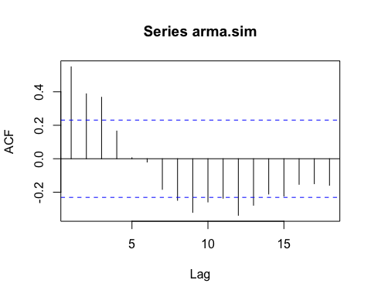

## , , 1  
##   
## [,1]  
## [1,] 0.549357167  
## [2,] 0.388096245  
## [3,] 0.367623116  
## [4,] 0.165666847  
## [5,] 0.006112673  
## [6,] -0.019838269  
## [7,] -0.183102515  
## [8,] -0.248674930  
## [9,] -0.320889586  
## [10,] -0.258465587  
## [11,] -0.236178041  
## [12,] -0.338259006  
## [13,] -0.278153979  
## [14,] -0.211176145  
## [15,] -0.223407235  
## [16,] -0.153101240  
## [17,] -0.149556740  
## [18,] -0.158915347

$\hat{ϕ}=\frac{r_{2}}{r_{1}}=\frac{0.388}{0.549}=0.706.$ Given that $r_{1}=\frac{\left(1-θ\hat{ϕ}\right)\left(\hat{ϕ}-θ\right)}{1-2θ\hat{ϕ}+θ^{2}}$. The solutions for the quadratic equation on $θ$ are complex valued so no method of moments of $θ$ exists for this series.

1. Find the conditional least squares estimates of phi and theta and compare them with part (a).

arima(arma.sim,order=c(1,0,1),method='CSS')

##   
## Call:  
## arima(x = arma.sim, order = c(1, 0, 1), method = "CSS")  
##   
## Coefficients:  
## ar1 ma1 intercept  
## 0.7655 -0.3605 -0.2444  
## s.e. 0.0961 0.1480 0.3075  
##   
## sigma^2 estimated as 0.868: part log likelihood = -97.07

The estimate of phi in this part is larger than then one obtained from part (a). However, they are significantly different

1. Find the maximum likelihood estimates of and and compare them with parts (a) and (b)

arima(arma.sim,order=c(1,0,1),method='ML')

##   
## Call:  
## arima(x = arma.sim, order = c(1, 0, 1), method = "ML")  
##   
## Coefficients:  
## ar1 ma1 intercept  
## 0.7771 -0.3055 -0.0203  
## s.e. 0.1190 0.1647 0.3409  
##   
## sigma^2 estimated as 0.9147: log likelihood = -99.19, aic = 204.39

The results from part b and c are quite close to each other

1. Repeat parts (a), (b), and (c) with a new simulated series using the same parameters and same sample size. Compare your new results with your results from the first simulation

par(mfrow=c(1,1))  
set.seed(54000)  
arma.sim1<-arima.sim(list(ar=0.7,ma=-0.4),n=72)

acf(arma.sim1)$acf

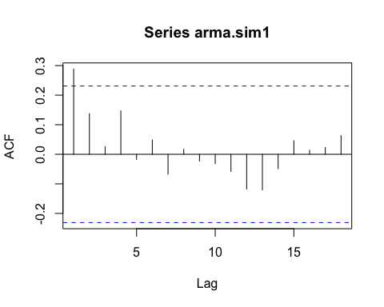

## , , 1  
##   
## [,1]  
## [1,] 0.28823431  
## [2,] 0.13733049  
## [3,] 0.02543394  
## [4,] 0.14668313  
## [5,] -0.01741404  
## [6,] 0.04831740  
## [7,] -0.06720818  
## [8,] 0.01688249  
## [9,] -0.02261804  
## [10,] -0.03174919  
## [11,] -0.05795037  
## [12,] -0.11740729  
## [13,] -0.12010520  
## [14,] -0.04876209  
## [15,] 0.04567420  
## [16,] 0.01406161  
## [17,] 0.02321934  
## [18,] 0.06319468

arima(arma.sim1,order=c(1,0,1),method='CSS')

##   
## Call:  
## arima(x = arma.sim1, order = c(1, 0, 1), method = "CSS")  
##   
## Coefficients:  
## ar1 ma1 intercept  
## 0.5834 -0.3141 -0.2226  
## s.e. 0.3518 0.4199 0.2134  
##   
## sigma^2 estimated as 1.127: part log likelihood = -106.47

arima(arma.sim1,order=c(1,0,1),method='ML')

##   
## Call:  
## arima(x = arma.sim1, order = c(1, 0, 1), method = "ML")  
##   
## Coefficients:  
## ar1 ma1 intercept  
## 0.5191 -0.2401 -0.2531  
## s.e. 0.3697 0.4187 0.1949  
##   
## sigma^2 estimated as 1.116: log likelihood = -106.16, aic = 218.31

The results from simulation 1 and 2 are not very close to each other. In simulation 2, phi values are quite close to each other while theta values are not close to each other.