**Meenakshi Nagarajan**

**Assignment 8**

**STT4110/6110**

**9.6** Using the seasonal means model *with* an intercept shown in Exhibit 3.4 on page 33:

**(a)** Forecast the average monthly temperature in Dubuque, Iowa, for April 1976.

**(b)** Find a 95% prediction interval for that April forecast. (The estimate of 0  for this model is 3.419 F.)

**(c)** Compare your forecast with the one obtained in Exercise 9.5.

*Solution:*

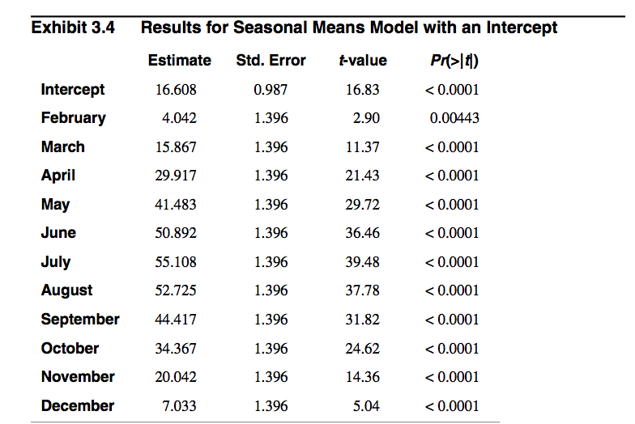

**(a)** Forecast the average monthly temperature in Dubuque, Iowa, for April 1976.

t = 1976.25 for April

= 16.608 + 29.917 = 46.525

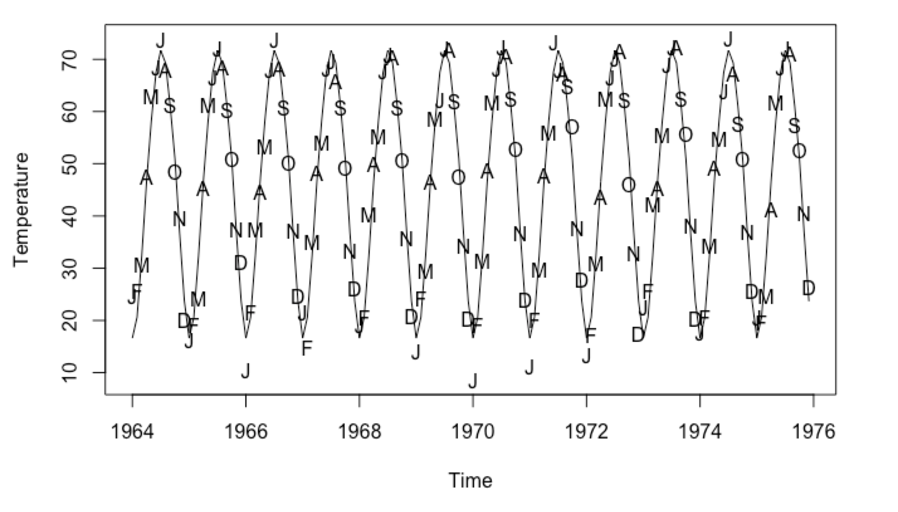

b) Find a 95% prediction interval for that April forecast. (The estimate of

for this model is 3.419 F.)

Prediction limits could be evaluated using,

c) Compare your forecast with the one obtained in Exercise 9.5.

The value obtained for April 1977 is approximately the same for model without intercept

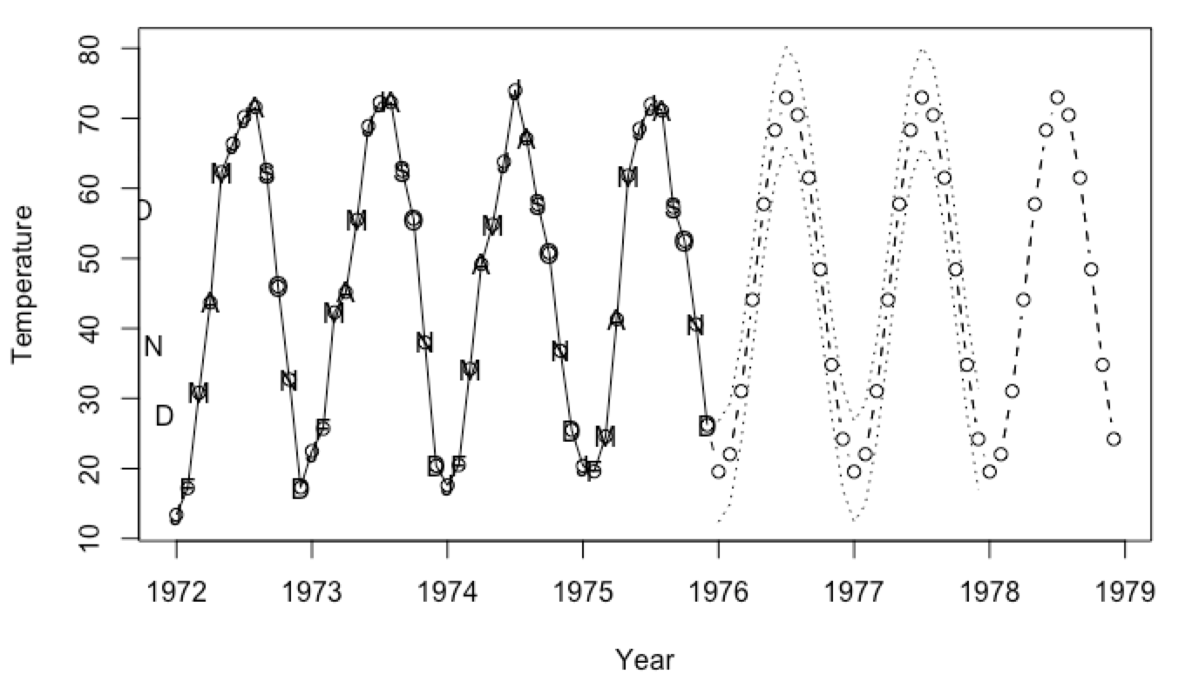

**9.7** Using the seasonal means model *with* an intercept shown in Exhibit 3.4 on page 33:

**(a)** Forecast the average monthly temperature in Dubuque, Iowa, for January 1976.

**(b)** Find a 95% prediction interval for that January forecast. (The estimate of 0  for this model is 3.419 F.)

*Solution:*

= 16.608

b) Find a 95% prediction interval for that January forecast. (The estimate of

for this model is 3.419 F.)

Prediction limits could be evaluated using,

9.12 Simulate an MA(2) process with 1 = 1, 2 = 0.6, and = 100. Simulate 36 values but set aside the last 4 values with compare forecasts to actual values.

(a)  Using the first 32 values of the series, find the values for the maximum likelihood estimates of the ’s and .

(b)  Using the estimated model, forecast the next four values of the series. Plot the  series together with the four forecasts. Place a horizontal line at the estimate of the process mean.

(c)  What is special about the forecasts at lead times 3 and 4?

(d)  Compare the four forecasts with the actual values that you set aside.

(e)  Plot the forecasts together with 95% forecast limits. Do the actual values fall  within the forecast limits?

(f)  Repeat parts (a) through (e) with a new simulated series using the same values  of the parameters and same sample size.

*Solution:*

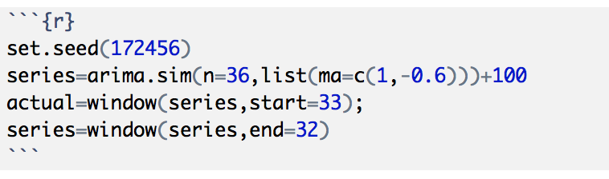

1. Using the first 32 values of the series, find the values for the maximum likelihood estimates of the ’s and .

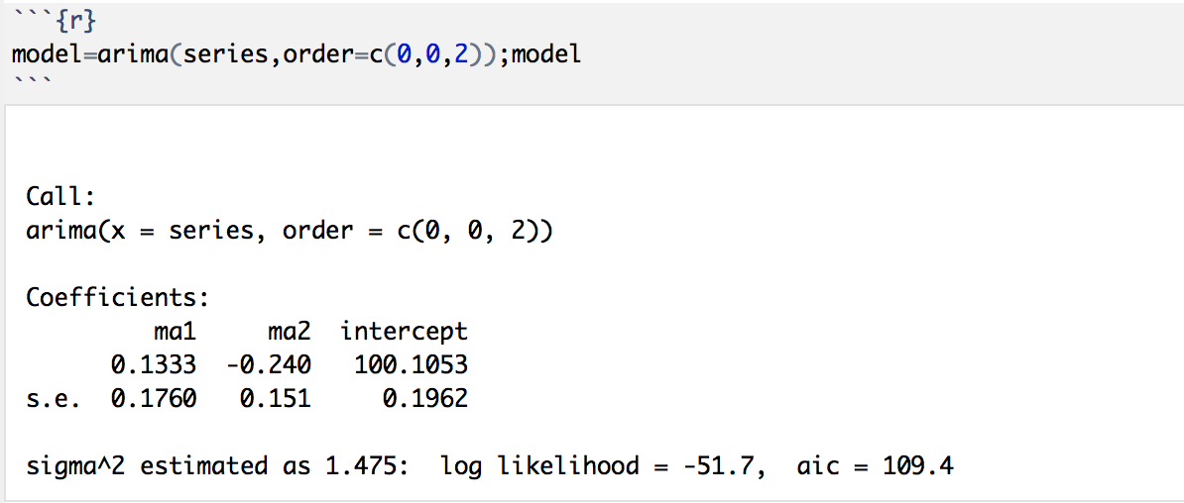

Comment: The maximum likelihood estimates are away from the true values

1. Using the estimated model, forecast the next four values of the series. Plot the  series together with the four forecasts. Place a horizontal line at the estimate of the process mean.

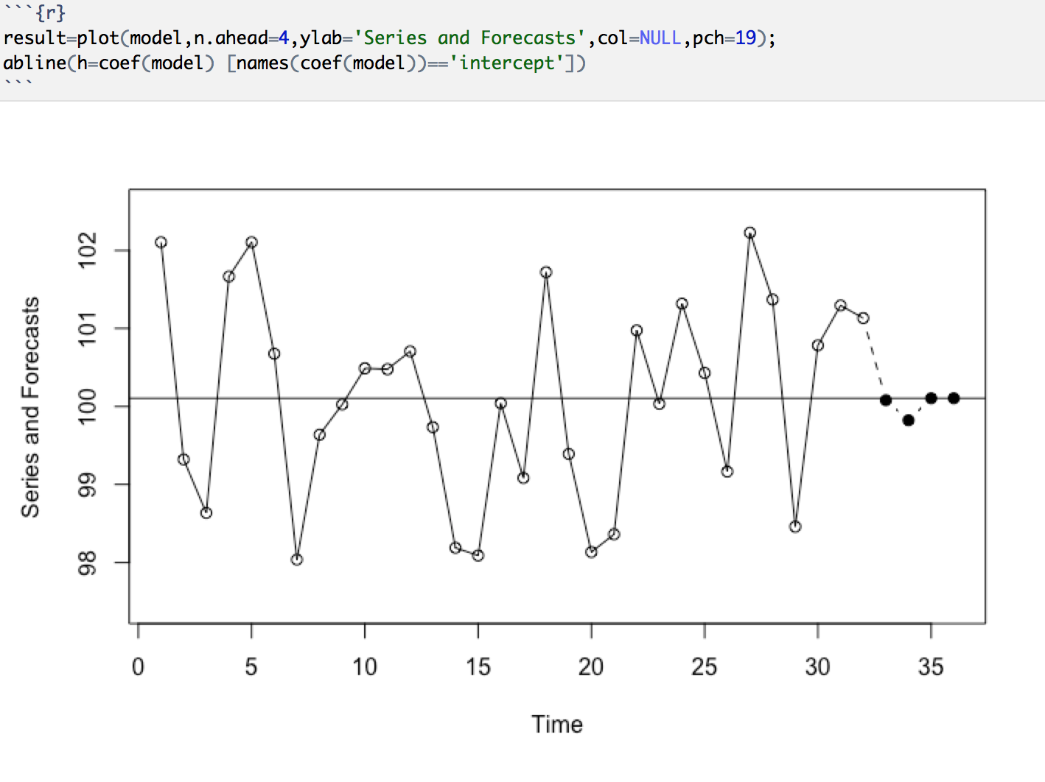

Comment: Almost are forecasts are equal or close to process mean quickly

1. What is special about the forecasts at lead times 3 and 4?

Both are of same value which is equal to process mean

1. Compare the four forecasts with the actual values that you set aside.

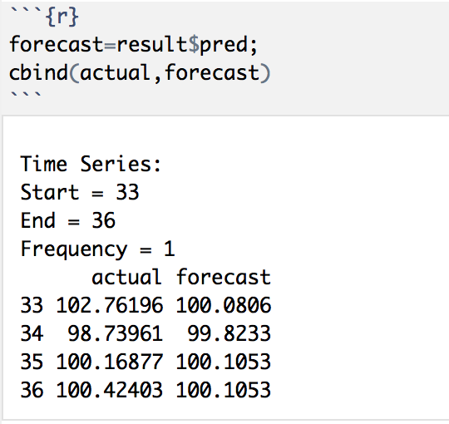

1. Plot the forecasts together with 95% forecast limits. Do the actual values fall  within the forecast limits?

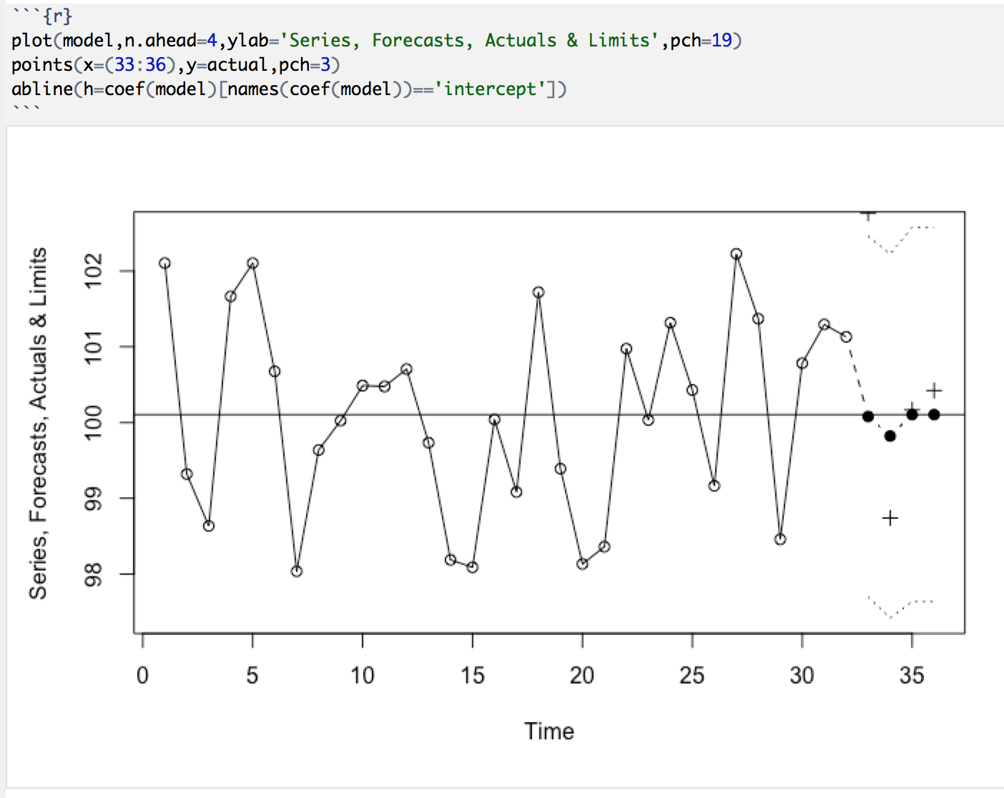

Comment: No actual values doesn't fall within 95% CI

1. Repeat parts (a) through (e) with a new simulated series using the same values  of the parameters and same sample size.

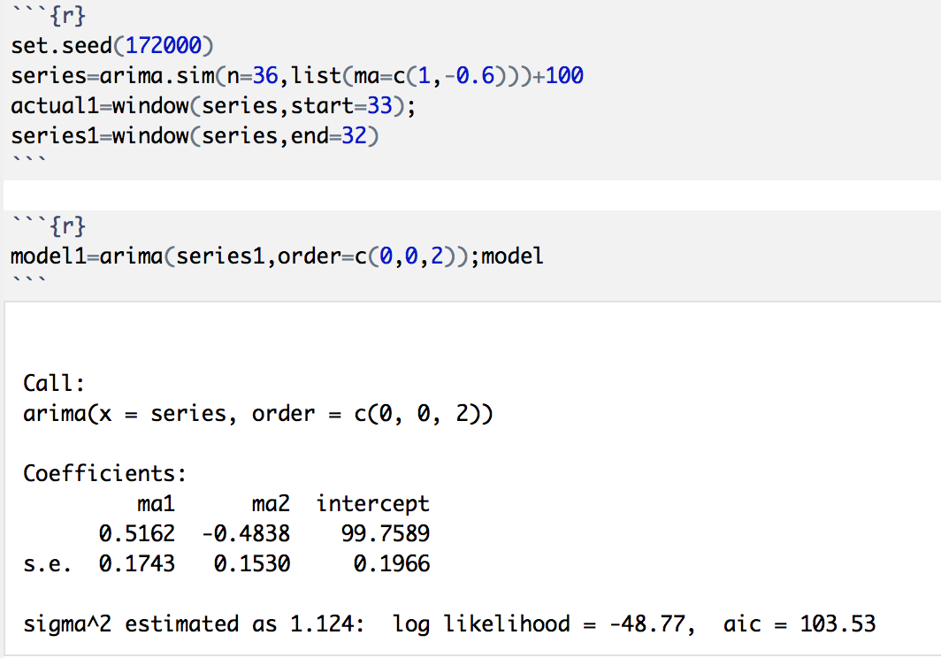

Comment: The maximum likelihood estimates are prettyclose to true values

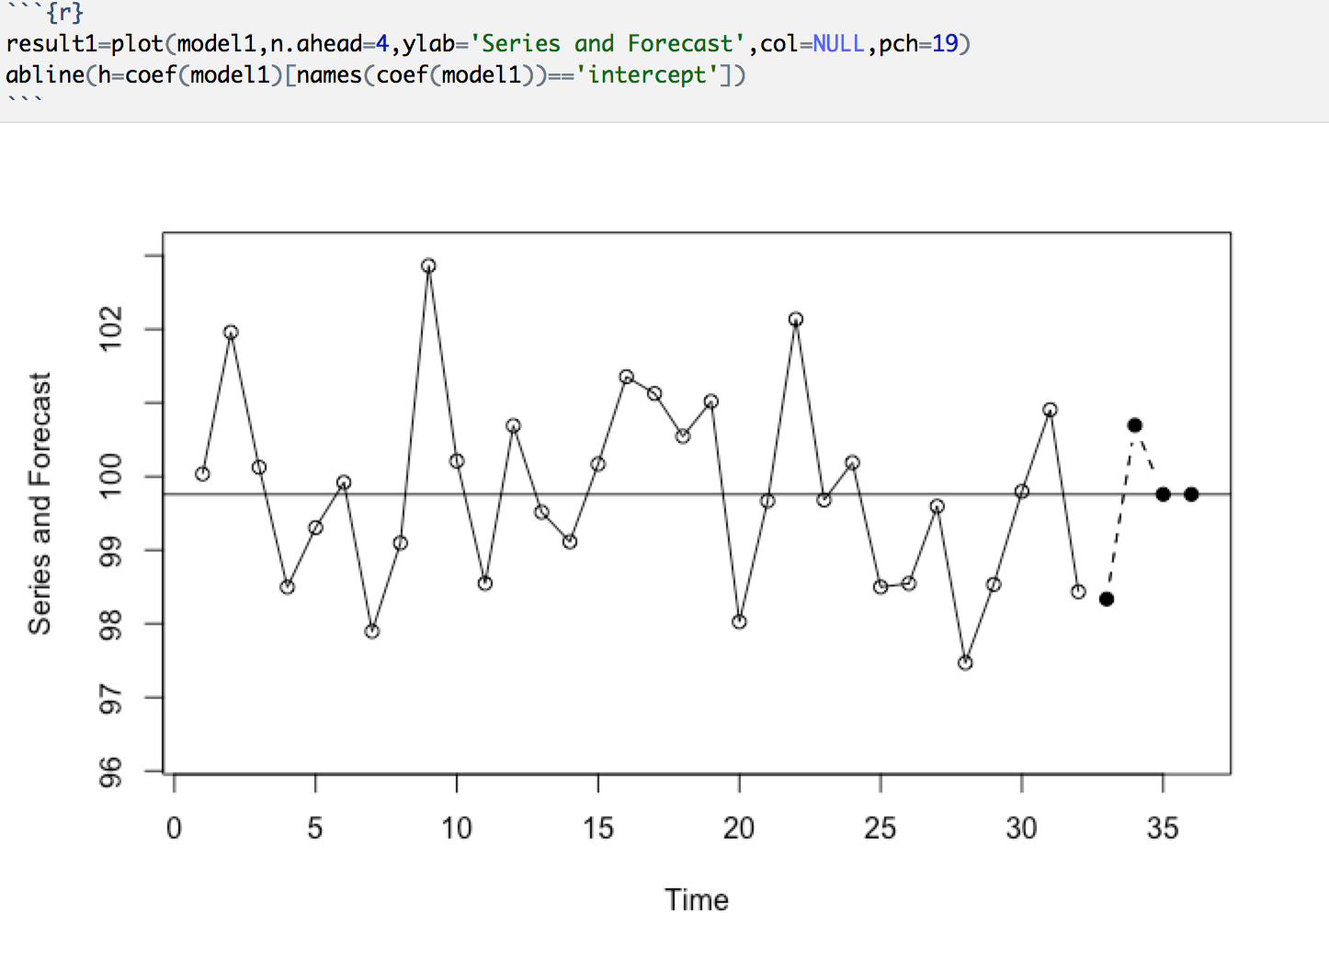

Comment: Difference between first 2 values of forecasts are quite high while the third and fourth are equal to series mean

What is special about the forecasts at lead times 3 and 4?

Both are of same value which is equal to process mean

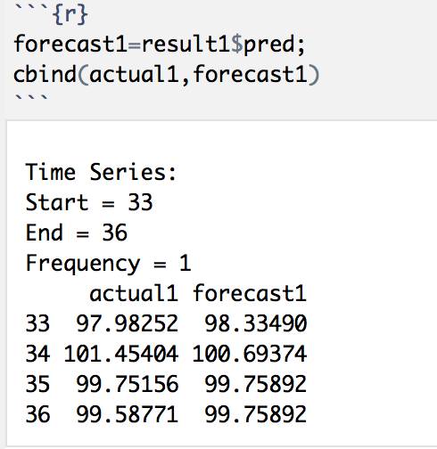

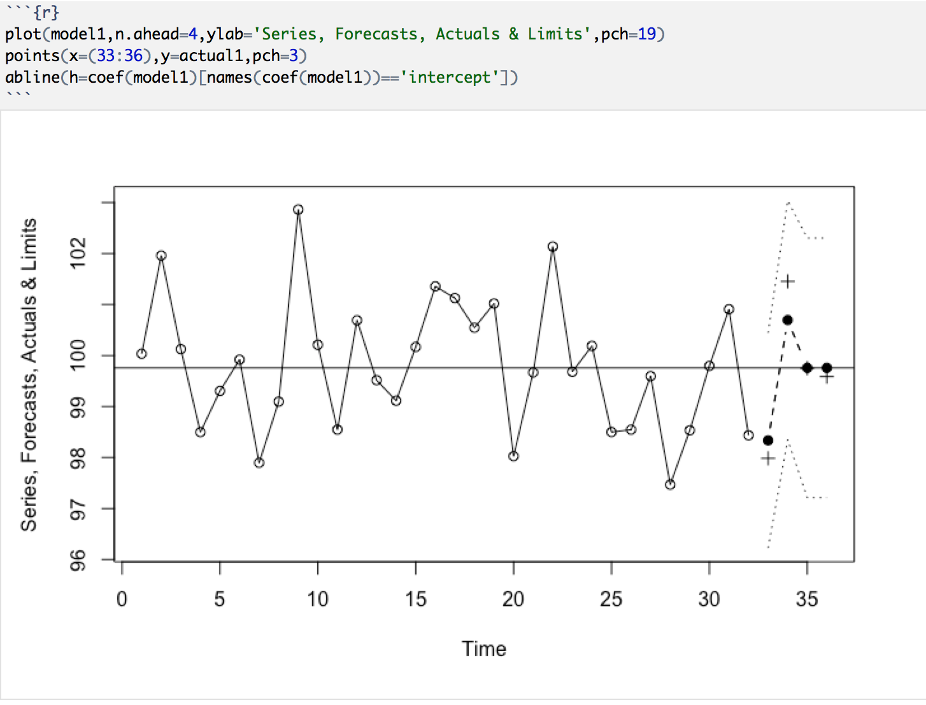

Comment: Actual values doesn't fall within 95% CI

6. Refer to the sweet white wine sales (§3.4.2).

a) Use the HoltWinters procedure with α, β and γ set to 0.2 and compare the SS1PE with the minimum obtained with R.

b) Use the HoltWinters procedure on the logarithms of sales and compare SS1PE with that obtained using sales. 66 3 Forecasting Strategies

c) What is the SS1PE if you predict next month’s sales will equal this month’s sales?

d) This is rather harder: What is the SS1PE if you find the optimum α, β and γ from the data available at each time step before making the one-step-ahead prediction?

*Solution:*

a) Use the HoltWinters procedure with α, β and γ set to 0.2 and compare the SS1PE with the minimum obtained with R.

mydata=read.csv("/Users/meenakshinagarajan/Downloads/monthly-australian-wine-sales-th.csv")  
wine.dat <- read.table("/Users/meenakshinagarajan/Downloads/monthly-australian-wine-sales-th.csv", header = T) ; attach (wine.dat)  
sweetw.ts <- ts(mydata, start = c(1980,1),end=c(1995,7),freq = 12)  
plot(sweetw.ts)

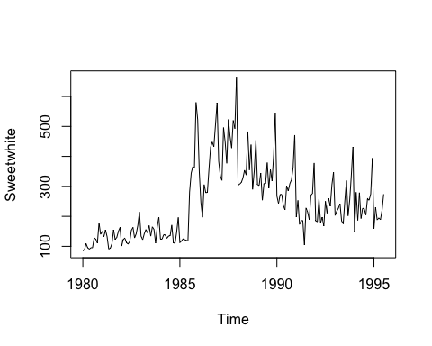

sweetw.hw <- HoltWinters (sweetw.ts, alpha=0.2, beta=0.2, gamma=0.2, seasonal = "mult")  
plot(sweetw.hw)

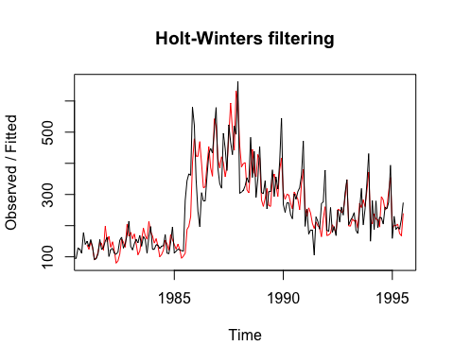

sweetw.hw$SSE

## [1] **651777**

The SS1PE of this model is 651777.

sweetw.hw <- HoltWinters (sweetw.ts, seasonal = "mult")  
plot(sweetw.hw)

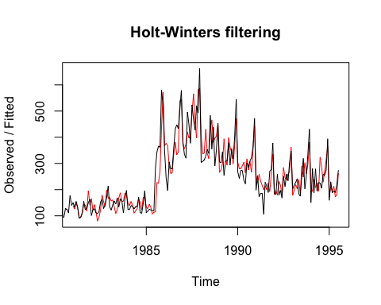

sweetw.hw$SSE

## [1] **477693.9**

The SS1PE of this model is **477693.9**.

sweetw.hw ; sweetw.hw$coef

## Holt-Winters exponential smoothing with trend and multiplicative seasonal component.  
##   
## Call:  
## HoltWinters(x = sweetw.ts, seasonal = "mult")  
##   
## Smoothing parameters:  
## alpha: 0.4086698  
## beta : 0  
## gamma: 0.4929402  
##   
## Coefficients:  
## [,1]  
## a 285.6890314  
## b 1.3509615  
## s1 0.9498541  
## s2 0.9767623  
## s3 1.0275900  
## s4 1.1991924  
## s5 1.5463100  
## s6 0.6730235  
## s7 0.8925981  
## s8 0.7557814  
## s9 0.8227500  
## s10 0.7241711  
## s11 0.7434861  
## s12 0.9472648

## a b s1 s2 s3 s4   
## 285.6890314 1.3509615 0.9498541 0.9767623 1.0275900 1.1991924   
## s5 s6 s7 s8 s9 s10   
## 1.5463100 0.6730235 0.8925981 0.7557814 0.8227500 0.7241711   
## s11 s12   
## 0.7434861 0.9472648

We notice that the parameters in the second model: α = 0.4086698, β = 0, and γ = 0.4929402. β =0 doesn’t indicate trend or slope

b) Use the HoltWinters procedure on the logarithms of sales and compare SS1PE with that obtained using sales.

logdata<-log(mydata)  
head(logdata)

## Sweetwhite  
## 1 4.442651  
## 2 4.488636  
## 3 4.691348  
## 4 4.553877  
## 5 4.510860  
## 6 4.553877

sweetw.ts1 <- ts(logdata, start = c(1980,1),end=c(1995,7),freq = 12)  
plot(sweetw.ts1)

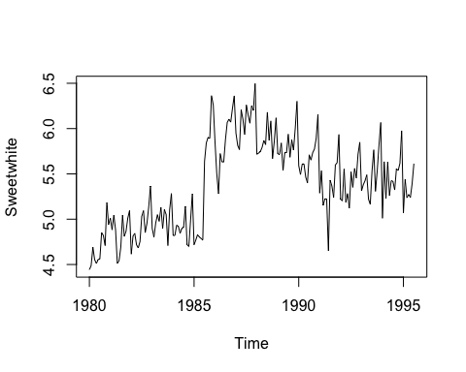

sweetw1.hw <- HoltWinters (sweetw.ts1, seasonal = "mult")  
plot(sweetw1.hw)

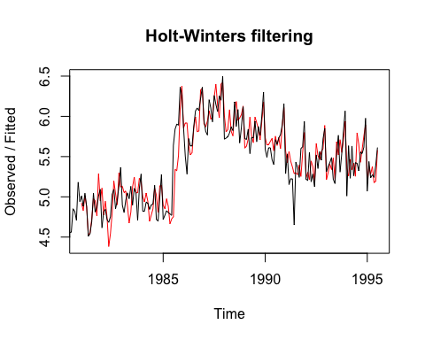

sweetw1.hw$SSE

## [1] 7.61344

It could be seen that SS1PE is reduced after logarithm, SS1PE=7.61344, log(SS1PE)=2025.233.

sweetw1.hw ; sweetw1.hw$coef

## Holt-Winters exponential smoothing with trend and multiplicative seasonal component.  
##   
## Call:  
## HoltWinters(x = sweetw.ts1, seasonal = "mult")  
##   
## Smoothing parameters:  
## alpha: 0.4002885  
## beta : 0  
## gamma: 0.4736874  
##   
## Coefficients:  
## [,1]  
## a 5.64036055  
## b 0.01148402  
## s1 0.99382115  
## s2 0.99855944  
## s3 1.00747184  
## s4 1.03454575  
## s5 1.07926178  
## s6 0.93037318  
## s7 0.98152322  
## s8 0.95283683  
## s9 0.96813137  
## s10 0.94600731  
## s11 0.94921766  
## s12 0.99336392

## a b s1 s2 s3 s4   
## 5.64036055 0.01148402 0.99382115 0.99855944 1.00747184 1.03454575   
## s5 s6 s7 s8 s9 s10   
## 1.07926178 0.93037318 0.98152322 0.95283683 0.96813137 0.94600731   
## s11 s12   
## 0.94921766 0.99336392

However, α = 0.4002885, β = 0, and γ = 0.4736874, like the one before.

c) What is the SS1PE if you predict next month’s sales will equal this month’s sales?

mydatanew=read.csv("/Users/meenakshinagarajan/Downloads/monthly-australian-wine-sales-add-month.csv")  
wine.dat <- read.table("/Users/meenakshinagarajan/Downloads/monthly-australian-wine-sales-th.csv", header = T) ; attach (wine.dat)

## The following object is masked from wine.dat (pos = 3):  
##   
## Sweetwhite

sweetw2.ts <- ts(mydatanew, start = c(1980,1),end=c(1995,8),freq = 12)  
plot(sweetw2.ts)

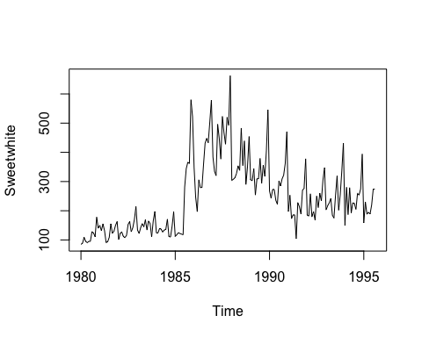

sweetw2.hw <- HoltWinters (sweetw2.ts, alpha=0.2,beta=0.2,gamma=0.2,seasonal = "mult")  
sweetw2.hw$SSE

## [1] 652461.7

sweetw2.hw <- HoltWinters (sweetw2.ts,seasonal = "mult")  
sweetw2.hw$SSE

## [1] 477695.7

It could be seen that SS1PE when you predict next month’s sales will equal this month’s sales, doesn’t differ much from the values obtained before

d) This is rather harder: What is the SS1PE if you find the optimum α, β and γ from the data available at each time step before making the one-step-ahead prediction?