R Notebook

Simulate an AR(1) series with = 0.8 and n = 48.

library(ggplot2)  
library(grid)  
library(TSA)

## Loading required package: leaps

## Loading required package: locfit

## locfit 1.5-9.1 2013-03-22

## Loading required package: mgcv

## Loading required package: nlme

## This is mgcv 1.8-17. For overview type 'help("mgcv-package")'.

## Loading required package: tseries

##   
## Attaching package: 'TSA'

## The following objects are masked from 'package:stats':  
##   
## acf, arima

## The following object is masked from 'package:utils':  
##   
## tar

par(mfrow=c(1,1))  
set.seed(4321)  
arma.sim<-arima.sim(list(ar=0.8),n=48)

1. Find the method-of-moments estimate of phi

acf<-acf(arma.sim)

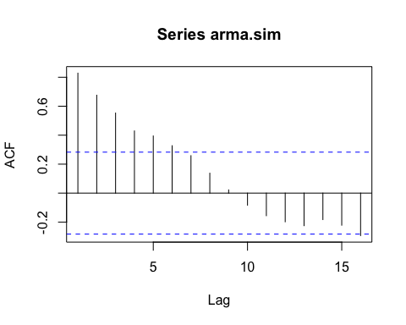

print(acf[1])

##   
## Autocorrelations of series 'arma.sim', by lag  
##   
## 1   
## 0.829

1. Find the conditional least squares estimate of and compare it with part (a).

arima(arma.sim,order=c(1,0,0),method='CSS')$coef[1]

## ar1   
## 0.8367125

1. Find the maximum likelihood estimate of and compare it with parts (a) and (b).

arima(arma.sim,order=c(1,0,0),method='ML')$coef[1]

## ar1   
## 0.849501

1. Repeat parts (a), (b), and (c) with a new simulated series using the same parameters and same sample size. Compare your results with your results from the first simulation.

par(mfrow=c(1,1))  
set.seed(4000)  
arma.sim1<-arima.sim(list(ar=0.8),n=48)

acf1<-acf(arma.sim1)

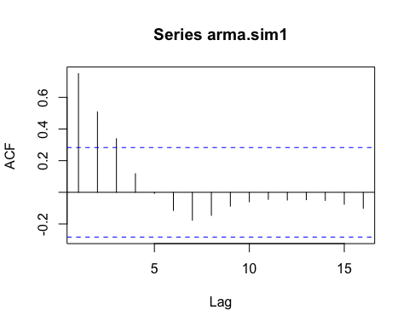

print(acf1[1])

##   
## Autocorrelations of series 'arma.sim1', by lag  
##   
## 1   
## 0.75

arima(arma.sim1,order=c(1,0,0),method='CSS')$coef[1]

## ar1   
## 0.7521422

arima(arma.sim1,order=c(1,0,0),method='ML')$coef[1]

## ar1   
## 0.7374492