R Notebook

Simulate an ARMA(1,1) series with phi=0.7 and theta=0.4, and n=72

library(ggplot2)  
library(grid)  
library(TSA)

## Loading required package: leaps

## Loading required package: locfit

## locfit 1.5-9.1 2013-03-22

## Loading required package: mgcv

## Loading required package: nlme

## This is mgcv 1.8-17. For overview type 'help("mgcv-package")'.

## Loading required package: tseries

##   
## Attaching package: 'TSA'

## The following objects are masked from 'package:stats':  
##   
## acf, arima

## The following object is masked from 'package:utils':  
##   
## tar

par(mfrow=c(1,1))  
set.seed(54321)  
arma.sim<-arima.sim(list(ar=0.7,ma=-0.4),n=72)

1. Find the method-of-moments estimates of theta and phi

acf(arma.sim)$acf

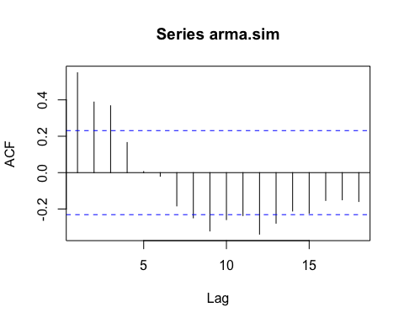

## , , 1  
##   
## [,1]  
## [1,] 0.549357167  
## [2,] 0.388096245  
## [3,] 0.367623116  
## [4,] 0.165666847  
## [5,] 0.006112673  
## [6,] -0.019838269  
## [7,] -0.183102515  
## [8,] -0.248674930  
## [9,] -0.320889586  
## [10,] -0.258465587  
## [11,] -0.236178041  
## [12,] -0.338259006  
## [13,] -0.278153979  
## [14,] -0.211176145  
## [15,] -0.223407235  
## [16,] -0.153101240  
## [17,] -0.149556740  
## [18,] -0.158915347

1. Find the conditional least squares estimates of phi and theta and compare them with part (a).

arima(arma.sim,order=c(1,0,1),method='CSS')

##   
## Call:  
## arima(x = arma.sim, order = c(1, 0, 1), method = "CSS")  
##   
## Coefficients:  
## ar1 ma1 intercept  
## 0.7655 -0.3605 -0.2444  
## s.e. 0.0961 0.1480 0.3075  
##   
## sigma^2 estimated as 0.868: part log likelihood = -97.07

Comment: The estimate of phi in this part is larger than then one obtained from part (a). However, they are significantly different

1. Find the maximum likelihood estimates of and and compare them with parts (a) and (b)

arima(arma.sim,order=c(1,0,1),method='ML')

##   
## Call:  
## arima(x = arma.sim, order = c(1, 0, 1), method = "ML")  
##   
## Coefficients:  
## ar1 ma1 intercept  
## 0.7771 -0.3055 -0.0203  
## s.e. 0.1190 0.1647 0.3409  
##   
## sigma^2 estimated as 0.9147: log likelihood = -99.19, aic = 204.39

The results from part b and c are quite close to each other

1. Repeat parts (a), (b), and (c) with a new simulated series using the same parameters and same sample size. Compare your new results with your results from the first simulation

par(mfrow=c(1,1))  
set.seed(54000)  
arma.sim1<-arima.sim(list(ar=0.7,ma=-0.4),n=72)

acf(arma.sim1)$acf

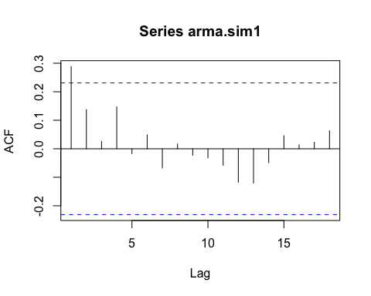

## , , 1  
##   
## [,1]  
## [1,] 0.28823431  
## [2,] 0.13733049  
## [3,] 0.02543394  
## [4,] 0.14668313  
## [5,] -0.01741404  
## [6,] 0.04831740  
## [7,] -0.06720818  
## [8,] 0.01688249  
## [9,] -0.02261804  
## [10,] -0.03174919  
## [11,] -0.05795037  
## [12,] -0.11740729  
## [13,] -0.12010520  
## [14,] -0.04876209  
## [15,] 0.04567420  
## [16,] 0.01406161  
## [17,] 0.02321934  
## [18,] 0.06319468

arima(arma.sim1,order=c(1,0,1),method='CSS')

##   
## Call:  
## arima(x = arma.sim1, order = c(1, 0, 1), method = "CSS")  
##   
## Coefficients:  
## ar1 ma1 intercept  
## 0.5834 -0.3141 -0.2226  
## s.e. 0.3518 0.4199 0.2134  
##   
## sigma^2 estimated as 1.127: part log likelihood = -106.47

arima(arma.sim1,order=c(1,0,1),method='ML')

##   
## Call:  
## arima(x = arma.sim1, order = c(1, 0, 1), method = "ML")  
##   
## Coefficients:  
## ar1 ma1 intercept  
## 0.5191 -0.2401 -0.2531  
## s.e. 0.3697 0.4187 0.1949  
##   
## sigma^2 estimated as 1.116: log likelihood = -106.16, aic = 218.31