**EGR 7050 Design and Analysis of Engineering experiments**

**Homework 10**

1. *Problem 6.36 describes a study of resistivity in silicon wafers. The full factorial, 24 design for 4 factors would have 16 runs, as shown in Table P6.10. Suppose that only 8 runs could be made in this process.*
2. *Create the data table for a $2^{4-1}$ design with D = AC as the design generator (show the 8 rows). Fill in the appropriate 8 observations from Problem 6.36. You won’t use all of the data in Table P6.10.*

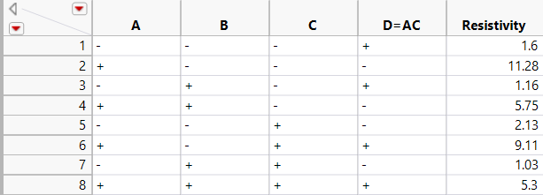

1. *Find the alias structure for this $2^{4-1}$ design (with D = AC as the design generator). What is the resolution of this design?*

This is a $2^{4-1}$ design. The aliases are found using each of these generators with the main effects and $2^{nd}$ order interactions:

|  |  |  |
| --- | --- | --- |
| A | (ACD) | CD |
| B | (ACD) | ABCD |
| C | (ACD) | AD |
| D | (ACD) | AC |
| AB | (ACD) | BCD |
| BC | (ACD) | ABD |
| BD | (ACD) | ABC |
| ACD | (ACD) | I |

The design generator has three letters, hence this is a resolution 3 design. Also, no main effect is aliased with any other main effect and some main effects are aliased with 2 factor interactions.

*c. Analyze the data from the $2^{4-1}$ data table from part a. and estimate the factor effects using a combination of the Normal plot of effects and an ANOVA analysis. (You don’t need to include your residual analysis or show connecting letters report in your submission for this problem.)*

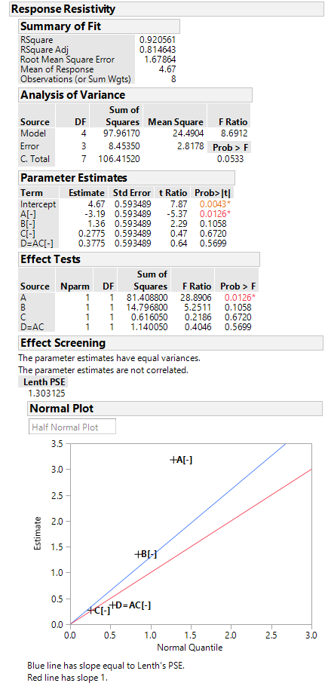

Main effect regression coefficients are given here. The effect estimate can be calculated from this.

The main effect A is less than 0.05 and appears to be statistically significant

Factor A appear to be significant. A is aliased with CD.

*d. Considering the limitations in the design you discovered in part b., what conclusions can you draw about significant effects?*

Except A no other main effect appears to be significant. A is aliased with CD alone. Leaving the other effects might result in an inconsistent model.

*e. Is there a better design in Table 8.14 that you would recommend? If so, why?*

D = ABC could be a better design. It could result in a design with better resolution.

*2. An article in Soldering & Surface Mount Technology (“Characterization of a Solder Paste Printing Process and Its Optimization,” 1999, Vol. 11, No. 3, pp. 23–26) describes the use of a 28_3 fractional factorial experiment to study the effect of eight factors on two responses; percentage volume matching (PVM) – the ratio of the actual printed solder paste volume to the designed* volume; *and non-conformities per unit (NPU) – the number of solder paste printing defects determined by visual inspection (20_ magnification) after printing according to an industry workmanship standard. The factor levels are shown below and the test matrix and response data are shown in Table P8.9.*

|  |  |  |
| --- | --- | --- |
| Parameters | Levels | |
| Low(-) | High (+) |
| A. Squeegee pressure, MPa | 0.1 | 0.3 |
| B. Printing speed, mm/s | 24 | 32 |
| C. Squeegee angle, deg | 45 | 65 |
| D. Temperature, deg C | 20 | 28 |
| E. Viscosity, kCps | 1100-1500 | 1250-1300 |
| F. Cleaning interval, stroke | 8 | 15 |
| G. Separation speed, mm/s | 0.4 | 0.8 |
| H. Relative humidity, % | 30 | 70 |

1. *Verify that the generators are I = ABCF, I = ABDG, and I = BCDEH for this design.*

The below table s generated by using F=ABC, G=ABD, H=BCDE generators. The runs obtained correspond to the table given in the question.

8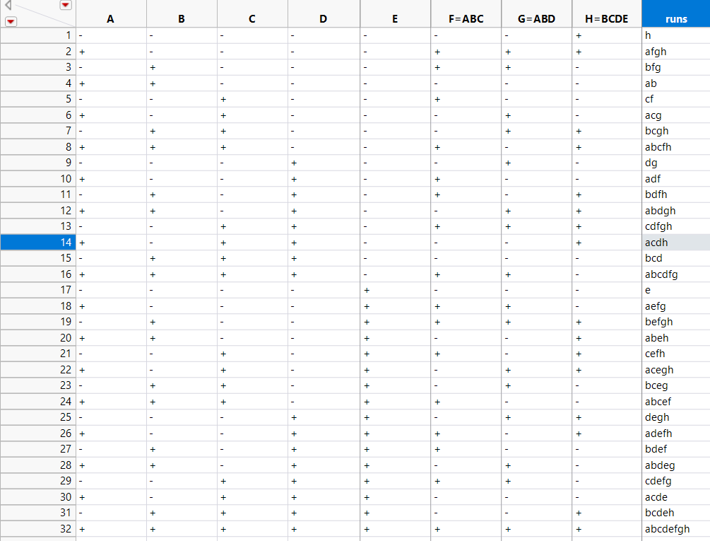

b. *What are the aliases for the main effects and two factor interactions? You can ignore all interactions of order three and higher.*

*I = ABCF, I = ABDG, and I = BCDEH*

*This is a $2^{8-3}$ design. The aliases are found using each of these generators.*

|  |  |  |  |  |  |  |  |  |  |
| --- | --- | --- | --- | --- | --- | --- | --- | --- | --- |
| A | (*ABCF)* | =BCF | A | (*ABDG)* | =BDG | A | (BCDEH) | =ABCDEH | A=BCF=BDG=ABCDEH |
| B | (*ABCF)* | =ACF | B | (*ABDG)* | =ADG | B | (BCDEH) | =CDEH | B=ACF=ADG=CDEH |
| C | (*ABCF)* | =ABF | C | (*ABDG)* | =ABCDG | C | (BCDEH) | =BDEH | C=ABF=ABCDG=BDEH |
| D | (*ABCF)* | =ABCDF | D | (*ABDG)* | =ABG | D | (BCDEH) | =BCEH | D=ABCDF=ABG=BCEH |
| E | (*ABCF)* | =ABCEF | E | (*ABDG)* | =ABDEG | E | (BCDEH) | =BCDH | E=ABCEF=ABDEG=BCDH |
| F | (*ABCF)* | =ABC | F | (*ABDG)* | =ABDFG | F | (BCDEH) | =BCDEFH | F=ABC=ABDFG=BCDEFH |
| G | (*ABCF)* | =ABCFG | G | (*ABDG)* | =ABD | G | (BCDEH) | =BCDEGH | G=ABCFG=ABD=BCDEGH |
| H | (*ABCF)* | =ABCFH | H | (*ABDG)* | =ABDGH | H | (BCDEH) | =BCDE | H=ABCFH=ABDGH=BCDE |
| AB | (*ABCF)* | =CF | AB | (*ABDG)* | =DG | AB | (BCDEH) | =ACDEH | AB=CF=DG=ACDEH |
| CF | (*ABCF)* | =AB | CF | (*ABDG)* | =ABCDFG | CF | (BCDEH) | =BFDEH | CF=AB=ABCDFG=BFDEH |
| DG | (*ABCF)* | =ABCDFG | DG | (*ABDG)* | =AB | DG | (BCDEH) | =BCEGH | DG=ABCDFG=AB=BCEGH |