**EGR 7050 Design and Analysis of Engineering experiments**

**Homework 11**

1. The data shown in the Table P11.2 were collected in an experiment to optimize crystal growth as a function of three variables x1, x2, and x3. Large values of y (yield in grams) are desirable. Fit a second-order model and analyze the fitted surface. Under what set of conditions is maximum growth achieved?

|  |  |  |  |
| --- | --- | --- | --- |
| **x1** | **x2** | **x3** | **y** |
| -1 | -1 | -1 | 66 |
| -1 | -1 | 1 | 70 |
| -1 | 1 | -1 | 78 |
| -1 | 1 | 1 | 60 |
| 1 | -1 | -1 | 80 |
| 1 | -1 | 1 | 70 |
| 1 | 1 | -1 | 100 |
| 1 | 1 | 1 | 75 |
| -1.682 | 0 | 0 | 100 |
| 1.682 | 0 | 0 | 80 |
| 0 | -1.682 | 0 | 68 |
| 0 | 1.682 | 0 | 63 |
| 0 | 0 | -1.682 | 65 |
| 0 | 0 | 1.682 | 82 |
| 0 | 0 | 0 | 113 |
| 0 | 0 | 0 | 100 |
| 0 | 0 | 0 | 118 |
| 0 | 0 | 0 | 88 |
| 0 | 0 | 0 | 100 |
| 0 | 0 | 0 | 85 |

***Solution:***

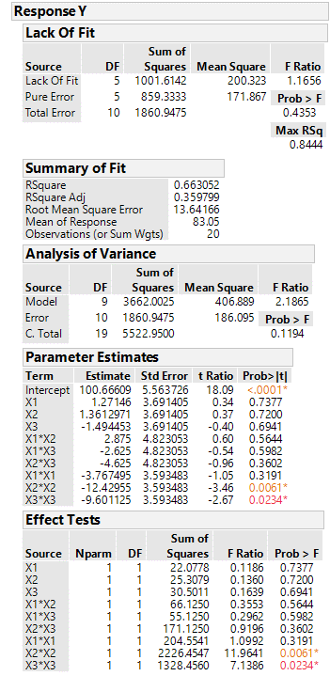

Rsquare value is not very large. Therefore a better fitting model would be more useful

From the effect tests, we could see that many terms are not significant at $α=0.05$. Only X2*X2 and X3*X3 are significant.

As there are many insignificant factors, the model is not significant and hence few terms needs to be removed.

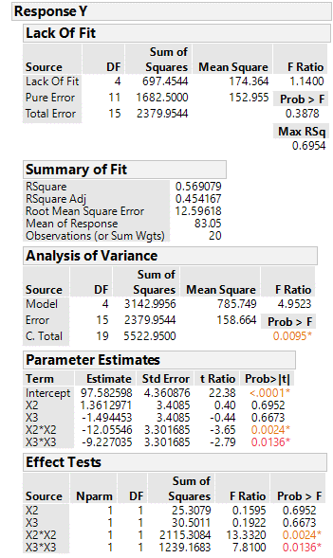

This is the final model from this analysis. Although the fit of the model is not great, it is the best information we have from the available data.

$\hat{y}$ =97.582+1.361 $x_{2}$-1.494 $x_{3}$-12.055 ${x^{2}}_{2}$-9.227 ${x^{2}}_{3}$

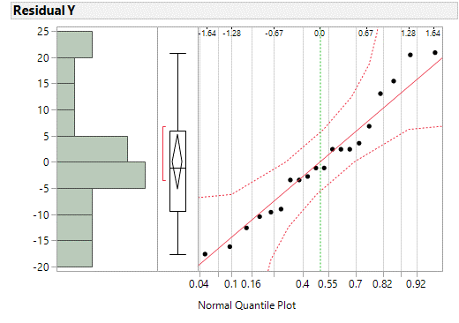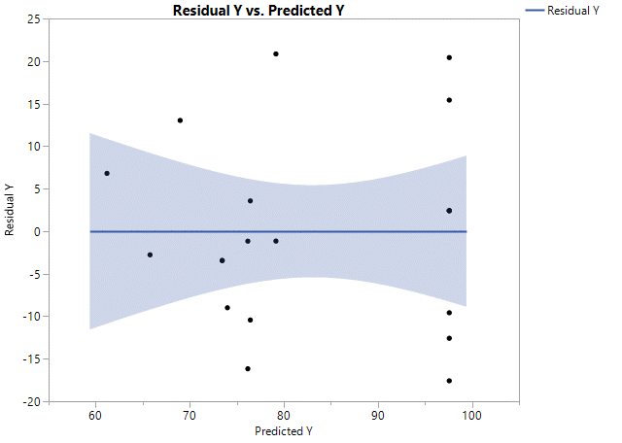

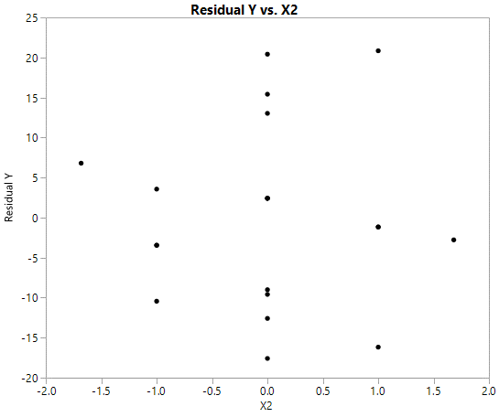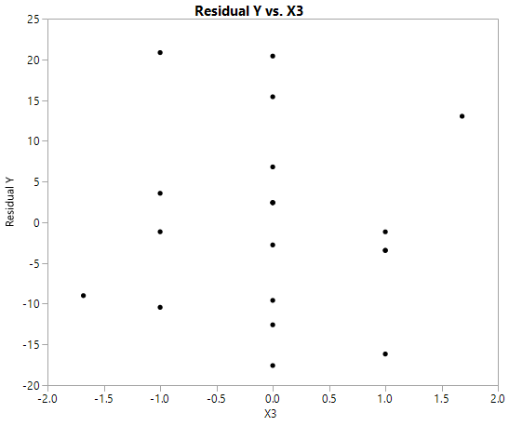

The normal plot has all points close to the line and within the error bounds, indicating no unusual departure from normality. The residual vs. predicted plot and residual vs factors plot show no unusual pattern. This does not violate the model assumptions although the model fit does not great.

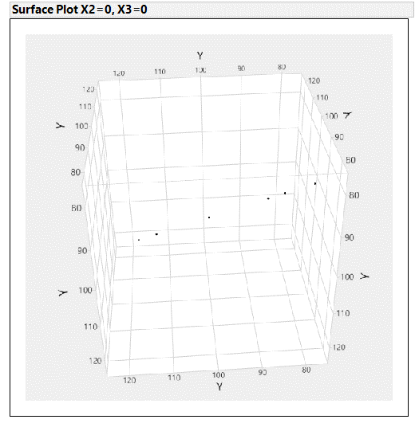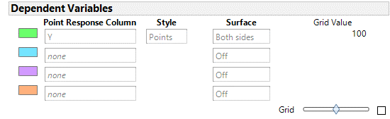

This is the maximum yield obtained in this experiment for the input setting x2 and x3 =0 approximately. This can be verified using contour plot.

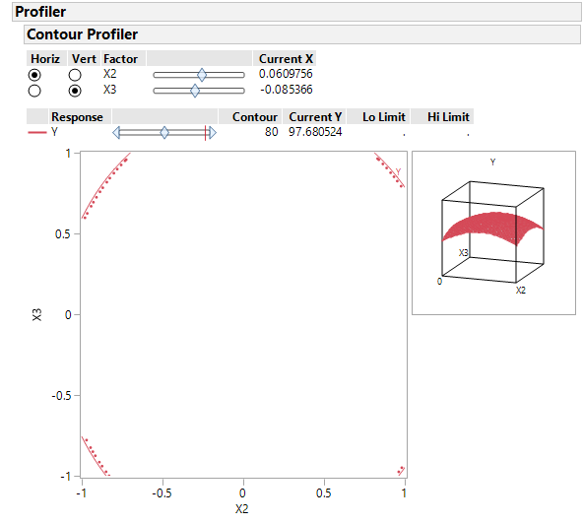

From the contour plot, we could see that maximum yield can be obtained at x2=0.0609 and x3=-0.085366 approximately.